TIV GRAMMAR

Tiv Nouns
A noun is a word that represents people (ior), places (ajiir), or things (akaa) such as objects (ikav), animals (aninyamev, zendeinya), and ideas (mbamhen). Proper nouns are those that represent names of people (ati a ior), countries (ityar), and places (ajiir a vesen).
Examples of proper nouns are:

Lucy Aba
Bem Gba
Torkuma Ifan
Boston
Gboko
Lagos
River Benue
Niger River
University of Mkar
Mount Kilimanjaro
January
Nigeria
(Note that all these proper nouns begin with capital letters.)

Common nouns are those that represent objects or things. They name things we can touch [e.g., “rock” (iwen), "bull" (nombua), "mango" (mongol), "phone" (fon)], but sometimes they name things we cannot touch [e.g., "beauty" (mdoom), "mile" (mel), "love" (dooishima)].

Examples of Nouns
Here are some examples of common nouns in English and Tiv (in parentheses). (For more examples, see the section on English-Tiv Vocabulary Guide, pp 52-84.

African pear (mzembe)
afternoon (atetan)
airplane (igirgi purugh)
animal (zendeinya)
bag (ikpa)
banana (ayaba)
bank (banki, bam)
bed (gambe)
bird (inyon)
bitter leaf (ituna)
block (akam)
blood (awambe)
box (akwati)
brick/block (ikamegh)
brother (aningbian nomso)
bus (mato u tôôn ior)
car (mato)
carve, butcher (bur)
cat (kpatema)
chair (ikônogh)
chemist (kemesi)
chicken (ikegh)
city (gar)
cocoyam (mondo)
corn (maize)
corpse (ikom)
cross (terankon)
doctor (ortwer)
dog (iwa)
drum (genga)
duck (ikeghdam)
ears (ato)
eyes (ashe)
farm (sule)
father (ter)
fever (iyolhian)
flower (imondon kon)
food (kwaghyan)
forehead (ichur)
ginger (seta)
goods (ikav)
grain (ishange)
hair (ice)
horse (nyinya)
house (iyough)
kettle (ketul)
knife (ihô)
madness (ihundugh)
maize (ikuleke)
mat (butu)
millet (amine)
money (inyaregh)
moon (wer)
mooshy (bôdobôdo)
morning (pepe)
mother (ngô)
mountain (wo)
mouse (ihev)
mud (aingbôr)
neck (mon)
night (tugh)
oil (mkurem)
okra (atuur)
palm nuts (ivile)
pawpaw (mbuer)
peanuts (abun)
pig (igo)
plantain (kôôkombo)
policeman (orpuloshi)
pond (itungu)
pot (itiegh)
potato (atsaka)
rabbit (alôm)
river (uwagh)
roots (amishe)
run after (zenda)
salt (bar)
sea (ifi)
shoes (akôv)
sin (ishoribo)
sister (anigbian u kwase)
slim (zengalii)
smell (ihuma)
snail (ikôôr)
soldier (orsoja, orshoja)
straight (jighirii)
sun (iyange)
tea (tii)
tear(s) (mliam)
telephone (telefon)
thin (zenga zenga)
train (girgi dogo)
tree (kon)
trousers or pants (wondo)
very thin (zengem)
wasp (ihambe)
water (mngerem)
weekend (mbee u kasua)
wobbly (zezeze)

In Tiv language there are words that have the exact spelling but different meanings, depending on how you pronounce them. For example, tor (chief), tor (a mouse the lives in the ground), tor (mortar), and tor (roof); kor (sew) and kor (rope). Sometimes the spellings are the same and the pronunciation is also the same. For example, ya (home) and ya (eat); yem (gone) and yem (well cleaned).

Singular and Plural Nouns
There are no set rules for making plural nouns from singular noun like there is in English. While there may appear to be some pattern, only practice helps identifying plural nouns possible.

Examples:
Singular Noun |  | Plural Noun
Tiv word | English equivalent | Tiv word | English equivalent
Ijondough | Calabash or gourd | Mzôndom | Calabashes, gourds
Bua | Cattle | Ibua | Cattle
Nombua | Bull | Anom a ibua | Bulls
Bagu | Monkey | Ibagu | Monkeys
Itiough | Head | Mtom | Heads
Butu | Mat | Ubutu | Mats
Alôm | Hare, rabbit | Mbaalom | Hares
Or | Person | Ior | Persons, people
Kwase | Woman, female | Kasev | Women
Ortiv | A Tiv person | Ônovtiv, ôntiv | Tiv people
Tamen or | An elderly person | Tamen mba iorov | Elderly people
Ngokwase | Old woman | Ungô mba kasev | Elderly women
Wanye | Child | Mbayev | children
Wanye nomso | Male child (boy) | Mbayev nomso | Male children (boys)
Wankwase | Girl | Mbayev kasev | Girls
Lu | Mortar | Ilu | Mortars
Zwa | Mouth | Ijwa | Mouths

Note: There are polite and impolite ways of referring to people. For example, tamen or (polite) and tse or (impolite), ngokwase (impolite) and kwase vesen (polite).

Like in English, some nouns do not have suffixes and prefixes or change the spelling to show the plural form. For example:

ahumbe = wind
ambi = faeces
amine = millet
inya = dirt
humbe = air
ikuleke = maize
ime = darkness
mngerem = water
mnyim = smoke
mtsee = heat

toho = grass
waarawa = sand
aingbiôr - mud
amine - millet
amishe - roots)
atsaka - potato
atuur - okra
awambe - blood
ayaba - banana
bar - salt
igo - pig
ihuma - smell
ikav - goods
ikegh - chicken
ikeghdam - duck
ikuleke – maize or corn
inhev - mouse
inyaregh - money
inyon - bird
ituna - bitter leaf
iwa - dog
iyolhian - fever
seta - ginger

Tiv Pronouns
m = I (as in m mough sha/I stood up)
m, mo = me as in dem/leave me or
ka mo/it’s me).
i = it
kwagh (thing) = it
se = we, us
ne = you (plural)
ven = you (plural)
we = you (singular)
ve = they, them

Tiv Pronouns
Pronouns are words used in place of nouns to avoid repetition of the nouns. Like nouns, they can stand for people, places, things, or concepts. In the previous section on greeting, you used some pronouns (he, she, it, we, they).
There are direct object pronouns and indirect object pronouns.

Direct Object Pronouns: A direct object answers the question what? or whom? For example: Dr. Abunku treats patients. The direct object is patients. Another example is: Claudia roasted chicken. Claudia roasted what? Answer is chicken (the direct object). A direct pronoun can replace the direct object. For example:

Dr. Abunku ser mbauangev = Dr. Abunku treats patients. | Un (Dr. Abunku) ser ve = He (Dr. Abunku) treats them.
Claudia kaa ikegh = Claudia roasted chicken. | Un (Claudia) kaa i = She (Claudia) roasted it.
Paseto nyen yila Daniel = The Pastor called Daniel yesterday. | Paseto nyen yila m = The Pastor called me yesterday.
Riga wou ande = Your shirt is torn. | I ande = It is torm
Akôv ne taver ishe gande = These shoes are too expensive. | De yamen a ga = Do not buy them.
Ka an nan tee itiakeda ve? Who took their book? | Ka i yen ga; ka i yase. = It is not yours (pl) ; it is ours.
Tica na ne ibo = The teacher blamed you (pl). | A va hen ya wase. = He/she came to our home.

Indirect Object Pronouns: They follow and are attached to affirmative commands; may follow and be attached to infinitives and present participles. For example:
- Shie gen ka u (sing., pl) nder fere ga. = You (sing., pl) sometimes wake up late.
- We a rumun yô tile sha heen = Stand up here, please. (If you agree stand up here.)
- Za heera za tôô shebul la = Go there and grab that shovel.
- Mbayev kasev mba tilen sha hegen = The girls are standing up now.
- De tem inya ga = Do not sit down.

Independent possessive pronouns
Possessive pronouns show possession of a noun by replacing it. They must stand alone and be used without a noun. The independent possessive pronouns are mine (am/wam/agh), ours (ase), yours (a en, u wen, plural), yours (u wou, singular), his or hers or its (u/i na), theirs (u/i ve, mba vev), and ours (wase, mba asev). Possessive pronouns make construction of sentences simpler and clearer. For example, it would be awkward to say: The points per game Sesugh made were more than my points per game (Ako a Sesugh a ye bol iyange imom hemba ako a m ye bol iyange imom).
U kaan er “bol iyange imom” kwa har doo ungwan ga (To say “points per game” twice does not sound good). Rewriting with a possessive pronoun solves the problem like this:
Ako a Sesugh a ye bol iyange imom hemba ako am = The points per game Sesugh made were more than mine.

More examples of possessive pronoun
Mato wam vihi. Mtôô u wou we? = My car is stalled. May I use yours?
Wegh ku Asôngo Nor hemba lihen a ku agh = Asôngo Nor’s arm is longer than mine.
Ukrani ngu nôngon num u ngohol tar ve = Ukraine is fighting to reclaim the land that is theirs.
Ya u sha 65 Alder Drive ka u wase = The house on 65 alder drive is ours.

These independent possessive pronouns often come at the ends of clauses or phrases.

Summary of pronouns:

m = I (as in m mough sha/I stood up)
m, mo = me as in dem/leave me or
ka mo/it’s me).
i = it
kwagh (thing) = it
se = we, us
ne = you (plural)
ven = you (plural)
we = you (singular)
ve = they, them

Pronouns—short sentences and phrases:
m ngu = I am
ne mba = you (plural) are
kwagh ngu = there is something
ka kwagh = it is something
ka kwagh ga = it is nothing
u ngu = you (singular)
m ngu = I am
un ngu = he/she is
ne mba = you (plural) are
ve mba = they are
se mba = we are

i hide = it returned (came back)
i yem = it went (away)
a = he/she/it
a hide = he/she returned
se ya kwagh = we ate something
ve tema = they sat
kwagh er = something happened
kwagh er ga =nothing happened

Pronoun-Verb Practice

De  (Let) | m  (me)  se  (us)  ve  (hem)  un  (him/her)  i/un (“i” if starts with an i; “un” if starts with any other letter)  (it) | yevese  (run)  yem  (go)  tema  (sit)  ya  (eat)  lam  (speak)  ulugh  (pull)

Exercise 3

One way to understand pronouns well is to practice using them in conversations. This exercise will help you in furthering your understanding.

- A tema inya.
- Ve mough sha.
- Se hide fere.
- Ne nyôr vee?
- U nam ga.
- A via dedo.
- Se mba a nyor mato.
- Wankwase yevese;

a vôr.
- Wankwaor dugh itiough

tsemberee.
- Se na ve kwagh ve.
- M fa ayenge dedo.
- M soo u man ve cii.
- Un fa kwagh u (a)tindi(gh).
- I yevese (i) yem.
- Ve na se iwua.
A nav ve injô
The following pronouns are found in the Tiv language.
M - I
Se - We
Un - He/she
I - It
U - You (singular)
Ne - You (plural)
Ve - They

Short phrases and sentences with Tiv pronouns:

m ngu - I am
se mba – we are
un ngu – he/she is (“un” is often omitted)
i ngi – it is (“i” is often omitted)
u ngu – you (sing) are
ne mba – you (pl) are
ve mba – they are
ne mba lamen - you (plural) are speaking
kwagh ngu - there is something
kwagh ngu hian – something is burning
ka kwagh - it is something
ka kwagh ga - it is nothing
u ngu = you (sing) memen – you (sing) are resting
m ngu ngeren kwagh - I am writing something
un ngu a takerada go - he/she has no book
ne mba sha nongo - you (plural) are on the line
ve mba a hide ga - they are not yet back (the “ve” is often omitted)
se mba moughon higen - we are leaving now

Note: The following may also be heard in Tiv speech:

i hide - it returned (came back)
i yem - it went (away)
a hide - he/she returned
m rumun – I agreed
se ya kwagh - we ate something
ve tema - they sat
ve yem – they left (went)
kwagh er - something happened
kwagh er ga - nothing happened
Ka nyi? – What is it?
Ka kwagh ga – nothing
Saa me hide – till I return (come back): a response to “goodbye”
(za dedo).

Tiv Common Verbs
A verb is a word which explains or describes an act, occurrence, or state of being. A complete sentence must have a verb, though it may not have all parts of speech for the sentence to make sense.
The three main types of verbs are: action verbs, linking verbs, and helping verbs.
- Action verbs describe action or possession in transitive or intransitive form. Transitive verb words must have a noun that is being described or explained, known as a direct object. An indirect object, a noun or phrase, may also be part of the sentence. The following are some examples used in a sentence. (Tiv equivalents in parentheses).
- Transitive verb examples: (i) I arranged the desks yesterday (Nyen m sôr udeseke dedo.). The verb is “arranged,” (sôr) and the direct object is “desks” (udeseke), the noun being acted upon. (ii) Pass me the dish. The verb is “pass,” and the direct object is “dish;” the indirect object is “me.” Note that intransitive verbs do not address or act upon an object or an indirect object. It only has a modifier.
- Intransitive verb examples: (i) I climbed the ladder to reach the books (M unde lada sha u aren sha itiakeda). The intransitive verb is “climbed” (unde). There is not a direct object that is received by “climbed.” Like in English, some Tiv verbs are always intransitive, such as go (yem), stop (tile), squeeze (kam), sit (tema), and enter (nyôr); and others like eat (ya), can be either intransitive or transitive. For example, “U ya kwaghyan ve? En, m ya (no object); Did you eat food? Yes, I ate (no object). Object is underlined.
- Linking verbs connect the subject of a sentence to a noun or adjective that describes it. For example: (a) This meat tastes salty (inyam ne yua bar). In this sentence, meat is the noun/subject, and salty is the adjective. “Tastes” is the linking verb that connects them. (b) All the necklaces are beautiful. The subject is “necklaces,” and the adjective is “beautiful.” The linking verb is “are.” (Write example b in Tiv and identify the linking verb and the connector.)
- Helping verbs are used before action or linking verbs to convey additional information. The main verb with an accompanying helping verb is called a verb phrase. For example: (i) The mechanic will help us with the used car (Mekaniki una wase se a tse mato). In this sentence, “mechanic” (mekaniki) is the subject, “help” (wase) is the main (action) verb, and “will” (una) is the helping verb. (ii) In this tape, Golozo was singing for two hours (Ken tep ne, Golozo lu gberen imo mba ahwa uhar). Here, the underlined helping verb helps to form the tense (highlighted), which is the tense being acted upon.

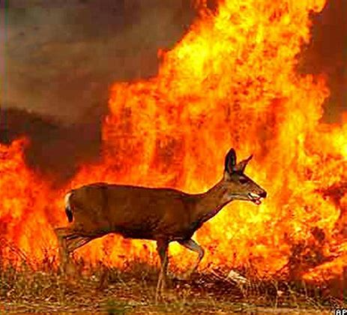 | Kwantera ngu yevese usu. A fa ape una za ga, gadia hanma ijiir cii toho man ikô ngi hian; uya mba iorov kpa mba hian; man igbinda i karen zan za pilin usu shon ngi ga.  The deer is running from the fire. It does not know where to go, because everywhere the grass and the forest are burning; people’s homes are also burning; and there are no roads to go and put out the fires.

More Verb Word Examples
Transitive (tra) only | Intransitive (intr)only | Both Transitive and Intransitive  (Ambitransitive)
The girl carried the water  Wankwase too mngerem | They jumped  Ve tsuwe | She sang when urged by Viki (intra)  A lam shie u Viki tuur un yô
Rumun hit the ball  Rumun gbidye bol | The dog ran  Iwa yevese | He can sing the hymn (tra)  Una faityô u wan icam
Please phone Jayshawn  Wea rumun yo yila Jayshawn | That light was shining  Usu la lu yeghen (nyôron ashe) | We left the hall after singing (intra)  Se due ken iyough shie u se bee ichamwan yô.
Dooyer caught a deer  Dooter kor a kwantera | The bird flew  Inyon purugh | Mwuese left the coat on the hook (transitive)  Mwuese undu koti sha iwev
Msendo saw a rainbow  Msendo nenge a ikume | Yesterday the boys played  Nyen mbayev numbe | I eat when I am hungry (intransitive)  Ka m ya shie u ijen i kerem yô
Erdoo read the book  Erdoo ôr takeda | Baba slept in the couch  Baba yav shin ikôn | I eat peanuts every day (transitive)  M ye abun hanma sev (iyange).

As for nouns, some Tiv verbs are spelled the same, pronounced the same, but have different meanings. For example, “bee” (finish) and “bee” (resemble). The following sentences illustrate the point: (1) Sesugh er kwaghyan bee ( Sesugh has finished cooking). (2) Ka i kaa er Terngu bee tern na (They say that Terngu resembles his dad).

Activity

In each of the following items, underline the verb and highlight the object, if any.

- This dog bites.

(Iwa ne i nyom.)
- Bite the coconut to chew.

(Nyuma ikeve sha er u tam yô.)
- The bone broke.

(Kuhe hembe.)
- He broke the bone by accident.

(A hembe kuhe sha aaikôr.)
- A large family needs a bigger car.

(Tsombor u zegenan soo mato u vesen.)
- Tersur bought shoes.

(Tersur yam akôv.)
- Gajir bought his wife shoes.

(Gajir yam kwase na akôv.)
- The boy took off his shoes.

(Wanye tsuwa akôv na.)
- Open the door.

(Bugh hunda.)
- Open the door wide.

(Bugh hunda u gbabger.)
- He passed on the message.

(A samber a loho.)
- Ashi rose to sing.

(Ashi mough u wan icam.)
- Orban ate plantain.

(Orban ya ayaba.)
- The mother hugged her child.

(Ngô kuve wan na.)
- The people clapped.

(Ior kule ave.)
- Pila laughed.

(Pila se.)
- The dust caused him to sneeze.

(Ihundu er un a yesem.)
- His father reads newspapers.

(Ter na er takeda u abaver.)
- He surely reads.

(Er kpee.)
- Such crime must be punished.

(I mbia kwaghbo la doo u tsahan.)
- I’ve finished cooking.

(M er kwaghyan m bee.)
- Sesugh is done cooking.

Sesugh bee kwaghyan u eren.
- The wild animal is running.

(Inyam toho ngi yevese.)

Verbs List
Below is a selection of verbs for greater understanding of verbs. You can find more verbs and their Tiv equivalents in the Tiv-English Dictionary or the English-Tiv Vocabulary Guide below. Though the examples on this verbs list are given in present tense, the examples may be in the past tense as well.
The list is separated into action, helping, and linking verbs. You may notice that some words like am, appear, was, can act as multiple types of verbs. In Tiv language a word may have the same spelling but also have different meanings. The way you pronounce the word will indicate its meaning. In the following examples, the first word is a verb and the second is a noun: ya (eat) and ya (home), hondo (shave) and hondo (whistling sound), and ker (throw) and ker (seek). The following verbs have been used in sentences, both in English and Tiv.

Active verbs:
Achieve: Teachers must help students achieve higher scores on their tests.
(zua: doo u atica a wase mbayev makerant ve zua a ingegh ki vesen sha akaren ve)
Assemble: The parents and their children assembled for a lecture on school absentism.
(kohol: mbamaren mba mbayev vev kohol sha u ungwan kwagh u mbunde u makeranta)
Accelerate: students have accelerated their understanding in math.
(hemban yemen hemen: mbayev makeranta ve hemba yemen hemen sha u henen ayenge)
Allow: I cannot allow you to eat in class.
(rumun u eren: me faityô u rumun we yan kwagh ken kelase ga)
Apply: the doctor applied medicine to her wound (ivav).
(eren: ortwer er icigh sha ivav)
Appear: He appeared suddenly (gagh).
(due: a va due gagh)
Appoint: The BSSB should appoint a new headmaster for the school.
(tsuwa: ka keng u BSSB a tsuwa hedmasa u he u makeranta)
Buy: Wasem bought eggs for five dollars.
(yam: Wasem yam aji sha dola utaan)
Bring: Bring your running shoes to the race.
(vaa: va a akov a yevese shie u inumbe)
Build: Wanan is building a new shack.
(maa: Wanan ngu maan itumbe i he)

Choose: You must choose who will play football.

(tsuwa, dugh: tsuwa/dugh mba vea gbidye futubol yô)
Close: Yesterday I closed the door when I left the room.
(wuhe: Nyen m wuhe hunda shie u m lu duen ken iyough la)
Compare: Compare the heights of Sesugh and Dooter.
(kar: Kar itiavev i Sesugh man i Dooter)
Convince: I convinced my father to buy me a bicycle.
(ôrkuma: m ôrkuma nahan terem yamem ikeke)
Continue: We continued our journey after we rested for a long time.
(zahemen: Se za hemen a zende shie u se vande memen gbem yô)
Cut: I cut the okra before cooking
(tondo: ka m tondo atuur cii man m jiir ye)
Eat: I eat porridge every morning.
(ya: Ka m ya iber hanma pepe)
Encourage: My mother encouraged me to take a bath.
(seer ishimataver: Ngôm seer mo ishimataver u ôôn iyol)
Earn: I earned an A on my religion test.
(zua, ya: M zua a “A” ken ikaren yam i kwahaôndo)
Examine: You should really get that pain in your knee examined.
(nenge shami(n): Nôngo i nenge sha inuinyion you la)
Expect: I expect results of the blood tests within two days.
(ver ishima: M mver ishima u zuan a ikaren i awambe ken ayange ahar)
Food: Always eat food with lots of protein.
(kwaghyan: yaan kwaghyan ua lu a porotin yô)
Fry: Fry potatoes in hot oil.
(kaa: Kaa atsaka shin mkulem ma tseen)
Grow: We grow cassava for food.
(lôô: Se mba lee (past tense) logo shaci u kwaghyan)
Happen: He asked what happened to my hand.
(er: A pine kwagh u a erem sha we yô)

Hurt: I fell and hurt my toe or hurt myself (vihi iyol)
(vihi iyol, nyion: M gba nahan ihonguhar wam nyion)

Joke: Do not joke about someone’s physical disability.

(kwagh u ahan: De tôôn iwan i or hingir kwagh u ahan ga)
Laugh: Sesugh and Terngu laugh together all the time.
(se: Sesugh man Terngu mba sen imôngo hanma shie)
Learn: We are learning about multiplication in math.
(hen: Se mba henen u eren ayenge a kwaghkwa)
Lizard: The lizard climbed the wall.
(vange: vange unde sha kpepke)
Mention: Lucy mentioned that she is traveling to America.
(ter, kaa: Lucy ter er un ngu zan ken Amerika)
Own: This house is owned by Yadoo’s parents.
(kwagh u alu u wou yo: ya ne ka u mbamaren mba Yadoo)
Promise: Wasem promised to go to bed early every night.
(tondo zwa: Wasem tondo zwa er una yaven faa hanma tugh)
Read: I read a geography book each week.
(ôr, er: M er takeda u kwaghtaregh hanma kasua)
Send: Ngumimi sent us a giftbox for Christmas.
(tindi: Ngumimi tindi se a akwati u iyua i Kirmishi)
Steal: The thief stole money from the bank.
(ii: Ormbaiv ii inyaregh ken/ki bam/banki)
Tell: She did not tell her mom that she was sick.
(kaa: A ôr ngô na er yan lu dedo ga nahan ga)
Theft: Stealing an orange fruit is still theft.
(iv: U iin itiamegh ki alum kpa ka iv)
Thief: The thief was caught, so he did not run away.
(ormbaiv, kwasembaiv: I kôr ormbaiv, nahan a yevese ga)
Trash: Take the trash out of the house.
(inyarev: Tôô inyarev due a min ken iyough sha)
Trumpet: The trumpet is sounding loudly.
(kakaki: imo i kakaki ngi taver geng geng)
Understand: I understand the difference between addition and division in math.
(fa, zua a iwanger: m fa mkposo u seer man kwaghkaren ken ayenge)
Value: Our family values hard work.
(nanjighjigh: tsomol wase na jighjigh sha u eren tom tavera)
Wait: We waited for over two hours.
(kegh: Se kegh hemba mba ahwa uhar)
Walk: We walk to Lake Somerset every week.
(zende: Ka se zende se za shin Lake Somerset hanma kasua)
Wear: Wear white clothes when it is hot outside.
(zer, huwa: zer/huwa akondo a pupul shie u i tsee ken won yô)

Linking Verbs:

Is: Mom is sleeping.
(ngu: Mama ngu yaven)

Am: I am happy you passed the test.
(m: Doo m er u kar ikaren nahan)

Are: The boys are running.
(mba: Mabayev mba yevese)

Was: He was so sad to see his father leave.
(iyan(ge) lu: Iyange lu a ivihishima u nengen ter na yemen)

Were: They were releaved that the plane was arriving on time.
(iyan(ge): Iyan(ge) ishima agba ve shimin er igirgi purugh ngi van sha shie)

Be: I will be waiting till the train arrives.
(lu: Me lu keghen zan zan igirgi dogo ia va nyôr)

Been: He has been sleeping for an hour.
(lu: un lu yaven er ihwa i mom nahan). Compare: ve lu yaven, se lu yaven, ne lu yaven, etc.

Being: He is being naughty.
(lun, tesen, van: ngu lun a/tesen itiough ki taver). “Itiough ki taver” means naughtiness.

Appear: She appears to be feeling much better.
(inja er: Ngu inja er ka hemban u lun un guda nahan). Compare: Ka inja er … (It appears...)

Become: Joshua has become used to eating fufu because his mom taught him how to make it.
(hingir: Josh hingir or u yan ruam shaciu ngô na tese un u eren)

Helping Verbs:

Is: Everyone is talking about the high cost of eggs.

(ngu: hanma or ngu ôron kwagh u isheitaver i ajiaikegh)

Am: I am waiting to see what will happen.

(m ngu: M ngu keghen mer me nenge kwagh u una er yô)

Are: They (we/you (pl)) are sleeping on a mat.

(mba: mba yaven sha butu. Not spoken but understood are “ve/se/ne” mba or they/we/you (pl) are….

Was: I was asked to stand up.

I … er (pine/kaa): I pine er (mo) m tile sha.

“Were”: the police stopped them because they were speeding in the car.

Lu: Poloshi kôr ve shaaciu ve lu nahan mato karen ishiva inya.

Be: She had to be crying since her eyes were wet with tears.

Lu: Un lu vaan sha er ashe na iv a mliam yô.

Been: They have been working for five days.

Lu: Ve lu eren tom kuma ayange ataan. Here, the word “ve” must be spoken before lu.

Has: She/he has moved from Lagos (and has gone) to Abuja.

A: A mough hen Lagos a yem Abuja. You can also use “due” in place of “mough.”

Have: We have always visited Mkar Mountain whenever we go to Gboko.

Illusive word, understood only in context, as in “Se mba bundu u zan sha Wo Mkar ga hanma shie u ka sea za Gboko yô.” You can compare to: (Ve) mba/ne mba, (un)—they/you (pl) have …

Another example: I have always believed in miracles. (M de u nan jighjigh sha akaaeren a cier iyol (mayange) ga.)

Had: I had worked as a teacher before working on the School Board.

Vande: M vande eren tom u tesen cii man u teman sha School Board ye.

Does: Does Mer remember her email password?

Illusive word, understood only in context, as in “Mer umbur paswoed na kpa?”

Do: I do understand how a computer works.

Illusive word, understood only in context, as in “M fa er kômputa a eren tom yô.” “M fa tom u eren u kômputa.”

Did: I did try to sleep after taking a lot of coffee.

Illusive word, understood only in context, as in “M nôngo me ma m yav shie u m me kofi (kpishi) yô.”

Can: Can you sing a Golozo or Burna Boy song?

Illusive word, understood only in context, as in U gber imo i Golozo shin Burna Boy kpa? Compare: Could/would you sing a Golozo or Burna Boy song? Ne gber imo i Golozo shin Burna Boy kpa? (Or Ne faityô u gberen imo i Golozo shin Burna Boy kpa?)

Will: We will rest after reaching the top of Mkar Mountain.

Illusive word, understood only by intonation, as in “Se mem shie u se ar sha itiough ki Wo Mkar yô.” Compare: We rested after reaching the top of Mkar Mountain (“Se mba aren sha itiough ki Wo Mkar yô, se mem.”)

Shall: We shall wear nice clothes to go to the wedding. Illusive word, understood only in context, as in “Se huwa akondo a dedo shie u se lu zan ivese i eren yô.”

Could/would: You could (would you) stop by the store to buy bread (?).

Faityo: U faityô u tilen hen shôpu u yamen beredi (?).

Should/will: I should/will start running when I hear the whistle.

Illusive word, understood only by intonation, as in “Me hii u yevese shie u me ungwa usur yô.”

Must: You must remember to complete your schoolwork well.

Keng keng/kpee: Ka kpee/keng keng u we bee tom makeranta wou dedo.

May: You may raise your hand if you want to answer the question.

A soo yô: We a soo yô u kende wegh sha aluer (if) wea soo (want/desire) u nan mrumun sha mpin (question) yô.

Might: Perhaps I shall take a mathematics class next year.

Alaghga: Alaghga me tôô kelase u ayenge inyom i lu van la. Lu van means “next.”

English-Tiv Common Adjectives

An adjective is a word or clause that describes or modifies a noun or situation or pronoun (i.e., its quality, condition, or state). The description can be independent or in comparison to something else. Ses is a tall man (Ses ka or u taven). Ses is taller than Alex (Ses hemba taven a Aleks).

Study the Liat:

alert (gengeree)

alive (uma)

amused (doo sen)

annoyed (ishima vihi)

anxious (tenge tenge)

arrogant (kaan ihagh)

ashamed (kunya kor)

attractive (doo nengen)

average (heratô)

awful (vihi kpishi)

bad (doo ga)

beautiful (doo ashe)

better (hemba)

black (il)

bloody (awambe awambe)

blue (dindilii)

brainy (a mfe)

brave (mchiem ga)

bright (wanger)

brightness (iwanger)

busy (tom ave)

calm (mem mem, ving)

careful (ishima i wan)

cautious (sha kwaghfan)

clean (wanger)

clever (ayom)

cloudy (abeen abeen)

clumsy (dera de dera)

colorful (ngee a ukola)

confused (taver ungwan)

crazy (bee u ihundu)

creepy (chier iyol)

crowded (yar, ngee)

cruel (sha ishima vihin)

curious (sha mba mker)

cute (dooshe)

dark (milim milim)

dead (kpen ku)

defeated (u i hembe)

defiant (hidden jime ga)

different (kposo)

difficult (taver fan/eren)

distinct (due kposo)

disturbed (za iyol)

dizzy (zu kôr)

doubtful (bee ga)

drab (dimii)

dull (kpughul)

easy (taver ga)

elated (msaan iyol)

elegant (u wan sha da)

evil (kwaghbo, akaabo)

excited (agher)

faithful (na jighjigh ken)

famous (za gwa)

fancy (kwahir kwaghalom)

fierce (va taver)

filthy (hôv)

fine (dedo)

foolish (imbume)

fragile (u hemben)

frail (hundughuu sha ashe)

frantic (sha ishima i vihin)

friend (or u u soo yô)

friendly (sha msoo)

funny (doo sen)

gentle (sha mhe)

glorious (iyol kenden)

good (doo)

gorgeous (doo je gande)

graceful (vine doo)

grieving (vaan ku)

grotesque (vihi nengen)

grumpy (gban num)

happy (saan saan)

healthy (a mkpeiyol)

helpful (wasen)

helpless (iwasen shio)

hilarious (ahan zwa)

homeless (ya ishio)

homely (engem kuma ga)

horrible (chier iyol)

hungry (ijen i kôr)

hurt (vihi iyol)

ill (dedo ga, u ange)

illness (angev)

itchy (agher)

jealous (iwuhe)

jittery (mmem sha ga)

jolly (ishaaniyolough)

joyous (masaan iyol)

kind (doo a ior/akaa)

lazy (wa hwev)

laziness (hwevwan)

light (iwanger)

lively (sar sar)

lonely (orishio)

long (lihe)

lovely (doo ashe)

lucky (ikôr doon)

modern (u ayange ne)

mushy (kpôtu kpôtu)

nasty (iren i vihin)

naughty (ieren i bo)

nice (doo)

odd ( u a zough ga yô)

open (ivegher)

panicky (ishima za iyol)

pleasant (doo ashe)

poised (ger age gera ga)

poor (gban ican)

powerful (tahav)

proud (wan iyol)

putrid (i guran) as in meat

puzzled (ishima tan)

quiet (ving)

real (kpôô kpôô)

repulsive (doo nengen ga)

rich (inyar)

scary (kpilighiyol)

shiny (engem)

shivering (ikarikase)

shy (engem engem)

silly (eren akaa a hômon)

sleepy (mnyam ashe)

smiling (ahan ahan)

smoggy (cing)

stormy (igam)

strange (kposo a akaa gen)

stupid (ibume, dang))

tasty (nyoho, doo ke zwa)

tender (legem)

tense (lun a ishima i vihin)

terrible (u gban kera)

thankful (lun a ishughun)

tired (vôr)

tough (tsulugh, taver

ugliest (hemba vihin ashe)

ugly (vihi ashe)

unusual (er ma i lu ga)

usual (sha er ma i lu la)

upset (ishima vihi)

vain (gbilin)

vanity (gbilin kwagh)

vast (mkehe u ingegh …)

weary (tese ivôron)

wicked (inja dang)

worried (ishima zan iyol)

wrong (shamin ga)

zany (eren sha ibume)

zealous (ishima i eren kwagh u dedo).

Some Tiv adjectives may not have one word with their English equivalents. A longer explanation will be needed. The following are selected examples:

adorable (kwagh u doon ashe)

adventurous (u keren akaa a he)

aggressive (sha agee)

agreeable (feityo u rumun a kwagh)

angry (ishima vihin)

annoying (u vihinshima)

bewildered (kunda (un) ishima)

bewilderment (kundashima)

blushing (kende iyol sha)

bored (hingir kera ke kera)

breakable (una faityo u hemben)

charming (eren akaa a doon ior)

cheerful (saan saan)

clear (wanger) after explanation

combative (u hedan kwagh)

comfortable (tema bem bem)

concerned (waiko sha kwagh)

condemned (wan ken mtsaha)

cooperative (u eren tom a ior mba (akaa) gen.

courageous (u lun a ishimataver)

dangerous (u van a akaabo)

delightful (doo nenge ashe je gande)

depressed (vôriyol)

depression (iyolvôron ker)

determined (torough u zan hemen)

disgusted (vihi m/se je gande)

eager (ishima i eren kwagh)

embarrassed (vihi je er ma ihide a min yô)

enchanting (tsaren ieren i akaa)

encouraging (kwagh u seer ishima i taver)

energetic (agee a een kwagh)

enthusiastic (doo un kpishi u eren kwagh)

envious (u soon kwagh u or gen); covet

expensive (taver ishe)

exuberant (u lun sar sar je ganden)

fair (nengen hanmakwagh vough)

fantastic (gande jighjigh u nan)

frightened (chier iyol)

gifted (kwagh u Aôndo a neu yô)

glamorous (ichivir keren)

gleaming (ijongol usu)

handsome (doo kwaor)

important (lun a inja)

impossible (u fanityô ga)

inexpensive (doo ishe)

innocent (kwagh kôron ga)

inquisitive (soo u fan hanma kwagh)

worrisome (kwagh ze un iyo)

worry (kwagh u zan iyol)

magnificent (doo je er ka kwav aondo nahan)

misty (dindirii a avur a wura/a mngeem)

motionless (tenger ga)

muddy (aningbor aningbor)

mysterious (kwagh u chier iyol)

nervous (ishima kundun ga)

nutty (u tesen mhen u bo, u lun ke zwa

er ka ake a kon nahan)

obedient (u rumun u eren kwagh)

obnoxious (eren akaa a dang)

outrageous (u eren akaaa vikin shima)

outstanding (hemba mbagenev cii)

uninterested (gbaishima ga)

old-fashioned (utse utse)

perfect (gba her jighrii)

plain (wa kwagh sha min ga, kpur kpur, ikpur)

precious (mdoo ashe u kwagh)

prickly (ngu a asar/asagher)

quaint (mlu kposo u kwagh)

relieved (ishima gba shimi)

selfish (hemba nengennsha iyol you)

sore (nyion - u ijiir iyolough)

talented (ngu a mfe u marami)

tame (tesen inyam u lun ikua a ior)

thoughtful (henen nkwagh)

thoughtless (mhenkwagh)

troubled (za un iyol)

sparkling (engemee, engem engem)

splendid (doo gande)

spotless (kungu pulututu; kungu je

ijiir ilen ngi sha min ga)

successful (due doo, za doo)

super (zegenan, hemban kehen)

unsightly (vihi nengen)

victorious (gban ken mhemba)

vivacious: full of life (lun a uma iyol gbing)

wandering (u zenden nzughul nzughul)

wild (er ka kwagh u ke toho nahan)

witty (henen kwagh ôron fere)

Possessive Adjectives
Possessive adjectives show ownership. The possessive adjectives, also called possessive determiners, are my, our, your, his, her, its, and “their.” We break down each type and offer examples of their usage below.
Possessive adjectives also clarify who or what owns something. Unlike possessive pronouns—which replace nouns—possessive adjectives go before nouns to modify them.
Independent possessive pronouns and possessive adjectives can help sentences r statements less awkward. For example:
Msendo soo Bibilo i Msendo (Msendo likes Msendo’s Bible).
It sounds odd to use Msendo’s name twice in this sentence. A possessive adjective modifying the noun Bibilo (Bible) solves the problem: Msendo soo Bibilo na (Msendo likes her Bible).
Thus, possessive adjectives are helpful, and you should use them in Tiv language as in the English language sentence construction.

Examples of Possessive Adjective
Girgi yam va fere ga (My plane is delayed.)
I ver kwaghyan wou (Your dinner is served.)
We a rumun yô due un a kwaghyan na (Please bring his food out to him.)
Iyô ne nyuma tsa na (This snake bit its tail).
Ve lu ken iyou ve shie u m va nyôr yô (They were in their house when I arrived.)

Exercise 4

Examine the adjectives in the above examples and from dictionaries to complete the following activities.
- Translate the following statements into English.
- Ortwer ngu soron un anev mbu hough bar.
- Ortwer nger un ichigh ki itough ki nanden.
- A soo u ngohol mba mhen av ga.
- Tôô riga na va na un.
- Ishima za un iyol sha kwagh u wan na u kwase.
- U ngoron imo sha aighe er usu gba ka kwagh u dang.
- Underline the adjectives (word or phrase) in each of the following:
- Pick the black and red grains from the white ones.
- He turned around so fast that he felt dizzy.
- My room is filthy.
- A fireman is always brave.
- Stop doing evil things.
- He was punished for cursing at her.
- Okocha always bragged about scoring the most goals.
- Translate the following sentences into Tiv.
- A lazy boy cannot work.
- She feels very happy when she scores a goal.
- Give us some food to eat. (May we have some food, please?)
- Kate blew her whistle very hard.
- She climbed Mt. Kilimanjaro because she was an adventurous woman.

Adjectives with Comparisons and Translations
alive (uma)

amused (doo sen)
annoyed (ishima vihi)
anxious (tenge tenge)
arrogant (te hwa)
ashamed (kunya kor)
attractive (doo nengen)
awful (vihi kpishi)
bad (doo ga)
beautiful (doo ashe)
better (hemba doon)
black (il)
brainy (a mfe)
brave (mchiem ga)
bright (wanger)
busy (tom ave)
calm (mem mem, ving)
careful (a ishima i wan)
cautious (sha kwaghfan)
clean (wanger)
clever (sha ayom)
cloudy (abeen abeen)
clumsy (dera de dera)
confused (taver ungwan/kaven)
crazy (bee u ihundugh
creepy (chier iyol)
crowded (yar, ngee)
cruel (sha ishima vihin)
curious (sha mba mker)
cute (dooshe)
dark (milim milim)
dead (kpen ku)
defiant (hidden jime ga)
different (kposo)
difficult (taver fan/eren)
distinct (due kposo)
disturbed (za iyol)
dizzy (zu kôr)
drab (dimii)
dull (kpughul)
easy (taver ga)
elated (msaan iyol)
evil (kwaghbo, akaabo)
excited (agher)
faithful (na jighjigh ken)
famous (za gwa)
fancy (kwahir kwaghalom)
fierce (va taver)
filthy (hôv)
fine (dedo)
foolish (ibume)
fragile (u hemben)
frail (hundughuu sha ashe)
frantic (sha ishima i vihin)
friendly (sha msoo/tesen ishoon)
funny (doo sen)
gentle (sha mhe)
glorious (iyol kenden)
good (doo)
gorgeous (doo je gande)
graceful (vine/zende doo)
grieving (vaan ku)
grotesque (vihi nengen)
grumpy (tesen ishima vihin)
happy (saan saan)
healthy (a mkpeiyol)
helpful (lun a iwasen)
helpless (iwasen shio)
hilarious (ahan zwa)
homeless (ya ishio)
horrible (chier iyol)
hungry (ijen i kôr)
hurt (vihi iyol)
ill (dedo ga, u ange)
itchy (agher)
jealous (u tesen iwuhe/u iwuhegh)
jittery (mmem sha ga); also, nervous
jolly (lun a ishaaniyolough)
joyous (lun a masaan iyol)
kind (eren dedo a ior/akaa)
lazy (wan hwev)
laziness (hwev); see being lazy - hwevwan
light (iwanger)
lively (sar sar)
lonely (sar sar ga shaciu orishio)
long (lihe)
lovely (doo ashe)
lucky (ikôr doon)
modern (u ayange ne)
mushy (kpôtu kpôtu)
nasty (iren i vihin)
naughty (ieren i bo)
nice (doo)
odd ( u a zough ga yô)
open (ivegher)
pleasant (doo ashe)
poor (gban ican)
powerful (lun a tahav)
proud (wan iyol)
putrid (i guran) as in meat
puzzled (ishima tan)
quiet (ving)
real (kpôô kpôô)
repulsive (doo nengen ga)
rich (inyar)
scary (kpilighiyol)
shiny (engem)
shivering (lun a ikarikase)
silly (eren akaa a hômon)
sleepy (mnyam ashe)
smiling (ahan ahan)
smoggy (cing)
stormy (igam)
strange (kposo a akaa gen)
stupid (ibume, dang))
tasty (nyoho, doo ke zwa)
tender (leghem); see soft
tense (fanityo u nalegh iyol/igbira ga)
terrible (u gban kera)
thankful (lun a ishughun)
tired (vôr)
tough (tsulugh, taver
ugliest (hemba vihin ashe)
ugly (vihi ashe)
unusual (er ma i lu ga)
usual (sha er ma i lu la)
upset (ishima vihi/doo ker ga)
vain (gbilin)
vanity (gbilin kwagh)
vast (mkehe u ingegh …)
weary (tese ivôron)
wicked (inja dang)
worried (ishima zan iyol)
wrong (shamin ga)
zany (eren sha ibume/er i eren ga)
zealous (ishima i eren kwagh u dedo).

Tiv Conjunctions, Interjections, and Determiners

Tiv Homonyms

Homonyms are two or more words that have the same spelling or pronunciation (sound the same) but have different meanings. They may also have different spellings but the same pronunciation.

Homographs
Homographs are two or more words spelled or pronounced the same (but not necessarily pronounced the same) and having different meanings. For example, “close” (shut and “close” (near) Tiv examples are “ya” (eat) and “ya” (home). Study and add to the Tiv homographs below.

Agbo (water yam), agbo (bullets)
Agbur (Mbatiav stream), agbur (log or block seats)
Agena (smallpox), agena (its shin)
Ago (readiness), ago (pidgin, imitation language)
Anger (Tiv traditional clothing), anger (gossip)
Azembe (vuture), azembe (axes, plural of ax)
Bam (bank), bam (trick, luring, treachery)
Bende (sumo-style loincloth or mawashi), bende (touch)
Cia (fear, afraid), cia ( , as in tacia or iciaikyôr)
Gande (grown), gande (watery)gbande (plate, dish), gnande (Tiv drum)
Gar (town, settlement), gar ( ,as in Kuma Gar)
Gbem (always), gbem (chin)
Gber (cut), gber (to sing: a song)
Hungul (forgot), hungul (to smell), hungul (fish of forgetfulness)
Igbo (bullet, Igbo (Ibo language)
Ihinga (nose, ihinga (Tiv mid-size burrow mouse)
Ijen (hunger), ijen (lump
Iji (fly), iji (egg)
Iko (goal or score in a game), iko (preparedness)
Ikume (python), ikume (rainbow)
Inima (umbrella), inima (bat: animal)
Isha (gizzrd), isha (necklace)
Ivungu (drill tool), ivungu (owl), ivungu (wood worm)
Ivur (piece), ivur (verse, stanza)
Iyongu (palaver), iyongu (Tiv drinking cup or gourd)
Iyough (yam), iyough (house), iyough (bee)
Ker (throw), ker (seek, find)
Kera (away), kera (in the past)
Kper (net, nest), kper (tomorrow)
Kpera (draw), kpera (crawl), kpera (drag)
Kperegh (wing), kpeegh (tangled)
Kuma (enough), kuma (pierce)
Kume (pound), kume (growling), kume (to make a thunderous sound)
Kwar (thread), kwar (contemporary)
Kwembe (clam, clam shell), kwembe (Tiv medicinal Akombo rights)
Mumu foolishness), mumu (roasted millet flour)
Naha (oar), naha (row as in a boat, stir)
Nande (burn with fire, feverish), nande (shout, high-pitched voice)
Num (cause to flee), num (fight, fihting)
Pev (test for doneness/ripeness), pev (valley)
Sar desire), sar (spread)
Se (laugh), se (we)
Shie (rub), shie (time)
Sule (farm, garden), sule (cool, cooled), sule (shilling: British money)
Suwa (to vomit), suwa (fish catch game)
Ta (spread seeds), ta (shoot)
Tar (world or land), tar lay, prepare a place to sit or sleep)
Ter (father), ter (mention)
Tindi (to send), tindi (rule, lwa)
Tor (chief), tor (mortal), tor (roof), tor (special mouse) tor (lift with supports)
Tsa tail), tsa (last a long time)
Tume (to spear), tume (to weave)
Uma (life), uma (dry, dried)
Ume (grow: fruits), ume (grow: hair)
Usa (blow:nose), usa (boil: liquid)
Uve (couch), uve (sink, submerge)
Vande (earlier, before), vande (rock slate)
Wua guineacorn, wua (kill, slay), wua (grind)
Za (deep), za (go)

Conversational Tiv and Exercises
Sentence Build-up Activity 1
Write the English language equivalent for each of the following Ti language sentences:

Tiv Language
M soo kwaghyan
Nam kwaghyan
Ka mo
Ka mo ga
Mbayev mba numben
De u numben
Dem m yem
De se a akaabo ase
De ve ve yem

English Language
________________________________
________________________________
________________________________
________________________________
________________________________
________________________________ ________________________________
________________________________
________________________________

Sentence Build-up Activity 2
Write the English language equivalent for each of the following Ti language sentences:

Tiv Language
M soo kwaghyan
Nam kwaghyan
Ka mo
Ka mo ga
Mbayev mba numben
De u numben
Dem m yem
De se a akaabo ase
De ve ve yem

English Language
________________________________
________________________________
________________________________
________________________________
________________________________
________________________________ ________________________________
________________________________
_______________________________

Sentence Build-up Activity 3
Write the English language equivalent for each of the following Ti language sentences:

Tiv Language
M soo kwaghyan
Nam kwaghyan
Ka mo
Ka mo ga
Mbayev mba numben
De u numben
Dem m yem
De se a akaabo ase
De ve ve yem

English Language
________________________________
________________________________
________________________________
________________________________
________________________________
________________________________ ________________________________
________________________________
________________________________

3
Sentence Build-up in Tiv
The sentence build-up is based on the Tiv alphabets and parts of speech discussed above. You should now begin to make and understand short sentences as you connect nouns, verbs, adjectives, and adverbs. We concentrate on conversations you usually have at home, school, market or store, and sports fields. Use the audio and video tools for practice.

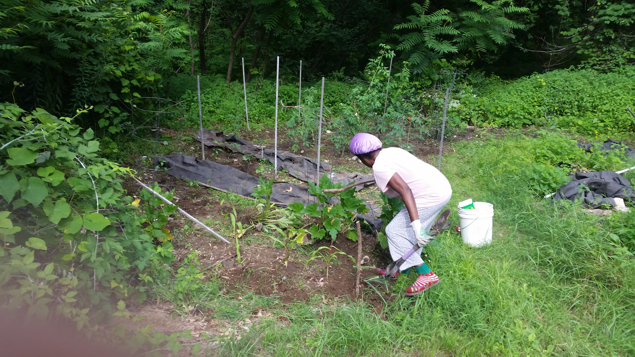
Sule u ken kungur (Backyard garden)

Abeen (Clouds)

Sentence Build-up Practice 1

Ka we u lu gberen imo ye= It's you (singular) singing (a song)
Ka ne ne lu yevese ye= It’s you (plural) running
A nau kwaghyan= he/she gave you food
A nam mngerem = he/she gave me water
A nam ga = he/she did not give me
A nam mngerem ga = he/she did not give me water
A venda u tilen sha = he/she refused to stand up
Ve venda u lamen = they refused to talk
U venda u teman inya= you (singular) refused to sit down
Ne venda u duen = you (plural) refused to get out (exit)
Yem nen = you (plural) go
Tema nen = you (plural) sit
Ve hide = they are back
Se hide = we are back
Mba a hide ga = they are not (yet) back
Na ve = Give (it to) them
Zenda ve = Drive them (away)
Ka tom ve = It's their work
Ngu a hide ga = He/she is not yet back
Ngu hiden ga = He/she won't return
wam = my mine
Kwaghyan wam = my food
Takeda ne ka u wam = This book is mine
na = his, her, him
ka kwagh na = It is his/her (own) thing
Ka u na = It is his/hers

K u ve = It is theirs
Ka iyou ve = It's their house
Se soo kwagh na = We like him/her
kpishi, gbing = very, much
dedo, tsemberee = very well
A fa kwagh dedo = he/she is a lot nice
Un ngua a mfe kpishi = he/she is knowledgeable
Se cii = All of us (We all)
kpa = but
kpaa = also
We kpaa = you also
kpee, keng = albeit, must
Hide kpee = assuredly return (You must return or come back)
kpem, gbem (gbem) = always
Ve heen gbem = He comes here always
ashighen ashighen = sometimes
Vee heen ashighen ashighen = He comes here sometimes
shighe = time
shighe (shie) gen = some other time or another time
nya = down
sha = up
tile = wait, remain standing/waiting
tile her = remain standing up
Tema nya = sit down
mough sha = stand up

mough nen sha = You (plural) stand up
Ver ihô (i)nya = Put the kife down
a min, aci = for (as ngi sha aci wam: it is for me)
nahan = by, like, as
kôrom a min = hold it for me
kwase man nom = wife and husband
a de sha aci wam = he/she stopped because of me
a undu (he) sha ci wase = (he/she left it for us)
Va er ahwa atar nahan = Come by three o'clock.
We ye? = How about you? (singular)
Ne ye? = How about you? (plural)
Za dedo = Good-bye (Go well)
Saa shie gen = See you later (Till another time)
Aôndo a za a we = I wish you Godspeed (God go with you), Journey Mercies
Aôndo a za a ven = I wish you (plural) Godspeed (Let God take you there)
hanma kwagh = everything
A wa hanma kwagh shin akwati = He/she put everything in the box.

Meeting People
Iti you er ana? (What is your name?)
Iti yam er Terngu (My name is Terngu)
M ngu wan u Nomishan (I am the son of Nomishan)
Ka we i yer er Terdoo ye? (Are you the one called Terdoo?)
Ei, ka mo Iorwuese (No, I am Iorwuese.)
U lamen zwa Tiv kpa? (Do you speak Tiv?)
U fa zwa Tiv kpa? [Do you know (how to speak) Tiv?]
M fa zwa Tiv dedo ga; (I don't know Tiv very well or
I don't know much Tiv); kpa m ngu henen (but I’m learning)

En, m lamen cuku cuku (Yes, I speak a little)
Inumbe kule, nahan m ngu yemen ken ya (The game is over, so I’m going home)
Ka an nan lu yemen a we? (With whom are you going home?)
Ka u er nena ve u yem ken ya? (How do you usually get home?)
Baba ka a va toom (My grandpa picks me up)
U ngu a anigbian u kwase e? ( Do you have a sister?)
Ei, kpa m ngu a anigbian u nomso (No, but I have a brother)
We iee? (What about you?)
M ngu wanmom (I’m an only child)

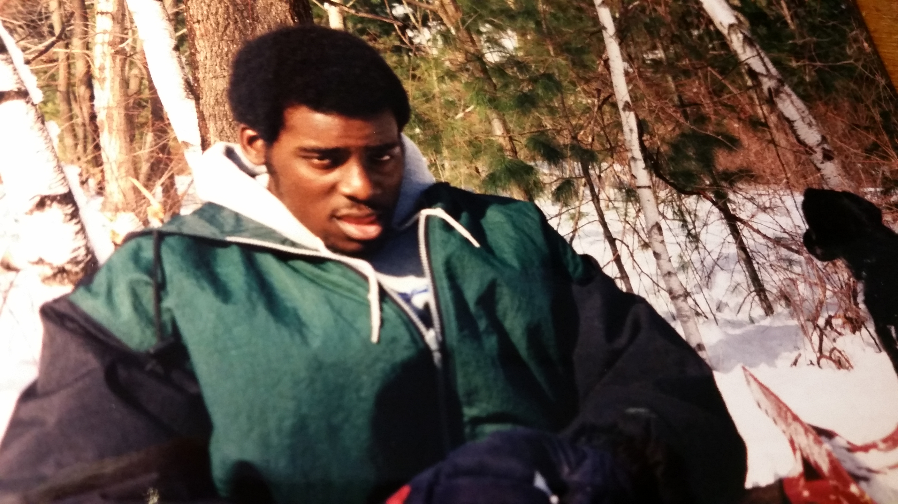 | Wanye kwaor huwa koti u yangen wuhe (kôron).  The handsome young man is wearing a coat to prevent (getting) cold.  Shie u i ndohol kpishi man u huwa koti u civir ga yo, alaghga hough una kôrou.  When it is cold and you do not wear a thick coat, you may catch a cold.

Vocabulary II

dedo = well
doo = good
fa = know
faityô = able, can
fefa = quick, fast
ga = not
ikar, huror = friend
inyaregh = money
inyarev = farm flies
ishiôr¹ = one who courts
ishiôr² = courtship
lam = speak
liam = speech
na = give
ngu = is
orkwav = contemporary
pine = ask
sôôr = to woo, to court
tsegher = only, merely
yem = go
za = go

Sentence Build-up Practice 2

Conversational Tiv 1:
Iti yam er Terdoo (My name is Terdoo)
Mba yerem er Terdoo (They call me Terdoo)
Mba yer un er Terdoo (They call her Terdoo)
U yer iyolyou wer ana? (What do you call yourself?
Terdoo, U ngu nena? (How are you, Terdoo?)
M ngu dedo (I am well.)
A venda (He/she refused)
A venda ga; a rumun (He/she did not refuse; he/she agreed)
A due (He/she went out)
Ngu her(egh); ngu heen (He/she is present; he/she is here)
Iti na er Sesugh ga (His name is not Sesugh)
Ka Ngunan la ga (That is not Ngunan) or (Se is not Ngunan)
Ka we Ngizan ne? (Are you Ngizan?)
En, ka mo Ngizan (Yes, I am Ngizan)
M sugh u, Ngunan (I greet you, Ngunan). Note: sugh also means “thank.”
Niehema lamen (zwa) Tiv ga (Niehema does not speak Tiv). You can omit the word, “zwa.”

Ngukeghen lamen (zwa) Tiv dedo (Ngukeghen speaks Tiv well). You can omit the word, “zwa.”
M fa zwativ (I (know) can speak Tiv language)
M fa zwa Hausa kpaa (I can also speak Hausa)
Se mba ior mba shin Bini (We are (people) from Benin)
M ngu shin Hyusten (I am or live in Houston)
Ve mba shin Abuja (They are or live in Abuja)
M za ke(n) ya (I went home)
M sember hidden ke(n) ya (I just returned from home)
M soo u pinen we kwagh (I want to ask you something)
Ka nyi kwagh(a)? (What is it?)
Ka hanma shie u luz an kasua? (What time are you going to the market?)

Conversational Tiv 2:
Ngôu ka ana? Who is your mother?
Ngôm ka Yeye My mother is Yeye

It I tereu er ana? What is your father’s name?
It i terem er Kaanpila My father’s name is Kaanpila

Ijen kôrou we? Are you hungry?
En, ijen korom. Yes, I am hungry.
Ka nyi u soo u yan a? What do you want to eat? (…would you …)
Ka nyi nyen u ya? What did you eat yesterday?

Ne nyi ne ya nyian a? What would you (pl) eat today?

Me ya piza I will eat pizza
Mo m soo piza ga I do not want pizza
Se ya chinkafa We will eat rice

M soo inyam ga I don't want meat
M soo iue i atuur(ugh) I want okra soup
Yadoo soo inyam ivo Yadoo likes goat meat

JN soo u man zar mbuer JN likes to drink papaya juice
QWK soo u man atumba QWK likes to drink milk
RDD soo u man zar alum RDD likes to drink orange juice

Vocabulary III

bugh = open
wuhe = close
de = stop
iti = name
kwase = woman
inuun kwase = young woman
ngô = mother, female
nom = male, husband
nomso or = man
wanye = child
ngô kwase = "old" elderly woman
wanye (wan) kwase = girl
wanye nomso = boy
soo = like, love
wuhe kôr = it feels cold (cold catch)
i ndôhol = it is cold
ngô man wan = mother and infant
ter = father
Or Tiv (A Tiv man)
Kwase Tiv (A Tiv woman)
Mbayev Tiv (Tiv children)
Ônov Tiv (Tiv people)
Or Amerika (An American)
Or Kyanada (A Canadian)

Shopping Conversation

Tiv: English:
Ka nyi u soo u yamen a? What do you want to buy?
M soo u yamen takeda I want to buy a book
Ishe na ka nena? How much is it? (The price is how much?)
Va a naira unyiin Bring four naira
Me na naira uhar I'll pay (give) two naira
Me nau naira uhar I'll pay you two naira
Kuma ga It's not enough
Shi seer naira môm Add one (more) naira
U teen utsuwa kpa? Do you sell pots?
M teen ve I do sell them
Nam ve u har Give me two (of them)
Kohol cii ka naira pue The total is ten naira

Vocabulary IV

môm = one (1)
har = two (2)
tar = three (3)
nyiin = four (4)
tann = five (5)
teratar = six (6)
taan kar uhar -seven (7)
nigheni = eight (8)
taan kar unyiin = nine (9)
pue = ten (10)
pue kar môm = eleven (11)
pue kar u har = twelve (12)
pue kar u tar = thriteen (13)
pue kar u nyiin = fourteen (14)
ikundu = twenty (20)
ikundu kar môm = twenty-one (21)
ikundu gber = thirty (30)
akundu a har = forty (40)
akundu a har gber = fifty (50)
akundu a tar = sixty (60)
akundu a nyiin = eighty (80)
deri (akundu a taan) = one hundred
dubu (akundu ikundu gber)
= one thousand
dubu deri = one hundred thousand
dubu dubu = one million
dubu dubu deri = one hundred million
kar = past, pass, over
kar kwar = to share
kwar karen = sharing
nam = give me
namegh = thigh
naregh = stretch
ngohol = get (take) it
Ka u me? = how many?
Mba u me? = How many are they?
Mba ikundu = There are twenty of them

Sentence Build-up Activity 1
Translate the Tiv sentence into English after studying the example in the following:

Ka nyi nee? What is this?
Ka nyi la?

Ngun ka ikônough This is a chair.
Mban ka mkonom.

Ngura ka nyi? What is that?
Ngura ka tebul. That is a table.
Ngun ka nyi?

Ngun ka ayaba. This is a banana.
Kwagh ne ka nyi? (What bis this?)
Mba ye? Is it edible? (Do they eat it?)
Mba ye un gaa?

Mbera ka uno?

Making/Receiving a Phone Call

Halo, ka an ne? Hello, who is this?

M soo u yôôso a Mr. Ami (“I want to
speak with Mr. Ami.”
“Can I speak to Mr. Ami?”)

Ka ya u Ndur ne ga? Is this not
Ndur’s house?

En, ka an u yere? Yes, who’re
you calling?

Iti you er ana? What is your name?

Ka we Terfa? Are you Terfa?
En, ka mo Terfa. Yes, I am Terfa.
Mama wou ngu her kpa? Is your
mother there?
En, ngu her(egh). Yes, she is here.
Tile, m yila un. Wait, I'll call her.

Tereu (papa wou) ngu her kpa?
Is your father there?

A za kasua. He has gone to the
market (gone shopping).

Ngu her (heregh), de m yila un. He is
there/here, let me call him.

In the Family

Shie ngu nena? What time is it?
Ka ahwa a tar. It's three o'clock.

Shie kuma u za yaven. It is time
to go sleep. It’s bedtime.
(It is time to go to bed)

Yem za (da) yav. Go and sleep

Yem za ôô iyol. Go take a bath

Kile zwa dedo. Brush your teeth well.

Kile anyi a yem. Brush your
teeth clean. (Brush well.)

Nder, sev av (Wake up, it’s daybreak)

Yav, shie kuma u yaven (Sleep, it’s time to sleep)

Ngutor ngu yaven. (Ngutor is sleeping.)

Sesugh ngu a nder ga. (Sesugh is not
yet awake.)

***
Terngu yar tom. Terngu has gone
to work. (Terngu is working.)

Yem za er (homwek) tom u makeranta.
Go (and) do homework.

Jayshawn ngu ôron Takeda.
Jayshawn is reading a book

M ver kwaghyan . Food is served
(I have served food)

Ka nyi kwaghyana? What's for food
(dinner)? What type of meal/food)?

Kwaghyan bee .The food is finished
(i.e. all eaten up)

M er kwaghyan ga. I did not
prepare any food. Chinkafa i bee.

Se yem hwatev. Let’s go
to the restaurant (hotel).

Yila piza. Call (for) pizza.

Nam mngerem ma man. Give me
(some)drinking water.

Mngerem ma ndohol. Cold water

M soo u suwan. I feel like vomiting

Isho ngi van mo. I feel like vomiting.

Itiough ki nanden mo. I am having a headache.

Ma/mena ichigh kin. Drink/swallow this medicine.

M ngu fanityo u nyian ga. I am constipated (unable to poop).

M soo u nyian. I want to excrete.
(I want to poop/excrete).

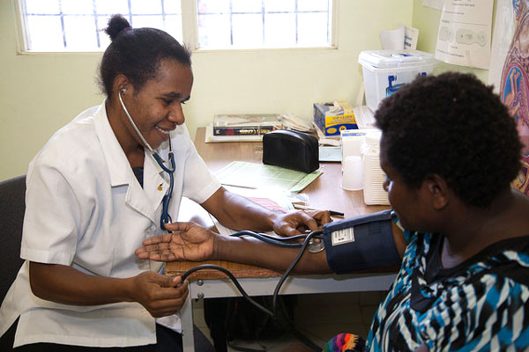  This Photo by Unknown Author is licensed under CC BY-NC-ND | 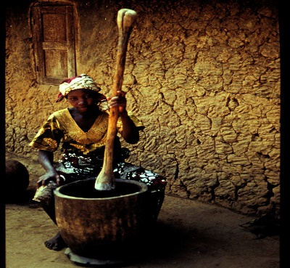 | Imese: Ortwer ngu nengen or u ange.  Iyan: Kwase ngu kumen kwagh shin lu.


Itough ki nanden mo.
(I have a headache)

Aluer wan kaa er doo un iyol ga shin u nenge wer kera ngu sar sar ga yô, yila ortwer shin tôô un za a na iyoughci. De deen kwaghnyion shon a za hemen ga. Ortwer un ana icigh kwagh la una bee, sha iwasen i Aôndo.

When the child says they are not feeling well or you observe that they are not active, call the doctor or take them to the hospital. The doctor will prescribe medication and the illness will stop, with God’s help (God willing).

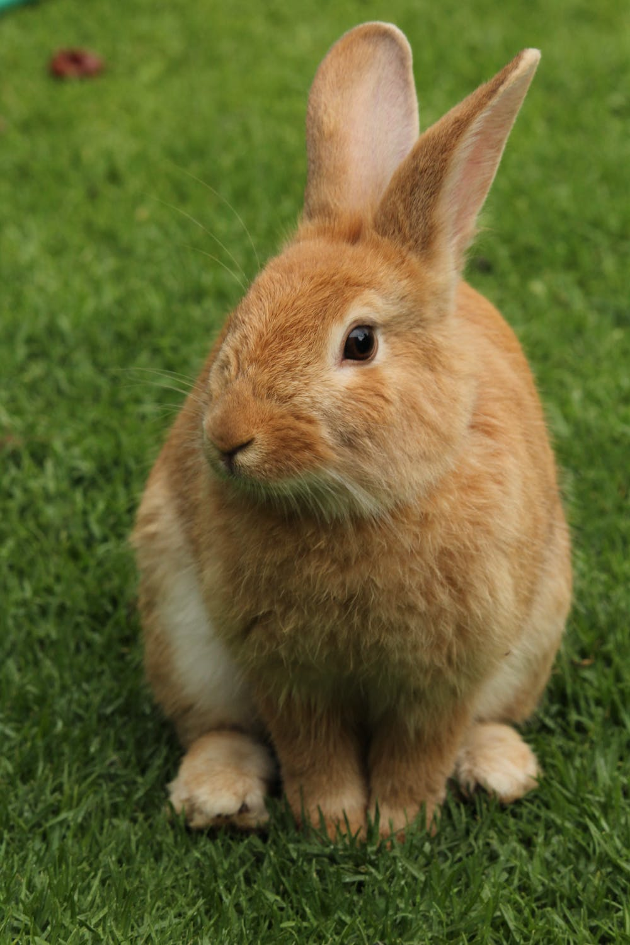 | Imese:  Alôm (Rabbit/hare)  Alôm ka waninyam u ken toho. A wa atsera kpishi shi tesen er un hemba fankwagh a hanma inyam cii.  [The rabbit is a small bush (wild) animal. It is very clever and thinks it is the wisest of all animals.]  Shin inya:  Kwase yar tom a wan ken jime.  [Woman working with baby at back]  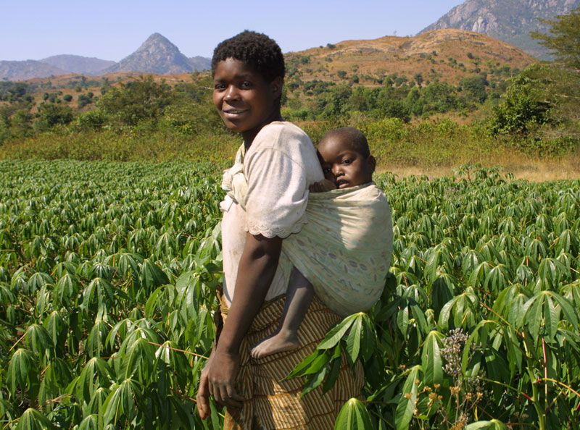

Vocabulary VA

ya = eat  huwa = gluttony  ma = drink  hunde mosorom = drunk  tsee = hot  atse = where food is cooked  uma = dry  uma = life  oso = crunchy  ombor = without water  iuwe = soup  kwaghyan = food  swase = variety of meat  iber = poridge  ruam = pudding, fufu  akuese = kuasa, fried bean ball  akamu = corn cereal  ayia = grass stalks  gbenda = road, path  igbudu = laterite road  inya = earth, soil  inya = ground  Tartor = Heaven | (a)tetan = afternoon  Aikighe = evening  nomiyange = noon  tugh = night  sha use = at dawn  pepepe = early morning  hegen (higen) = now  fese = quick  hen = think  ishemberkwagh = letter of the alphabet  asemberakaa = letters of the alphabet  mhen = thought, thinking  mbamhen = thoughts, ideas  jiir = cook  jijingi = shadow  ijiir = place  beba = broken  pughul = to boil  dem dem = very cool  ange = bitter  yuwa = spicy  turugh = steam  mnyim = smoke

Sentence Build-up Practice 3

Tema shin tso.
Sit in the boat

Mato ne yevese gande.
This car (truck, van) is speeding
(is running too much).

M fa mato u nahan ga.
I don't know how to drive.
(I can’t drive.)

Bugh hunda.
Open the door.

Bugh iyou.
Open the door.
(Lit.: open the house)

Nyôr (ker).
Enter (inside).

Tema inya.
Sit down.

Tile sha.
Stand up.

Iyange ngi a due ga.
The sun is not yet up.

Iyange mire.
It is dusk (the sun has gone down).

Uwer due.
The moon is out.

Uwer ta .
The moon shines.

Uwer u Julai.
The month of July.

A yem sha wo.
He/she went to the mountain.

Wo tav kpishi.
The mountain is very tall.

Hakeem tav kar Ugba.
Hakeem is taller than Ugba.

Unde igungu.
Climb the hill.

Hungwa sha.
Climb down (Get from it).

Iyange i dugh sha
itiough ki tar.
The sun rises from the east.

Iyange mire shin ityô tar.
The sun has set in the west.

Note: The Tiv “up” with reference to the Earth is east, not north. Similarly, the Tiv people consider west as “down,” not the south of earth. The word “sha” is used when a location is at a higher altitude/level; the word “shin” implies a lower altitude/level. To when no altitude/level is unknown, the word “ken” is used.

VOCABULARY VB

ada = bow
ahwa = stiring spoon
aji = eggs
ajingi = glasses
alev = beans
ateghatô = middle
ato = ears
ato = center, buttocks
atoghto = into the night
azurfa, goldu = gold
begha =lion
bird = inyon
biriki = brake
dagi = spear
donko = rubber
gambe = bed
gbande = dish, plate
geri = town, city
hembe = break
hemen = front
hen ato = between
hondo = handle of axe or hoe
hondo = shave
hondo = whistling sound
hough = cough
houghbar = tuberculosis
huma = smells
hungur = sniff
igirgdogotrain
igirgi purugh = airplane
iho = knife
ihuma = smell
ihundu = dust
ihundugh = madness
ihungwa = pit
ijiir = judgment
ijingi = glass
ikambe = crab, spanner
ikeke = bicycle
ikese = basket
ikeve = coconut
ikôôr, agbum = snail
ikuhe = bones
ikumen wura = storm
ikuran = partridge
ikureke = Indian corn
ikwembe = clams, clam shell
ikwembe = spoons
ilyaku = canary
imon = bedbug
inyam bua = beef
inyam toho = wildlife
inyamikume = beast
inyan tsar = climbing animal
ishôho = frog
ishondoike = ant

ishu = fish
itiev, sule = farm
ityeku = ocean
ivaan = arrow
ivo = goat
iwa = dog
iwanger = light
iyough = bee
ken won = outside
kimin = inside
kuhe = bone
kunde = stir
kwembe = clam, clam shell
kwembe = spoon
mato = car
mato = car
mhoonom = pity
mnyim = smoke
naha = knead with spoon
naha = oar, wooden spoon
non bua = bull
nor mnger = hippo
nor tar = elephant
nyadeawambe = bilharzia
nyinya = horse
place = ijiir
shauga, soga = sugar
suse = suck
tar = land, country
tar = land, country
tema tor = reign
toho = grass
tough =ear
tser = playing record
tswekeli (sepun) = spoon
tungwa hondo = to whistle
usu = fire
wua = Guinea corn
wura = rain
zanaria = silver

Sentence Build-up Activity 2

Complete the second Tiv sentence in English in each of the following:

M fa ga. (I don't know)
A fa ga.

U ngu zan hana?
Where are you going?
Ne mba zan hana?

M ngu zan makeranta
I am going to school.
Se mba zan makeranta.

Baba yen New York
Father has gone to New York.
Ngom za New York ga.

Mama kaa er we u nam mkurem.
Mother says you should give me oil.
Mama haa mkurem shin ikpe.

Huwa ikondo
Put on clothes.
Huwa wondo.

Zer ikondo
Wear (wrap on) clothes

Ngu idyeregh ga.
He/she is not naked.
Ngu avegha ve.

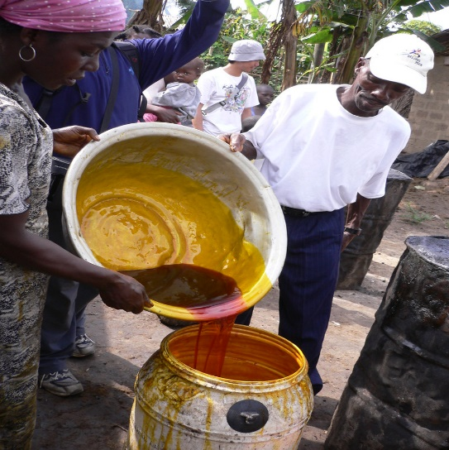
This Photo by Unknown Author is licensed under CC BY-SA
Mkulem ma nyian (Palm oil)

Sentence Build-up Activity 3

Translate the third sentence into English in each of the following:

Chir ikondo iyol
Cover yourself (cover clothes on body).
Chir itiegh.

Bugh ikondo iyol sha.
Uncover yourself (open cloth off body).
Bugh akembe sha.

Chir kughur sha min.
Cover with a lid.
Bugh hunda.

Kile agbande.
Wash the dishes .
Kile agbande sha soso.

Kile akondo.
Wash the clothes.
Kile akondo sha chahul.

A tondo ivav.
He/she has a cut.
Kwagh mura un sha inu.

Ngu a ivav iyol.
He/she has a cut (wound on body).
Se mba a kwaghyan ga.

Er ichigh sha ivav.
Apply medicine on the cut (wound).
Shighe ichigh imor i bee.

Itiough ki nanden mo.
I have a headache (headpain)
Inyian kôrom.

Iyav mbu nyion Ngufan.
Ngufan has a stomachache.
Nguemo ngu suwan kpishi.

Ngôdo, va ma ichigh.
Ngôdo, come (and) drink
(take) medicine.
Mama na un ichigh.

Sentence Build-up Activity 4
Study the first two sentences in activity 5 and then translate the third one from English to Tiv.

Ichigh kin yuwa.
This medicine is bitter.
This line is short.
________________________

I nyoho.
It is sweet.
It is tall.
_________________________

Ki nyoho ga.
It is not sweet.
It is bad.
___________________________

Angôm u kwase
My sister
My mother.
___________________________

Angôm u nomso
My brother
My father has gone home.
___________________________

Angôm u nomso gbidi bol.
My brother plays ball.
My friend plays ball.
__________________________

Se yem ishu koron.
Let's go fishing.
Let us pray.
___________________________

Haa kper shin ifi.
Cast the net in the river.
He cast the net in the ocean.
___________________________

Ber Awuna ngu a ishu.
Lake Ber Awuna has fish.
Mkar Mountain has rocks.
____________________________

Kon la ngu a ahu.
That tree has leaves.
The horse has ears.
___________________________

Ngi ndol
It is wet
You (pl) are wet.
___________________________

I taver.
It is hard (strong).
It is soft.
___________________________

A taver iyol.
He/she is strong.
He/she is weak.
___________________________

Ngu a agee.
He/she has strength.
They have no strength.
___________________________

Er msen hen Aôndo.
Pray to God.
Kneel.
___________________________

Aôndo ka dooshima.
God is love.
God had mercy on us.
___________________________

VOCABULARY VI

(and have
abuku = viper
adua = church (service)
agba = arm band
agbe = hook with legs
agbo = bullets
agbo = water yam
Agbo = open market at Kunav
agbur = logs used for seats
agena = smallpox
agwa, alabar = news
akiki = gray owl
akpa = whip
akpagher = good luck charms
akpe = bottles
akpe, ape = a place of
akpekpa = native bread
akpera, lu = mortar
akpev = scabies disease
ambe = crocodile
amire = chicken pox
apesuur = a place of rest
apu = vulture
ashe = eyes
ayarikule = jaundice
dem dem = very cool
gbing = full
gbing gbing = very full
huer = iguana
hur = white ants
ifam = frog
igbo = bullet
Igbo = Ibo (people)
igbur = bench
iguve = eagle
ijiir = place
ikange = guinea fowl
ikpe = bottle
ikume = python
ikume = rainbow
ikungugh = dove
imemegh = bell
inima = bat, an umbrella
inyian = diarrhea
ishe = eye
ishoho = toad
ishondoike = black ants
ishwa = beniseed
ivo = goat
ivungu = owl
iyo = snake
Iyo ne ka i lun a megh =
iyongo = sheep
kokombo = butterfly
kwantera = deer
kwen = gong
ngôikegh = hen
nomikegh = cock
gbinde = a poisonous snake.
tor = king, roof, kind of mouse
tugh = night
tugh tugh = early morning
wanikegh = chick

 | Mbayev makeranta ve kôr itiakeda.  The school children are holding books. | 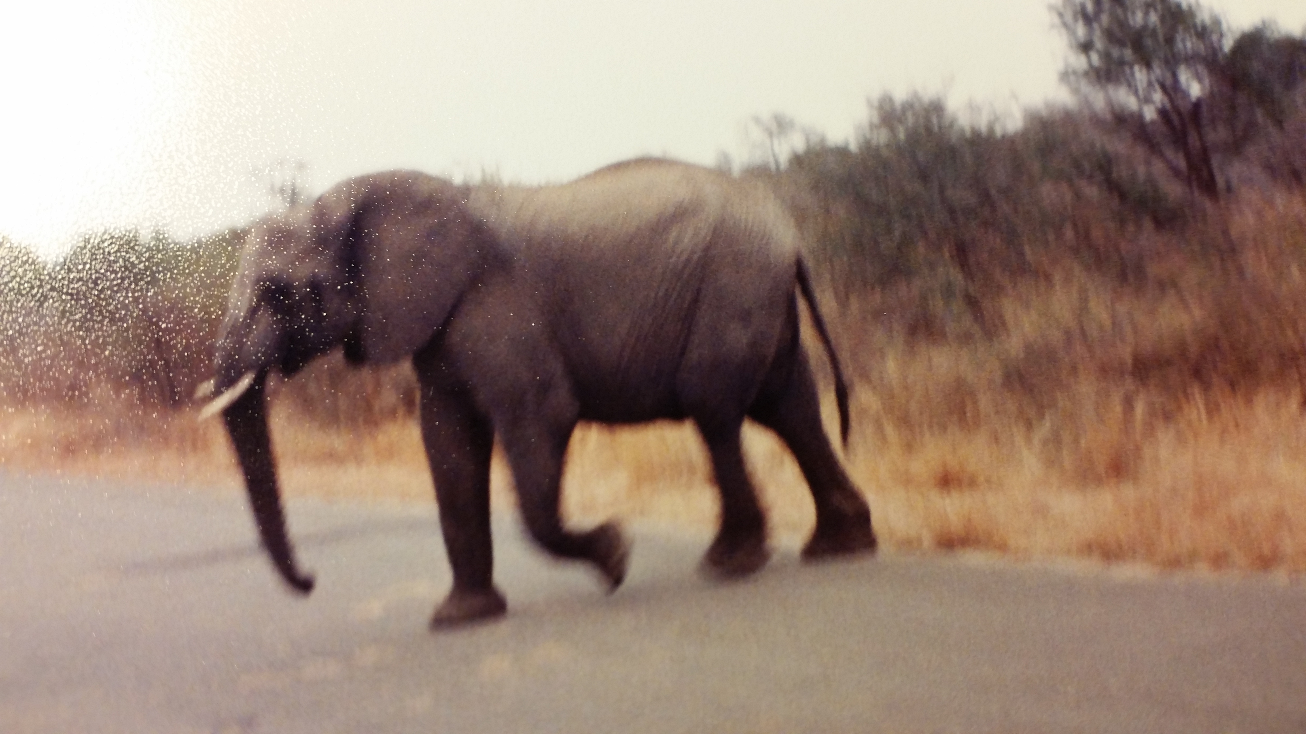 | Nor tar ngu yevese.  The elephant is running.

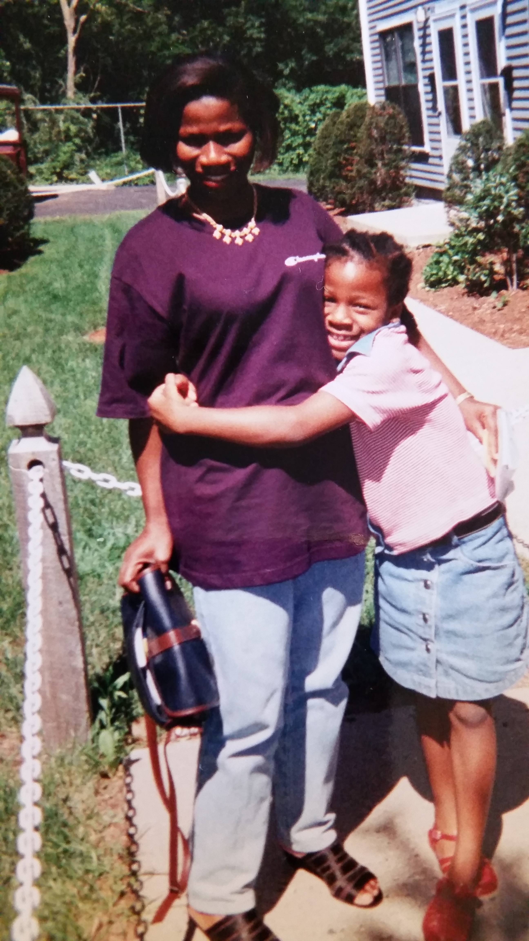 | Wan u kwase kuve ngo na.  The daughter hugs her mother.  Ve cii mba a ahan zwa.  They both are with smiles. | 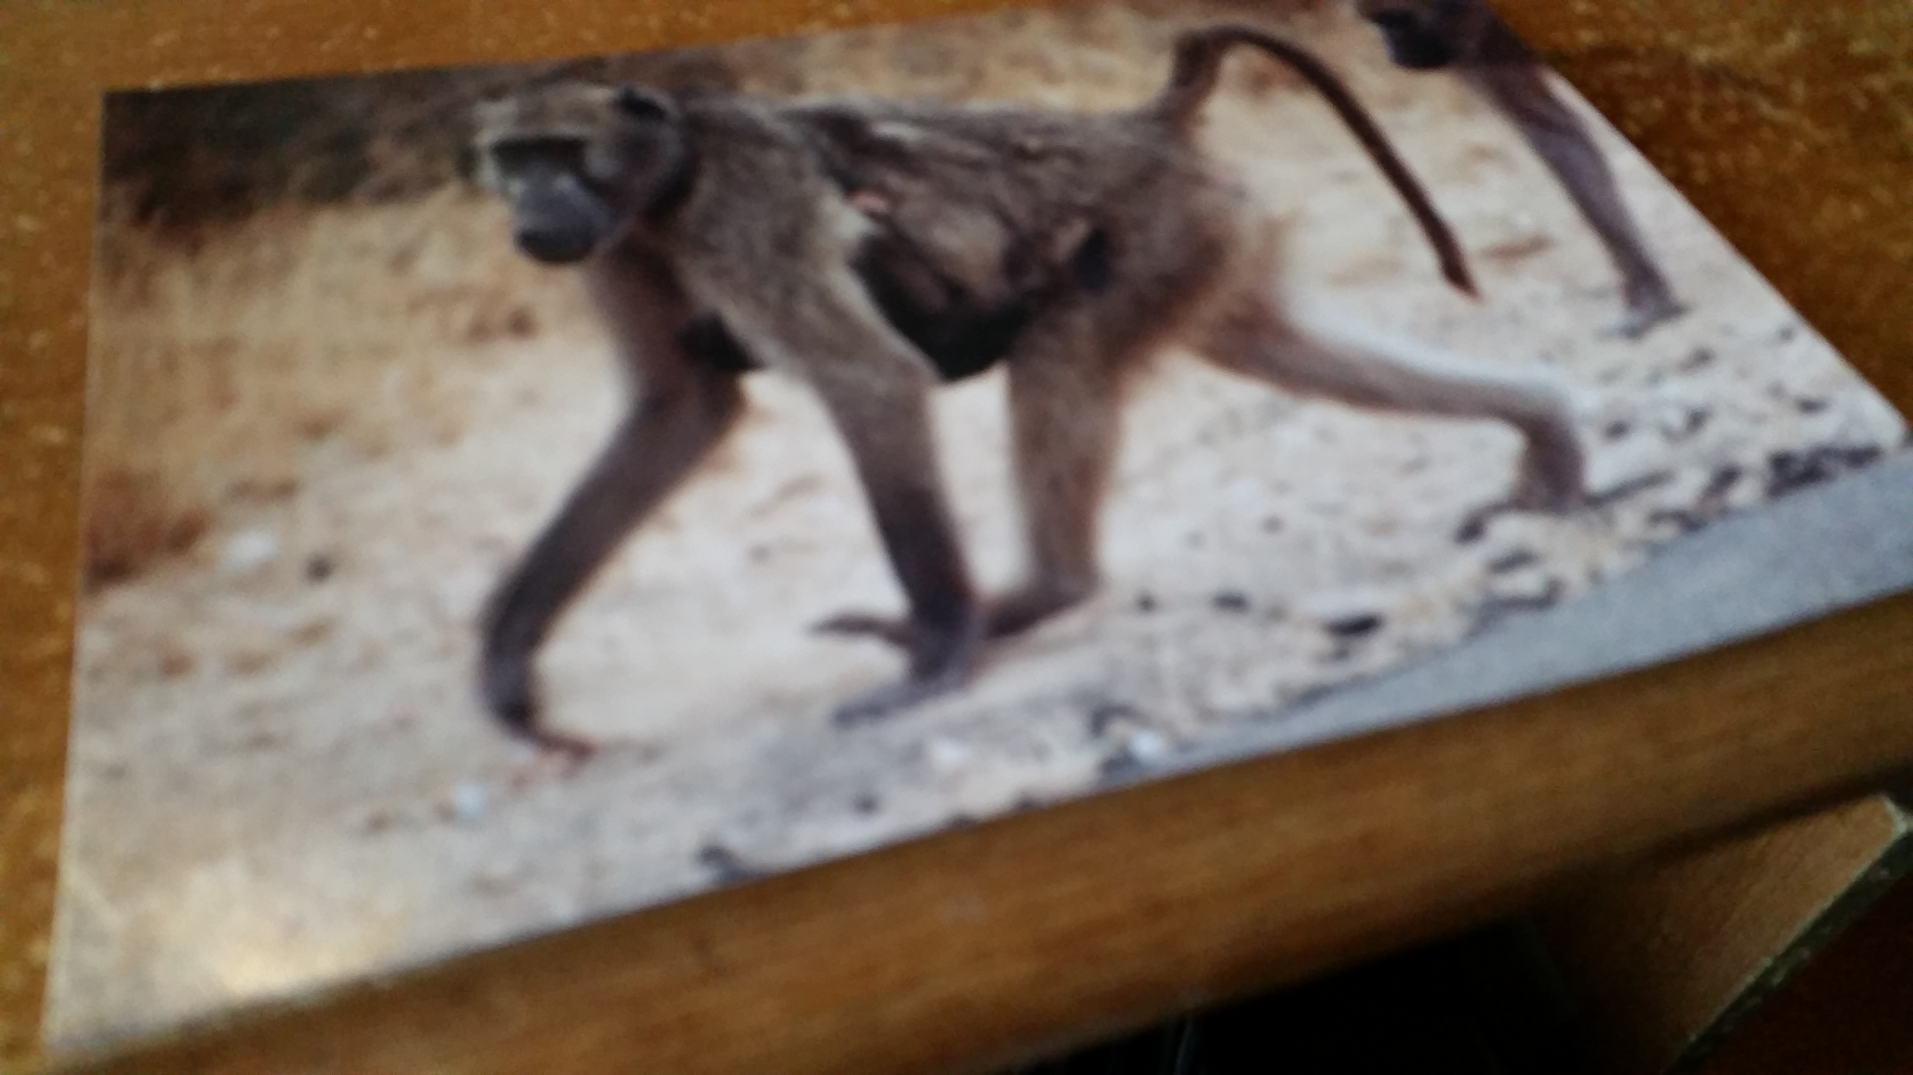 | Bagu ngu keren kwaghyan sha kpe wough.  The monkey is looking for food on the mountain side.

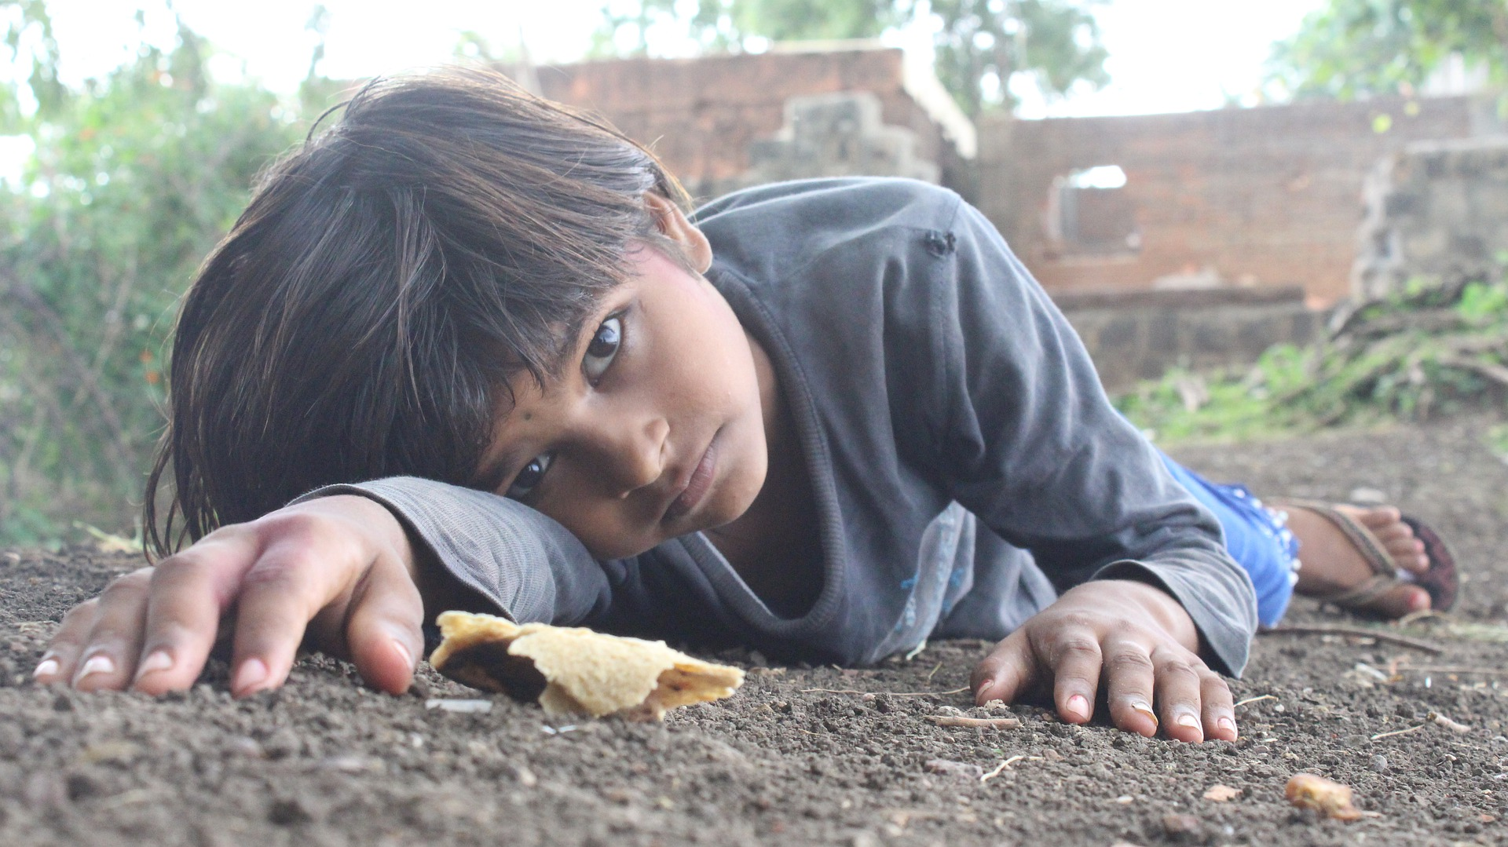 | 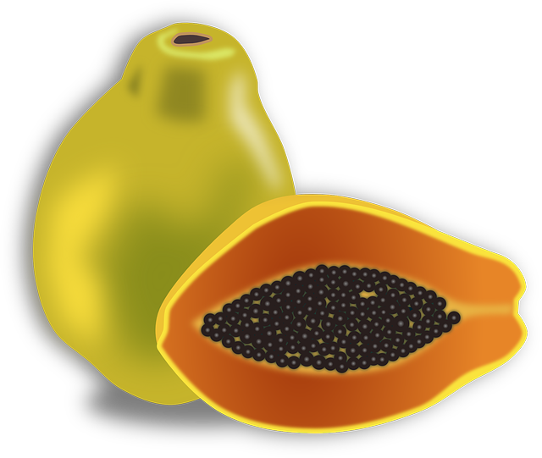 | 
Ijen kôr wanye  (Child in poverty) | Mbuer  (Pawpaw) | Kwa u ayaba  (Plantain leaf)

Asking Questions

When you arrive in Tivland, Nigeria, people will ask you questions, and you too would like to ask them questions. Study and practice how questions are asked and how to answer them.

- ana, an = who
- u ana? = whose
- hana = where

- nyi = what
- sha aci u nyi = why
- nena = how

Questions Example 1:

Ihungwa ngi hana?
Where is the lavotory?
(Lit. The pit is where?)

Ka ana?
Who is it?

Ka mo, Terna
It's me, Terna

Ishe na ka nena?
How much is it?

Ka han ma shie ne va nyere
When did you arrive?

Se va nyôr tugh
We arrived at night

Ka nyi i ere?
What happened?

Ka nyi i lu erene?
What is happening?

Kwaghyan ngu nena?
How is the food?

Kwaghyan doo kpishi
The food is very good (delicious)

Ka nyi kwagh(a)?
What is it?

Ka kwagh ga
It's nothing

The word ka is important in asking questions or making statements. It is used like is, in English.

Questions Example 2:

Where are you going?
U ngu zan hana?

M ngu zan kasua.
I am going to the market.

U hide ve?
Welcome (Lit.: Are you back?)

U za yam nyi?
What did you buy?
M yam wua, temato, inyam,
man mkurem.
I bought Guinea corn,
tomatoes, meat, and oil.

Ka han Ami a lu?
Where is Ami?

Ami yar tom.
Ami has gone to work.

U yam ishu sha nyi?
How much did you buy the fish for?

Ishe i ishu (la) ka nena?
What is the cost of the fish?

M yam ishu sha naira pue.
I bought the fish for ten naira.

Inyam bua taver ishe gande.
Beef (cow meat) is too expensive.

Takzi ngu kpa?
Is there taxicab?

Homophones
Homophones are two or more words that have the same pronunciation but different meanings or spellings. For example, “right” (correct) and “write” (as when you write your name on paper). There are hardly any homophones in the Tiv language. The list below is the closest from our team.
Afo (camp), ato (ears)
Fon phone), hon (horn)
Gom (schist), tom (work)
Hwange (line), kwange (belt)
Iker (stoppage), ifer (wrong-doing, crime)
Iwanger (light), imanger (pride)
Kar (divide), har (hung)
Kende (lift), sende (crucify)
Ker (throw), zer (wrap, wear)
Keran (argumentative), teran (crosspiece, rung)
Kimbir (repeat), timbir (delay)
Kor (rope), tor (mrtal)
Koti (court), kuoti (coat)
Mor (soaked), hor (sharpen)
Na (give), fa (know), ya (eat), ga (not)
Sue (to support), due (to exit)
Sunda (harvest), hunda (door)
Tam (chew), kam (squeeze)
Tange (gaher), sange (pick up small stuff to separate)
Tofi (famous Tiv trader), kofi (coffee)
Tor (chief), nor (elephant)
Twev(settlement), hwev (laziness)
Za (go), ta (shoot, slap)
Zwa (mouh), gwa (fame)
Zwar (large Tiv water container), gwar (strand)

