3
Sentence Build-up in Tiv
The sentence build-up is based on the Tiv alphabets and parts of speech discussed above. You should now begin to make and understand short sentences as you connect nouns, verbs, adjectives, and adverbs. We concentrate on conversations you usually have at home, school, market or store, and sports fields. Use the audio and video tools for practice.

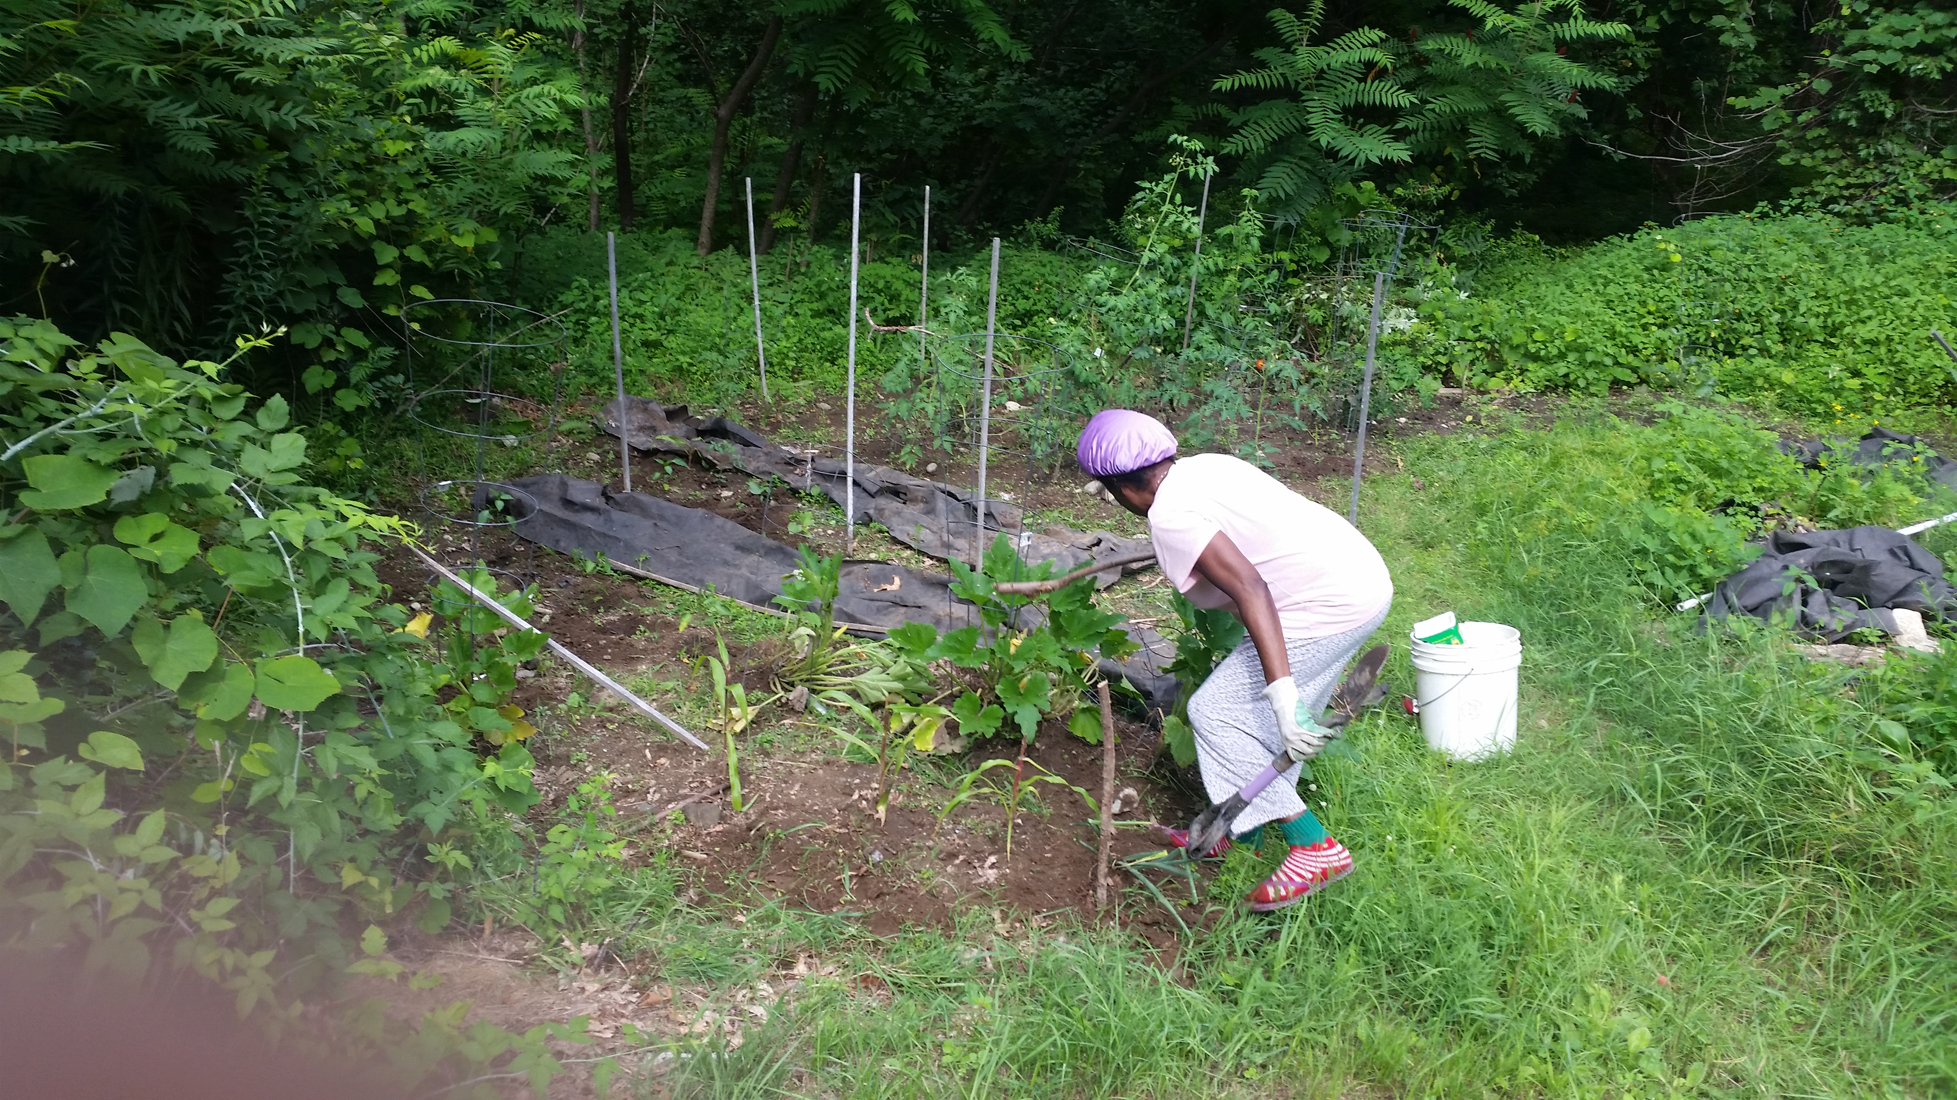
Sule u ken kungur (Backyard garden)


Abeen (Clouds)

Sentence Build-up Practice 1

Ka we u lu gberen imo ye= It's you (singular) singing (a song)
Ka ne ne lu yevese ye= It’s you (plural) running
A nau kwaghyan= he/she gave you food
A nam mngerem = he/she gave me water
A nam ga = he/she did not give me
A nam mngerem ga = he/she did not give me water
A venda u tilen sha = he/she refused to stand up
Ve venda u lamen = they refused to talk
U venda u teman inya= you (singular) refused to sit down
Ne venda u duen = you (plural) refused to get out (exit)
Yem nen = you (plural) go
Tema nen = you (plural) sit
Ve hide = they are back
Se hide = we are back
Mba a hide ga = they are not (yet) back
Na ve = Give (it to) them
Zenda ve = Drive them (away)
Ka tom ve = It's their work
Ngu a hide ga = He/she is not yet back
Ngu hiden ga = He/she won't return
wam = my mine
Kwaghyan wam = my food
Takeda ne ka u wam = This book is mine
na = his, her, him
ka kwagh na = It is his/her (own) thing
Ka u na = It is his/hers

K u ve = It is theirs
Ka iyou ve = It's their house
Se soo kwagh na = We like him/her
kpishi, gbing = very, much
dedo, tsemberee = very well
A fa kwagh dedo = he/she is a lot nice
Un ngua a mfe kpishi = he/she is knowledgeable
Se cii = All of us (We all)
kpa = but
kpaa = also
We kpaa = you also
kpee, keng = albeit, must
Hide kpee = assuredly return (You must return or come back)
kpem, gbem (gbem) = always
Ve heen gbem = He comes here always
ashighen ashighen = sometimes
Vee heen ashighen ashighen = He comes here sometimes
shighe = time
shighe (shie) gen = some other time or another time
nya = down
sha = up
tile = wait, remain standing/waiting
tile her = remain standing up
Tema nya = sit down
mough sha = stand up

mough nen sha = You (plural) stand up
Ver ihô (i)nya = Put the kife down
a min, aci = for (as ngi sha aci wam: it is for me)
nahan = by, like, as
kôrom a min = hold it for me
kwase man nom = wife and husband
a de sha aci wam = he/she stopped because of me
a undu (he) sha ci wase = (he/she left it for us)
Va er ahwa atar nahan = Come by three o'clock.
We ye? = How about you? (singular)
Ne ye? = How about you? (plural)
Za dedo = Good-bye (Go well)
Saa shie gen = See you later (Till another time)
Aôndo a za a we = I wish you Godspeed (God go with you), Journey Mercies
Aôndo a za a ven = I wish you (plural) Godspeed (Let God take you there)
hanma kwagh = everything
A wa hanma kwagh shin akwati = He/she put everything in the box.

Meeting People
Iti you er ana? (What is your name?)
Iti yam er Terngu (My name is Terngu)
M ngu wan u Nomishan (I am the son of Nomishan)
Ka we i yer er Terdoo ye? (Are you the one called Terdoo?)
Ei, ka mo Iorwuese (No, I am Iorwuese.)
U lamen zwa Tiv kpa? (Do you speak Tiv?)
U fa zwa Tiv kpa? [Do you know (how to speak) Tiv?]
M fa zwa Tiv dedo ga; but I’m learning (I don't know Tiv very well or
(I don't know much Tiv); kpa m ngu henen.

En, m lamen cuku cuku (Yes, I speak a little)
Inumbe kule, nahan m ngu yemen ken ya (The game is over, so I’m going home)
Ka an nan lu yemen a we? (With whom are you going home?)
Ka u er nena ve u yem ken ya? (How do you usually get home?)
Baba ka a va toom (My grandpa picks me up)
U ngu a anigbian u kwase e? ( Do you have a sister?)
Ei, kpa m ngu a anigbian u nomso (No, but I have a brother)
We iee? (What about you?)
M ngu wanmom (I’m an only child)

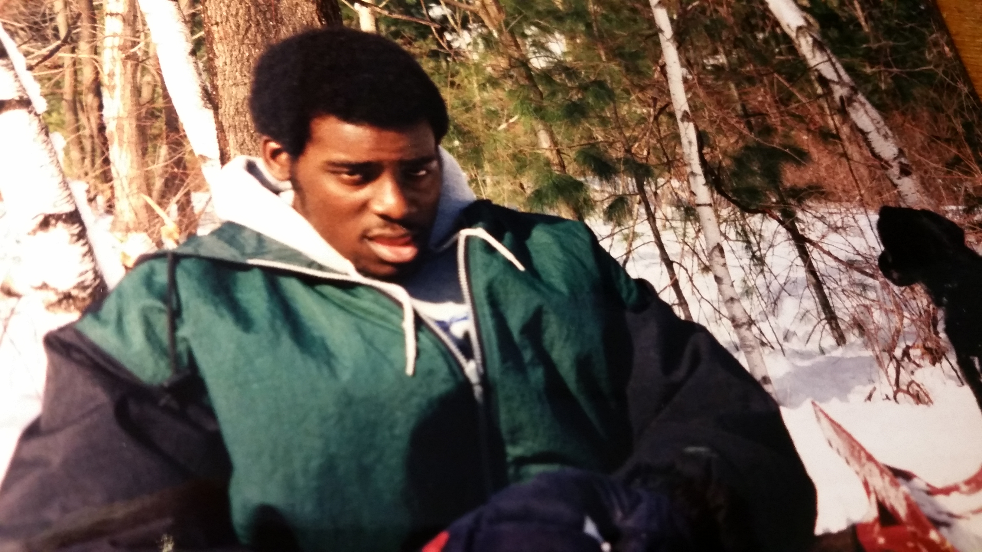 | Wanye kwaor huwa koti u yangen wuhe (kôron).  The handsome young man is wearing a coat to prevent (getting) cold.  Shie u i ndohol kpishi man u huwa koti u civir ga yo, alaghga hough una kôrou.  When it is cold and you do not wear a thick coat, you may catch a cold.

Vocabulary II

dedo = well
doo = good
fa = know
faityô = able, can
fefa = quick, fast
ga = not
ikar, huror = friend
inyaregh = money
inyarev = farm flies
ishiôr¹ = one who courts
ishiôr² = courtship
lam = speak
liam = speech
na = give
ngu = is
orkwav = contemporary
pine = ask
sôôr = to woo, to court
tsegher = only, merely
yem = go
za = go

Sentence Build-up Practice 2

Conversational Tiv 1:
Iti yam er Terdoo (My name is Terdoo)
Mba yerem er Terdoo (They call me Terdoo)
Mba yer un er Terdoo (They call her Terdoo)
U yer iyolyou wer ana? (What do you call yourself?
Terdoo, U ngu nena? (How are you, Terdoo?)
M ngu dedo (I am well.)
A venda (He/she refused)
A venda ga; a rumun (He/she did not refuse; he/she agreed)
A due (He/she went out)
Ngu her(egh); ngu heen (He/she is present; he/she is here)
Iti na er Sesugh ga (His name is not Sesugh)
Ka Ngunan la ga (That is not Ngunan) or (Se is not Ngunan)
Ka we Ngizan ne? (Are you Ngizan?)
En, ka mo Ngizan (Yes, I am Ngizan)
M sugh u, Ngunan (I greet you, Ngunan). Note: sugh also means “thank.”
Niehema lamen (zwa) Tiv ga (Niehema does not speak Tiv). You can omit the word, “zwa.”

Ngukeghen lamen (zwa) Tiv dedo (Ngukeghen speaks Tiv well). You can omit the word, “zwa.”
M fa zwativ (I (know) can speak Tiv language)
M fa zwa Hausa kpaa (I can also speak Hausa)
Se mba ior mba shin Bini (We are (people) from Benin)
M ngu shin Hyusten (I am or live in Houston)
Ve mba shin Abuja (They are or live in Abuja)
M za ke(n) ya (I went home)
M sember hidden ke(n) ya (I just returned from home)
M soo u pinen we kwagh (I want to ask you something)
Ka nyi kwagh(a)? (What is it?)
Ka hanma shie u luz an kasua? (What time are you going to the market?)

Conversational Tiv 2:
Ngôu ka ana? Who is your mother?
Ngôm ka Yeye My mother is Yeye

It I tereu er ana? What is your father’s name?
It i terem er Kaanpila My father’s name is Kaanpila

Ijen kôrou we? Are you hungry?
En, ijen korom. Yes, I am hungry.
Ka nyi u soo u yan a? What do you want to eat? (…would you …)
Ka nyi nyen u ya? What did you eat yesterday?

Ne nyi ne ya nyian a? What would you (pl) eat today?

Me ya piza I will eat pizza
Mo m soo piza ga I do not want pizza
Se ya chinkafa We will eat rice

M soo inyam ga I don't want meat
M soo iue i atuur(ugh) I want okra soup
Yadoo soo inyam ivo Yadoo likes goat meat

JN soo u man zar mbuer JN likes to drink papaya juice
QWK soo u man atumba QWK likes to drink milk
RDD soo u man zar alum RDD likes to drink orange juice

Vocabulary III

bugh = open
wuhe = close
de = stop
iti = name
kwase = woman
inuun kwase = young woman
ngô = mother, female
nom = male, husband
nomso or = man
wanye = child
ngô kwase = "old" elderly woman
wanye (wan) kwase = girl
wanye nomso = boy
soo = like, love
wuhe kôr = it feels cold (cold catch)
i ndôhol = it is cold
ngô man wan = mother and infant
ter = father
Or Tiv (A Tiv man)
Kwase Tiv (A Tiv woman)
Mbayev Tiv (Tiv children)
Ônov Tiv (Tiv people)
Or Amerika (An American)
Or Kyanada (A Canadian)

Shopping Conversation

Tiv: English:
Ka nyi u soo u yamen a? What do you want to buy?
M soo u yamen takeda I want to buy a book
Ishe na ka nena? How much is it? (The price is how much?)
Va a naira unyiin Bring four naira
Me na naira uhar I'll pay (give) two naira
Me nau naira uhar I'll pay you two naira
Kuma ga It's not enough
Shi seer naira môm Add one (more) naira
U teen utsuwa kpa? Do you sell pots?
M teen ve I do sell them
Nam ve u har Give me two (of them)
Kohol cii ka naira pue The total is ten naira

Vocabulary IV

môm = one (1)
har = two (2)
tar = three (3)
nyiin = four (4)
tann = five (5)
teratar = six (6)
taan kar uhar -seven (7)
nigheni = eight (8)
taan kar unyiin = nine (9)
pue = ten (10)
pue kar môm = eleven (11)
pue kar u har = twelve (12)
pue kar u tar = thriteen (13)
pue kar u nyiin = fourteen (14)

ikundu = twenty (20)
ikundu kar môm = twenty-one (21)
ikundu gber = thirty (30)
akundu a har = forty (40)
akundu a har gber = fifty (50)
akundu a tar = sixty (60)
akundu a nyiin = eighty (80)
deri (akundu a taan) = one hundred
dubu (akundu ikundu gber)
= one thousand
dubu deri = one hundred thousand
dubu dubu = one million
dubu dubu deri = one hundred million
kar = past, pass, over
kar kwar = to share
kwar karen = sharing
nam = give me
namegh = thigh
naregh = stretch
ngohol = get (take) it
Ka u me? = how many?
Mba u me? = How many are they?
Mba ikundu = There are twenty of them

Sentence Build-up Activity 1
Translate the Tiv sentence into English after studying the example in the following:

Ka nyi nee? What is this?
Ka nyi la?

Ngun ka ikônough This is a chair.
Mban ka mkonom.

Ngura ka nyi? What is that?
Ngura ka tebul. That is a table.
Ngun ka nyi?

Ngun ka ayaba. This is a banana.
Kwagh ne ka nyi? (What bis this?)
Mba ye? Is it edible? (Do they eat it?)
Mba ye un gaa?

Mbera ka uno?

Making/Receiving a Phone Call

Halo, ka an ne? Hello, who is this?

M soo u yôôso a Mr. Ami (“I want to
speak with Mr. Ami.”
“Can I speak to Mr. Ami?”)

Ka ya u Ndur ne ga? Is this not
Ndur’s house?

En, ka an u yere? Yes, who’re
you calling?

Iti you er ana? What is your name?

Ka we Terfa? Are you Terfa?
En, ka mo Terfa. Yes, I am Terfa.
Mama wou ngu her kpa? Is your
mother there?
En, ngu her(egh). Yes, she is here.
Tile, m yila un. Wait, I'll call her.

Tereu (papa wou) ngu her kpa?
Is your father there?

A za kasua. He has gone to the
market (gone shopping).

Ngu her (heregh), de m yila un. He is
there/here, let me call him.

In the Family

Shie ngu nena? What time is it?
Ka ahwa a tar. It's three o'clock.

Shie kuma u za yaven. It is time
to go sleep. It’s bedtime.
(It is time to go to bed)

Yem za (da) yav. Go and sleep

Yem za ôô iyol. Go take a bath

Kile zwa dedo. Brush your teeth well.

Kile anyi a yem. Brush your
teeth clean. (Brush well.)

Nder, sev av (Wake up, it’s daybreak)

Yav, shie kuma u yaven (Sleep, it’s time to sleep)

Ngutor ngu yaven. (Ngutor is sleeping.)

Sesugh ngu a nder ga. (Sesugh is not
yet awake.)

***
Terngu yar tom. Terngu has gone
to work. (Terngu is working.)

Yem za er (homwek) tom u makeranta.
Go (and) do homework.

Jayshawn ngu ôron Takeda.
Jayshawn is reading a book

M ver kwaghyan . Food is served
(I have served food)

Ka nyi kwaghyana? What's for food
(dinner)? What type of meal/food)?

Kwaghyan bee .The food is finished
(i.e. all eaten up)

M er kwaghyan ga. I did not
prepare any food. Chinkafa i bee.

Se yem hwatev. Let’s go
to the restaurant (hotel).

Yila piza. Call (for) pizza.

Nam mngerem ma man. Give me
(some)drinking water.

Mngerem ma ndohol. Cold water

M soo u suwan. I feel like vomiting

Isho ngi van mo. I feel like vomiting.

Itiough ki nanden mo. I am having a headache.

Ma/mena ichigh kin. Drink/swallow this medicine.

M ngu fanityo u nyian ga. I am constipated (unable to poop).

M soo u nyian. I want to excrete.
(I want to poop/excrete).

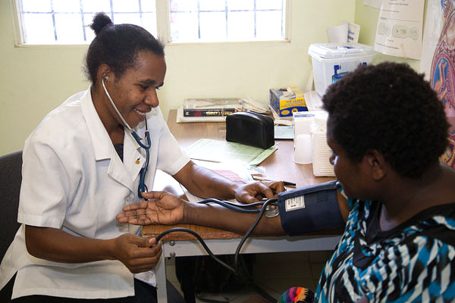  This Photo by Unknown Author is licensed under CC BY-NC-ND | 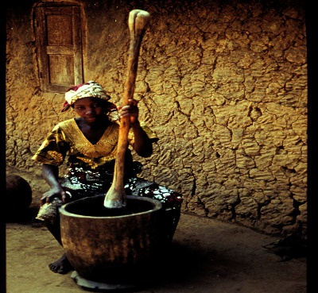 | Imese: Ortwer ngu nengen or u ange.  Iyan: Kwase ngu kumen kwagh shin lu.


Itough ki nanden mo.
(I have a headache)

Aluer wan kaa er doo un iyol ga shin u nenge wer kera ngu sar sar ga yô, yila ortwer shin tôô un za a na iyoughci. De deen kwaghnyion shon a za hemen ga. Ortwer un ana icigh kwagh la una bee, sha iwasen i Aôndo.

When the child says they are not feeling well or you observe that they are not active, call the doctor or take them to the hospital. The doctor will prescribe medication and the illness will stop, with God’s help (God willing).

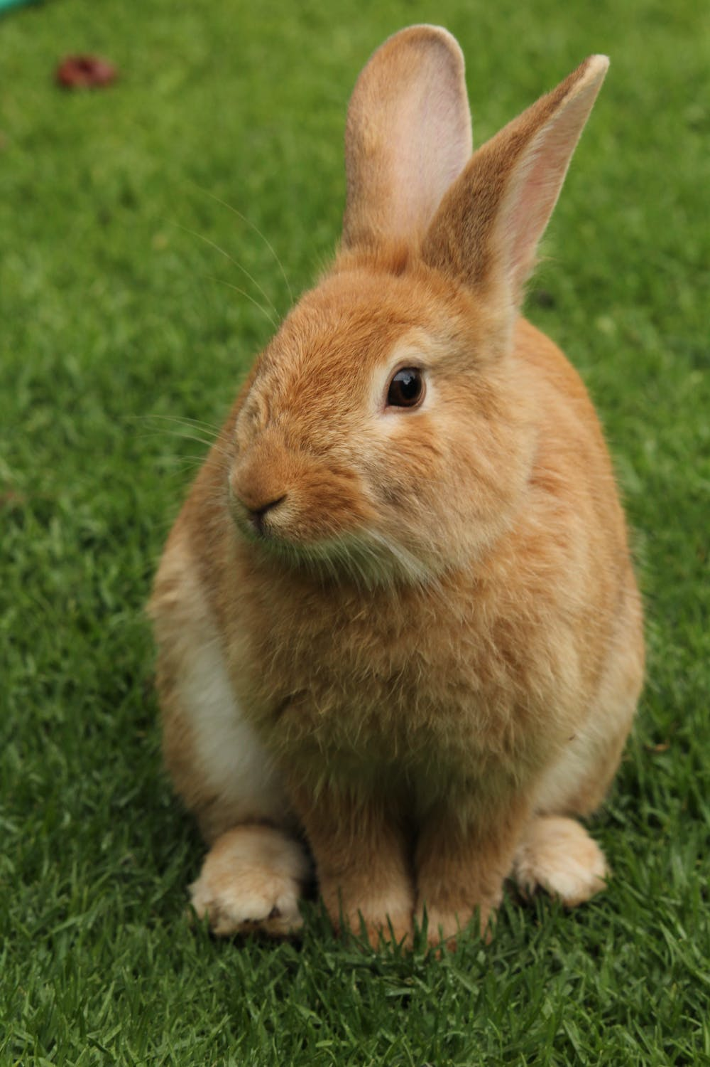 | Imese:  Alôm (Rabbit/hare)  Alôm ka waninyam u ken toho. A wa atsera kpishi shi tesen er un hemba fankwagh a hanma inyam cii.  [The rabbit is a small bush (wild) animal. It is very clever and thinks it is the wisest of all animals.]  Shin inya:  Kwase yar tom a wan ken jime.  [Woman working with baby at back]  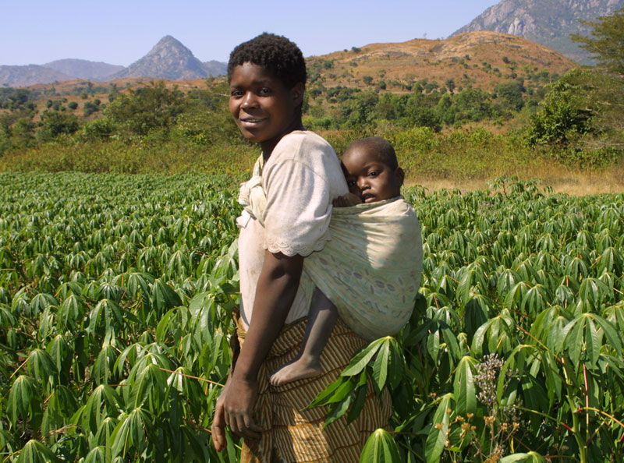

Vocabulary VA

ya = eat  huwa = gluttony  ma = drink  hunde mosorom = drunk  tsee = hot  atse = where food is cooked  uma = dry  uma = life  oso = crunchy  ombor = without water  iuwe = soup  kwaghyan = food  swase = variety of meat  iber = poridge  ruam = pudding, fufu  akuese = kuasa, fried bean ball  akamu = corn cereal  ayia = grass stalks  gbenda = road, path  igbudu = laterite road  inya = earth, soil  inya = ground  Tartor = Heaven | (a)tetan = afternoon  Aikighe = evening  nomiyange = noon  tugh = night  sha use = at dawn  pepepe = early morning  hegen (higen) = now  fese = quick  hen = think  ishemberkwagh = letter of the alphabet  asemberakaa = letters of the alphabet  mhen = thought, thinking  mbamhen = thoughts, ideas  jiir = cook  jijingi = shadow  ijiir = place  beba = broken  pughul = to boil  dem dem = very cool  ange = bitter  yuwa = spicy  turugh = steam  mnyim = smoke

Sentence Build-up Practice 3

Tema shin tso.
Sit in the boat

Mato ne yevese gande.
This car (truck, van) is speeding
(is running too much).

M fa mato u nahan ga.
I don't know how to drive.
(I can’t drive.)

Bugh hunda.
Open the door.

Bugh iyou.
Open the door.
(Lit.: open the house)

Nyôr (ker).
Enter (inside).

Tema inya.
Sit down.

Tile sha.
Stand up.

Iyange ngi a due ga.
The sun is not yet up.

Iyange mire.
It is dusk (the sun has gone down).

Uwer due.
The moon is out.

Uwer ta .
The moon shines.

Uwer u Julai.
The month of July.

A yem sha wo.
He/she went to the mountain.

Wo tav kpishi.
The mountain is very tall.

Hakeem tav kar Ugba.
Hakeem is taller than Ugba.

Unde igungu.
Climb the hill.

Hungwa sha.
Climb down (Get from it).

Iyange i dugh sha
itiough ki tar.
The sun rises from the east.

Iyange mire shin ityô tar.
The sun has set in the west.

Note: The Tiv “up” with reference to the Earth is east, not north. Similarly, the Tiv people consider west as “down,” not the south of earth. The word “sha” is used when a location is at a higher altitude/level; the word “shin” implies a lower altitude/level. To when no altitude/level is unknown, the word “ken” is used.

VOCABULARY VB

ada = bow
ahwa = stiring spoon
aji = eggs
ajingi = glasses
alev = beans
ateghatô = middle
ato = ears
ato = center, buttocks
atoghto = into the night
azurfa, goldu = gold
begha =lion
bird = inyon
biriki = brake
dagi = spear
donko = rubber
gambe = bed
gbande = dish, plate
geri = town, city
hembe = break
hemen = front
hen ato = between
hondo = handle of axe or hoe
hondo = shave
hondo = whistling sound
hough = cough
houghbar = tuberculosis
huma = smells
hungur = sniff
igirgdogotrain
igirgi purugh = airplane
iho = knife
ihuma = smell
ihundu = dust
ihundugh = madness
ihungwa = pit
ijiir = judgment
ijingi = glass
ikambe = crab, spanner
ikeke = bicycle
ikese = basket
ikeve = coconut
ikôôr, agbum = snail
ikuhe = bones
ikumen wura = storm
ikuran = partridge
ikureke = Indian corn
ikwembe = clams, clam shell
ikwembe = spoons
ilyaku = canary
imon = bedbug
inyam bua = beef
inyam toho = wildlife
inyamikume = beast
inyan tsar = climbing animal
ishôho = frog
ishondoike = ant

ishu = fish
itiev, sule = farm
ityeku = ocean
ivaan = arrow
ivo = goat
iwa = dog
iwanger = light
iyough = bee
ken won = outside
kimin = inside
kuhe = bone
kunde = stir
kwembe = clam, clam shell
kwembe = spoon
mato = car
mato = car
mhoonom = pity
mnyim = smoke
naha = knead with spoon
naha = oar, wooden spoon
non bua = bull
nor mnger = hippo
nor tar = elephant
nyadeawambe = bilharzia
nyinya = horse
place = ijiir
shauga, soga = sugar
suse = suck
tar = land, country
tar = land, country
tema tor = reign
toho = grass
tough =ear
tser = playing record
tswekeli (sepun) = spoon
tungwa hondo = to whistle
usu = fire
wua = Guinea corn
wura = rain
zanaria = silver

Sentence Build-up Activity 2

Complete the second Tiv sentence in English in each of the following:

M fa ga. (I don't know)
A fa ga.

U ngu zan hana?
Where are you going?
Ne mba zan hana?

M ngu zan makeranta
I am going to school.
Se mba zan makeranta.

Baba yen New York
Father has gone to New York.
Ngom za New York ga.

Mama kaa er we u nam mkurem.
Mother says you should give me oil.
Mama haa mkurem shin ikpe.

Huwa ikondo
Put on clothes.
Huwa wondo.

Zer ikondo
Wear (wrap on) clothes

Ngu idyeregh ga.
He/she is not naked.
Ngu avegha ve.

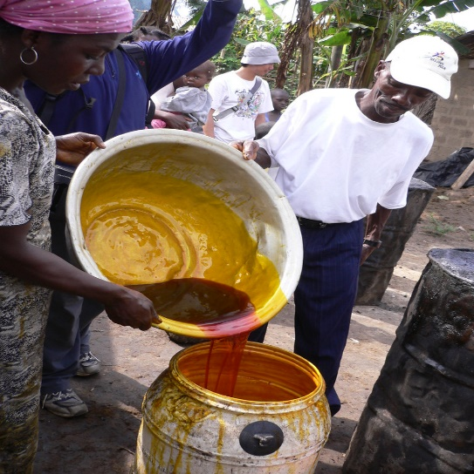
This Photo by Unknown Author is licensed under CC BY-SA
Mkulem ma nyian (Palm oil)

Sentence Build-up Activity 3

Translate the third sentence into English in each of the following:

Chir ikondo iyol
Cover yourself (cover clothes on body).
Chir itiegh.

Bugh ikondo iyol sha.
Uncover yourself (open cloth off body).
Bugh akembe sha.

Chir kughur sha min.
Cover with a lid.
Bugh hunda.

Kile agbande.
Wash the dishes .
Kile agbande sha soso.

Kile akondo.
Wash the clothes.
Kile akondo sha chahul.

A tondo ivav.
He/she has a cut.
Kwagh mura un sha inu.

Ngu a ivav iyol.
He/she has a cut (wound on body).
Se mba a kwaghyan ga.

Er ichigh sha ivav.
Apply medicine on the cut (wound).
Shighe ichigh imor i bee.

Itiough ki nanden mo.
I have a headache (headpain)
Inyian kôrom.

Iyav mbu nyion Ngufan.
Ngufan has a stomachache.
Nguemo ngu suwan kpishi.

Ngôdo, va ma ichigh.
Ngôdo, come (and) drink
(take) medicine.
Mama na un ichigh.

Sentence Build-up Activity 4
Study the first two sentences in activity 5 and then translate the third one from English to Tiv.

Ichigh kin yuwa.
This medicine is bitter.
This line is short.
________________________

I nyoho.
It is sweet.
It is tall.
_________________________

Ki nyoho ga.
It is not sweet.
It is bad.
___________________________

Angôm u kwase
My sister
My mother.
___________________________

Angôm u nomso
My brother
My father has gone home.
___________________________

Angôm u nomso gbidi bol.
My brother plays ball.
My friend plays ball.
__________________________

Se yem ishu koron.
Let's go fishing.
Let us pray.
___________________________

Haa kper shin ifi.
Cast the net in the river.
He cast the net in the ocean.
___________________________

Ber Awuna ngu a ishu.
Lake Ber Awuna has fish.
Mkar Mountain has rocks.
____________________________

Kon la ngu a ahu.
That tree has leaves.
The horse has ears.
___________________________

Ngi ndol
It is wet
You (pl) are wet.
___________________________

I taver.
It is hard (strong).
It is soft.
___________________________

A taver iyol.
He/she is strong.
He/she is weak.
___________________________

Ngu a agee.
He/she has strength.
They have no strength.
___________________________

Er msen hen Aôndo.
Pray to God.
Kneel.
___________________________

Aôndo ka dooshima.
God is love.
God had mercy on us.
___________________________

VOCABULARY VI

(and have
abuku = viper
adua = church (service)
agba = arm band
agbe = hook with legs
agbo = bullets
agbo = water yam
Agbo = open market at Kunav
agbur = logs used for seats
agena = smallpox
agwa, alabar = news
akiki = gray owl
akpa = whip
akpagher = good luck charms
akpe = bottles
akpe, ape = a place of
akpekpa = native bread
akpera, lu = mortar
akpev = scabies disease
ambe = crocodile
amire = chicken pox
apesuur = a place of rest
apu = vulture
ashe = eyes
ayarikule = jaundice
dem dem = very cool
gbing = full
gbing gbing = very full
huer = iguana
hur = white ants
ifam = frog
igbo = bullet
Igbo = Ibo (people)
igbur = bench
iguve = eagle
ijiir = place
ikange = guinea fowl
ikpe = bottle
ikume = python
ikume = rainbow
ikungugh = dove
imemegh = bell
inima = bat, an umbrella
inyian = diarrhea
ishe = eye
ishoho = toad
ishondoike = black ants
ishwa = beniseed
ivo = goat
ivungu = owl
iyo = snake
Iyo ne ka i lun a megh =
iyongo = sheep
kokombo = butterfly
kwantera = deer
kwen = gong
ngôikegh = hen
nomikegh = cock
gbinde = a poisonous snake.
tor = king, roof, kind of mouse
tugh = night
tugh tugh = early morning
wanikegh = chick

 | Mbayev makeranta ve kôr itiakeda.  The school children are holding books. | 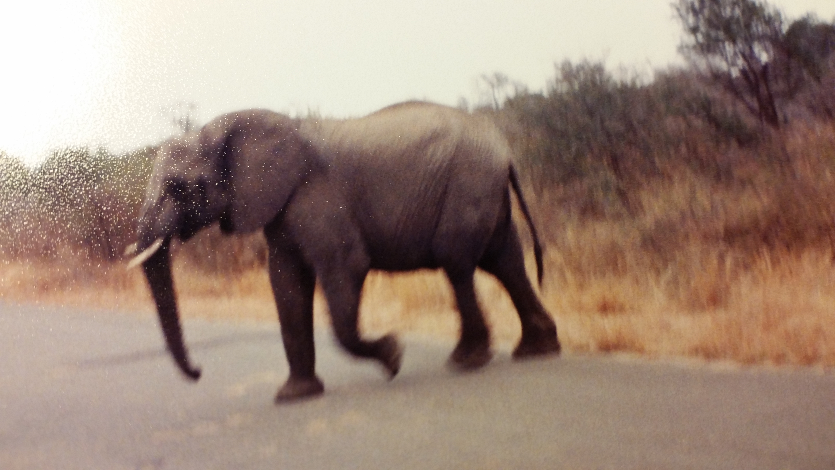 | Nor tar ngu yevese.  The elephant is running.

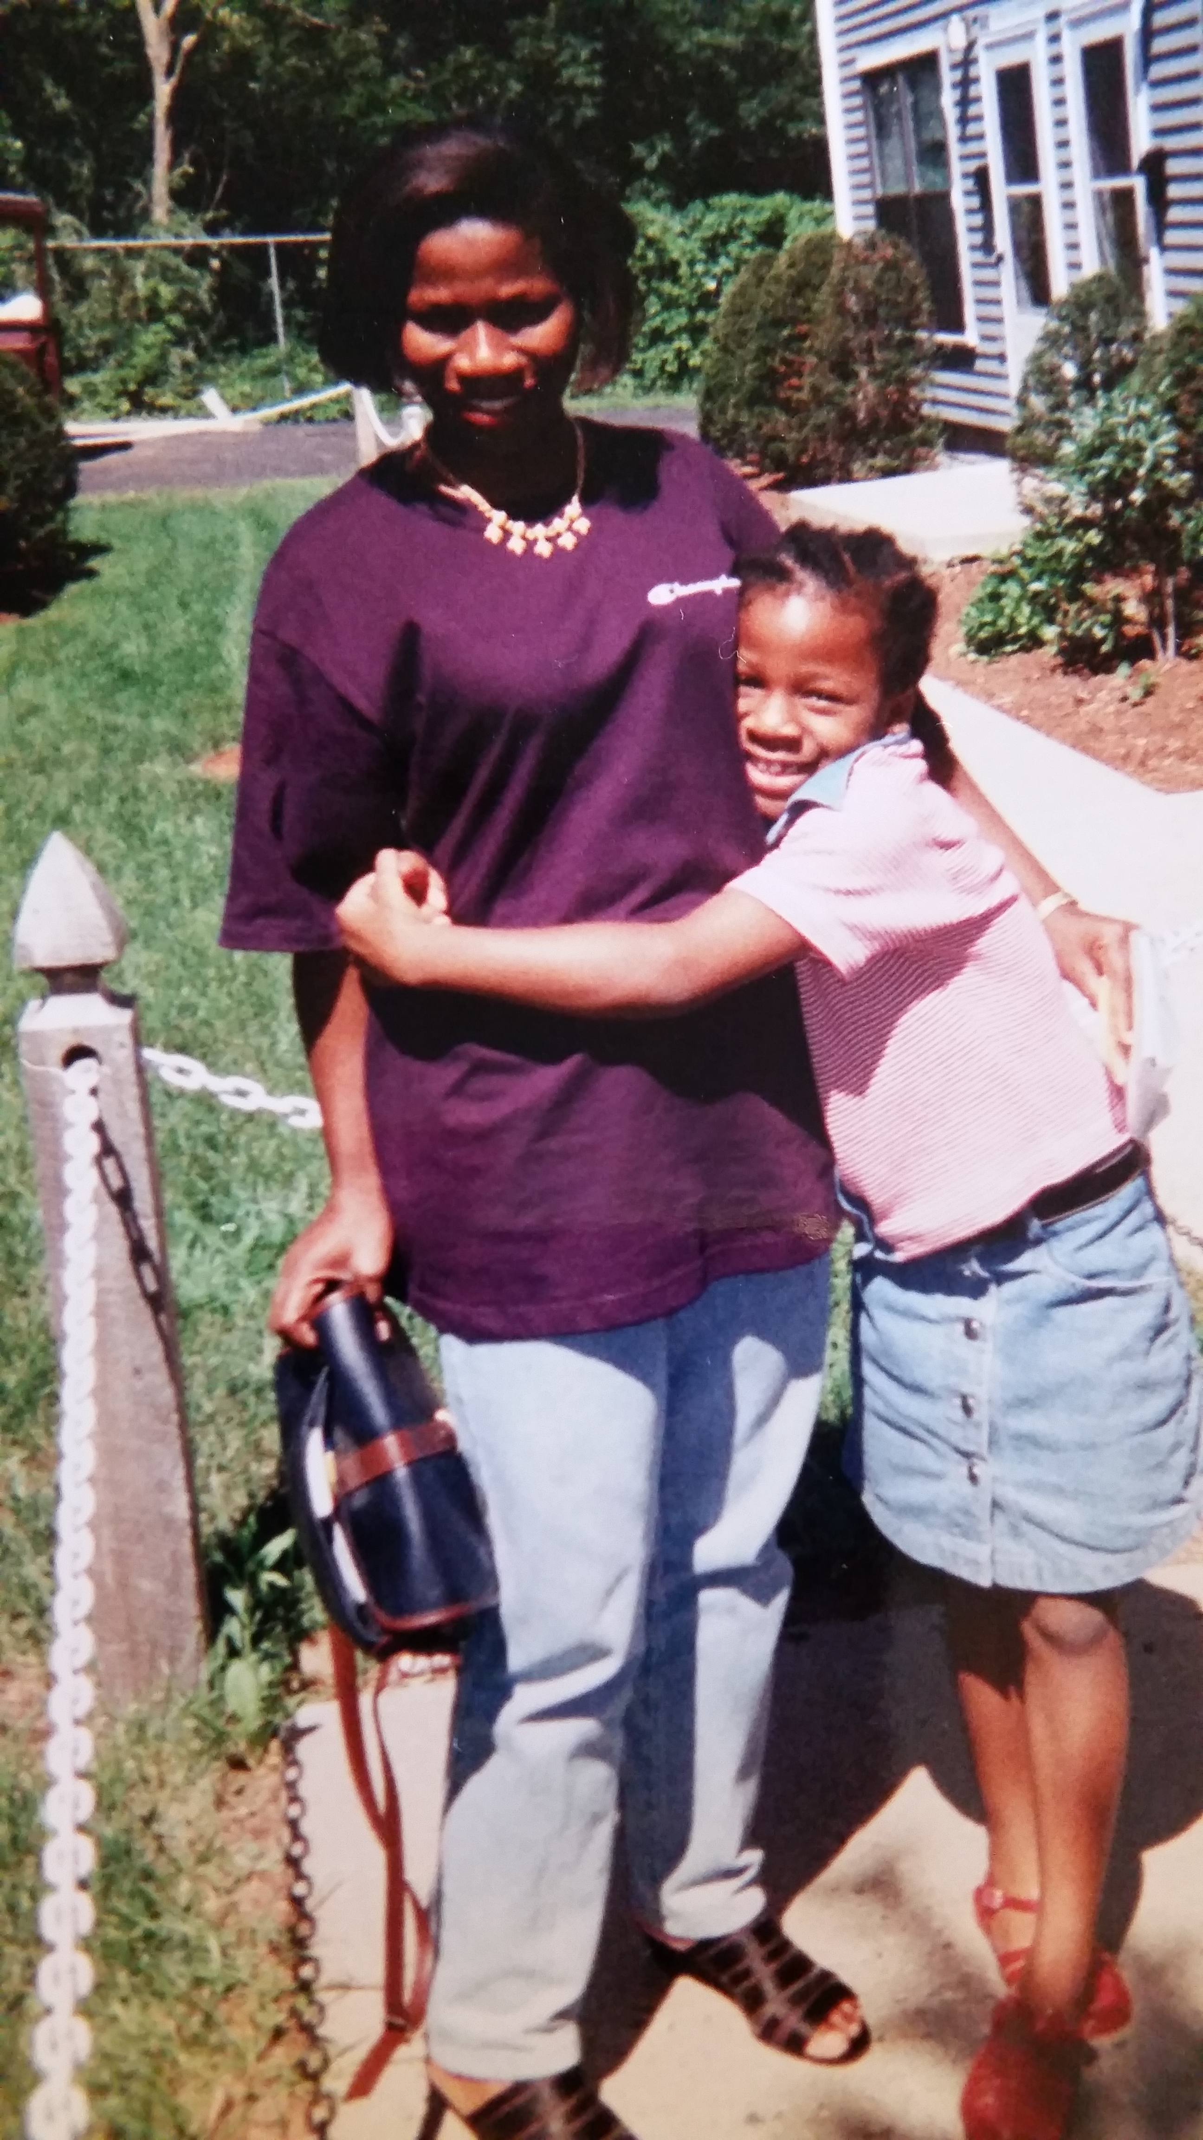 | Wan u kwase kuve ngo na.  The daughter hugs her mother.  Ve cii mba a ahan zwa.  They both are with smiles. | 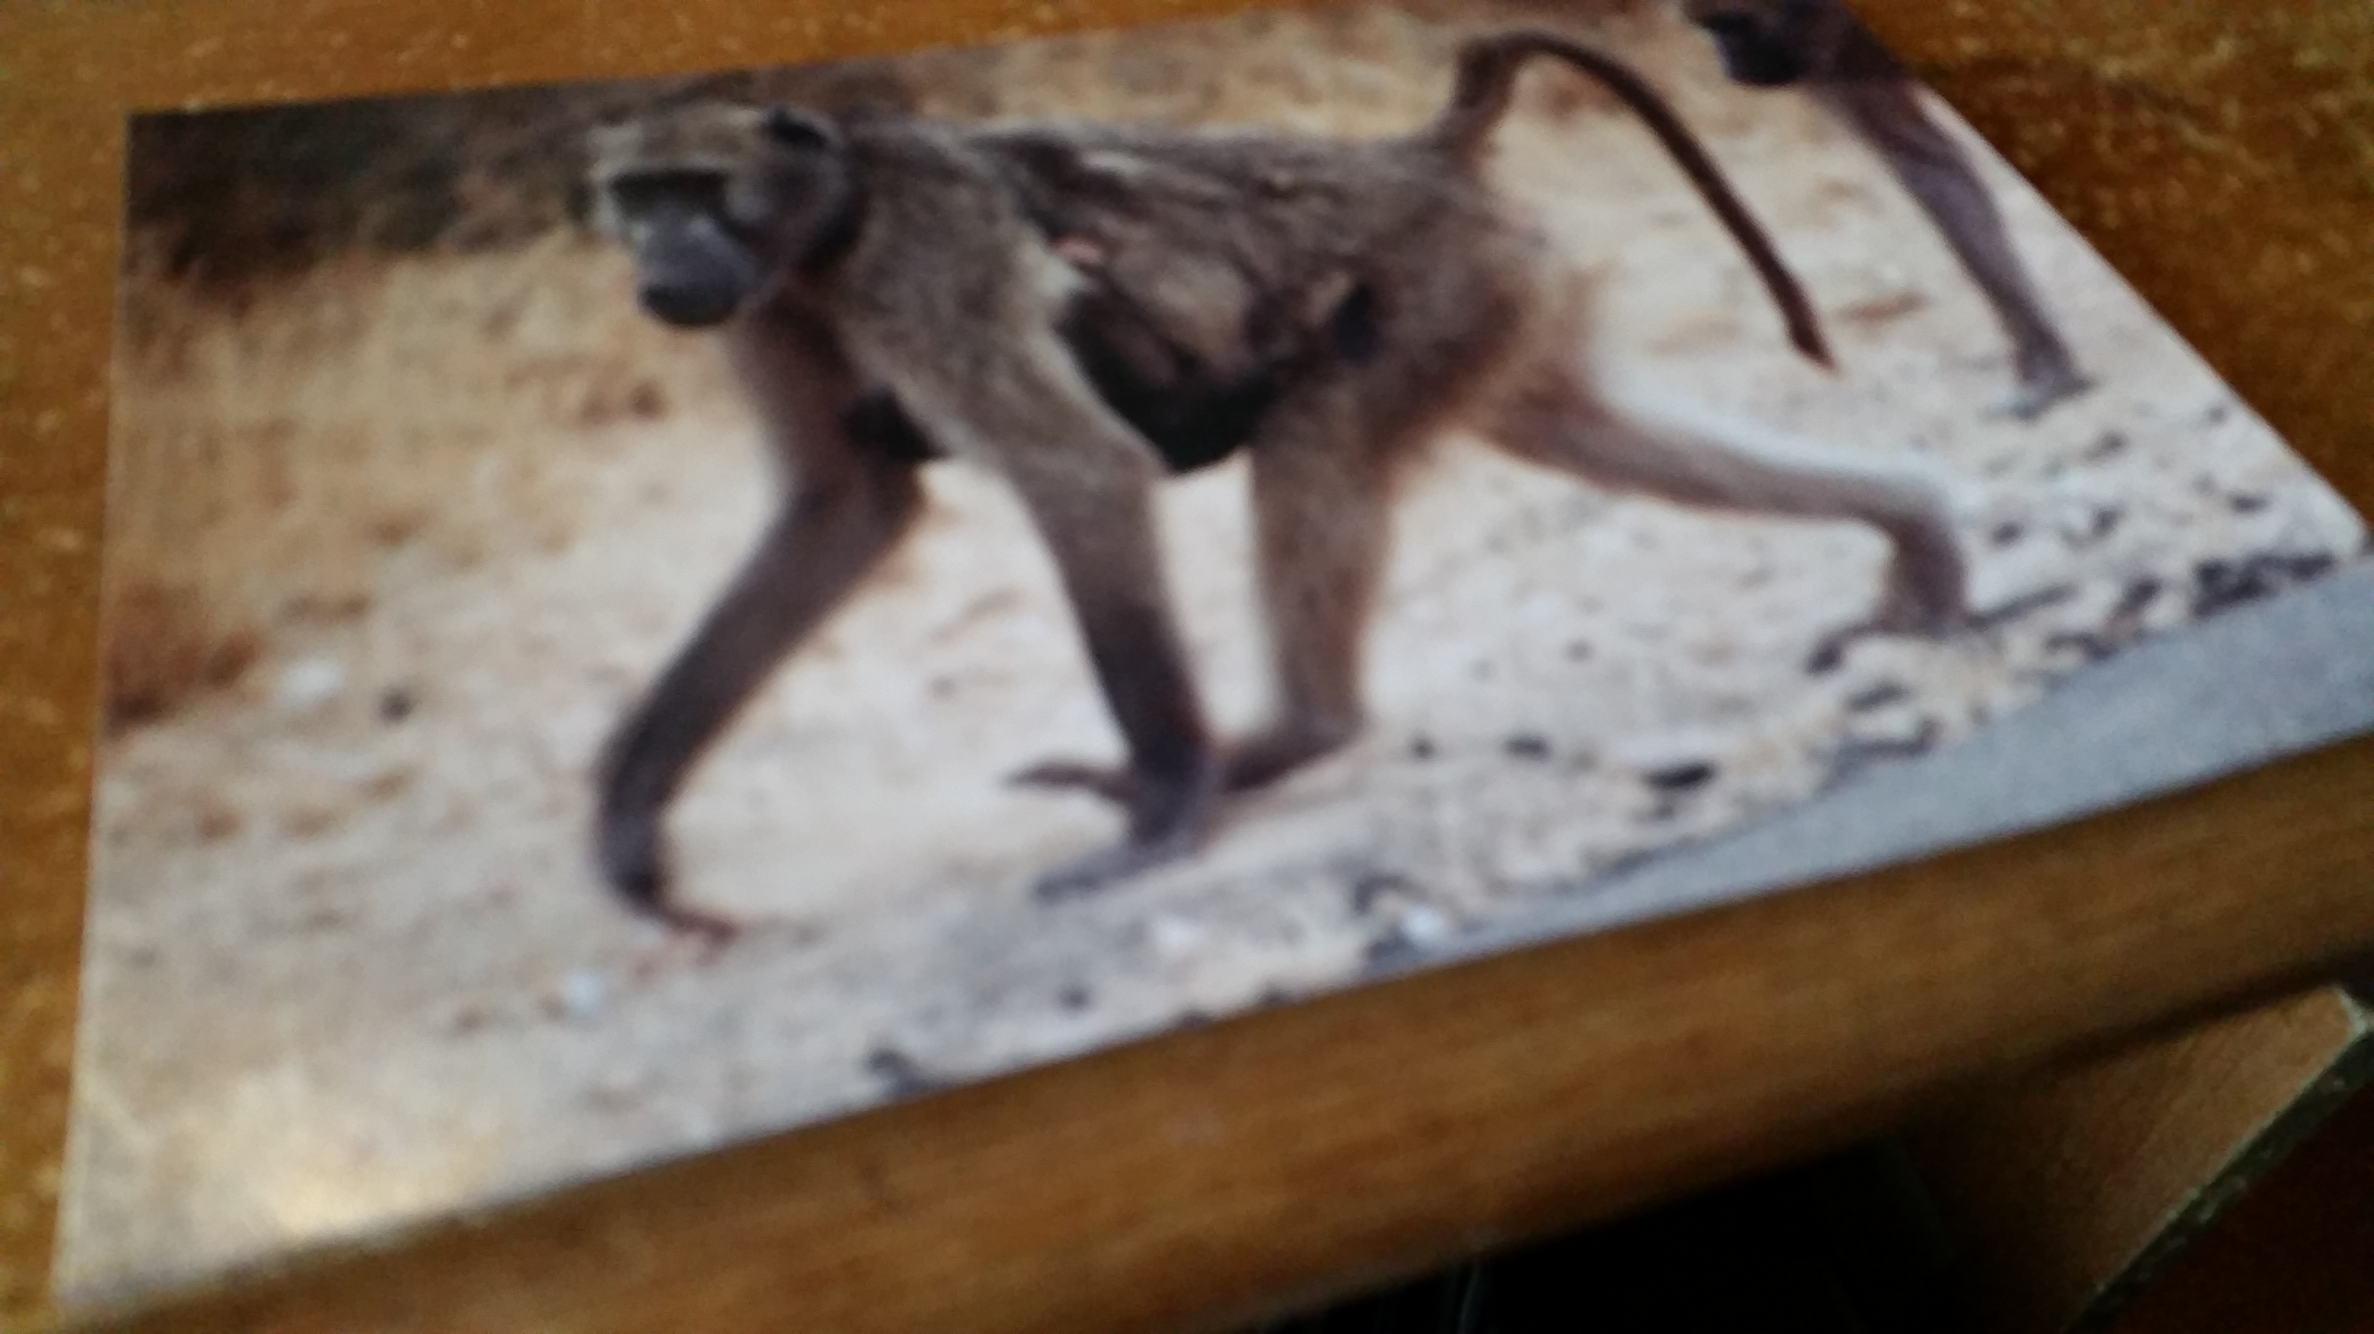 | Bagu ngu keen kwaghyan sha kpe wough.  The monkey is looking for food on the mountain side.

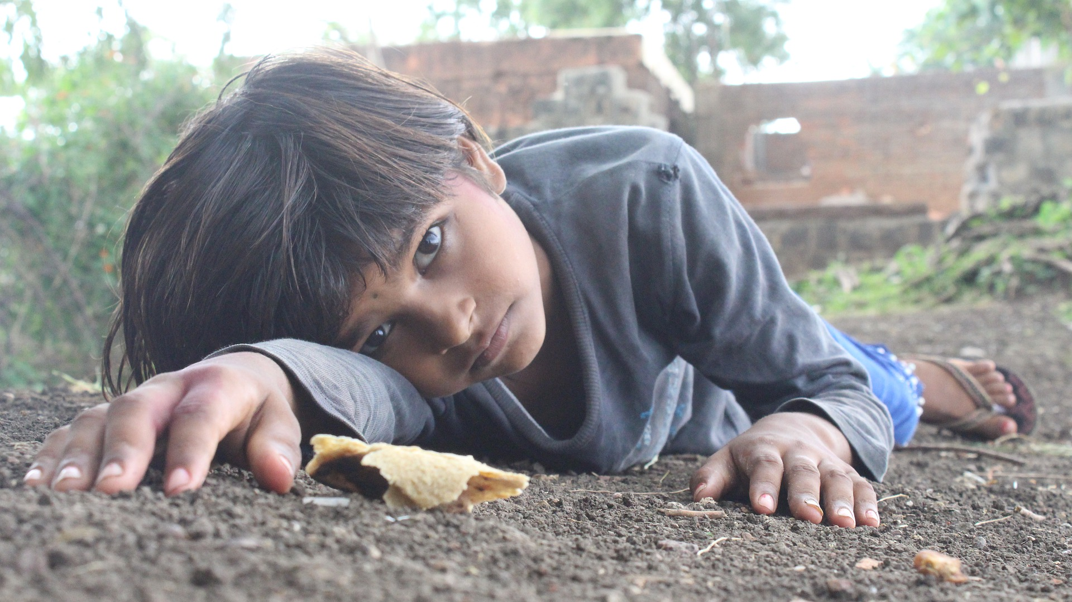 | 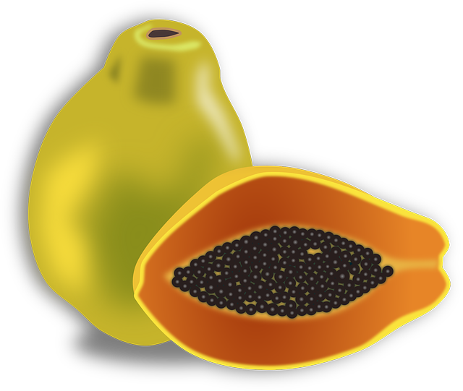 | 
Ijen kôr wanye  (Child in poverty) | Mbuer  (Pawpaw) | Kwa u ayaba  (Plantain leaf)

Asking Questions

When you arrive in Tivland, Nigeria, people will ask you questions, and you too would like to ask them questions. Study and practice how questions are asked and how to answer them.

- ana, an = who
- u ana? = whose
- hana = where

- nyi = what
- sha aci u nyi = why
- nena = how

Questions Example 1:

Ihungwa ngi hana?
Where is the lavotory?
(Lit. The pit is where?)

Ka ana?
Who is it?

Ka mo, Terna
It's me, Terna

Ishe na ka nena?
How much is it?

Ka han ma shie ne va nyere
When did you arrive?

Se va nyôr tugh
We arrived at night

Ka nyi i ere?
What happened?

Ka nyi i lu erene?
What is happening?

Kwaghyan ngu nena?
How is the food?

Kwaghyan doo kpishi
The food is very good (delicious)

Ka nyi kwagh(a)?
What is it?

Ka kwagh ga
It's nothing

The word ka is important in asking questions or making statements. It is used like is, in English.

Questions Example 2:

Where are you going?
U ngu zan hana?

M ngu zan kasua.
I am going to the market.

U hide ve?
Welcome (Lit.: Are you back?)

U za yam nyi?
What did you buy?
M yam wua, temato, inyam,
man mkurem.
I bought Guinea corn,
tomatoes, meat, and oil.

Ka han Ami a lu?
Where is Ami?

Ami yar tom.
Ami has gone to work.

U yam ishu sha nyi?
How much did you buy the fish for?

Ishe i ishu (la) ka nena?
What is the cost of the fish?

M yam ishu sha naira pue.
I bought the fish for ten naira.

Inyam bua taver ishe gande.
Beef (cow meat) is too expensive.

Takzi ngu kpa?
Is there taxicab?

4
ENGLISH-TIV VOCABULARY GUIDE

This is an English-Tiv vocabulary list that you can use as a quick reference in your quest to learn Tiv. Do not hesitate to call me if you have any questions that our Tiv relative may not be able to help you.

About¹ (kwagh u): on the subject of. Akiga Story is a book about the Tiv people. “Akiga
Story” ka takerada u kwagh u Tiv.
About² (kuma er): a little more or a little less of something; almost. There are about forty
beans in the can. Asange a alev nga shin pampam kuma er akundu ahar nahan.
Accident (aburabur): something that happens by mistake. He stepped on the glass by
accident. A ndyar sha jingi sha aburabur.
Accused (or u i yer nan ijir): the person or group accused of a crime or offense. The
accused denied the charges. Or u i yer nan ijir nan tuna akaa a i we nan ijir la.
Acetylcholine (asetilkolin): a chemical released by a vagus nerve fibre of the body that
controls the rate and force of the heartbeat—weaker and slower. Compare epinephrin-impulses from the cardiac sympathetic nerve that make the heartbeat stronger and faster. Too low or too high acetylcholine is not good. U lun a asetilkolin kuman ga shin ngeen yum doo ga.
Acid (asid): compound that produces positive hydrogen ions when dissolved in water. An
orange fruit has acid in it. Itiamegh ki alum ki a asid kimin.
Acquittal: (i pase or, ijir kôr ga): judgment that a criminal charge has not been proven
beyond a reasonable doubt; found “not guilty.” The lawyer moved for acquittal, because the accused was not found guilty. Loya kaa er i pase or u iyer nan ijir la, shaciu ijir kôr nan ga.
Across (per): to go from one side of something to the other. I cross the stream to reach the
school. Ka m per wagh u aren ken makeranta.
Actor (aketo, or u ke kwaghhir): pretending to be someone else in a play. Will is an actor.
Will ka aketo.
Adaptation (mvar a ijiir, hingir ikpareghaa): the adjustment of organisms to their
environment. Marvin write about the adaptation of the turtle and the desert. Marvin nger kwagh u mvar u kurugh aa desereti.
Add (seer): to put one thing with another or others. Add one more cup of hot water to the
first two to make three cups. Seer kôp u mnger mom sha mba hiihii mba uhar mbera i kuma utar.
Addition (seer): the act of adding something or number to another. Three plus two (3 + 2)
are five. Utar seer uhar (3 + 2) ka utaan.
Adult (igyandenor, igyandenkwase, igyandenkwagh): a grown-up man, woman, or other
creature. A twenty-year old man is an adult. Or u lun anyom ikundu ka igyandenor.
Affidavit: (wanwegh sha kwagh u u sôugh yô): a written statement of facts confirmed by
the oath of the party making it. Affidavits must be notarized to be authentic. Saa u wa wegh sha afideviti man una lu a inja ye.
Afraid (mciemiyol): being scared or frightened. The child was fraid because her mother
left her. Wan ngu a mciemiyol shaciu ngô na undu un.
Again (kimbir, kwahar): to do something one more time or a second time. If you wash your
hands but still have soil on them, you must wash them again. Aluer u ôô ave kpa inya ngi shamin her yô, kimbir ôôn a.
Agree (rumun): to think the same way or want the same thing as another person or as other
people. We agree to be quiet in church. Se rumun u lun ving ken iyough adua.
Ahead (sha hemen): to be in front of something or someone. Vanger is ahead of Atume in
the four-hundred-meter race. Vanger ngu sha hemen u Atume ken ayem a mita deri unyiin.
AIDS (EIZ): a disease caused by a virus that makes a person’s immune system unable to
Air (ahumbe): what we breathe or feel when the wind blows. Blow air to put out the lamp’s flame. Fehe ahumbe nombol usu u imenger u pir.
Airplane (igirgi purugh): a machine that carries people and goods and flies in the sky; has
wings like a bird. She rode an airplane to Kano. A nyôr igirgi a yem Kano.
Alcoholism (angev mbu man msôrom ganden): disease caused by drinking large amounts of
alcohol daily and not being able to stop the habit. The disease of alcoholism is hard to cure. Angev mbu man msôrom ganden taver u sôron been.
Algae (ikon): large group of primitive plants, ranging in size from microscopic to the visible
kind. The surface of the pond has green algae. Taregh ku ijande ngu a ikon (gba ikon).
All (cica): everything with nothing left. I carried all my books. M tôô itiakeda yam cica.
Allegation (u kaan er or er kwaghbo): Something that someone says happened. The
allegation is that Doe stole Jane’s bags. I kaa er kwaghbo u Doe a er yô a ii akpa a Jane.
Allow (na ian): to let someone do or say something. Please allow me to speak. We a rumun
yô nam ian m ôr kwagh.
Alone (tswen, tsegh): having no one with a person. (1) He came alone. A va (wen) tswen.
(2) It is you alone wo did not have food. Ka we tesgh u zough a kwaghyan ga ye.
Along¹ (hen): moving from one point to another on a road or path. Jay walked along the
side of the road to go to his house. Jay zende hen kpegbenda u yemen ke nya na.
Along² (vea): together with. Please come with me. We a rumun yô va vea mo.
Aloud (imo i due sha, taver taver): to say something so it can be heard. Speak aloud so
people can hear. Lam imo i due sha er ior vea ungwa yô.
Alveolus (akpa a huhu): grape-like cluster of tiny balloons in the lungs (plural: alveoli). Her
alveolus has holes. Akpa a huhu na pev.
Always (hanma shie, hôron shio): all the time. I always remember to put medicine drops
in my eyes at night before going to sleep. Ka m umbur hanma shie u tan icigh ken tugh man m za yav ye.
Amoebic dysentery (amobik): disease caused by protozoa of the amoeba group. Amoebic
dysentery caused his loose bowl movement. Amobik va un a inyian.
Amount (ingeegh): how much or how many of something there is. (1) The amount of money
The amount you paid for the chair is too high. Ingeegh ki inyar(egh) ki u kimbi sha ikônough la ki kehe gande. (2) How much did you pay? Five thousand naira? U kimbi inyaregh nena? Naira dubu utaan na?
Anger (ishimavihin): to possess a feeling of madness about something. She is filled with
about my messy room. Ngu a ishimavihin sha er iyough yam i hev yum yô.
Angry (ishima vihi): to be upset about something. Ade is angry at me. Ishima vihi Ade a mo.
Angry (ishima vihi): to get mad about something; one does not like what is happening or
the condition or situation. I am angry that my son’s room is messy. Ishima vihim sha er iyough i wan wam i hôv yum.
Animal (inyam, kwaghuma u a lu kon shin toho ga): any living thing that is not a plant or
protist. A rabbit is an animal, a cotton tree is not. Alôm ka aniyam, kon mough yô ga.
Another [u gen(egh)]: one more of something or a different kind of thing or way. (1)
Terhemba wants another banana. Terhemba soo ayaba u gen(egh). (2) I don’t want this one; give me another. M soon ngun ga; nam u gen(egh).
Answer¹ (amsa, ikar i nan, mrumun): The formal written statement by a person
responding to a question. My answer is, “No”. Ikar i nan yam ka, “Ei”.
Answer² (na mrumun, na ikyar, na amsa): to respond or reply to something such as a
question or a signal (ringing of a bell or phone). (1) Please answer the question. Wea rumun yô na mrumun sha mpin la. (2) The phone is ringing; I must answer it. Fon ngu gbiyen; me amsa un.
Ant (ishondokye): a small, crawling insect such as a bee or wasp. I don’t want an ant (pl)
in my food. M soo ishondoikye shin kwaghyan wam ga.
Antibiotic (chigh ki yangen jeem u samber): chemical substance that slows down or stops
bacteria from spreading. The doctor gave me antibiotic for my ear infection

