1

Tiv Step-By- Step: Introduction

People have a desire to speak Tiv for different reasons. Tiv Step-By-Step is written for children born of Tiv speaking parents living outside Tivland whether they reside in Nigeria or elsewhere in the world. The book will also be of use to those non-Tiv spouses and partners of Tiv-speaking individuals.
If you are from other parts of Nigeria or outside Nigeria and are planning to visit or settle in Tivland, this book will walk you through learning Tiv in a short period of time. The vocabulary build-up, practice activities, and glossary of terms are designed to enrich you with the skills to be able to pick up conversation at home, market, restaurant, or the courts. Emphasis is given to language which would aid communication between children and grandparents, including Tiv language use in the digital world.
You are advised to study and practice as often as possible. Write or illustrate with drawings. Tiv Step-by-Step is accompanied by video and audio recording to help you learn Tiv with greater pronunciation ability. Other methods of learning Tiv faster include the following:

- Practice: Contains questions about each word to use to prepare to test yourself or be quizzed by friends or family members.
- Vocabulary Practice: Study from the lists of vocabulary provided in each section to prepare for spelling power tests, quizzes, or assignments.
- Spelling Power: Test your spelling ability. Read the short definition, listen to the word with audio or video method and try spelling it.
- Learning Activities: These are given throughout for Tiv language learners, to monitor their progress.
- Quiz: Quizzes are provided to test your vocabulary and sentence construction skills.

This book will probably help fluent Tiv speakers who may be struggling with English as a second language but is required for instruction. The parts involving Tiv grammar and parts of speech would be particularly helpful. Skip these parts if you only desire to understand conversational Tiv.

Tese wan wou Zwativ

Abaacaa (Alphabet)
Many Tiv letters sound the same as in English, but some Tiv letters are pronounced or written differently.
To learn Tiv sound of these letters or a combination of them, say the word in the example many times and then write it down. In the examples below, the English equivalent is given in parenthesis.

Tiv Letter English Sound Example Write Word

a uh bar (salt)

b b bam, banki (bank)

c ch chia (fear)

ch ch chiv (dip)

d d ada (bow)

e e (as in let) se (laugh)

f f fa (know)

g g gar (city)

gh gh sugh (thank)

gb - gba (fall)

h h har (hang)

i ee ime (darkness)

j g (as in gem) ijen (hunger)

k k koti (court)

kp - kper (net)
kpera (draw)
kperegh (wing)

l l lam (speak)

m m ma (drink)

n n na (give)

o oh or (man, person)

oo o too (as in floor), (pour)

ô o môm (one)

p p per (cross)

r ruam (e.g., pounded yam food)

s s sar (spread)
sar (desire)

t t ter (father)

u oo bagu (monkey)

v v ivo (goat)

w w wase (help)

y y ya (eat)
yem (go) – more like ordering

z z za (go) – more like a request

Sounds, Symbols, and Spellings of Tiv Words
Tiv sounds in general have nasal sounds. However, there are flat sounds: consonant sounds, vowel sounds, and consonant-vowel sounds.
Vowel sounds are made by allowing the breath to come out freely as the lips are pursed. To make a consonant, the breath stream is partly blocked, and the sound lowered or raised. A word as it is spelled may have different meanings depending on the way it is pronounced.

Vowel Sounds and Symbols
Vowel sounds usually are short sounds. A long sound is made by using two vowels together. Use vowel sound in the following manner:

/a/ sound is said as if it were /u/ in sun, not as /a/ in cat or at.

Short Long
va (come) vaa = cry, weep
za (go) zaar = storage shelf on posts
ma = drink maa = build
ka = it is kaa = say, said
na = give
man = and
vange = lizard

/o/ as in orbit and story:

Short Long
or = person too = measure, pour out
tor = chief, king doo = good
mor = soaked up soo = like
nor = elephant
bol = ball

Note: doo is the long /o/ sound and not pronounced as /oo/ (as in book, but as in door).

/o/ sound as in pot and dot.

Short Long
kor = catch ishoon = a liking, attraction
tom = wish too = pour out a liquid or drink
gom = skin lump in the neck ndoor = shed leaves
bom = bomb poo = to the brim (as in iv poo:
won = brother- or sister-in-law filled to the brim)
bom = bomb doo ga = not good
kon = tree doo gande = extraordinarily goo d
nom = male-type doom = I like
pon = reveal, expose dooshima = love

/i/ sound as if it were ee in feet, beet, keep, or ea in beat, seat, and meat.

Short Long
yina = not enough; incomparable atii = sparrow
yima = save ii = bury
tim = destroy, post ii = steal
shi = left fiir = bunch (v)
ifi = large river fiishi = let out stomach gas; fart
time = dig
iti = name

/e/ as in bed and net. For a long sound, use /ee/.

Short Long
de = stop bee = finish
ve = them neer = excess
se = we seer = add
sen = flow keer = kindle
ime = darkness mee = entice
we = you (singular)
ne = you (plural)
ve = they
pepe = morning

/u/ as is said as in the English /oo/ in book or look.

Short Long
Mu = name of a river tuur = push
kuma = pierce or prick kuma = enough, suit, satisfy
guma = laterite puu = criticize
usu = fire suur = support
kume = to pound uma = life, dry
ku = death

Exercse1

These practice exercises show how vowels and vowel sounds are used in phrases for conversation. Use the words in the vocabulary list to construct short sentences in Tiv. You may consult a Tiv language dictionary or other sources to translate the sentences in #2 below into English.
- Vocabulary: ya (eat), bee (finish(ed)), ya (home), ma, za, ka, nan, vange, vaa, wan, kaa, daa, baba, Adamu, Adagi, Jigawa, Jighjigh, jime, zor, tor (mortar), kuma (enough), kumam (I’m satisfied), guma (laterite), de, yem, makeranta, ga, kwagh, ôr, or, inya, ishange (grain).
- Sentences:

- M ya m bee.
- Aya yem ken ya.
- Va ma mngerem.
- Za makeranta.
- Ortwer na un ichigh.
- Vange yevese.
- Wan vaa ga.
- M kaa kwagh ga.
- Terngu ôr takeda bee.
- Baba yem za yav.
- Na jighjigh hen Aôndo.
- Adamu yem adua
- Adingi yan lu orshoja.
- Wantor tôô tor kume ruam.
- Tegh tegh hemba ayem.
- Ishankwagh ker inya ga.

The Article

In Tiv language, it is difficult to pinpoint where "a" and "the" should be used. One needs to understand how these articles are used. They are mastered through practice and by becoming familiar with the language.
All the words in the following examples have the article "a" or "an" before them:

alom = a rabbit (as in alom ngu a zege mba atoov = a rabbit has long ears)
bua = a cow (as in bua ye toho = a cow eats grass)
ijembe = an axe (as in gber kon sha ijembe = cut the tree with an axe)
nduhar = a hoe (as in nduhar ka kwagh u kahan sule a min = a hoe is for farming)
ihô = a knife (as in mba tende atuur sha iho = a knife is for cutting okra)
nor tar = an elephant

To indicate the article "the", the word ne or la needs to be used. This is usually accompanied by pointing. For example,

Nam ihô la. Give me the (that) knife.
Iho ne ese. This knife is sharp.
Kwaghyan ne tsee. The (this) food is warm (or hot).
Bagu ngu yan ishoho. The monkey is eating tiger nuts.

A tema shin ikon. He/she sat in the chair (seat).
Inyon ngi purugh ken The bird is flying in the air.
ahumbe.
He cuts onions with a knife. Ka a tôndo alabesa sha ihô.

Consonant Symbols and Spellings 1

The following thirteen consonants are used with vowels that have different dictions to form Tiv words.

Consonant Example

/b/ bem = peace
bam = bank
ber = lake
bar = cave
bua = cattle
butu =mat

/c/ cia = fear
cir or chir = close

/d/ de = stop
dem = leave me
demdem = cooled down
dafa = cooked whole grain
dagi = small spear
dan = counter (v)
damiyo = a kind of yam
dura = make thunder sound
dogo = railroad
deri = hundred
dubu = thousand
dubudubu = million

/f/ fa = know
fam = know me, wet season
fese = quick
fefa = soon
fere = fast, quick
fesefese = quickly
ferefefere = quickly
Fada = Rev. Father

/g/ ga = not
gege = back of leg
gom = cyst
gar = town, city
gema = turn
ger = cheer
gule = kneel
guda = better
gundu = trunk
guma = red soil

/h/ har = hung
haa = pour or spill
hôn = to trap
hondo = whistle (with lips)
hôm = funny
hôm = produce shoots
hôô = rot, decay (v)
hundu = become muddy
hunde = mad
hungwa = descend
hura = make noise
hur = friendship
huror = friend
hunda = door, entrance
hingir = turn during roasting
hide = return, come back
hide jime = to backup
hule = meander, fold
huma = smell
hungur = forget
hange = stuck, hung
hongor = kernel
hoghol = narrow
hogholoo (narrow condition)

/i/ Ijande = swamp or pond
ijem = steep slope
Ijen = hunger
ijor = a well
aji = eggs
iji = egg,
iji = fly
ikange = a partridge
ikon = green algae
ikundu = twenty
ikungugh = dove
ifi =sea
ityeku = ocean
Ifa = Eve (first Bible woman)
Imande = leprosy
Ivungu = owl
Ivurugh = piece, verse

/j/ jime = back
Jighjigh = belief
Jighirii = straight
Jato = Hausa for red
Jaki = donkey
Ajikegh = eggs
Jukum = ethnic group
Jamber = torn piece
Januari = 1st month of year
Jun = sixth month of year

/k/ kam = mould, press
kor = rope, sew
kôr = hold, catch
kua = also, and
kon = tree
kuma = enough, pinch, kuma = pierce or inject
kwaghfan = knowledge
kile – wash
kimbi = pay

/l/ lam = talk, speak (verb)
lanegh = foolishness
lankwagh = is foolish
lu = mortar
liam = speech, talk (noun)
lian = lean, lay

/m/ ma = drink
Mfe = understanding
Mimi = truth, truly
Mindi = burst
mo = me
môm = one (the number)
mon = neck
mem = rest
mena = swallow
mula = swollen
musan = change, exchange
mor = soaked up
mir = soaked in water
mnyam = sleep
mnyam ma cien = dream
mnyim = smoke

/n/ na = give
Ne =you (pl),
nura = needle, injection
nungwa = mix
num = scatter, destroy
num = a fight
/o/

Omon = to suck on dry
matter
Ongol = drill
Or = person
Ortwer = doctor
Orvesen = elder
Osough = get free
Orsar = a man needed

/p/
Pa = path
Pam =pound sterling
Pampam = can
Pande = subtract
Penda = put, pay
pav= divide, cut open
paa = cut (grass), clear
pel = plate, armor
per = cross
pev = valley, has hole in it
pon = expose
pir = quench, put out light
pira = boasting
piraikaa = boastful fact
pepa = paper
pepe = morning
pepepepe = early morning
pitapita = soggy
pupur = white
puu = disparage, criticize
putôputô = puddle
purututu = all, completely
turughtutu = steam

/r/ rumun = agree
ruam = fufu
rule = ruler
roboti = robot

/s/ se = we, us
Seta =ginger
Sende = hung
Senda = harvest
Sha = up
Shin = down
Shin inya = down earth
Shingir = sweater
Shuga = sugar
Shigari = cigarette
soo = like, love
sev = day
suruwa = skeptical
sur = dampen, to cool

/t/ ta = shoot, shot
Takeda (takerada) = book
Tam = chew
Tamen = older (in age)
Tamenor = old man
Tamen kwase = old woman
Tar = land, earth
Tav = tall
Taver = strong
Taverishima = to persevere
Tem = crack open
tom = work
ter = father
tim = destroy, erect, post
tem = crack open
time =dig
tema = sit
tule = pull, snap
tenger = shake
tuta = flag
tumba = to thread

/u/ ungwa = hear
Undu = left behind
Uma = dry
Uma = life
Ume = bear fruits
Ulugh = pull

/v/ va = come
vaa = cry
ve = they, them
vambe = cotton tree
venda = refuse
vendeve = gecko
via = cooked

/w/ wua = kill
wa = pack
wan = son or daughter
waarawa = sand
wuhe = cold, chill
wuhe = concubine
wuhe = to shut or imprison
wuhe = to uproot

/y/ ya = home, eat
yem = go, gone
yuwa = bitter
yam = buy
yevese = run
yese = scorpion
yôô = announce

/z/ za = deep
Za = go, proceed
Zegenan = big
zeze = persistent
zer = wear
zwar = gigantic pot
zu = dizziness
zuzu = dizziness
zungwe = to feel for
zurum = nearing
zanenge = go and see
zanalia = silver

Consonant-Consonant Symbols and Spellings 2
Beginners of Tiv language study may find consonant-consonant symbols and blends the most difficult aspects of learning the language. With practice, this problem is easily overcome.

/bw/ bwagi = a pick (for digging)

/gb/ gba = fall
gbaa = branch
gbande = dish
gbande = triangular drum
gbanger = wide
gbem = chin
gbem = large brown ant
gbemgbem =always
gber = cut (a tree), sing
gbide = hit, beat, whip
gbir = lay (as in a crib)
gbor = stomach

/kp/ kpaa = also
akpa = a whip
kpar = partition
kpe = die
kpekpe = wall
kper = tomorrow, net
kpera = draw, drag

/ch/ chia = fear
chicha = all
chii = all

/sh/ sha = up, away
ishe = eye
ishima, shima = heart
shase = cashew

/ny/ nyam = meat
nyen = yesterday
nyian = ripe
nyian = today
nyon = bird
nyuma = bite

/gh/ comes at the end of a word and is pronounced English words like dough, borough, and Burrough.

bugh = open
dugh = take out
kegh = wait
kough = erase
dugh = take out
sugh = thank
tugh = night
tugh tugh = early morning

tegh tegh = slowly

/gw/ gwa = fame
gwar = strand

/kw/ kwase = woman
kwe = a crack
kwende = elbow

/sw/ Swem = Tiv traditional god
Swange = a Tiv dance
Swase = meat
ishwa = beniseed

/tw/ twev = settlement
twer = medical treatment
twar = leftovers of produce
twande = boil on body
the armpit

/ts/ tsar = bridge
tsav = witchcraft
tsa = sleep over
tsa = stayed/lived a while
tser = cut up (into pieces)
tser = to skip the line
tsen = sun dry
tsenda = spray water, spits
tswar = anus
tswen = alone
tswer = abstain

/zw/ zwa = mouth
zwar = large pot

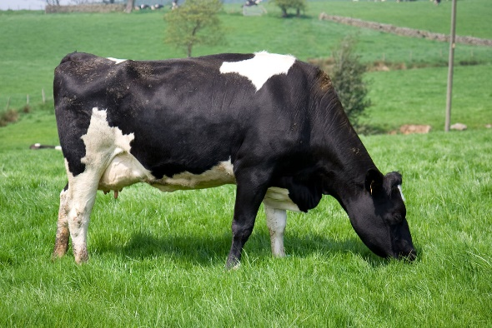
Bua

Bua ye toho. Toho doo bua.

Toho



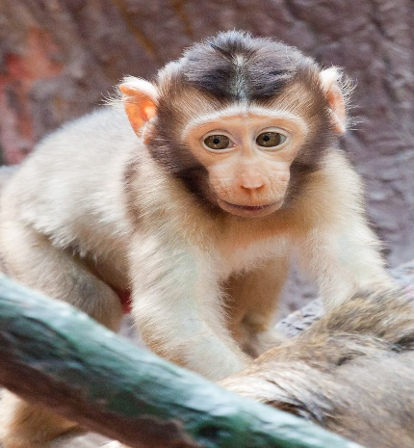
Bagu

Bagu ye ahi. Ahi doo bagu.

Ahi
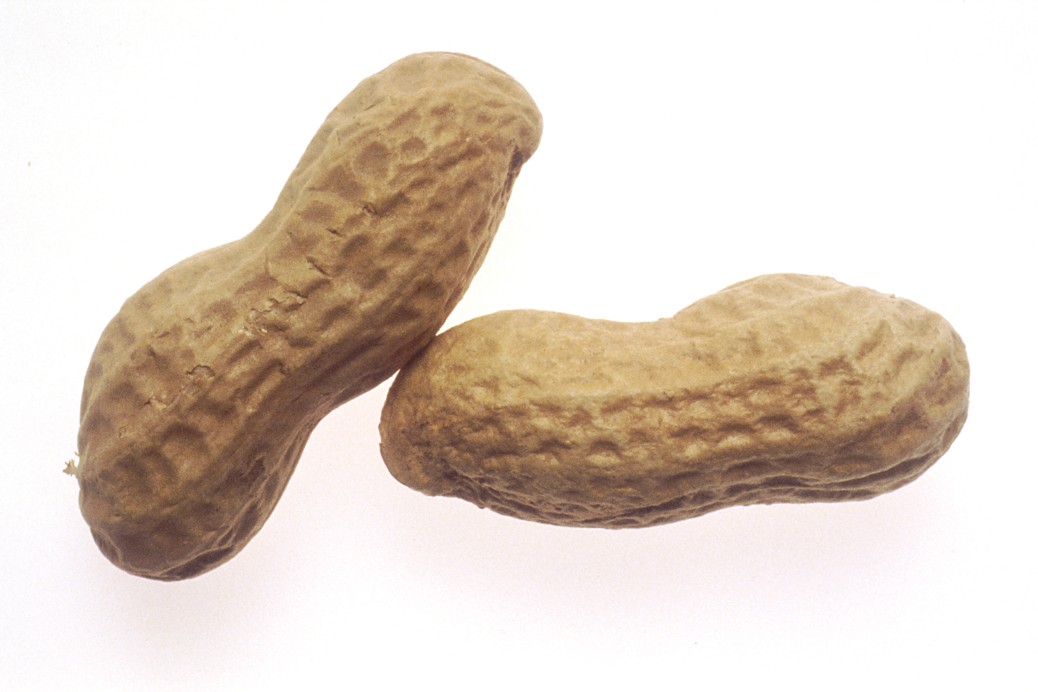

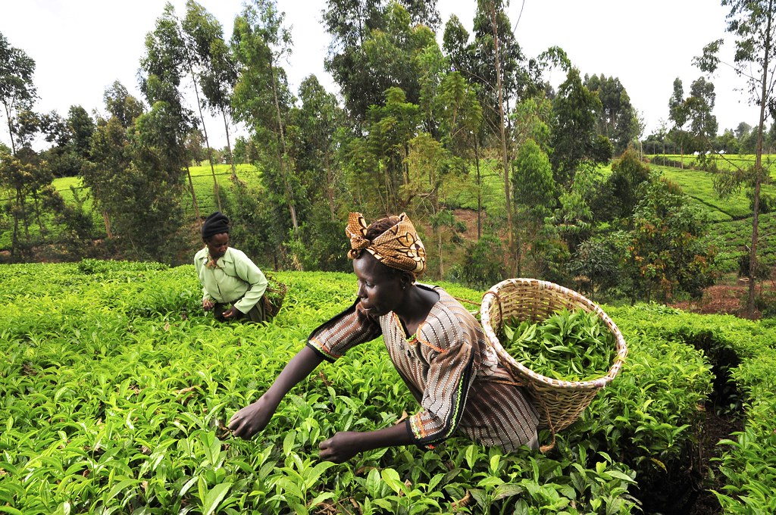
This Photo by Unknown Author is licensed under CC BY-SA
Kasev ken sule (Women in the farm)


U henen kwagh u sainz ka mzehemen Mbayev mba agher sha kwagh u sainz
(To learn science is progress) (Children are excited about science)


This Photo by Unknown Author is licensed under CC BY-NC-ND

Kasev mba gbiyen futubol (soka) mba Nigeria Mbayev mba nan mhen sha mbampin
Nigeria women football (soccer) team (Children are answering questions)

