Tiv-English Dictionary

A
abainyam (trap-jaw ant): predator ant that produces a smell when crushed. Abainyam kpe; ihuma ngee. The trap-jaw ant died;
there’s a lot of smell.
abaver (news): information coming from all directions. M ungwa abaver a doon. I heard the good news.
abeda (Nigerian wrapper clothing): a large piece of clothing for wrapping around the waist. Zer abeda.
Wear (wrap) the Nigerian wrapper clothing.
abeen (clouds): a collection of water droplets in the sky. M nenge a abeen a wura. I see rain clouds.
abia (little hoe): a little hoe for cleaning the yard or farm mounds. Tôô abia hura tembe. Take the little hoe to clean the yard.
abukumcer (cobra), noun: snake that can rise with a hood in defense; considered highly poisonous.
Abukumcer ngu a megh. The cobra (also called abuku) is venomous.

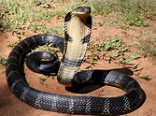
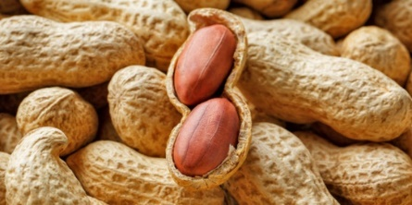
cobra (abukumcer) groundnuts (abun)

abume (swing blade), noun: thin blade that sounds when flung around and around. Ker abume a er imo i taver.
Fling the swing blade to make a loud sound.
abun (peanut/groundnut), noun: a nutlike seed that grows underground. Tem abun. Crack open a groundnut.
ada (bow), noun: a device used with an arrow to shoot at a target. Ada ngu a kwange. A bow has a string.
adeda (house), noun: a rectangular-shaped house. Andiir maa adeda. Andiir built a rectangular-shaped house.

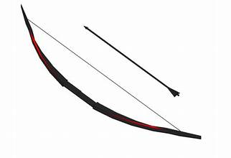
bow (ada) and arrow (ivaan) wedding (ivese)

adenger (curly pea pods), noun: creeping curly peas usually harvested while green or mature yellow. The
mature pods are also edible. Jiir ishu sha adenger. Cook fish with curly pea pod. adenger afilifi, noun.
adiguve (African harp), noun: a harp-like musical instrument with three strings. Kuha adiguve. Play the African harp.
adôlik (hydraulic oil), noun: oil for lubricating machine parts. Wa adôlik sha gia mato. Apply hydraulic oil on the car gears.
adua (church service), noun: the church worship service conducted by a priest or pastor, usually on Sundays.
Aya ze adua hanma Lahadi. Aya goes to church service every Sunday. See iyough adua (church): a church is a
place of Christian worship and services.
adudu (chest, trunk), noun: an archaic container used like a trunk or chest. Wa akondo shin adudu. Place
clothes in the “adudu” chest.
afo (camp), noun: a temporary military or other encampment. Afo a Fulani mba kuran ibua. A cattle-Fulani’s camp.
aga (staff), noun: a staff for the Blind. Aga ka a wase orapirashe u zenden. A staff aids a blind person to walk.
agba (arm band), noun: Tiv traditional arm wear made of beads. Ngôkem wa agba. Mother-in-law wore
the traditional arm band.
agbadu (pumpkin), noun: a large gourd-like rounded orange-yellow fruit with edible flesh. Jiidi agbadu wa ishwa
shami. Cook the pumpkin with ground benniseed (sesame seeds).

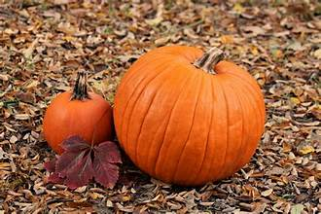
pumpkin (agbadu) snail (agbum)

agbe (hook with legs), verb: a type of boys’ game where each player tries to hook the other with legs. A wa
agbe u zôhôn un. He hooked with legs to throw him down.
agbo¹ (wateryam), noun: type of yam that is soft and fluffy when cooked. Na wan agbo a ya. Give the child
water yam to eat.
agbo² (bullets), noun, pl: what one puts in a gun to shoot. Gbuuka na tee agbo ikundu kwa mom. His gun takes
twenty bullets at once. See igbo, singular noun.
agbum (snail), noun: spiral-shelled animal found in ponds and damp places as it craws. Agbum doo u yan ga. It is
not good to eat spiral shelled snail.
agbur (seats), noun, pl: logs used for seats (archaic). Mba kera tem sha agbur ken makeranta ga. They no longer
use (sit on) logs (as seats) in schools.
agena/agina (smallpox), noun: disease that affects the skin; can be deadly. Agina bee ken tar Tiv. Smallpox has
been eradicated in Tivland.
ager (draw soup plant), noun: made from climbing plant that produces rubbery liquid for a variety of purposes.
` Kunde ager. Make ager soup.
agir (mound), noun: a long mound for planting cassava. Kaha agir kuma logo. Cultivate a long mound to plant
cassava.
ago¹ (ready), verb: to prepare to do or say something. Wa ago iyol u yem kasua. Get ready to go to the store.
ago² (pidgin English), noun: broken English spoken in West Africa. M fa u lamen ago ga. I don’t know how to
speak pidgin English.
agom (tall grass), noun: grass with tall talk and smooth leaves used as cattle-feed. Na ibua agom i ya. Give
cattle tall grass to consume.
agum (young things), adj: things that are young, usually also strong. Ka agum a ior tsegh vea nyôr shoja ye.
Only the young and strong people (enter) join the military. Agum a ukase. Young women.
agundô (earthworm), noun: a long, thin worm that lives in rich, loamy, or sandy soil. Agundô ye inya. The
earthworm eats soil.
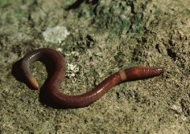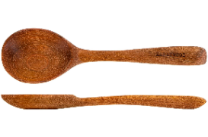
earthworm (agundô) wooden spoon (ahwa)

agwa, alabar (news), noun: information that comes from all directions concerning something worthy of note.
Makir ya Tor Tiv, nahan agwa za nyor India. Makir was crowned Tor Tiv, so the news spread to (reach) India.
ahan (laughter), noun: the sound, accompanied by a grin, one produces when they find something funny. A se
ahan taver. He laughed loudly.
ahir (magic), noun: using fast tricks or supernatural powers to influence what people see. U nanden toho hingir
mtuhem ka ahir ga; ka sainz. To burn grass not ash is not magic; it’s science.
ahumbe (wind), noun: what is produced when a lot of air moves at a high speed. Wura va a ahumbe ngee. The
rain came with a lot of wind.
ahwa (stirring spoon), noun: a large spoon for stirring usually wooden or metallic. Kunde iue sha ahwa. Stir the
soup with a stirring spoon.
aie (lie), noun: something told that is known to be untrue. De aie u eren. Stop (your) lying.
aikie (evening), adj: part of day after “afternoon” and leads into supper time. Mama er kwaghyan u aikighe.
Mother has made (cooked) the evening meal.
ainge (current, present time), adj: happening at the present time or not long ago. Itiav mbi Gaza man Mbaiserael
ken 2023 ka kwagh u ainge. The war between Gaza and Israel in 2023 is a recent event.
ainge ainge (recently), adv: not so long ago. Se nenge a Jay ainge ainge. We saw Jay recently.
aiodin (iodine tincture), noun: an antiseptic medicine used in treating recent cuts. Aiodin una wase ivav i m
tende sha ihôwe ne. Iodine tincture will help with the cut on my finger.
aiviief (invitro fertilization or IVF), noun: the use of technology in fertility treatment to help a couple get
pregnant. Aiviief bee kwagh u ikôm ken tara? Does IVF end infertility issues in the world?
ajav (rags): old piece of cloth/clothing. Ajav ne ka a esen jingi. These rags are for cleaning the glass.
aji (eggs, pl), noun: laid by some animals from which their babies come. Ikegh ta aji. The hen laid eggs.
Compare: Ajikegh (chicken eggs); Aji a ishu (fish eggs); Aji a hungwaja (cricket eggs). See iji, singular noun.
ajingi ashee (eyeglasses), noun: used by people o correct vision problems or eye protection. Oo ta kpishi; wa
ajingi ashee. It is very sunny; wear eyeglasses.
ajo (stringed drum), noun: a Tiv stringed two-sided talking drum. Kuha ajo. Play the Tiv stringed drum.
aka (charcoal), plural noun: remains of wood that has not burned to ash. Aka tsee her. The charcoal is still hot.
akaa (things), plural noun of kwagh (thing). Akaa ngee a m fe ga yô. There are many things I don’t know.
akaangise (history): information about past events or happenings. Akiga iyange nger takerada u
akaangise a Tiv. Akiga wrote the history of Tiv.
akaca (hand-held shaker instrument): a Tiv musical instrument with bamboo limbs and enclosed pebbles.
Mbaatsamev mba iyough adua ka ve kuha akacha. The hand-held shaker instrument is used in the church
choir.
akam (bricks; blocks): plural noun for ikamegh (brick; block). Ta akam. Lay (some) blocks/bricks.

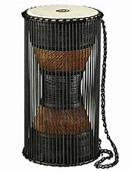
eggs (aji) talking drum (ajo)

akaren (tests, examinations). Plural for ikaren (test; examination), singular noun.
akausu (charcoal): a dark lump of material left after wood is burnt. Dugh akausu za keer usu a min. Remove
the (glowing) charcoal to go kindle the fire. Ikausu (charcoal), singular noun.
akem (scooping gourd): a gourd with long stem used for scooping liquid from a narrow-mouth pot. Kese iber
sha akem. Scoop the porridge with a scooping gourd.
akiki (African hummingbird, grey owl): a bird that hums continuously in the mornings. Akiki tema sha
atur. The African hummingbird sits on the fig tree.
akinde (Tiv rubber tree): Gber akinde a due mningem. Cut the Tiv rubber tree to produce rubbery liquid.
akô (arrow shaft): the long part of an arrow on which the target point is fixed. Ivaan yam ngi a akô u lihen.
(My arrow has a long shaft.)
akô (forests), plural noun. See ikô, singular noun.
akombo (idol), noun: a Tiv idol that is worshiped for good luck. Ior mba genev mba civir akombo. Some people
worship idols. See ikondo, sing.
akor (horns), noun: plural noun for korough (horn). Nommbua ngu a akor. A bull has horns.
akôv (shoes), noun: plural noun for ikovough (shoe). Wa akov. Put on shoes.
akpa (whip), noun: a long stick, or belt, or sold object used as a whip. A gbidye nyinya sha akpa. He hit the
horse with a whip.
akpagher (good luck charms, plural noun); see ikpagher (good luck charm, sing noun)
akpe (bottles, plural noun); see ikpe, singular noun.
akpe, ape (a place of): a place of … as in ape suur (a place of rest or comfort).
akpekpa (Tiv native bread), noun: food made by cooking mixed bean or Bambara nut flour with water and some
oil. Jiidi akpekpa ior ve ya. Cook native bread for people to eat.
akpem (large Tiv cloth), noun: a Tiv cotton clothing with wide white and grey stripes. Ter na cir akpem iyol.
His father wore a Tiv cloth with white and grey stripes.
akpera, lu (small mortar): small mortal used for pounding little chunks of things. Kume tuwe shin
akpera. Pound the dried okra in the small mortar.
akpev (scabies disease), noun: an itchy skin rash caused by mites that get into the skin; the disease is
contagious. Akpev er wan mom man gema tsar ônov mba genev. One child got scabies which got transmitted to the other
children. Ikpev, singular noun.
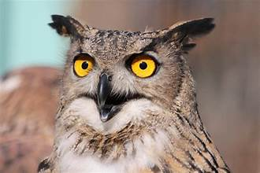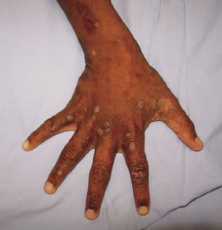
African grey owl (akiki) scabies (akpev)

akpu (Nigerian fermented cassava), noun: peeled cassava white fermented and filtered; dried flour used for
fufu or ruam. Ruam u akpu huma doo ga. Fermented cassava fufu smells bad.
aku (parrot), noun: a colourful bird with a down-curved bill some of which may mimic human voice. Aku ye
guavee. A parrot eats guava.
akuese (Hausa kose), noun: fried beans paste in balls after cover removed (also called akara in Yoruba). Er
akuese man kamu. Make kose or akara balls and akamu (corn porridge).
akusu (hooves), noun: the hard covering on the feet of cows, horses, pigs, and some animals. Nor mnger kpa
ngu a akusu. The hippo also has hooves (or hoofs).
akya (Tiv oboelike instrument), noun: a Tiv oboelike musical instrument made of wood. Tongo akya m vine
amar. Let me dance to the tune of the Tiv Oboe.
alabar (news), noun: information coming from all corners of the earth. See agwa, noun. A va a alabar a bo.
He/she brought bad news.
alev (beans), noun: a leguminous plant that produces edible seeds in bean pods. Alev ka kwaghyan u nan
mkpeiyol. Beans are a healthy food.
alômôde (African grape). noun: African grape tree that bears white fruits. Zor atam a alômôde ya. Pick the
African grapes to eat.
alum (orange), noun: a juicy citrus fruit grown in tropical and subtropical climates. Alum ne ngu a zar kpishi.
This orange has a lot of juice (is juicy).
amar (dance), noun: movements made by people following rhythmic music. Ka m vine amar. I dance.
ambe (crocodile), noun: a reptile with long jaws, long tail, and a rough skin. Aji a ambe. The crocodile’s eggs.
ambo (gorilla), noun: a large grey monkey. Ambo unde sha wo. A gorilla climbed the mountain.
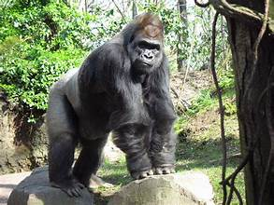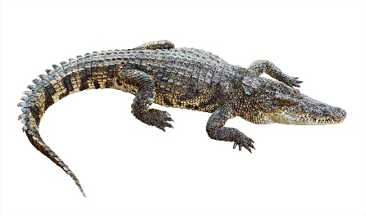
gorilla (ambo) crocodile (ambe)

ambi (faeces; droppings), noun: solid waste produced after food is digested. Ambi a ibua. Cattle faeces or
droppings.
ameen (temptations, enticements), noun: things done to attempt/entice another. De zaan a mo ape ameen a
lu ga. Do not lead me into temptations.
amende (yam creeping stems), noun: when the creeping stems of the yam plant dry up. Wa amende jiir iyough
sha min. Boil yams on top of yam creeping stems.
amine (millet), noun: grains that grow on tall stalk used for food. M wua amine m kunde iber. I ground the
millet to make porridge.
amire (chickenpox), noun: a contagious illness caused by the varicella-zoster virus that produces a red rash
with blisters. Amire ka a va a mnyam ma yaven. Chickenpox brings sleepiness.
amishe (roots), noun: part of a plant that gives it support. Amishe a toho za shin inya ga. The roots of grass
do not go deep into the soil.
ancaver (pre-owned or worn-out clothing), adj: Nam ancaver ikondo you la. Give me your worn-out clothing.
ange (sour), adj: having an acid taste like that of a lemon. Alum nyian ga; nahan, zar na ange. The orange is not
ripened; so, its juice is sour.
anger¹ (Tiv traditional clothing), noun: Tiv traditional clothing of black (toil) and white (purity) stripes. Me throw
over the shoulder; women wear as wrapper and headtie. Cir/zer anger; shi vine amar. Wear the Tiv traditional clothing; then, dance.

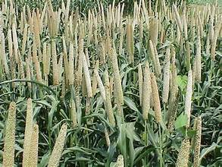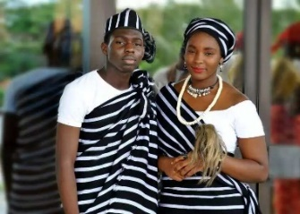
millet (amine) Tiv traditional clothing (anger)

anger² (torch feathers or skin on animal), verb: to remove the hair or feathers off an animal or bird by
torching. Anger ivo man u bur aci ye. Torch the goat skin before carving into pieces.
angereke (gossiping), noun: when one talks about others behind their back. De angereke; u va wa or ken
kwaghbo. Stop gossiping; you may get someone into trouble.
aningbian (relative), noun: a person’s relative other than mother or father. Wan nomso u anigbian u ngôm u
nomso ka anigbian. The son of my mother’s brother is my relative. Aningbianev (relatives), plural noun.
aninge (aromatic leafy vegetable), noun: leafy vegetable usually eaten with Tiv fufu (ruam). Ya aninge shin
Mbatiav za gever sha Gaav. Consume aromatic veges in Mbatiav; and burp at Gaav (a long distance away).
aninja (minor misbehavior), noun: a minor misbehavior such as yawning loudly in class. Me faityo u zuan a
mtsaha aluer m er aninja u bo yô. I may be punished for a minor misbehavior.
ankon (small/little tree), noun: a small tree not named. Ankon ne tav ga. This small tree (shrub) is not tall.
anumbe (games, sports), plural noun: Abuja hemba Kaduna mozough u anumbe. Abuja defeated Kaduna at the
games meet. See inumbe, singular noun.
anyam (tiger/tigress), noun: a large male or female wild cat found in Asia. Anyam ye inyam tsegh. The tiger
eats only meat (i.e., it is carnivorous).

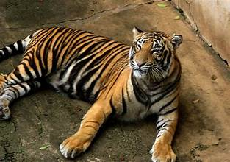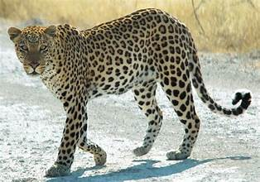
tiger (anyam) leopard (anyamazenga)

anyam azenga (leopard), noun: large wild cat that looks like a tiger found in Africa. Anyam azenga yevese
kpishi. A leopard runs fast.
ayarikule (jaundice), noun: an illness caused by the buildup of bilirubin in the blood, noticed by the yellowing of
the eyes. M gba ayarikule; nahan m zua a iyolhian. I caught jaundice; so, I have a fever.
anyigôr (earthworm), noun: a long, thin worm that lives in rich, loamy, or sandy soil where there is sufficient
moisture, and the climate is not too cold. Anyigôr zough a kwaghyan ken inya i yan. The earthworm gets its food from the soil it eats. See agundô. Mbaanyigôr, plural noun.
anyilasenge (earthworm, archaic), noun. See agundô and anyigôr; singular nouns.
anzereke (tricks), noun: tricks performed to deceive in real life situations. Wanye wa anzereke; nahan, ka a
bume ior mbavesen. The boy is full of tricks; so, he deceives grownup people.
aper¹ (hollow grass stalk), noun: grass stalk with clean hollow between leaf nodes used as a musical instrument.
Tôndo aper er akya. Cut the hollow grass stalk (like a straw) to make an oboe.

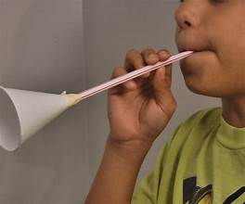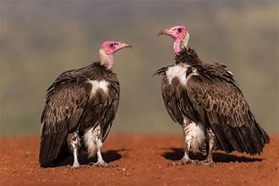
grass-stalk oboe (aper) vulture (apu)
aper² (will cross), verb: prediction of crossing (a stream/road). Ior ve aper wuagh. People will cross the stream.
ape suur (place of comfort), noun phrase: a place to find rest, comfort, help, or care. M zua a ape suur itiough. I
have got a place of rest, comfort, help, or care (lean head against). Apesuur (ultimate helper).
apir (let be extinguished), verb: call to extinguish a fire. De un a pir usu: Let him/her extinguish the fire.
apu (vulture), noun: a large bird with no feathers on its head that feeds on dead animals. Apu ye ihiev i kpen.
A vultue eats dead rats.
apusu (rinds; peals), plural noun: rinds or peals of fruits. Mba ye apusu a mongol. The rinds of the mango are
edible. See ipusugh, singular noun.
asema (hearts), plural noun. See ishima (heart), singular noun.
asemberakaa (letters of the alphabet), noun: the letters of the alphabet, a-z. (Also known as abaca, including asemberakaa a taan.:
a, o, i, u, e). Aôndona fa u ôron asemberakaa. Aôndona can say the letters of the alphabet.
asenge (joke), noun: something that is said to make people laugh. Sam ôr kwagh u asenge (hômon). Sam said a joke (something
funny).
ashe (eyes, plural noun): See ishe (eye), plural noun.
asid (acid), noun: a substance that turns blue litmus to red. Alum ngu a asid. An orange contains acid.
asongo (chunks), noun: large pieces of meat. Asongo a inyam igo. Chunks of pork. Plural noun.
asorabo, akaabo (sins, trespasses): See ishoribo (sin), singular noun.
ate¹ (public/common hut), noun: Tiv traditional hut in front of the house built as a common meeting place. Ate
u Buruku kehe. Buruku’s common hut is large.
ate² (forum), noun: a physical or digital stage for people to meet and discuss issues. Ate u Tiv or kwagh u
kwase eren. The Tiv forum discusses marriage.
ateghatô (middle), noun: the center of something; a point of equal distance from the end or sides. Ikeghdam ngi ôôn ken ateghatô u
ityungu. The duck is swimming in the middle of the pond.
Atese (pastor's wife), noun: the pastor’s wife who is also a Bible teacher. Atese hemen kasev. The pastor’s wife
leads the women.
atetan (afternoon), noun: the period of day between noon and evening. 1. Mbayev due makeranta atetan. The
children are out of school in the afternoon. Adverb. 2. Ka ve va hanma atetan. They come every afternoon.
atii (dove), noun: small bird that has brownish feathers and lives in most parts of the world. Atii ye wua.
Sparrows eat guinea corn. Mbaatii, plural noun.
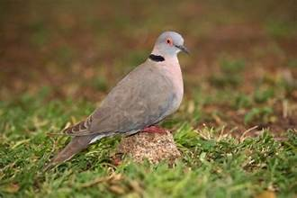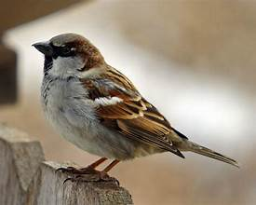
African mourning dove (atii) house sparrow (atsator)

ato (ears), plural noun: part of the body that serves as the organ of hearing. Ato a iwa kehe. The dog has big
ears. See tough (ear), singular noun.
atô (buttocks), plural noun: the part of body that is the back of the hips with which a person sits. M tema sha
atô am. I sat on my buttocks.
atôutu (into the night), adv: sometime shortly after midnight and before dawn. Igirgi purugh va nyôr atôutu.
The airplane arrived well into the night.
atsaka (sweet potato), noun: a vegetable grown for its underground tubers. Jiir atsaka i ya. Cook the sweet
potato to eat.
atsator (sparrow; finch), noun: a small songbird that lives inside thatched roofs and feeds on seeds. Asator soo imo i
gberen pepe pepe. The sparrow likes to sing early in the morning.
atse (cooking posts), noun: a place with three posts (rocks) on which a round cooking pot can be placed. Penda
itiegh sha atse. Place the pot on the cooking posts.
atungô (pond frog), noun: an animal that can live on land and in water with a short squat body, smooth skin, and
very long hind legs. Ifam tsuwe mita pue. The frog jumped ten meters.
atur (fig tree), noun: a tropical tree that grows fig fruits like a sycamore tree. Inyon soo u yan sam u atam a atur.
The birds like to feed on the seeds from the fruits of the fig tree.

aver (yawn), verb: to take in deep breath in a feeling of sleepiness. Mnyam kôr un, nahan ngu aver. He is sleepy, so
he is yawning.
awambe (blood), noun: the red liquid in humans and other vertebrate animals that carries oxygen to and carbon
dioxide from the tissues of the body. Ivav tôndon na awambe due. The cut brought out blood.
Aya (grandma), noun: one of several ways to refer to grandmother. Aya yila mbayev ve va ya kwaghyan.
Grandmother called the children to come eat food.
ayaba (banana), noun: a tropical and subtropical plant that produces banana fruits in bunches. Ayaba mba atô
kposo kposo. There are many different varieties of banana.

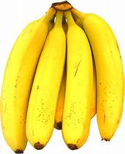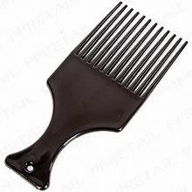
bananas (ayaba) comb (ayaligh)

ayange ayange (daily), adv: what happens day after day. Kile anyi ou ayange ayange (hanma iyange). Brush
your teeth daily (everyday).
ayaligh (comb), noun: what is used for combing one’s hair. Ngohol ayaligh dugh itiough you. Take the comb and
straighten your hair. (Itiough means head; ice means hair!).
ayarikule (jaundice), noun: a disease indicated by the yellowing of the whites of the eyes and caused by the
excess of the pigment bilirubin (caused by liver disease or produced by dead red blood cells). Ayarikule na un iyolhian.
Jaundice gave him/her fever (caused him/her to have fever).
ayem (run, running race), noun: to move from one place to another by running, not walking or
riding. Yevese ayem a mita deri môm. Run the one-hundred-meter race.
ayenge (mathematics, math problems), noun: working with numbers—whole numbers, rational numbers, and
shapes. Er ayenge (Solve math problems). See iyenge (math problem).
ayia (dry grass stalks), noun: grass stalks used to light a fire or use as a torch. Imenger ngi ga; tsar ayia. There is
no lantern; light grass stalks. Iyiagh, singular noun.
ayila (will call), future tense: See yila, verb; to call.
ayom (tricks), noun: crafty ways or methods meant to deceive someone or others. Alôm wa ayom. Hare is tricky.
ayongu (annoyances), noun: acts produced to annoy someone. Ngu a ayongu sha hanma or cii. He/she displays annoyances on
everyone.
ayôôso (loud voices, noise), noun: loud voices made by people that make it hard to listen to conversations. De
ayôôso; tor ngu ôron kwagh. Stop loud talk; the chief is speaking.
azande (scabies medicine), noun: green grass use for treating scabies disease. Wua azande cir sha kpie. Grind the scabies grass to
apply on the scabies sores.
azembe (African harrier-hawk), noun: a large bird of prey found in South Saharan Africa. It often preys on small animals and birds.
Akper a azembe hemba kehen a tsoghor. The African harrier-hawk has larger wings than those of the falcon.
azer (spits), plural noun; ijer (spit), singular noun: spits in the mouth. Ta azer. Throw pits. Ijer (sputum), singular noun.
a zungwe (may he/she have mercy), verb: to show mercy. Ter a zungwe se mhooôônom. Let the Lord have
mercy on us.
azurufa, goldu (gold), noun: a precious metal used in making coins and jewelry. M ngu a azurfa ga. I have no gold.

B
Baa (cave), noun: open space between rock on the side of a hill or mountain. Anema nga ken baa. There are
bats in the cave. Ubaa (caves), plural noun.
bagu (monkey), noun: a furry and quite animal that resembles an ape. Bagu tema sha avande. The monkey sits
on the rocks.
bam, banki (bank), noun: a place where people and organizations keep money and valuables. Za sha banki za
dugh inyaregh. Go to the bank to withdraw money.
bamber (split wood), adj: torn/split piece of wood usually used in the fireplace. Ar kon; dugh bamber. Split
the log; get the split piece.
ban (lack), verb: to not have/possess something. Ikondo ban un ga. He/she does not lack clothing.
bar (salt), noun: a chemical substance used to give taste to foods. Wa bar sha iue. Add salt to the soup.
Batur (white man), noun: a general name for a white person from Hausas bature. Batur tema sha agugu. The
white man sat on a motor bike.
bazaa (Bazar), noun: a gathering where people bet on things to purchase. M yam gbande hen bazaa. I bought
the dish at the bazar.

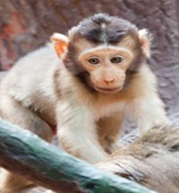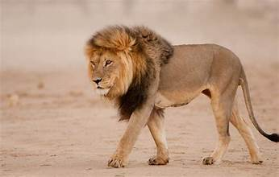
monkey (bagu) male lion (begha)

beba (broken), adj: a broken piece of something; as in beba genga: broken drum; beba ijôndo: broken calabash.
bebanan (large), adj.; archaic: a large portion usually about a share. Orya tôô vegher u bebanan. The head of the
house got the large portion.
bee (finish), verb: to come to the end of something. Mkulem bee. The oil is finished.
beer (pretense, hoax, acting), noun: to try to make something that is not real appear true. 1. De beer. Stop
pretending. Verb. 2. Beer bee (no more pretense/hoax).
begha (lion; lioness), noun: a large male or female cat with a mane, sharp teeth, and claws. Begha una faityo
u yan kwantera. A lion can devour a deer. Lioness (ngôbegha), noun.
bem (peace), noun: a calm condition with no fighting or argument. Bem gba. Peace has reigned.
bema (thoughtless), adv: to say or do something without much thought. A bema ôronkwagh. He/she said
something without thinking. Compare, bemabebema (thoughtlessly),
ber (lake), noun: a large piece of water surrounded by land. Ber Awuna ngu a ishu shimi. Awuna Lake has fish in it.
bika (beaker), noun: a container like a measuring cup. Haa mngerem shin bika. Pour water in the beaker.
biriki (brake), noun: a device that helps moving vehicles to stop. Kor biriki. Apply the brake.
bokoti (bucket), noun: a container with a looped handle. Haa amine shin bokoti. Place the millet inside the bucket.
bol (ball), noun: an air-inflated tool for kicking or throwing. Gbidye bol. Kick the ball.
Bolabola (Ebola), noun: a disease that causes severe bleeding and organ failure. Angev mbu Bolabola wua ior
shin Tombasa. The Ebola virus has killed people in Tombasa.
bologo (blanket), noun: a woolen blanket used as a night cover. Cir bologo iyol. Use a woolen blanket to cover yourself (body).
bom (bomb), noun: a chemical device that can explode. Amerika ta bom u wuan ior . America dropped a bomb to kill people.
bongo (container), noun: large straw container. Wa ikav shin bongo. Put the load in the straw container.
bua (cattle), noun: a cow or bull or calf kept on the form for meat. Wua nombua u zegenan. Kill the fattest
bull. Compare: ngôbua (cow); wanbua (calf).
bugela (trumpet), noun: instrument that makes a loud sound. Tungwa bugela ior ve nder. Blow the trumpet to wake up people.
bugh (open), verb: to take the cover off or shutter away from the door. Bugh hunda. Open the door. Verb.
bume (act foolishly), verb: to act foolishly or with stupidity. A bume karen kwar. He distributed stupidly.
bunde (pospond, absent), verb: to be away from or miss something. Wasem bunde makeranta kwa har.
buter (whiteman, European), noun: See batur (bature in Hausa or oinbo in Yoruba).
butu (mat to sleep on), noun: a mat for sleeping on. Tar butu; yav sha min. Spread the mat; sleep on it.
bwagi (a pick—for digging), noun: a tool for digging holes. Tôô bwagi time ihungwa. Take the pick to dig a hole.

C
cado (woven wrapper), noun: Tiv woven wrapper for men. Tamenor zer cado. The elderly man wore a woven
wrapper. (archaic, noun)
cahul (soap), noun: something used for cleaning and washing. ôô ave sha cahul. Wash hands with soap.
cenji (change), noun: part of money one gets back during a purchase. Cenji yam ka naira pue. My change is ten naira.
chamber (humiliate), verb: to humiliate. De ior ve chamber a mo. Let people humiliate me.
chamber chamber (totally ruined), adv: to be totally ruined or humiliated. Ve undu un chamber chamber.
They left her/him totally ruined.
Chi/ci (share), noun: a portion to be shared among people. Nam ci wam. Give me my share. Examine these phrases: Ci wou (your share);
singular Ci wen (your share).
chicha/cica (all), determiner: looking/considering everything. M ma iber cica. I drank all the porridge.
chiv/civ (dip), verb: to dip solid food material in a sauce/soup/dip. Civ ruam shin iue. Dip the fufu in the stew/soup.
cia¹ (fear). verb: to be afraid of something. M cia mer me va gba. I fear that I may fall.
cia² (contract/treaty), noun: agreement that something will happen. Cia i kyôr. The contract has been kept.
cii man (before), adv: when something happens ahead of another. Me wa akôv cii man se yem ye. I shall put on shoes before we leave.
cir, chir (close), verb: to cover something. cir ikpe i tematu. Close/cover the bottle of tomato.
cuku (little), adj: not a lot of something. Seer Msendoo iber cuku. Add a little porridge for Msendoo.

D
Daar (storage place), noun: hoisted storage structure for raw corn (archaic). Wa aile wua sha daar. Place
bundles of guinea corn on the hoisted storage place.
dafa (boiled grain food), noun: boiled guinea corn or millet. Jiir dafa wua. Cook Guinea corn grain (meal).
dagbaikôn (three-legged Tiv chair), noun: one-piece three-legged Tiv chair. Ayua tema shin dagbaikôn. Ayua
sat in the three-legged chair.
dagi (small spear), noun: spear for hunting small animals. Ker kwantera dagi. Throw a small spear at a deer.
damiyo (a kind of yam), noun: a soft sweet rare yam. Va a damiyo shan ivese. Bring the sweet yam to the wedding.
dan (ramble) verb: not answering in a straightforward manner. A dan kwagh; a na mrumun dedoo ga.
He/she did not answer in a straightforward manner.
dar (Tiv counting game), noun: a two-person game used for counting. Gire fa dar yan. Gire knows how to play
the Tiv counting game.
de (stop or don't), verb: a command to stop doing something . De benden ave ga. Do not touch it. Sample
phrases: de aie (stop lying); De m (leave me); De nen (you stop), plural; De ve (leave them).
dedoo (well, fine, okay), adv: state of being well. M ngu dedoo. I’m well.
dedoo ga (not well, sick), adv: state of being unwell. M ngu dedoo ga. I’m not well (I’m sick).
dem dem (very cool), adj: of something at a very low temperature. Mngerem ndohol dem dem. The water is
very cool.
deraba, derava (driver), noun: a person who drives a vehicle. Orfa ka deraba u Alek. Orfa is Alek’s driver.
deri (hundred), noun: the number one hundred. Naira mom ka kobo deri mom. One naira is one hundred kobo.
digirii (degree), noun: what you receive after completing your undergraduate studies. M zua a digirii ken
ayenge. I have a degree in mathematics.
dodo (fried plantain), noun: fried plantain or banana. Kaas ayaba. Fry (some) plantain or bananas.
dogo (rail track), noun: one of rails that form a train track. Gbenda u dogo. The track/road of rails.


rail track (dogo) doctor (dôkta; ortwer)

dôkta, ortwer (doctor), noun: a person well trained to examine and treat sick people. Ortwer nger un cigh.
The doctor prescribed medication for her/him.
dola (dollar), noun: money currency used the United States of Aerica. Na Jay dola pue. Give Jay ten dollars.
dombo dombo (flappy), adj: when the belly has excess muscle. Yav nav mbu dombo dombo. His stomach is flappy.
dondo (follow), verb: to go with or behind someone. Wendy dondo ngô na u zan adua. Wendy followed her
mother to church.
donko (rubber), noun: material that is elastic; stretches and snaps. Donko tôndo. The rubber (band) broke.
doo (good), adj: when something is nice, fine, or pleasant. Ya doo. The home is good. C.f., doo ga (not
good); doo gande (extraordinarily good): when something is very good; doo m (I like), adjective; doo ishe (cheap/inexpensive).
dooshima (love), noun: a deep liking for someone. Ngô ngu a dooshima hen wan na. A mother has love for her child.
dubu (thousand), noun: the number one thousand. Naira dubu uhar. Two thousand naira.
dubudubu (million), noun: the number million. Ya u Gemade kuma inyaregh naira milien akundu ahar.
Gemade’s house is worth forty million naira.
due (come/go out, appear), verb: to come/go out; appear. 1. Or due ken won. Someone came outside. 2. Ikume due sha kwavaôndo.
A rainbow appeared in the sky.
dugel, polishi (police officer), noun: a law enforcement officer. Dugel kôr ormbaiv. The police caught a thief.
dugh (remove, pick out of), verb: take something from a container or body. Dugh sam sha. Remove the seeds.
dundôô (straitened), adv: Gbidye iyough ki hingir dundôô. Beat the metal to become straightened.
dura (make thunderous sound), verb: to make a thundering sound, during a thunderstorm. Wura dura. It (the rain) thundered.

E
ei (no), adv: a response to non-agreement. Ei, m ngu yaven ga. No, I am not sleeping.
eize (AIDS), noun: a disease caused by a virus that makes the body unable to fight off even simple diseases. A
gba eize. He/she has caught AIDS.
ember (rejoice, be glad), verb: not showing sadness. A ember sha er kwase na a mar wan yo. He is glad that
his wife gave birth to a child.
engem (shinny), adj.: display lustre due to light reflection on the surface after polishing. M ese akov engem je m nenge a ishigh yagh
ker. I polished the shoes so well that I saw the image of my face in it. See iengem (shininess), noun.
enger (slack; loose), verb: not form. Wondo enger. The pants are slack.
er (happen), verb: to take place; to do something. Kwagh er. Something happened. Noun. Er asenge (joke); er doo
(did well); er kwaghyan (cook food); er tom: do work or work; erdoo (good deed); eren angereke (gossiping).
ese¹ (sweep), verb: to clean up. Ese tembe iyoough. Sweep the floor of the house.
ese² (sharp), adj: having a thin edge that can cut. Ihô ne ka i esen. This is a sharp knife.
ese³ (cut), verb: to be cut by a sharp object. Ihô ese m. I am cut by a knife.

TIV-ENGLISH DICTIONARY

F
fa (know; understand), verb: to have information or possess skills about something. Fa kwagh. Know something.
fa ga (not know), verb: ignorant about something. M fa ga. I don’t know.
faa (early), adv: at the beginning of or before the regular time. Va faa. Come on time or early.
Fada (Reverend Father), noun: preacher in the Catholic church. Fada pase Bibilo. The Reverend Father preached (on) the Bible.
faityô (able to; can), verb: ability to do something. Faityô u eren kwagh. Could do something.
fan ityô ga (impossible), adj: cannot. U faityô u ôron ingeegh ki asan cii ga. You cannot count the number of all the stars.
fa kwagh (to be friendly), adj: to show friendliness toward others. Bam fa kwagh. Bam is friendly.
fam (summer), noun: wet season. Fam gba. It`s wet season.
fa ngee (brainiac), adj: claim of intelligence ( to know all). A hen er un fa ngee. He/she claim to know all.
fefa; fere; fese (quickly), adv: without delay. Za fefa. Go quicky. C.f., fese fese (very quickly).
fekefeke (out of breath), adj: the state of being out of breath. Wasem yevese je hingir fekefeke. Wasem run
so much that he was out of breath.
ferefefere (fast), adv: moving speedly. Yevese ferefefere za hide. Run fast to go and come back.
fere fere (hurry), verb: Er fere fere sha er se yem yô. Hurry up so we can go (or leave).
fiil (tuck), verb: to hold in place the edges or ends of cloth or beddings. Fiil tsombol ku abeda a de saghen ga.
Tuck the edge of the “abeda” clothing so it does not come loose.
fiir (bunch), verb: to make into a group. Fiir akondo; wa shin iba. Bunch the clothes; place in a sack. Verb.
foto (photograph, picture), noun: images of something, animals, or people. Tôô foto. Take a picture.
Fulani (Fulani), noun: ethnic group in Nigeria. Fulain mba gen ka mbakuran ilev. Some Fulani are herdsmen.
fulô (mashed millet balls), noun: ball made from millet four used for food. Ma fulo man atumba. Drink mashed millet balls and milk.
fulum (green squash), noun: green squash eaten after boiling. Jiir fulum shaciu mbayev. Cook green squash for the children.

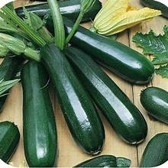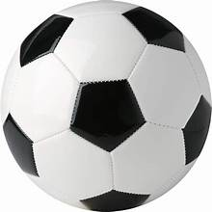
squash (fulum) bed (gambe) football (futubol)

futubol (football), noun: ball used for playing soccer. Gbidye futubol. Play football.

G
ga (not), adv: used to make a word or statement negative. Doo ga. Not good.
ga yô (nothing else/no one else), conjunction: no other … . Aluer kwagh gen a er ga yô, me va. If nothing
else happens, I shall come. Phrase.
gagh (suddenly), adv: something that happens without warning. Andyar nule gagh ta sha mo. Andyar suddenly
launched at me.
gambe (bed), noun: what you sleep on. M ngu yaven sha gambe. I`m sleeping on the bed.
gamber gamber (entangled), adj: of growing creeping plants. Amende a iyough wuha gamber gamber sha
ikon. The creeping plants are entangled in the trees.
gande¹ (extraordinarily), adv: something that is beyond the normal. Taver gande. Extraordinarily hard.
gande² (overgrown), verb: vegetable with tough skin. Atuur gande. The okra is overgrown.
gande³ (excessively/too), adv: something that exceeds the normal. Akwati yuha gande. The suitcase is too heavy.
gande⁴ (watery), adj: with too much water. Gbodi gande. The ground okra soup is watery.
gande gande (not thick), verb: of a paste that is very thin. A wa mngerem shin iber; i hingir gande gande. She/he
put water in the porridge paste; it is no longer thick.
gar; geri (town), noun: a place where a large group of people live. Gboko ka gar u vesen. Gboko is a large town.
gareji (garage), noun: a place to park vehicles for loading passengers and goods. Za nyor mato shin gareji yem Abuja. Go enter the
motor vehicle to travel to Abuja.
gari (fried cassava flour), noun: fried cassava flour that is consumed in different ways. Eba ka ruam gari. Eba is
fufu which is made from fried cassava flour.
gaz (gas) (gas), noun: source of power to burn or for running cars/trucks. Gaz mba atô kposo kposo. There are
different kinds of gas.
gba¹ (fall), verb: to drop to the ground. Bol gba shin inya. The ball fell to the ground. Idiomatic use: bem gba
(peace has reigned; gba jime (fall behind).
gba² (carve), verb: to shape into something from wood such as a boat. Gba tso. Carve out a boat.
gbaa (branch), noun: tree part that grows from the trunk. Kon mongol ngu a agbaa kpishi. The mango tree has
many branches. See ikahan (branch of roads or ideas).
gbagir (Tiv traditional men’s clothing), noun: made of cotton with large white stripes an tinny black or brown stripes. Tor kpande
cir gbagir iyol. The chief tax collector wore the Tiv traditional men’s clothing.
Gbajimba (name of village), proper noun: a fishing village along River Benue. M za yam ishu ken Gbajimba. I went and
bought the fish from Gbajimba.
gbaka (viper), noun: a spotted poisonous snake. Ikume ia ya alôm; gbaka una ya ihev. The python will eat a
rabbit; the viper will eat a mouse.

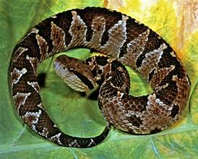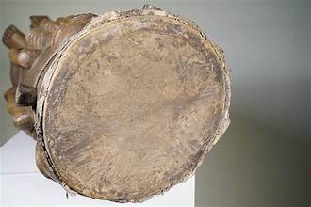
viper (gbaka) Tiv triangular drum (gbande)

gbami (start action), verb: to start doing something. Gbami u yan kwaghyan. Start eating (food).
gbande¹ (Tiv triangular drum, konga), noun: a drum covered at one end, the wider, with animal leather skin. Kuha gbande. Play the
Tiv the triangular drum or konga.
Gbande² (dish; plate), noun: something in which to serve food. Gbande u chinkafa. A plate of rice.
gbang gbang¹ (healthy, well), adj: indication of wellness. M ngu gbang gbang. I am well/healthy.
gbang gbang² (tightly), adv: closely and firmly together. Cir tsuwa gbang gbang. Cover the pot tightly.
gbange (wooden cymbals), noun: cymbals made from wooden pieces. Kuha gbange. Play the wooden cymbal.
gbanger (wide), adjective: having a large area. Ijande ne ka i gbanger. This is a wide lake.
gbangi (gigantic metal bowl), noun: gigantic metal bowl. Haa mngerem shin gbangi. Pour water in the gigantic metal bowl.

gbeenegh (insect leg), noun: leg of crab or cricket. Tondo gbeenegh ku ikambegh. Cut the crab`s leg. Agbeen, plural noun.

` 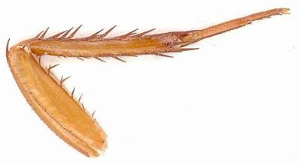 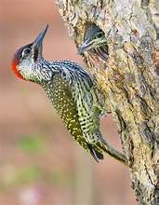
insect leg (gbeenegh) woodpecker (gberkpôôkpôô)

gbem¹ (often), adv: what happens often. Iyôn ngi nger heen gbem. The ants often enter here.
gbem² (chin), noun: part of the body beneath the mouth. Or ngu a ice sha gbem. The man has hair on the chin.
gbem³ (ant), noun: a giant black ant. Gbem nyuma wanye nomso. The giant black ant bit the boy.
gbem gbem (always), adv: every time; all the time. Me henen kwagh wou gbem gbem. I will always think
about you. C.f., gbem maiyange kera bee ga (for ever and ever); gbem sha yon (forever).
gbenda (road/path, noun): a way on which to move. Zende sha gbenda. Walk along the road.
gbendegh (strand of twig), noun: dry strand of creeping plants. Hule agbende wa shin itiegh. Fold the twig
strands to put in the pot.
gber¹ (cut), verb: make a long object into shorter pieces. Gbe kon ker atoon atar. Cut the wood into three pieces.
gber² (sing), verb: produce voice into a melodious sound. Golozo gber imo. Golozo sang a song.
gber (cut; sing), verb: To cut; to sing. 1. Gber kon—cut a tree; 2. Gber imo—sing a song.
gbera (core, vein), noun: the stringy center part of cassava; blood tube in the body. 1. Gbera u logo. The core of the cassava. 2.
Gbera u awambe a ken iyol. The blood vein in the body.
gberkpôôkpôô (woodpecker), noun: a bird with a strong, sharp bill which drills into wood to get insects.
Gberkpôôkpôô ngu gberen sha kon. The woodpecker is drilling the tree.
gbidye (hit, kick, whip), verb: to hit or beat. Gbidye bol. Kick/hit the ball.
gbiin¹ (vain, empty), adj: contains nothing. Itiegh ki gbilin. The pot is empty.
gbilin² (free), adj: without payment. Seta nam cigh gbilin. Seta gave me medication free (without charge).
gbinde (African adder), noun: venomous or non-venomous snake. Gbinde i ye asôhô. An adder eats toads.
gbing (full, a lot), adj: a large amount of something. M sugh gbing. Thank you, a lot. (slang).
gbing gbing (very full; stuffed), adj: showing great fullness. Gbor wam iv gbing gbing. My stomach is stuffed (very full).
gbir (lay), verb: to place in bed or in a crib. Gbir wan shin gambe. Lay the child in the crib (bed).
gbodi (ground dried okra), noun: used for soups. Kunde gbodi. Make dried ground okra soup.
gbondough ashe (roll eyes), verb: to roll one’s eyes in disagreement. De u gbondough mo ashe. Stop rolling
your eyes at me.
gbongul (prideful, disrespect), noun: showing disrespect. A gbongol ôron kwagh sha tica. He showed disrespect
in the way he spoke to the teacher.
gbôônough (lower limb), noun: the lower limb of an animal. Gbôônough ku ivo doo u yan ga. The lower limb of
a goat is not good to eat.
gbor (stomach), noun: the organ of the body which is kept before further digestion. Compare, iyav: where the
is located. Gbor wam iv a kwaghyan. My stomach is full of food.

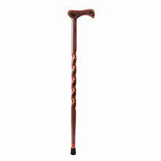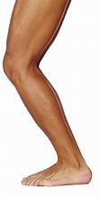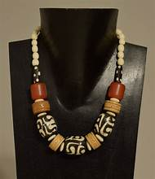
cane (gbough) back of leg (gege) African necklace (gbum)

gbough (stick/cane), noun: stick or cane for walking. Baba tôô gbough. Baba (grandpa) has taken the cane.
gbum (African necklace), noun: a necklace with large, colored beads. Melissa zer gbum sha iker. Melissa wore “gbum”
necklace.
gege (back of leg), noun: the back of the leg. Gege wam mula. The back of my leg is swollen.
gema (turn/turned), verb: to change direction. A gema ken iyan. He/she turned right.
gema ishima (repent), verb: to turn from old ways. A gema ishima a de asorabo na. He repented his sins.
gende (seizure attack motion), verb: to experience uncontrolled burst of electrical activity in the body. A gba;
hen inya shi ngu genden. He fell; and is moving like with seizure.
gende gende (rocky), adverb: when something moves in an unsteady or up-and-down manner. Mato ngu
yemen gende gende. The truck is moving in a rocky manner.
geng geng ( high-pitched/shrill), adj: of a sound that has a higher note than normal. Kwase gber imo a ikenge geng geng. The
woman sang with a high-pitched note. 2. Nancy gber icam geng geng. Nancy sang a hymn with a shrill voice.
genger (Tiv draw-soup), noun: tree with edible flower used in soups. Ruam doo sha genger. Fufu is good with
Tiv draw-soup.
ger (cheer; praise), noun: to make sounds or act in appreciation of another’s (others’). 1. Se ger er a ye iko yô. We
cheered for her scoring. 2. Se wa ger icam u sughun Aôndo. We sang a hymn of praise to thank God. Also: Ger ding (cheered loudly).
gera (arrogance), noun: a condescending way of behaving. Ieren you tese gera. Your behaviour shows
arrogance.
gera ge gera (unsteady; erratic), adj: displaying unsteady behaviour. Wankwase ngu eren gera ge gera. The girl is
acting in an erratic manner.
geraji, gyareji (garage), noun: a space where cars are kept. Ver mato ken geraji. Put the car in the garage.
gesa (brag), verb: to be boastful. Ta gesa. Brag about something.
gighgigh (calmly/motionless), adv: without moving. Tema gighgigh. Sit calmly/motionless/still.
gire (Tiv traditional clothing), noun: Tiv traditional clothing with black and greyish narrow stripes. A zer gire. He/she
is wearing the Tiv traditional clothing.
godo/bologo (blanket), noun: a woolen blanket used as cover sheet. Cir godo iyol. Cover yourself with a woolen blanket.
gom (cyst), noun: skin lump in the neck or body. Gom va m sha kwende. I grew a cyst on my shoulder.
gongol (pealed cassava), noun: the inside of cassava after peals removed. Sev due ken gongol. Reach the
cassava inside after pealing.
gôngur (trachea, throat), noun: part of the body through which food passes. Ruam kar ken gôngur. The fufu has
passed through the throat.
guda (better), adj: when something has greater value. Ka guda u zan sha mato a u zan sha ikyekye. It is
better to go by car than (to go) by bicycle.
gula (stale, of meat), adj: when meat is beginning to go bad. Inyam gula. The meat is stale.
gule (knee), verb: to take a knee in prayer. Gule anu er msen. Knee down to pray.
gum (young and strong), noun: of a young adult goat or lamb or cattle. Gum bua (young calf).
guma (laterite/red soil), noun: soil formed by prolonged weathering of rocks. Time inya due shin guma. Dig the
earth to reach clay soil.
gundu (trunk), noun: the trunk of an animal. Na orvesen gundu ivo. Give the trunk of the goat to the elder.
gungul (trunk), noun: the woody part of a tree on which branches grow. Gungul u kon kehe. The trunk of the tree is large.
gwa (fame), noun: to be widely known. Burna Boy ngu a gwa. Burna Boy has fame.
gwar (strand), noun: material that is thin and long. Gwar ice. A hair strand. gwar mough (cotton thread).

H
haa (pour; spill), verb: put in a container. Haa mngerem shin bokoti. Pour the water in the bucket.
haav (dwelling), noun: a place in which to live. M ngu a haav mbu tsan ker. I have a dwelling to live in.
haghelaiyol (anxious), adj: to be uneasy. Kam haghelaiyol. I am anxious.
halishon (hypertension), noun: disease brought about by high blood pressure. M ngu a halishon. I have hypertension.
hambe (hang), verb: to put on a hook. Hambe sha kor. Hang on the rope.
hange¹ (stuck), verb: cannot go in or out. Kusa hange ken ketako. The nail is stuck in the plank of wood.
hange² (need), verb: to desire something because it is necessary. Hangem u ma m ze Makurdi. I need to go to Makurdi.
hange hange (required; compulsory), adj: when something must happen. Ka hange hange u u kar ikaren man u
yem nongu utaan ye. You must pass the test to be promoted to 5th grade.
hanma (every), determ: all the individual members of a set of things. Hanma shie (every time); hanma kwagh (everything); hanma
ijiir (everywhere).
hanmô (any, anyone), determ: no preference between a collection of things. Alum shin mongol; me tôô hanmô cii.
Orange or mango; I will choose any.
har (hung), verb: put over the neck or shoulder. Har ikpa sha vande. Hang the bag on your shoulder.
haregh (path), noun: a passageway. Due haregh u gen yem. Leave by another passageway.
he(gh) (new), adj: something recently made or done; not long ago; not old. M yam mato u he. I bought a new car.
hedemasa (headmaster), noun: head of a school. Mr. Ger ka hedemasa wase. Mr. Ger is our headmaster.
heen (here), adv: a close position. Va heen. Come here.
hegen; higen (now), adv: at the present time. Higen u fa. You now know. (Now you know).
hemba doon (it’s better …), adj: when one thing better/nicer/more appropriate than the other. Bem
hemba itiav mbi nôngun. Peace is better than war.
hemba¹ (greater), adj: indicating something that is greater than another. Ter Aôndo hemba or. The Lord God is greater
than man. Hemban cii (greatest), superlative adjective.
hemba² (win), verb: to come first in a competition. Se hembe inumbe i futubol. We won the game of football.
hembe (break), verb: to crack open; to separate into pieces. Hembe ijikegh. Break an egg. See tem, applied to nuts
hemen¹ (lead; forward), adv: proceed. 1. Hemen se. Lead us. Verb. 2. Za hemen. Go forward (proceed/coninue).
hemen² (front), noun: farther from where one is facing. Tema ken hemen. Sit in front.
hen¹ (at), prep: used to indicate presence or near a place or tome. Hen ya wam (at my home).
hen² (learn, study), verb: trying to understand something. Hen takerada u ôron. Learn to read (a book). kwagh
henen (learning), noun.
hen³ (think), verb: to ponder on something. Hen kwagh u mgbe u tar. Think about the creation of the earth.
Derivatives from hen: hen kwagh (study), verb; hen sha kwagh (explore).
hen atô (between), prep: in the middle of two pints/sides. Va tema he atô ve. Come (and) sit between them.
henda (ride), verb: sit on a vehicle o an animal as you control its movement. Henda nyinya. Ride a horse.
hendan (argumentative), adj: to engage in argument. De kwagh hendan. Stop being argumentative.
Also: hendan kwagh (arguing with).
hengegh (cheek), noun; ahenge (cheeks), plural: side of the mouth. Wa kwaghyan ken henge(gh). Leave food inside the cheek.
hia (burn, hot), adj: A state of high heat or temperature. 1. Usu hiam sha ihôwe. I have burned my finger (verb) 2. Iyôgh kin hia.
This metal is hot. Compare: tsee (warm).
hiar (whirl wind), noun: a high tropical wind current. Hiar bugh tor. The whirl wind blew off the roof.
hide¹ (step back), verb: to step back. Hide jime. Step back (go backwards).
hide² (return), verb: come back from. Ade hide ken ya. Ade returned home. (Note: from wherever Ade was previously)
hide/hire jime (backup), verb: to go in the opposite direction or backwards. Hide jime Kamala a kar. Back up for Kamala to pass.
hime iyongu (contravene), verb: to come between warring parties. Paseto va hime iyongu. The Pastor came to contravene in
the dispute.
hingir¹ (become), verb: turn from previous stance. Iyough hingir ving. The house became quiet.
hingir² (turn), verb: run a spoon through nuts while being roasted. Hingir abun a de hie ga. Turn
the roasting peanuts so they don`t burn.
hir (Harmattan winds), noun: dry and cold Sahara Desert winds during dry seasons. Hir va. Harmattan winds
came (are here).
hire (protect, prevent), verb: to protect from harm. Hire itiough sha idyer i tom. Protect the head with a work hat (hard hat).
hoghol (narrow), adj: small passageway. Gbena hoghol. The road is narrow. Ngu hogholoo: (It`s narrow).


Road’s wide (gbenda gbanger) narrow (hoghol)

hôm (laughable, funny), adj: something said that makes one o laugh. Kwaghôron hôm; ior se. The
talk was funny; people laughed. Kwaghhômon (joke), noun.
hôm (sprout), verb: to bring out shoots by a plant. Kon hôm. The tree has sprouted. Ihômon (sprouts). Hômon,
(sprouting). Example: Vambe ngu hômon (the silk cotton tree is sprouting).
hôn (trap), verb: to set a trap. A hôn iyough; ihev gba sha min. He/she set a trap; the mouse got caught on it.
hondo¹ (whistling sound), noun: sound made by blowing through pursed lips. Tungwa hondo. Make a whistling
sound with lips.
hondo² (shave), verb: take hair off a part of the body. Hondo itiough you. Shave your head.
hondo³ (handle), noun: wooden part of a hoe or axe in which blade is inserted. Hondo ijembe. An axe`s handle.
hongol (kernel), noun: the hard piece inside a fruit. Hongol mzembe. The African pear kernel.
hongoloo (friendly), adj: in a close and pleasant relationship. Dooter man Kaidan mba hongoloo. Dooter and is friendly to Keidan.
hôô (rot), verb: at a stage of decay. Ayaba hôô. The banana rotted. Ihôôn, (rotten part),
hor¹ (pointy), adj: describing a sharp point. Ivaan hor. The arrow is pointy. 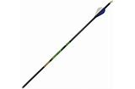
pointy (hor)

hor² (sharpen ), verb: to make a sharp point. Hor nuro tumba inyam; er cire. Sharpen the skewer to make suya.
hôtev, hwatev (hotel), noun: a place to stay or eat. Hwatev u Gyado taver ishe. Gyado Hotel is expensive.
hough (cold), noun: illness that causes soughing. Hough va m. I have a cold.
houghbar (tuberculosis), noun: illness caused by insulin deficiencies. Ngu a houghbar. He/she has
tuberculosis.
hua (wear), verb: put on clothing. Hua riga. Wear a shirt.
huan (quieten),verb: becoml quiet or calm. Ayôôso huan ving. The noise quietened a lot (tremendously).
huer (iguana), noun: a swamp lizard. Huer unde sha kon. The iguana climbed the tree.
hula (to sound), verb: making a massive sound. Mato hula. The car sounds. See ihulan (sound), noun.
hule (meander; fold), verb: to twist or fold. Hule ikondo. Fold the clothing.
hulông (heron), noun: a white bird (larger than a cattle egret that makes a “hulông” sound as it flies. Hulong tema sha itiough ki
kon. The heron sits on the top of the tree.
hum (), noun:
huma (smell), verb: not to have a pleasant odor. Inyam i hôôn huma. Rotten meat smells. See ihuma (smell), noun.
humbe (air), noun: a mixture of gases. Fehe humbe pir acibavbav. Blow air to quench the lamp.
hume (anesthetize), verb: to put in a state of temporary unconsciousness. Hume un cii man ipaven ye. Anesthetize
him/her before surgery.
hunda (door, entrance), noun: the point of entry. Bugh hunda. Open the door.
hunde (become mad), verb: to develop mental illness. Ngu hunden. He is getting mad. (angry as if mad). C.f., ihundugh (madness),
noun.
hunde (drunk), adj: when one loses control of behaviour from excessive alcohol consumption. See ihundugh (madness).
hundu (muddy), adj: water containing mud. Ijôr hundu. The well is muddy.
hungur¹ (forget), verb: not remember. M hungur fon wam. I forgot my phone.
hungur² (sniff), verb: to inhale air through the nose. Hungur mkulem maa huma doo yô. Sniff the oil to find
out if it smells good.
hungwa (descend), verb: to move to a lower level. Hungwa shin inya. Come down (the ground).
hur¹ (friendship), noun: a liking before people. May kôr hur vea Tay. May is in friendship with Tay.
hur² (termites/alates), noun: colon of flying insects that shed their wings in water. Ver mngerem kura hur. Get
termites with a bowl of water.
huror (friend), noun: someone another person likes. Ayo ka huror wam. Ayo is my friend. Ahuraior, friends, plural noun. See ikar
(friend).
hurugh (turn around), verb: change direction and go the opposite way. Hurugh hide yem. Turn around and go back.
huwa¹ (pathway), noun: a narrow path or passage. A er huwa u zan shin ijande. He made a path to the swamp.
huwa² (gluttonous; greedy), adj: taking more than one’s fair share. Oko wa huwa. Oko is gluttonous.
hwa (finger snap), verb: a clicking sound made by rubbing the thumb and another finger in a snap. Ta hwa.
Make a finger snap. (Done to beckon a dog or wish someone bad luck, among the Tiv people, usually by sounding the words kwa kwa.)
hwatev, hôtee (hotel), noun: where travelers stay and eat. Hwatev u Tofi doo ishe. Tofi Hotel is inexpensive.

I
i (it), pron: the thing spoken about. Imura kôr ivo; na i mngerem. The goat is thirsty; give it some water.
ian (space; permission), noun: space that can be filled with something. Ian kera ngi i ior vea tema ga. There is
no space (room) for any more people to sit.
iaven (pace), noun: a measure of distance between two points or positions. M dondo Isa iaven er mita mom nahan. I followed Isa at
a pace of about one meter.
iba (sack), noun: woven from straw or tough grass. Haa suabin shin iba. Pour soybeans into the sack.
iber (porridge), noun: cooked ground millet flour. Ma iber. Drink the porridge.
ibo (fault), noun: to own up or take responsibility for a wrongdoing. Ka ibo yam: It is my fault. na ibo (fault), verb.
Ibo (Igbo people; language), noun: ethnic group mostly found in Nigeria. Kalu ka or Igbo. Kalu is an Ibo man.
ibôr (underpad, Tiv mawashi, Hausa’s bende), noun: a kind of loin cloth warn to protect
private parts. Or wa ibôr. The man has on a Tiv mawashi.
icam (hymn), noun: a religious song of praise to one’s god. M wa icam u wuese Aôndo. I sang a hymn to praise God. Atsam, plural
noun.
ican (lack), noun: not having enough of needs. De ican i vaan. Stop crying for lack of things.
icongu (circumcised), adj.: describes one who (something which) is circumcised. Ivo ne ka icongun ivo. This is a circumcised goat.
icombo (navel), noun: the knotty healing in the front center of the body where the umbilical chord was cut at birth. Icombo na kehe.
Her navel is large.
icur (knot), noun: made when the ends of two ropes are tied together. Ta icur kor u lihe. Tie the knot to make the rope longer.
ieren (act), noun: something that one does. Ieren i dedoo. A good deed. Aeren (acts), plural noun. Compare,
“Aerenakaa a Mbaapostoli” (Acts of the Apostles).
iember (happiness; joy), noun: a state of being glad or pleased. Se mba a iember er ne ve nahan. We are filled with
happiness that you came.
iengem (shininess or radiance), noun: the property of having lustre or shine when something reflects light. Iengem i iyough ki
daimon nam ishima i veren. The shininess of the diamond metal caught my attention.
ifam (frog), noun: animal that can live on land and water and has long leaps. Ifam tsuwe mita pue. The frog
jumped ten meters. (Note: a toad (ishôhô), is not a frog)

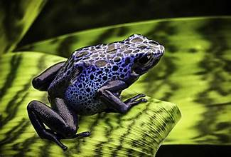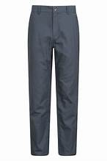
frog (ifam) trousers (ifo)

ifer; iferkwagh (sin; wrongdoing), noun: something that is not right to do. De ifer i eren. Stop
sinning/wrongdoings. Aferakaa (sins), plural noun.
ifi (river), noun: a largebody of water. Ifi u Benue. The Benue River. Uifi (rivers), plural noun.
ifo (trousers, pants, shorts), noun: short or long trousers worn by men and women. Huwa if. Wear pants.
igandenor (adult), noun: a grown-up person. Amide ka igandenor. Aminde is an adult. Uigandenmbaiorov,
(adults), plural noun.
igbanger (width), noun: how wide something is. Igbanger na ka sentimita pue. Its width is ten centimeters.
igbo (bullet), noun: the piece that leaves a gun when shot. Wa igbo ken gbuuka. Insert the bullet into the gun.
Igbo (language), noun: language spoken by the Igbo people. M fa zwa u Igbo ga. I can’t speak Igbo (language).
igbudu (road; highway), noun: a road for cars and trucks. Umato mba karen sha ingbudu. The vehicles are
passing on the road.
igbur (log-seat), noun: a long “seat” made of logs of wood used for sitting in class or church. Mbayev tema
sha igbur. The children sit on the log-seat. Agbur (log-seats), plural noun
igirigidogo (train), noun: many coaches that travel on rails. Igirigidogo tôô ikav. The train is carrying goods.

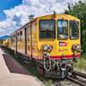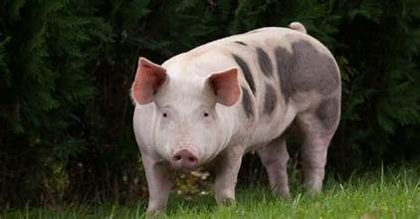
train (igirgidogo) pig (igo)

igirigi purugh (airplane), noun: airplane that carries people or goods. M nyôr igirigi purugh. I entered the airplane.
igô (larva), noun: found on tall tropical trees. Igô ngi sha ikon. The larvae are on the trees.
igo (pig), noun: an animal with short legs and a long nose or snout. Igo i Tiv i ye akaa a ndôhol ishima. The Tiv
pig devours nasty things.
igôr (steep hill), noun: a hill with steep slopes. Zege mato faityô u unden igôr la ga. The big truck couldn`t climb the steep hill.
igungu (hill), noun: agungu (hills, pl), noun: a slow-rising hill. M unde igungu je m vôr. I climbed the hill so
much that I am tired.
iguve (eagle), noun: a large bird with a hooked beak. Iguve i nengen dedoo. The eagle has good eyesight.
ihambe (wasp), noun: a flying insect that can sting. Ihambe tam. I was stung by a wasp. ahambe, plural noun.
ihembeato (naughtiness, lack of listening), noun: not listening to others. Ihembeato i nior yô NOAA yôô
zegeahumbe kpa ve yevese ga. Due to their inability to listen the people did not heed NOAA`s hurricane warning and did not flee.
ihi (nut), noun: a fruit with edible kernel inside a hard shell. Ihi ne i hôô. This nut is rotten. ahi (nuts), plural noun. Examples of nuts
are ground nuts, tiger nuts, etc.
ihinga¹ (grey fox), noun: an animal that looks like a dog but has a bushy tail; can burrow holes in soft soil and
feeds on plants and small animals. Ihinga ye abun. The grey fox devours peanuts.
ihinga² (nose), noun: part of the body used for sniffing and inhaling. Ihinga yam cir.
My nose (nostril) is clogged. Ahenga (noses), plural noun.
iho (slow antelope), noun: a kind of antelope that is slower than a deer. Azer wua iho. Azer killed a slow antelope.
ihô (knife); ahô (knives), plural noun: used for cutting things. Ihô ne ese. This knife is sharp.
ihom (conflict), noun: a serious disagreement with someone. Mbawav venda ihom a Mbazaka. Mbawav wants to avoid conflict with
Mbazaka.
ihônguhar (toe), noun: one of the small parts of the front end of the foot. Ihônguhar u tamen. The big toe.
Ahôrangahar (toes), plural noun.

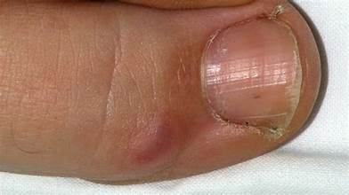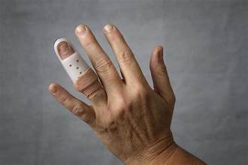
toe (ihônguhar) finger (ihowe)

ihoron (tip, sharp tip), noun: the pointy part of a skewer or needle. Ihoron mba asaegh kumam. The sharp
tips of the thorns pricked me.
ihôvonov (trash or garbage), noun: the rubbish o things no longer needed. Kula ihôvonov haa kera. Pick up the trash (and)
throw it away.
ihôwe (finger), noun Ahovegh (fingers), plural noun: one of the small parts of the front end of the hand. Ihôwe u
tamen. The thumb.
ihuma (smell), noun: the fumes come off certain liquids. Ihuma i Tabu doo. The smell of Tabu is nice.
ihuma¹ (Tiv brown bean); ahuma, plural noun: Ishange ihuma. The single Tiv brown bean.
ihuma² (smell), noun; huma, verb: huma vihi (bad smell/stench)
ihundu (dust), noun: particles of sand and earth in the air. Hir va a ihundu ngee. The harmattan brought a lot of dust.
ihundugh (madness), noun: mental illness that may lead to “crazy” acts. De ihundugh (yough). Stop your madness.
ihungwa (pit), noun: what is dug from the ground. Time ihungwa. Dig a pit.
ihura (hole), noun: an opening in something. Riga wam ngu a ihura (My shirt has a hole).
ihuugh (shrub), noun: a small leafy tree. Alôm yav ken ihuugh. The rabbit is sleeping in the shrub. ahu (shrubs), plural noun.
ihwa (hour), noun: a measure of time. Kohol mo ihwa imom jighjigh. Meet me in exactly one hour.
ii¹ (bury), noun: to put someone away after they are dead. A za ii ter na. He/she has gone to bury their father.
ii² (steal), verb: to take and claim what is not yours. Or ii ikeke. The man stole a bike.
ijande (swamp or pond), noun: a pond or swampy area. Ijande ngi a mngerem. The pond has water.
ijem (steep slope), noun: steep slope of a hill or stream bank. Ijem za. The steep bank is deep.
ijembe (axe), noun: used for cutting or splitting wood. Ijembe ngi a hondo. The axe has a handle.
ijen (hunger), noun: caused by lack of food. Ijen gba ken tar Tiv (There is hunger in Tivland)
ijen kôr (hungry), adj: having to be without food. Se ya kwagh ga, nahan ijen kôr se. We didn’t eat, so we are hungry.
ijer [sputum; azer spits plural noun]: saliva from the mouth. Ta ijer. Force out sputum.
iji¹ (egg), noun: where young animals (E.g., birds, reptiles) hatch; aji (eggs, plural noun). Iji hembe. The egg broke.
iji² (fly), noun: an insect with two transparent wings; house flies carry germ. Also, iji (flies), plural noun.
Imunan kpa ka iji. The mosquito is also a fly.
ijiir (place), noun: space or area which can carry or occupy something. Ijiir tom. Workplace.
ijingi (glass, mirror), noun: a clear or coated substance used in windows and in utensils. 1. Mato ngu a ijingi sha hemen. The car has
a glass front/screen. 2. Kenger ken ijingi. Look in the mirror. ajingi (glass, mirrors), plural noun.
ijir (accusation), noun: what one asserts has happened to them. Me za a ijir ken koti. I will take the
accusation to court.
ijir ôron (judgment), noun: the outcome of an accusation. Jooji na ikar sha ijir ôron. The judge rendered a
judgment.
ijôr (well), noun: a hole or pit that brings forth water. Ijôr za. The well is deep. Azor (wells), plural.
ijôugh/ijôv (witch, non-human person/life) Ngôijôv (a wicked witch); (c.f., angôijôv).
iju (fist): you make a fist by folding all fingers. Ta iju. Box using fist. Azu (fists), plural noun.
ijubu (sock), noun: one piece of clothing put on the foot before a shoe. Wa ijubu. Put on a sock. Azubu (socks), plural noun.
ikaa (prophesy; prediction),noun: offering a theory or forecast about something. Ikaa kôr. The prediction has
come true. (This is an unscientific statement.)

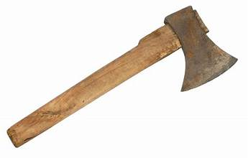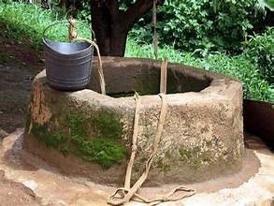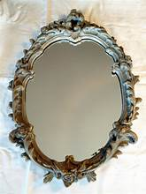
axe (ijembe) well (ijor) mirror (ijingi)

ikaan (gossip), noun: hurtful rumor about someone. Ikaan bee. It is the end of gossip (See angereke).
ikambe (crab, spanner): an animal with a hard shell and eight legs; can be eaten for food. Ikambe soo
mngerem. The crab likes water.
ikamegh (brick, block), noun: akam (bricks, blocks), plural. Made to be used for building. Ta akam; maa
iyough. Lay blocks to build a house.
ikange (guinea fowl), noun: a large flying bird with black and white feathers. Ikange ta aji. The partridge laid eggs.

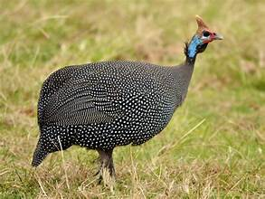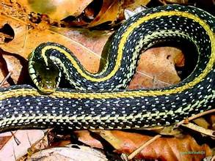
guinea fowl (ikange) garden snake (ikarem)

ikar, huror (friend), noun: someone you have a close relation with. Rhoda ka ikar u Mer. Rhoda is Mer`s friend.
ikarem (green, non-poisonous snake), noun: Ikarem wase Tiv ve per Ifi u Kongo. Ikarem helped the Tiv people
to cross the Congo River.
ikaren (test, examination), noun: a tool to assess learning. M kar ikarem. I passed the test.
ikeke (bicycle), noun: a vehicle with two wheels. Henda ikeke za makeranta. Ride a bicycle to (to go to) school.
ikembegh (bark), akembe (barks), plural noun. Bugh ikembegh ki kon tsen. Peel the bark of the tree to dry it.
ikenge (voice), noun: the sound made when talking or singing. Ikenge i taver. A high voice.
iker (front of neck), noun: the front of the neck of a mammal. M nenge a gbum sha iker. I saw the “gbum”
bead on the neck.
ikese (busket), noun: a container made by weaving material together. Haaa atsaka shin zege ikese. Place
potatoes in the large basket. Akese, plural noun.
ikeve (coconut), noun: a brown nut that contains liquid used for food. Hembe ikeve ma zar na. Crack (break)
the coconut to drink its juice.
ikô (forest), noun: wooded area with trees and brush. Dwem ngu shin ikô. The wolf is in the forest. Ako, plural noun.
iko¹ (score, goal); ako, plural noun: the point made by a team or player during a game or contest. Nigeria hemba
inumbe i futubol sha ako atar. Nigeria won the game of football (soccer) by three goals.
iko² (care, caution), verb: serious attention to something. Wa iko sha akaa eren a dedoo. Take care to do good
(things). Also: wa iko a iyol you (take care of yourself).
ikoiwan (consideration; preparedness), noun: careful thoughts. Tese ikoiwan hen ior mbagen(nev). Show
consideration for others. Also: ikoiwanga (unpreparedness)
ikôm (barren, adj.): unable to give birth. 1. Ikôm kwase. A barren woman. 2. Ngu ikôm. She is barren.
ikom/orkpen (corpse); ikom (corpses), plural noun: a dead human body. Ve wa ikom shin akwati u orkpen.
They put the corpse in the coffin.
ikôn (algae or seaweed, pond scum), noun: seaweed that is usually found on the surface of ponds. Ikôn cir sha
kwav u ijande. The seaweed covered the surface of the pond.
ikondo (apparel, clothing), noun: a general name for all kinds of clothing. Zer ikondo i abeda. Wear the “abeda” clothing.
ikônough (chair, couch), noun: a kind of furniture for sitting in. Tema shin ikôn(ough). Sit in the chair/couch. Mkônom, plural noun.
ikôôr (yellow shell snail), noun: snail that lives in swamps and damp areas. Igbende i ikôr i lihe. The shell of
the yellow shell snail is long.
ikooso (hip); akooso (hips, pl), noun: part of the body between the waist and the leg. Ikooso ngi nyion mo. My hip hurts.
ikôvogh (shoe), singular noun: worn to protect either foot. Akôv (shoes), plural noun. Wa akôv yar tom. Wear your shoes to work.
ikpagher (good luck charm), noun: an object made by man which is expected to bring good luck or save you, if you carry it. Aluer u
zer ikpagher she wegh yo u hemba ayem. If you wear the good luck charm on your hand, you will win the running race.
ikpam (antelope), noun: a kind of deer that looks like a cow. Ikpam ngi a akor. The antelope has antlers.

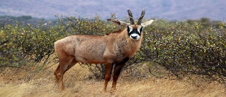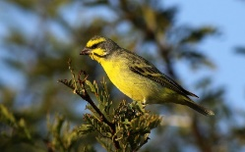
This Photo by Unknown Author is licensed under CC BY-SA
This Photo by Unknown Author is licensed under CC BY-SA
antelope (ikpam) ikpenger (African song bird)

ikpe (bottle), noun: a container for liquids usually made of glass or plastic. Akpe (bottles), plural noun. Ikpe
iv a zar u alum. The bottle is filled with orange juice.
ikpenger (African songbird), noun: a yellow-striped singing tropical bird. Ikpenger ngi gberen imo hanma pepe.
The African songbird sings every morning.
ikpine (thorny African berry), noun: bark used as a dye and floor strengthener. Ikpine ngi a asagh. Ikpine has thorns.
ikpur¹ (grass mat), noun. Tume ikpur kase kwa. Weave the mat to make a barrier or fence.
ikpur² (gathering/grazing plain), noun: field used by a group of animals for grazing or resting. Ibua yav ken i
kpur. The cattle are sleeping in the grazing plain.
ikuleke (corn, maize), singular, plural noun: vegetable that grows on a part of a plant. jiir ikuleke mbayev vey
a, cook corn (maize) for children to eat.
ikume¹ (python), noun: a large and powerful snake that kills its prey by crushing it. 1.Ikume ka iyô. The
python is a snake. 2. Ikume wua kwantera. The python killed a deer.
ikume² (rainbow), noun: a band of light of different colors seen in the sky. Ikume due sha kwavaôndo. The
rainbow can be seen in the sky.

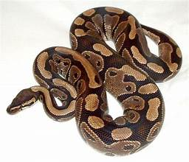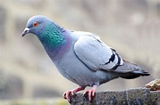
python (ikume) pigeon (ikungugh)

ikumen (thundering): refers to deep and loud sounds, as in thunder. Ikumen i wura za ken ato. The
thundering from the rainstorm was deafening. Adjective.
ikumen wura (thunderstorm), noun: a heavy thundering rainfall. Ikumen wura nôô iyange jimin. The
thunderstorm fell all day.
ikumior (crowd); akumaior (crowds), plural noun: A large group of people together. Ikumior zua sha Gboko u
sughun Tarka. The crowd gathered at Gboko to greet Tarka.
ikuna (partridge), noun: a short-tailed small bird with brownish plumage. Ikuna ngi yan wua. The partridge is eating guinea corn.
ikundun (stale, inactive), adj: something that has been left unused for a long time. Ikundun iber. Stale porridge.
ikungugh (pigeon), noun: a bird that looks like a dove usually friendly to humans. Ikungum ki yan wua. The pigeon is eating corn.
ikuran (partridge), noun: a medium sized bird that flies short distances. Ikuran ka i wa iya shin inya. The partridge
builds a nest on the ground.
ikwembe (clam shells), plural noun: The hard part that covers the soft body of a clam. U faityô u tôôn
kwembe er ka tswekeli nahan. You can take (use) a clam shell as a spoon. Kwembe (clam shell), singular noun.
ikya (gorilla), noun: a large ape found in tropical Africa. Ikya i ye iyough. A gorilla consumes yams.
ikya kôr (cramp), noun: sudden muscle spasm or tightening up in your feet or legs. Ikya kôrom m; nahan, m faityô u
zenden ga. I had a cramp; so, I could not walk.
ikyarakya (grey monkey), noun: found in cave dwellings and trees of tropical hills. Ikyarakya ya iyough. The
grey monkey devoured the yams.
ile (dark, dirty), adj: the state of little or no light; approaching a black colour; dirty. 1. Tugh ile. It is a dark night.
2. Ave na ile. He has dirty hands.
ilihen (length), noun: how long something is. Ilihen i gambe kuma mita ateratar. The length of the bed is six meters.
ilyaku (canary), noun: a small yellow songbird often kept as a pet in a cage. Pase ilyaku a yem. Free the canary to go.
ilyu (call device), noun: little Tiv wooden call device. Kuha ilyu ior ve va. Drum the Tiv call device for people
to come. Archaic, noun.
imaan (building, structure), noun: the whole structure of a building. Imaan i sha akam a inyaagh (shin akam a
sementu). A mud brick (or cement-bricks) structure.
imande (leprosy), noun: a disease of the skin. A gba imande. He/she is plagued by leprosy.
imanden (harmer or mallet), noun: something with which you force a nail or peg into another thing. Mande kusa sha imande. Hit the
nail with a harmer.
imanger (pride), noun: thinking too highly of oneself. A rumun ibo ga shaciu imanger na. He/she never
accepts faults due to his/her pride.
ime (darkness), noun: lack of light. Ime ka i va shie u iwanger i lu ga yô. There is darkness when the light goes out.
imeen (temptation), noun: a desire to do something wrong. Try not to fall into the temptation to lie. Nôngo
de gbe ken imeen i eren aie ga.
imemegh (bell), noun: device that rings to warn. Agogo gbidye imemegh. The clock sounded the bell.
imenger (lamp), noun: helps us get rid of darkness. Tsar imgenger tugh ôr takeda. Light the lamp at night to
read a book. amenger (lamps), plural noun.

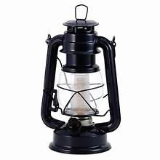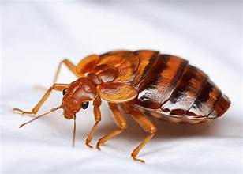
lamp (imenger) bedbug (imon)

imo¹ (song), noun: what you sing with music or melody. Golozo gber imo. Golozo sang a song.
imo² (sound), noun: made when the cords in the throat or some other strings (particles) vibrate. Se ungwa imo i kwen. We
heard the sound of the gong.
imon (bedbug, sing. noun): insect with a painful bite found in beds and mattresses. Imon nyuma or kura
awambe. The bed bug bit a person to suck up the blood. imon (bedbugs, plural noun).
imôngo¹ (together), adv: with each other. Se mba zan imôngo. We are going together. Imongo teman (sitting together).
imôngo² (social gathering), noun: Tema imongo. Have a social gathering.
imor, imulan (swelling), noun: an abscess that has swollen. Hura kumam, kpa m dugh ga; nahan, m zua a
imulan. I had a splinter, but I did not remove it; so, I got a swelling.
imotaver (loudness), noun: the degree of how loud the sound is. Wa cam a imotaver. Sing the hymn with loudness. Compare: a
ikenge i taveri
imunan (mosquito), noun: a small insect that causes malaria. Imunan nyuam. I had a mosquito bite. imunan
(mosquitoes), plural noun.
imusan (change), noun: the small amount one gets back after offering a large bill at sale. M yam kwagh sha naira ateratar. Aluer m
nau kwa u naira pue yô, imusan yam k naira unyiin. I bought something for six naira. I gave you a ten naira note (bill), my change is four naira.
indyer¹ (beard), noun: a growth of hair on the chin of a person. M soo u hondon indyer yam. I want to shave my beard.
indyer² (Tiv wooden device), noun: large wooden call instrument). Kuha indyer ior ve zua. Play the Tiv call device for people to meet.
ingbe (nut), noun: a device used with a bolt to help secure bicycle or automobile parts. Kange ingbe i taver. Tie the nut securely.
ingeegh (number), noun: a quantity of something. Ingeegh ki ior kuma dubu môm. The number of people reached one thousand.

inima (bat, umbrella), noun: 1. An animal that looks like a mouse but has wings to fly. 2. Something that protects us from rain. Inima
ngi purugh (the bat flies). An umbrella can fold (inima ka I faityo u hulen. anema (bats, umbrellas), plural noun.
inja (behavior), noun: a way of acting. Nana ngu a inja I dedoo. Nana has good behavior. anza (behaviors),
plural noun. injaibo (bad behavior, misbehavior); anzaabo (misbehaviors), plural noun
injin (engine), noun: part/unit of a vehicle that makes it work. Mato ngu a injin. Tha car has an engine. injin
woyel (engine oil). injinia (engineer).
inki (ink), noun: liquid in a pen that can mark paper for writing. Inki i nyian. Red ink.
inumbe (game, sport), noun: an organized sport; in a contest, one team tries to win. LHS hemba inumbe i
futubol. LHS won at the game of football.
inuun kwase (young woman), noun: Jeni vese hingir inuun kwase (Jenny has grown into a young woman).
Anuun a ukase (young women), plural noun.
inya (earth, soil, ground), noun: earth on which animal live and plants grow. Mngerem haa inya. The water spilled on the ground.
inyam (meat), noun: parts of cattle used for food. Inyam ivo. Goat meat. Inyam bua. Cow meat (beef). Inyam toho (wildlife meat, like
deer or rabbit meat). Inyam igo (pork). Inyam i waniyôngu (lamb meat). Inyam kwembeh (clam meat).
inyamikume (beast), noun: wild powerful and ferocious animal. Begha ka inyamikume. The lion is a beast.
inyam tsar (squirrel), noun: animals that live partly on trees and on the ground. Inyamtsar ka aniyam u unden
kon u lun a tsa yugh yugh. A squirrel is a small climbing animal with a fluffy tail.
inyaregh (money), noun: used for buying things. Nam inyaregh m yam akôv. Give me money to buy shoes. Orinyar (person with a lot
of money or a rich person). Torinyar (lover of money). Lit.: King of money.
inyarev¹ (trash), noun: things no longer needed or rubbish. Haa inyarev kera. Throw away the trash.
inyarev² (farm/forest flies), noun: very small annoying insects. Inyarev mbi nyôron mo ken ato. The forest flies are entering my
ears.
inyata (nut butter paste), noun: nut butter paste containing ground peanuts, pepper, salt, and seasoning. Inyata tsee ken zwa. Nut
butter paste is spicy (in the mouth).
inyian (diarrhea illness), noun: disease of increased bowel movement. Inyian kôrom. I am suffering from diarrhea.
inyigh (tooth), noun: bony part of the mouth used for chewing. Inyigh yagh ki tsongol. My tooth is getting loose. anyi (teeth), plural
noun.
inyom (year), noun: twelve months make a year. Inyom imom. One year is twelve months. Anyom (years), plural noun.
inyon (bird), noun: an animal with wings; some birds can fly. Atii ka inyon. A dove is a bird.
inyon bua (cattle egret), noun: white bird found near herds in Africa and can perch on the cattle as they move. Inyon bua tema sha
itiough ki bud. The cattle egret sits on the head of a bull.

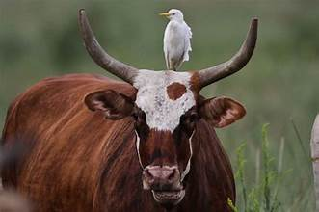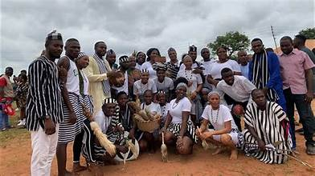
cattle egret bird (inyon bua) people (ior)

ior (people), noun: many men and women. Ior nenge. People saw. Also: Ior wuese (people have shown gratitude/are grateful); ior
rumun (people have agreed); ior ember (people are happy); ior puu (people disparaged, dismissed); ior tim (people ’ve been
destroyed); ior wa kwagh (people have advised); ior doo (people are good); etc.
ipaven (surgery), noun: an operation usually on an animal. I wam ipaven. I am scheduled for surgery (They have scheduled me for surgery).
ipusu (uncircumcised), adj.: not being circumcised. Wan u Amadu ngu ipusu. Amadu’s child is uncircumcised.
ipusugh (peal, rind), singular noun; Apusu (peals, rinds), plural: Na iyôngu ipusugh i ya. Give the lamb the rind to eat.
isha¹ (necklace), sing. noun; asa (necklaces), plural noun: a string of beads on a string. Har isha sha iker. Wear (hang) the necklace
on your neck.
isha² (gizzard), noun: digestive organ of a bird that grinds food for further digestion. Mba ye isha i ikegh. A chicken’s gizzard is edible.
ishan (star), noun: one of many stars in the heavens. Iyange kpa ka ishan. The sun is also a star. Asan (stars), plural noun.
ishange¹ (grain), noun: a small seed or piece of rock or sand. Ishange kwagh or ishankwagh (grain of thing).
ishange² (seed), noun: part of a plant that can be sown to produce new plants like the first. Ishange i tematu.
A tomato seed. See sam (seeds), plural noun.
ishase, shase (cashew), noun: a curved nut that grows on the fruit of a cashew tree in the Tropics in Africa and South
America. Ishange i ishase ngi a mkulem. The cashew nut has oil. asase (cashew trees), plural noun.
ishe¹ (eye), noun: the part of the body that makes animals see things. Kusu ishe imom. Close one eye. See
ashe (eyes), plural noun.
ishe² (cost/price), noun. Ishe na ka nena? What is the cost/price of it (its cost/price)?
ishemberkwagh (alphabet): a letter of the alphabet. See asemberakaa, plural noun. A, b, c, d, … z ka
asemberakaa (letters of the alphabet).
ishima¹ (heart), noun: a part of the body that pumps blood to other parts. Ishima ngi tan kwe. The heart is
beating. See the following idiomatic expressions:
- Wa ishima (take heart, gain courage)
- M wa ishima (I have gained courage)
- ishima sule ( is calm)
- Ishima ta kwe (pounding heartbeat): sudden uptick of heartbeat rate after a bad news or stressful event.
ishima² (will, mind), noun: feeling that seems to come from the heart. Ishima na (his/her will); dooshima
(love).
Also, see:
- msur ishima (comfort)
- ishimaimôm (truthful)
- ishimataver (encouragement)
- na ishimataver (encouraged)
- I er ishima you (let your will be done).
ishimavihin (anger), noun: when one has a feeling of displeasure, hostility, or disgust. M kende imo (yam) sha
ishimavihin. I raised my voice in anger.
ishiôr¹ (betrothal), noun: one who courts a woman with intent to marry. Dan ka ishiôr i Biddy. Dan is the
betrothal of Biddy.
ishiôr² (courtship), noun: the act of courting. Ishiôr (kwase) ngi zan doon. The courtship is going well.
ishiva (Tiv draft game), noun: a draft game played between two people. Wan hemba ishiva. The son won the
Tiv draft game.
ishô (clear, absolve), verb: to find (someone) blameless or not guilty. A ya ishoô sha ijir na. He/she was
acquitted in his/her trial.
isho (vomit), noun: the material thrown up from the stomach. A suwa isho a awambe shamin. He/she
threw up vomit with blood in it.
ishôhô (toad), noun: an animal that looks like a frog but has a bumpy skin and short legs. Ishôhô ngi tse sha
tar; ifam tse shin mnger. A toad lives on land; a frog lives in the water.
ishoho (tigernut(s), noun: tiny root vegetables that are starchy and chewy; contain much iron. Tiv mba lee
ishoho. The Tiv plant tigernuts.
ishôm (matchet), noun: has a long blade used for cutting grass or shrubs. Paa toho sha ishôm. Cut grass with a
matchet. asôm (matchets), plural noun.
ishondoke (small black ant(s), sing, pl): little black ants found in Nigeria, West Africa. Ishondoike i
nyom (sôôn). The black ant bites (stings).
ishor (dance move), noun: moving with the musical rhythm. Vine ishor. Dance.
ishoribo, kwaghbo (sin, trespass), noun: something wrong that one now recognizes they have done. Doo u
eren ishorbo ga. It is not good to sin.
ishu (fish), noun: a water animal that has gills for breahing. Jiir ishu. Cook (some) fish.

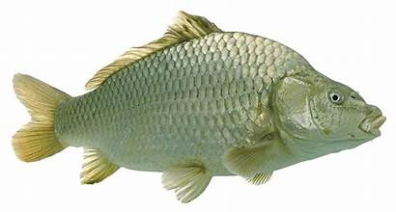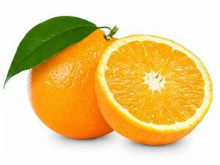
fish (ishu) fruit (itiamegh)

ishughun (thankfulness, greeting), noun: Tese ishughun shie u u ngohol iyua yô. Sow thankfulness when you receive a gift.
ishwa (benniseed, sesame seeds), noun: plant with small seeds that are used for food. Seer ishwa sha
iueinyam. Add benniseed to meat soup.
itendezwa (testament; promise): Bible narrative of a promise. Itendezwa i Aôndo. God`s promise.

iti (name), noun: what an object or person is known by. Iti you er ana? What is your name? iti yam (my name):
Iti yam er … (My name is …).
itiamegh (fruit), noun: some trees bear fruits that may be edible. Itiamegh ki mongol ki nyian. The mango fruit is red.
itiav (battle; war), noun: when parties engage in fighting. Yosua hemba itiav. Joshua won the battle.
itiaven (height), noun: how tall someone is. Itiaven i or la kuma mita mom man tion. The height of that man
is one and one-half meters.
itiegh (large pot), noun: a container made of metal or earth used for cooking. Some large pots may be used
for water storage. Jiir iyough shin itiegh. Boil the yams in a pot.
itieku; ityeku (ocean), noun: a large collection of water. M per Itieku i Atelantika sha igirigi purugh. I crossed
the Atlantic Ocean in an airplane.
itiev, sule (farm), noun: a large area to plant crops and vegetables. Orkuma ngu shin itiev. Orkuma has gone to the farm.
itiom (something to do), noun: an act to be performed. Wanye ne ze itiom. This child accepts being sent to do something.
itiough¹ (head; top), noun: part of the body containing brain, eyes, mouth, and more. 1. A cir idyer sha itio(ugh).
He/she put on a hat. 2. Inyon tema sha itiough ki kon(ough). The bird sits on top of the tree.
Itiough ki nanden (headache). Itiough ki ya (part of the village where the house of the head of the village is found.

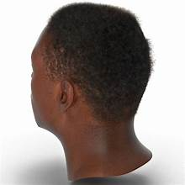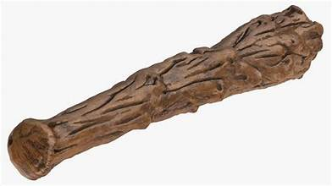
head (itiough) club (ityumbu)

itiough² (chapter), noun: the major parts of a book. Bugh takeda itiough ki sha ateratar. Open the book chapter six.
itumbe (hut, shed, shack), noun: a place to store tools and things. Haa akôr shin itumbe. Pu the yam
seedlings in the shack.
itungu (large stream pond area), noun. Itungu i Aku ngi a ishu shimin. The Aku stream pond has fish in it.
ityô (under; bottom), prep: the lower part of something. Shin ityô gambe (gayô ikônough). Under the bed (or couch).
ityôndo (glowing splint), noun: a piece of wood that has fire on it. Pir usu sha ityôndo. Put out the fire on the glowing splint.
ityônguhar (heel, back of foot), noun: M tôndo ivav ken ityônguhar. I have a cut on my heel.
ityu (smoking pipe): a device used for smoking tobacco. Wa taav shin ityu. Fill the pipe with tobacco.
ityumbu (club), noun: huge stick for defence. Tôô ityumbu wua iyô. Take the club to kill the snake.
Atumbu (clubs), plural noun.
ityundugh (a boil), noun: an abscess on the skin. Ityundugh mula un. He/she has a boil. atundu, plural noun
iuwe (soup), noun: made with water meat or vegetables and seasoning. Ya ruam sha iuwe i Egusi. Eat fufu
with Egusi soup.
iv¹ (full), adj: fill so there is no space available. Iya av iv; me kera faityô u yan kwagh ga. My stomach is full; I
cannot eat any more.
iv² (theft): when one takes what does not belong to them. Aluer we a too kobo momkpa ka iv. To steal one
penny is theft. Ormbaiv (a thief), noun.
iv³ (fill), verb: to pack things in a container until no space is available. Iv ikpe a mkulem. Fill the bottle with oil.
ivaan (arrow), noun: used to shoot a deer. Huror wam fa ivaan i keren dedoo. My friend can shoot an arrow
well. avaan (arrows), plural noun.

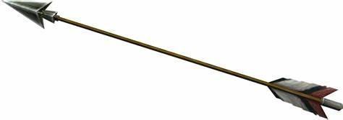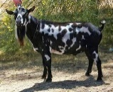
arrow (ivaan) goat (ivo)

ivambe (giant beast), noun: a mythical Tiv animal. Archaic; used only in idiomatic expressions; in kwambe
har mindi ivambe ishe: once beaten; twice shy (translated: twice pierces the giant beast’s eye).
ivav (wound), noun: a cut that is not healed. Ngu a ivav sha vande(gh). He has a wound on his shoulder. avav
(wounds), plural noun.
ivarivase¹ (whisper), verb: to speak softly without using the vocal cords. Lam ivarivase ken liberi. Whisper in the library.
ivarivase² (whisper), noun: a voice when speaking softly without using the vocal cords. M ungwa liam u ivarivase ken ato am. I
heard the whisper in my ears.
ive¹ (ogbono seed), noun: seed from ogbono fruit. Iuwe i ogbono doo yan ruam a min. Ogbono soup is good to
eat fufu with (goes well with fufu).
ive² (large amphibious lizard), noun: an animal that lives both in water and on land. Ive unde kon. The
amphibious lizard climbed the tree.
ivo (goat), singular noun: a farm animal with backward curving horns kept for its meat. ivo (goats), plural
noun. Example: Ivo imom; (one goat); ivo inyiin (four goats).
ivom (mound): heap for planting yams or sweet potatoes. Kaha ivom i loon iyough. Make a mound for planting yams.
ivor (seedling), noun: seeds or parts of tubers kept for planting. Sam ikuleke doo u veren ivor. Dry corn (maize) seeds are good for
seedling.
ivumbu (Tiv homemade tamper), noun: uivumbu/avumbu, plural. A gbidye tembe iyough u lu liana man u
taver sha ivumbu. He/she made the floor level and firm with the tamper.
ivungu¹ (wood/marsh worm), noun; avungu, plural. Worms that live on wood pulp. Ivungu ya kon ken atô. The
wood worm ate the inside of the tree.
ivungu² (owl), noun: bird with large eyeballs and a hooked beak. Ivungu purugh
yem. The owl flew away. avungu (owls), plural noun.
ivungu³ (drill), noun: echanical device for making holes in wood or metal. Tôô ivungu ongol ihula. Take the drill to make a hole.
ivur; ivurugh (verse), noun: a major part of a hymn or biblical chapter. Ôr Yohane itiough ki sha utar, ivur i
sha pue teratar. Read John chapter three, verse sixteen.
ivurugh (crumb, piece), noun: a piece that falls from food such as bread or yam. A ya beredi; ivurugh gba hen
inya ga. He ate bread; no crumb fell on the floor.
iwa (dog), noun: an animal trained to hunt or guide people and property. Iwa ngi gbehen. The dog is barking.
iwambe (vaccination), noun: inoculating against a virus that causes a deadly disease such as smallpox. Gber iwambe i angev mbu
COVID-19. Have the vaccination against COVID-19 disease.
iwan (disability), noun: when one is unable to use their organ as well as before/normal. Or ngu a iwan i
atoakondon. The man has a disability of deafness. gba iwan (disabled).
iwange (spear), noun: a long dagger used for hunting or fighting (archaic). Orshoja ker iwange. The soldier threw the spear.

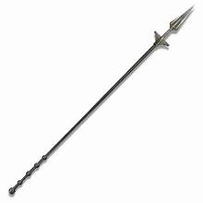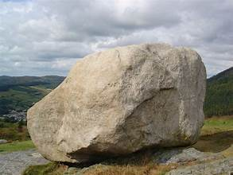
spear (iwange) stone (iwen)

iwanger (light, clarity), noun: 1. Tsar imenger i ta iwanger. Light the lamp to give light. 2. Ta iwanger sha
Atindiakaa a Pue. Give explanation for the Ten Commandments.
iwasen (help), noun: something that is needed that is done or given. Me nau iwasen sha iyough i esen. I will
give you help with cleaning the house. Iwasenshio (helplessness).
iwav (hypopigmentation), noun: changes in pigment formation in the skin. M ngu a iwav sha vande. I have
hypopigmentation on my shoulder.
iwen (stone, rock), noun: a piece of hard earth. Awen, plural noun. Tema sha iwen. Sit on the rock.
iwenge (waist), noun: part of the body between your back and buttocks. Wankwase zengem iwenge. The girl has a thin waist.
iwer¹ (meal), noun: what you cook for the family. M sugh u iwer! Thank you for the meal!
iwer² (African praise sound), noun: voicing sound in praise by wiggling one’s tongue back and forth many times very loudly. Gbilee iwer
shaciuman nom u kwase he. Make a praise sound for the newly married.
iwuese (thanks, gratitude), noun: M na iwuese sha tom wou u dedoo. I offer gratitude for your good work.
iyange¹ (day), noun: a day lasts wenty-four hours. ayange (days, pl). iyange i memen (day of rest): Lahadi ka
iyange i memen. Sunday is the day of rest.
iyange² (Sun), noun: one of the billions of stars. Iyange i ne se sev man tugh. The sun gives us day and night.
iyanngise (day before yesterday), adv. M hide iyanngise. I returned the day before yesterday.
iyav (abdomen), noun: houses the stomach and intestines. Iyav nyion mo. I have abdominal pain. Iyav mbu
nyion (stomachache), noun.
iyenge¹ (math problem), noun: a statement or problem expressed in mathematical terms. Iyenge ne taver. This
math problem is hard. C.f., ayenge (the study of numbers).
iyenge² (sum, total, number), noun: Iyenge i mbayev mba vihin makeranta kuma utaan. The number of
children absent from school is up to five.
iyese (scorpion), noun: an eight-legged animal that has a stinger on its tail. Iyese sôôm. I am stung by a scorpion.
iyô (snake), noun: an animal with no legs but is covered with scales. Iyô ne ka i lun a megh. This is a poisonous snake.
iyôshu (snake fish), noun: a type of fish that resembles a snake. Dugh iyôshu ver kposo a ishu i genegh. Separate the snake fish
from the other fish.
iyol (body), noun: the parts of an animal from head to toe. Iyol i orumace ngi a akper ga. The body of a human has no wings.
iyol ôôn (a bath, shower), noun: the state of bathing. M nyôr iyol ôôn. I am in the shower (I am taking a bath).
iyolkenden (pompous), adj: self-elevating oneself as if they were better than other people. De iyolkenden; hide a iyoljime. Avoid
being pompous; be humble.
iyongo; iyongu¹ (drinking gourd), noun: something the drink from. Haa mngerem shin iyongu ma. Pour water
in the gourd (and) drink.
iyongo; iyongu² (fighting, squabble, trouble): a noisy quarrel about an issue. Iyongu vihi. Fighting is not good.
iyôngu(o) (sheep), singular noun: a farm animal kept for its meat. Inyam iyôngu nyoho ga. The sheep’s meat (ram meat)
is not tasty. Also, nomiyôngu (ram); ngoiyôngu (ewe); waniyôngu (lamb). iyongu, plural noun, same as singular noun.

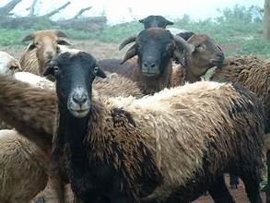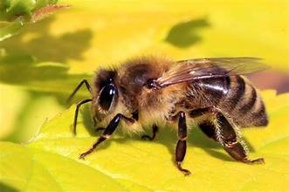
sheep (iyôngu) bee (iyough)

iyôugh (metal), noun: material made of iron, steel, aluminum, etc. Jiidi mngrem shin tsuwa iyôugh. Boil the
water in a metal pot.
iyough¹ (bee), noun: an insect with a hairy body and does make honey. Iyough tam. I am stung by a bee.
Iyough (bees), plural noun.
iyough² (yam), noun: a tuber grown in the ground for food. Kaa iyough. Fry yams.
iyough³ (house), noun: a dwelling place. Me za yav ken iyough. I shall go and sleep in the house.
iyuhe (jealous), adj: showing envy toward someone for their achievements. De iyuhe. Stop being jealous. See
wuhe (jealous one).

J
jaki (donkey), noun: animal that looks like a small horse. Jaki too ikav. The donkey is carrying loads.
jato; nyian (light/red colour), adj: a light-colored person (Hausa roots). U yila Terfa wer jato or. You will call
Terfa jato.
jighilii (straight), adj: not bending. Gbenda ngu jighilii. The road is straight.
jighjigh¹ (straight up; still), adj: to stand still or straight up. Tile jighjigh. Stand straight up.


straight (jighilii) bend (hule) back (jime)
jighjigh² (believe), verb: believing in something. A na jighjigh hen Aondo. He/she believes in God.
jiidi; jiir (cook), verb: the process of preparing food by heating materials. Jiir/jiidi alev. Cook some beans.
jijingi¹ (shadow), noun: an area of darkness when light is blocked by an object. M zenda jijingi wam kpa m kôr
ga. I chased my shadow but could not catch it.
jijingi² (spirit), noun: something that is believed to be in a erson that controls his/her actions. Cighan Jijingi
(Holy Spirit); jijingi u bo (bad spirit).
jimba jimba (rag-tag), adj: Or la huwa jimbajimba mba akondov. That man wore rag-tag clothing.
jime (back), noun: the part of the body opposite to the chest. Tiligh mo jime. Massage my back.
jindi (heap, group), noun: a group of things. Ta tihi u ihôvonough. Make a heap of trash or garbage.
jingi (glass, mirror): See ijingi.
jingir (wag; swing; fling), verb: to move tail side to side by a dog. Iwa ngi jingir tsa. The dog is wagging its tail.
juku (dormant; unsolvable; stalemate), adj: a state when something cannot be easily taken apart. Kwagh ta
juku ape zan ngu ga. The matter is at a stalemate; there is no place to go.
Jukun (ethnic group), noun: an ethnic group in Benue Nigeria. Or Jukun kôr ishu. The Jukun man caught a fish.

K
ka (it is): phrase containing a pronoun and the infinitive. Ka mo: it`s me. Ka we? Are you the one? ka ana?
Who is it? ka u me? How many? ka ve (it is they/them): Ka ve ve lu lamen ye. It is they who are speaking.
kaa¹ (fry), verb: to cook in very hot oil. Kaa ayaba (kôôkômbo). Fry plantains.
kaa² (tell), verb: to request something of someone. Kaa un a va. Tell him/her to come.
kaa³ (say, said), verb: to speak about something. U kaa we nena? What did you say? M kaa kwagh ga. I said nothing.
kaa⁴ mo (hug me), verb: request a hug from someone. Wan wam va kaa mo. My child come (and) hug me.
kabed (cupboard; locker; cabinet), noun: a place to store things. Wa itiakeda ken kabed. Put the books in the cabinet.
kaca kaca (totally), adv: condition of destruction. Bom vihi ayough kacakaca. The bomb totally destroyed the house.
kaha (make a heap), verb: to make a mound or ridge. Kaha avom lôô iyough. Make heaps to plant yams.
kakaki (horn, African trumpet), noun: musical instrument with long tube. Also called waza in Chad and Sudan,
and malakat in Ethiopia. Tungwa kakaki i sagher ior iyol. Play the “kakaki” trumpet to get people excited.

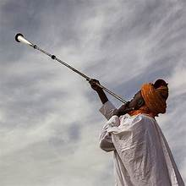
horn (kakaki) tie (kange)

kam (mold, press), verb: to squeeze with fingers or special tool. 1. Kam alum zar u due. Squeeze the orange
(fruit) to get out the juice. 2. Kam inya maa ityu. Mold the clay to make a pipe.
kamu, akamu (bean porridge), noun: Nigerian cereal made by mixing boiling water and bean flour, like cream
of wheat. M soo kamu sha kwaghyan u pepe. I like akamu for breakfast.
kande (lost weight), verb: to become skinny unnaturally. Ayem kera ya kwaghyan tsembelee ga; nahan, a kande. Ayem no longer
eats food well; so, she lost weight. Kande kande (very thin or slim), adjective.
kange (tie),verb: to tie up usually into a bundle. Kange ormbaiv ave. Tie the thief`s arms.
Kano (town in Northen Nigeria), noun: Dooshim za Kano. Dooshima went to Kano.
kanwa; kaun (potash), noun: food tenderizer and soup thickener. Wa kanwa sha inyam i leghem. Add potash
to meat to make it tender (less tough).
kapeti (carpet), noun: used to protect the floor. Musan kapeti ne. Change this carpet.
kapu (large calabash tray), noun: Haa mngeren shin kapu. Put water in the large calabash.
kar¹ (pass over), verb: to come through on one’s way. A kar heen u zan kasua. He passed here to go to the store.
kar² [taller (than)], adj: comparative adjective of tall—greater height than normal. Sesugh kar Sajid. Sesugh is taller than Sajid.
kar³ (past), adv: a farther position; comparative adverb of far. 1. Shie ka ihwa mom kar miniti utaan. The
time is five minutes past one o`clock. 2. M yevese m kar un. I run past him/her.
kar a kar (keep moving; continue), verb: a desire, tendency, or order to stay or stop. Poloshi na oda er se kar
a kar. The Police gave an order that we should keep moving.
kar kwar (share), verb: to divide among people. Kar kwar na hanma or vough. Shre equally among people.
kase¹ (enclose), verb: to form a circle around a thing or space. Kase kwa. Enclose a space.
kase² (sieve): to remove smaller paricles or separate from chaff. Kase iber amine. Sieve the coarse millet porridge.
kasua (market, week), noun: 1. A place to buy and sell. Aya za kasua u za yamen mkulem. Aya has gone to the
market to buy oil. 2. Days from one market day to the next 7 days) or a week. Wer mom ka kasua unyiin. There are four weeks in one month. Ukasua (markets, weeks), plural noun.
kav¹ (imitate), verb. To copy the actions of behaviour of someone. Ter kav iliam i Don. Ter imitates how Don
speaks (imitates Don`s speech).
kav² (understand), verb: to get the meaning of something. M mase kaven. (I understand at last.). Terna kaven
kwagh u “Sev man Tugh.” Terna understood at last the reasonableness of “Day and Night.”
keer¹ (kindle), verb: to start a fire. Keer usu jiidi kwagh. Kindle a fire to cook something.
keer² (limping), verb: hop walking when one foo is not well enough. M ngu keer yemen iyoughci. I am limping to the hospital.
kegh (wait), verb: to stay at a place until something happens. Kegh ve ve va. Wait for them to come.
kelase (class), noun: a group formed to study together. Kelase u Mkar nyen zua. Mkar class met yesterday.
kema (knock), verb: to make a light tap on the door. Kema wegh sha hunda. Knock at the door.
kemis (chemist), noun: a person trained to fill a doctor`s prescriptions. Kemis nam cigh ki ortwer a nger yô.
The chemist has given me the medicine the doctor prescribed.


Chemist (kemis) lift (kende)

ken (in), prep: showing that something is enclosed by another. Inyon ngi purugh ken ahumbe. The bird is flying
in the air. Also, ken tar (in the world); ken won (outside or surrounded by the world). De se tema ken won. Let us sit outside.
kende¹ (lift),verb: to pick up, or to raise. Kende ave sha. Lift up (your) hands. kenden iyol sha (being bombastic), idiomatic.
kende² (drop), verb: to let go down a lower level. Zôr mongol; kende un shin inya. Pick the mango; drop it down.
keng (necessary), adj: something that is required. Ka keng u we lu a mato man u eren tom u Uber ye. It is
necessary that you have a car to work for Uber. Keng keng (must), verb. Example, mba van keng keng (they must be here).
kenger (look; stare), verb: use eyes to see something. Kenger sha wer. Look at the moon.
ker¹ (seek, explore), verb: look for something. Ker abinkuni u a saa yô. Seek for the lost earring.
ker² (throw), verb: when you propel something through the air using your arm(s). Ker futubol a za ica. Throw the football far.
kera (no longer), adv: Se kera mba zan ga. We are no longer going.
keran (oppose), verb: have an opposite opinion. keran kwagh (oppose the issue)
kese (fetch, poach), verb: get some water from a well; poach eggs. 1. Kese mngerem. Fetch water. 2. Kese ajiikegh. Poach eggs.
keshi (scissors), noun: tool with two hinged blades for cutting. Tondo ice sha keshi. Cut hai with a scissors.
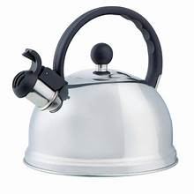
scissors (keshi) kettle (ketul)

ketul (kettle), noun: for boiling water in it. Jiir mngerem shin ketul. Boil water in the kettle.
kicin (kitchen), noun: area for cooking. M ver firiji ken kicin. I placed the fridge in the kitchen.
kighir (force; press; end), verb: to push or move something or someone to act. 1. Ve kighir mo er m tam ituna. They forced
me to chew bitter leaf. 2. Civ ihôwetamen shin inki, kighir sha pipa. Dip the thumb in ink and press on the paper.
3. Gbenda kighir heen. The road ends here.
kile (wash), verb: to clean. Kile agbande. Wash the dishes.
kilo (kilometer), noun: a measure of length or distance. M yevese kilo mom. I ran one kilo.
kimba (trapped), verb: to be in a fix. Ikyaa kimba m. I have been trapped by something.
kimbi (pay)verb: offer something (money) in exchange for another of value. Kimbi takeda u yam la. Pay for the book you bought.
kimbir (repeat), verb: say or do over. Kimbir itikwagh. Repeat the word.
kimbir ki kimbir (repatedly), adv: to do or say something over and over. A kema wegh sha hunda kimbir ki
kimbir. He/she repeatedly knocked at the door.
kimin¹ (inside), prep: found within the boundaries of something. M ungwa imo i Dabo kimin. I heard the voice of Dabo inside.
kimin² (inside), noun: the inner part of something or an enclosure. Kile mkulem kimin sha. Scrub the oil from the inside (of the pot).
kimin³ (inside), adverb: within the confines of a space. Ior mba ken iyough adua mba eren msen kimi zan zan.
kindigh (press fill), verb: to force more material into a hole or container. Haa inya shin ihungwa man
kindindigh dedo. Fill the pit with earth and press well.
kiriki (little, small), adj: not large. U faityô u nahan mato karen sha awen a kiriki. You can drive the car over little
rocks. Mbayev mba kiriki (children).
Kirimishi (Christmas), noun: day to celebrate the birth of Christ. Ka se er inongu sha iyange i Kirimishi. We have dinner on
Christmas Day.
kobo (Nigeria currency coin), noun: smallest naira unit, N1 = 100k); Mama nam naira dubu mom (mother gave
me one thousand naira).
kohol (gather), verb: 1. To put together. Kohol iyough ta tihi. Gather the yams into a heap. 2. Add up to. Uhar man utar kohol kuma
utaan. Two and three add up to five. Kohol (addition), noun; mkohol (meeting, conference), noun.
kokombo (butterfly), noun: an insect with a slender body and two colorful wings. Akper a kokombo kehe. The
wings of the butterfly are large.
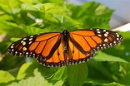
butterfly (kokombo) computer (kômputa)

kolta (coal tar), noun: dark material made from coal used for surfacing roads. Sôr gbenda haa kolta u he.
Resurface the road with treatment of new coal tar.
kômputa (computer), noun: an electronic machine that can process words, analyze stored data, and give
information. Hanma wanye makeranta ngu a komputa. Every student has a computer.
kon (tree), noun: a large plant with a trunk and many branches. Kon ne tav. This tree is all. ikon (trees), plural noun.
kondo (end), verb: of a hole or action—cannot continue or penetrate. Ihula kondo. 1. The hole/burrow has ended. 2. A kondo ato.
He/she is deaf.
kôngul¹ (bring up flame from throat), verb. Kôngul cii man u hii imo ye. Clear your throat before you start to sing.
kôngul² (smooth), adj: free from rough or uneven spots; not rough. Kpande u kôngul. A smooth slab. Kôngul
(smoothen), verb. Kongul kpande. Smoothen the slab.
kôôkômbo (plantain), noun: a kind of banana that is cooked rather than eaten raw. Kaa kôôkômbo na Dooter. Give Dooter fried
plantain.
kôr (hold, catch), verb: Kôr bol er un a gba ga yô. Catch the ball so it won’t drop.
kor¹ (rope), noun: a strong, thick cord made by twisting thinner strings together. Ta ivo kor sha mon. Tie the
rope on the neck of the goat.
kor² (sew), verb: to use a needle and thread to stitch things. Wondo ande; kor un. The pants are torn; sew it.
korough¹ (horn), sing. noun: one of bone growth on some animals. Nombua ngu a akor (plural). The bull has horns.

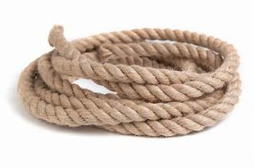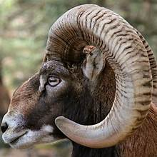
rope (kor) horn (korough) court (koti/iyoughjir)

korough² (horn/buggle), noun: buggle-like made from bull horn. Tungwa korogh ior ve zua. Blow the horn for
people meet.
kôso (tattle), verb: to tell on someone. De u kôson ior. Stop tattling on people. kôson or (tattletaling). Also,
mkôso u or (tattletale), noun.
koti, iyoughjir (court), noun: a place where cases are tried, and decisions made about law. Koti kaa er a
kimbi injô. The court said he/she should repay the debt.
kough (erase), verb: to wipe out. Kough akaa a kperan sha kpekpe. Erase the drawings on the wall.
kpa (but), conj: on the other hand. Luka venda, kpa Yohane yô rumun. Luka refused, but John agreed.
kpaa (also), conj: too; besides. We kpaa? You too? En, mo kpaa. Yes, me too.
kpaakpa (fufu spatula), noun: small wooden implement for dishing out fufu. Gber ruam sha kpaakpa. Serve
fufu with fufu spatula.
kpagh (tropical redwood), noun: wood which when shredded and ground can have a skin-softening effect.
Shighe kpagh iyol i leghem. Rub the redwood paste to soften the skin.
kpam (domain; authority), noun: the power to control others. U ngu tesen kpam sha amo. You are exercising
authority over me. See: Kpamor (person of authority), noun. Akpamaior (persons of authority), plural noun.
kpamor (leader, person of authority), noun: person with authority over others. akpamaior (people with authority over others),
plural noun. Dima ka kpamor u hen Ute. Dima is leader at Ute.
kpan (slave), noun: a person who is owned by and works for another person called “master.” Doo u orumace a
lu kpan ga. No human being should be a slave. ikpan (slaves), plural noun.
kpande (slab), noun: a wide slice of something, used as a board or furniture. Nger kwagh sha kpande. Write something on the slab.
kpandegh (tax), noun: money paid to governments by people for the benefit of public services. Ior mbe vesen
cii mba te kpandegh. All adults pay taxes.
kpar (partition), noun: division of a space into areas. Maa kpar dugh ayough ahar. Build a partition to make two rooms.
kpash! (exclamation), Kpash! De kwagh la. Kpash! Stop that.
kpatema (cat), noun: small domestic animal. Katema tema sha butu. The cat sat on a mat.
kpe¹ (die), verb: no longer living. Iyô kpe. The snake died.
kpe²; kur (edge), noun: a border or margin; where something stops. Kpe ijôr. The edge of a well.
kpe ilyegh (paralyzed), adj: unable to move a limb. Za a na iyoughci aluer a kpe ilyegh yô. Take him/her to the hospital if his/her
limb is paralyzed.
kpekpe (wall), noun: the sides of a container. Foto ngu sha kpekpe. The picture is on the wall.
kpenga (carrier), noun: carrying rack; archaic. Aya wam wa iyough shin kpenga. My grandma put yams in the carrier.
kper¹ (net), noun: a meshed thing that may be closed at one end. Haa kper; kor ishu. Cast the net; to catch fish.
kper² (tomorrow), adv: the day that follows today. Nian Sati; kper a lu Lahadi. Today is Saturday; tomorrow will be Sunday.
kpera (draw; drag), verb: 1. To create a picture or diagram. Kpera foto u iwa. Draw a picture of a dog. 2. To
move/pull something slowly. Kpera gbaakon sha gbenda kera. Drag the branch of wood off the road.

kperegh (wing), noun: part of an animal that helps it fly. Nam kpereh ku ikegh. Give me a chicken wing.
Akperaikegh (wings), plural noun.

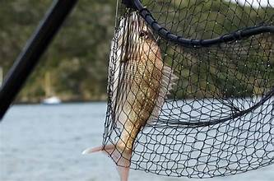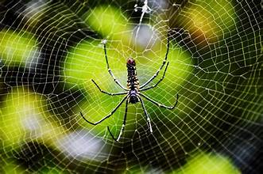
net (kper) spider (kpereketange)

kpereketange (spider), noun: a small animal with eight legs that can spin a web. Kpereketange ta kper. The
spider spun a web.
kpev (buck, billy goat), noun: male goat. Kpev soo num u nongon u itiough ki tan. The back likes to fight with the head.
kpiligh iyol (surprised),adj: to be astonished. Trump hemba kpa kpiligh mo iyol ga. I am not surprised that Trump won.
Kwaghkpilighiyol (a surprise, a surprising thing), noun. akaakpilighiyol (surprises), plural noun.
kpishi (much, a lot, plenty), adj. M sugh u kpishi. I thank you very much. Ve lam kpishi. They talked a lot.
kposo (different): not the same. Kon ngu kposo a toho. A tree is different from grass. Kposo kposo (differently,
in different ways), adverb.
kpughô (tilapia), noun: a fish with many scales. Jiir kpughô. Cook some tilapia.
ku (death), noun: end of life. Akaa a uma cii a kule ken ku. All life ends in death.
kua (also, and), conj: word that connects other words or sentences. Ilyaku kua ikeji. A canary and a cage.
kuha (play; drum), verb: to make music with an instrument like a drum. 1. Kuha genga. Play the drum. 2. M
ngu kuhan genga. I am drumming. See tungwa imar (play the flute).

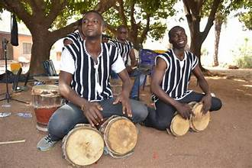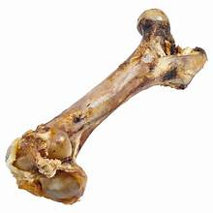
drum (kuha) bone (kuhe)

kuhe (bone), noun: a part of the skeleton of an animal. Iwa soo kuhe u yan. A dog likes to eat a bone. ikuhe
(bones, pl).
kule¹ (end), verb: the point of finish of something. Kwagh kule (has ended, that’s the end); mkohol kule (the
meeting has ended). Mkur (the end).
kule² (clap), verb: to hit together hands or other things. Kule ave ough. Clap your hands.
kuma¹ (enough; satisfy), det: of a sufficient amount. 1. Kuma. That’s enough. 2. M ya kuma m. I am satisfied eating.
kuma² (ready), adj: fully prepared for something to happen. M hen mato u nahan kuma u za tôôn ikarem. I
have learned driving (and am) ready to go take a test.
kuma³ (pinch; pierce), verb: to make a hole into something. Kwagh kuma m. Something pinched me.
kuma⁴ (fit; suited), verb: fitted around or to something. Riga kuma sha a na dedoo. The gown fits her/him well.
kume¹ (pound), verb: to hit into powder or paste. Kume ruam. Pound the yam fufu.
kume² (thunder), verb: loud noise when clouds collide. Wura ngu kumen. It is thundering.
kunda (iyol) (amazed, flabbergasted, stunned), adj: to be intensely shocked. Teghtegh ungwa ku u Sarwuan,
nahan kunda un iyol. Teghtegh heard the death of Sarwuan, so he was flabbergasted. Also, unbelievable; overwhelmed.
kunde¹ (stir), verb: to cause to move with a spoon or stirrer. Kunde iue. Stir the soup.
kunde² (shiver), verb: shaking as if feeling cold or feverish. M hia iyol man m ngu kunden iyol. I have a fever and I am shivering.
kundu (harden): to become hard. Iber kundu. The porridge has hardened.
kundushima (calmness, relaxation): state of being calm. M pase ikarem; nahan, m zua a kundishima. I passed
the test; so, I am in a state of calmness.
kungô (stream boundaries): space along which the stream water flows. Kungô hen ape peren hoghol. The
stream boundaries at the crossing are narrow.
kunu (drink), noun: non-alcoholic millet or corn beverage. Nam kunu. Give me (some) non-alcoholic drink.
kunya (humiliating), adj: causing someone to feel ashamed by treating or defeating them badly. Ve er a na kunya kôr; shie u ve
venda u nan un kwaghyan man mngeem yô. They treated him in a humiliating manner by refusing him food and water.
kusu (fold fingers): to make a fist or close fingers. Kusu wegh. Fold fingers (hand).
kusugh¹ (electric fish), noun: a fish that produces a small electric shock. Kusugh dura m. I was shocked by the electric fish.
kusugh² (lower leg ends), noun: lower ends of goat and sheep legs. Pandegh ngu sha kusugh ku iyongu. The hoof is on the lowerlrg
end of a sheep.
kuva (mesh), verb: to connect rafters in roofing. M kuva iyough. I meshed (the roof of) the house.

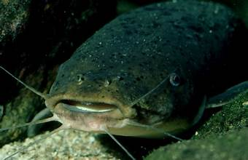
electric fish (kusugh) hug (kuve)

kuve (hug, embrace), verb: to squeeze someone tightly in one’s arms to show affection. Ngô kuve wan na. Mother hugged her
child. See kaa mo (hug me).
kwa (leaf), noun: part of a plant that makes food for the plant. Kwa u mbuel kehe. The pawpaw
leaf is large. ika (leaves), plural noun.
kwagh (thing; something), noun: existence of a physical material or idea. Kwagh ngu. There’s something. Also: Ka kwagh ga
(nothing); U ya kwagh ve? (Have you eaten?); kwagh bee (nothing left); de kwagh la (stop that thing or Stop it!).
- Kwaghtesen (instruction)
- Kwagh hemba (cannot do anything, is hopeless)
- Kwagh ken ishima (idea) - Adingi ngu henen kwagh u dedo ken ishima. Adingi has a good idea.
- Kwagh u i zough a min (result)
- Kwagh u nyohom shin u yuwan. (The tongue tells what is sweet and what is spicy)
- Kwagh u sha da (important) A ôr kwagh u sha da, nahan se ungwa. (He/she said something important, so
- Kwagh u van/nan a ahan (something funny, joke)
- Kwaghaôndo (religion, religious studies)
- Kwaghave (wealthy): to have plenty/lots of money and property. Naira ‘n Kobo iyange lu a kwaghave.
- Kwaghbee (finished, done)
- Kwaghbo (wrongdoing). Dem a kwaghbo wam (forgive me, forgive me my wrong doing)
- Kwaghfan (knowledge)
- Kwaghhange (to have need
- Kwaghhôô (something rotted)
- Kwaghhôôn (rotten stuff)
- Kwaghkwa (multiplication); ta kwaghkwa (multiply), verb
- Kwaghngise (ancient thing, history) Aya ka a or se akaa a ngise a Tiv (Aya tells us about ancient Tiv)
- Kwaghngu ga, zua a kwagh ga (no evidence, no clue)
- kwaghngu, zuakwagh (evidence)
- Kwaghteregh (geography)
- kwaghwan (advice), noun
- kwaghwan u ior (people’s advice)
- kwaghyan u pepe (breakfast)
- kwaghyan (food)
kwaghhir (tale, story), noun: what has been told about imaginary or real people, maily for ntertainment. Kwaghhir u alom man
kurugh. The story of the hare and the tortoise.
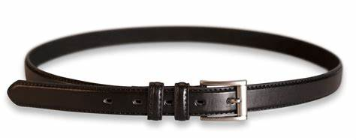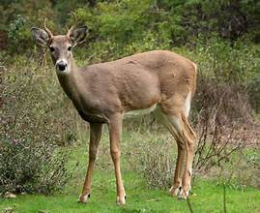
belt (kwange) deer (kwantera)

kwam (bosom buddy), noun: a close friend with whom you can discuss anything; a homegirl or homeboy. Ngozi vea
Ani mba kwam. Ngozi and Ani are “homegirls.” (Both natives of Enugu, married to natives of Tsar).
kwambe (Tiv tattoo): a Tiv marking on the body. Ayim gber kwambe sha mon. Atim has a Tiv tattoo on his neck.
kwange (belt), noun: a strip of material that goes around something or a person. Kôr wondo wou i taver sha kwange.
Tighten your pants with a belt.
kwantera (deer), noun: animal whose males grow antlers; some have white tails. Kwantera ye nyam ga. The deer
does not eat meat. (It is a herbivore.) See iyar asua (large antelope, a kind of deer)
kwar karen (sharing), noun: dividing among people. A er kwar karen u dedoo. He/she performed a perfect sharing.
kwase (woman, wife), noun: a grown-up human being. Kwase wam (My wife); Kwase Tiv (A Tiv woman)
kwav¹ (agemate), noun: of the same age. Ngutor man Tarhembe mba kwav mom. Ngutor and Tarhemba are the
same age (agemates).
kwav² (surface), noun: the top area of something. Kwav iyologh (skin); kwav mnger (water surface); kwavaôndo (sky)
kwaza (tin), noun: a metal found at Mbaagbanya, Mbatiav. Dugh kwaza er inyaregh a min. Mine tin to make coinage.
kwe (crack), noun: a split in something. Ijôndogh ki a kwe. There is a crack in the calabash.
kwembe (clam), noun: an animal with a soft body covered by a shell that lives in salt or fresh water. Clam shell—
used as a spoon (archaic); ikwembe (clams/shells), pl noun
kwen (hand-held gong), noun: A double hollow metal musical instrument. Kuha kwen. Play the hand-held gong.


laboratory (lab/ijiir i henen sainz)

TIV-ENGLISH DICTIONARY
L
la (that), pron: referring to a specific thing. Ngu la (that one); or la (that man); de kwagh la (stop that thing).
lab (laboratory), noun: where science tests are performed. Za lab da kar awambe. Go to the laboratory for blood
test. Orwasen ken lab (laboratory assistant), noun.
laha (reject), verb: refuse unfair share. A laha kwar; nahan, venda u ngohol. He rejected his share; so, refused to accept.
Lahadi (Sunday), noun: the Christian Sabbath Day. Ka ve za adua hanma Lahadi. They go to church every Sunday.
lam (talk, speak), verb: to say something. Lam sha fon. Speak on the phone.
leigh (foolishness), noun: having no sense. Kwagh eren wou tese lanegh. Your action shows foolishness (lack of sense).
leteriki, latirik (electric), adj: used to give light or run things. Iwen i kon akondo yam ka i lateriki. My pressing
iron is electric.
liam (speech, talk), noun: what is said when one speaks. Liam na taver. His speech was loud. Liambee (speechless)
lian (lean), verb: lay against something. Lian sha a mo. Lean on me. Also: lian ken kpekpe (lean against the wall).
logo (cassava), noun: a tuber that grows underground. Kaha logo. Cultivate cassava.

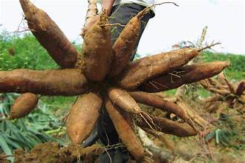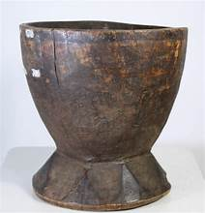
casava (logo) mortar (lu)

loho (message, news), noun: information to be transmitted. Loho u dedoo. Good news.
lôô (saw/plant), verb: to plant seeds or seedlings. Lôô iyough. Plant yam seedlings.
lu¹ (mortar), noun: a vessel to hold things to pound. Haa logo u uman shin lu sha u kumen. Place dry cassava
in the mortar for pounding. Ilu (mortars), plural noun.
lu² (stay), verb: to not leave; to remain. Lu heen. Stay here. Lun iyol haghelaa (anxious).
lulô (picker), noun: a pointy skewer for picking up lumps or slices of soft material. M dugh iough shin tsuwa sha lulo. I removed the yam from the small pot
with a picker.

M
M (I): as in M mough sha/I stood up), pronoun. M sugh u (I thank you); compare: daalu nna (Igbo), ekuise (Yoruba), na gode (Hausa).
m, mo (me), pron: referring to the one speaking. As in dem/leave me; ka mo/it’s me).
ma (drink), verb: take in water. Ma mngerem. Drink (some) water.
maa¹ (build), verb: to construct something. Maa iyough. Build a house.
maa² (chemical dye), noun: dye used for body beautification. Kwase gber maa sha ishigh. The woman decorated her face with dye.
man (and), conj: a word that joins other words or statements. Nomso or man kwase. A man and a woman.
mande (nail), verb: fix onto a surface by using nails. Mande foto sha kon. Nail the picture on the tree.
mape (anywhere or somewhere), adverb: when not referring to an exact time or place. A za mape ga. She/he did not go anywhere;
a za mape (he has gone somewhere).
mase (last), adj: after everything. Terna mase ityô. Terna came last. Adverb; maseityô (last): Terna ka or maseityô. Terna is the
last person.
masejime (afterwards), adverb: subsequently; later. Terdoo va ken masejime. Terdoo came afterwards.
mato; moto (automobile, truck, lory, bus), noun: a vehicle to carry people or goods. Mato too ior. The car carried
people. Noun; plural, umato.
mba (are), verb: to be, used with plural pronouns or some nouns. Alum mba pue. There are ten oranges. mba ikundu There are twenty of them.
Mba u me? How many are they? Se mba van. We are coming. (Ve) Mba yaven. They are sleeping. Use “mba” to form plural nouns:
- mbaaie (lies)
- mbahenen (thinkers)
- mbaitiomov (angels)
- mbamaren (parents)
- mbamhen (thoughts, ideas)
- mbatomov (workers)
- mbayev Tiv (Tiv children)
Mbayuda (Jewih people), noun: people of the Jewish faith. Ior Mbayuda mba ken Israel. The Jewish people in Israel.
mboromboro (metal mouth instrument), noun: a metal mouth musical instrument. Agidi fa u kuhan mboronmboro. Agidi can
(knows how to) play the metal mouth musical instrument.
mdugh u ken mkange (freedom), noun: free from bondage. M zua a mdugh ken mkange. I got freedom.
mee (entice, sneak on), verb: to move silently in search of a prey. Begha ngu meen iho. The lion is sneaking on the antelope.
mem (rest), verb: time when you are not doing something. Mem shie u u bee tom yô. Rest after you finish the work.
memiyol (holiday; rest time), noun: when one is not working. Se zua a memiyol u Kirimishi. We got Christmas holiday.
mena (swallow), verb: allow something to pass through your throat. Tam beredi man u mena ye. Chew the bread
before swallowing.
mende (germinate), verb: to begin to grow. Mkem mende. The peppers germinated.
m er u ken iyol (feeling), noun: A jolt of emotion. M er u ken iyol u dedoo. A good feeling. Msaan iyol (joy), noun.
mfe (awareness, knowledge), noun: a state of understanding. Ngu a mfe (has awareness; has understanding).
mgemshima (repentance); noun: a turn from previous bad ways. Er msen a vau a mgemshima. Pray for repentance.
mhange (desire, need), noun: a wish. Ngu a mhange sha u eren kwagh u dedoo. He/she has a desire to do good.
mhen (thought), noun: what one thinks about. Na mhen wou. Offer your thought.
mhôônom (mercy), noun: showing compassion. Zungwem mhôônom. Have mercy on me.
mile (sink), verb: to go underwater. Iwen mile shin mnger. The rock sank into the water.
mimi (true), adjective: not wrong or false. Ka mimi ikegh ka inyon. It’s true a chicken is a bird.
mimi mimi (truly), adv: in an honest or truthful way. Mimi mimi je hungul mo er nyian i lu Sati naha. I truly forgot
today was Saturday.
mindi (burst), verb: cut open a boil or pimple or boil. Mindi ityundugh. Cut open the boil.
mir (soak, soaked), verb: put in water for a while. Mir akondo man u kile ye. Soak the clothes before washing.
mishe (root), noun: part of a plant that supports it. Kon u mongol ngu a mishe hemba mom. The mango tree
has more than one root. amishe (roots), plural noun.
mishi (spray), verb: to sprinkle a liquid. Mishi mngerem sha ikuleke I vese. Spray water on the maize (corn) to grow.
mita (metre), noun: a unit of measure in the metric system. M zende mita deri mom. I walked one hundred meters.
mkem (pepper), noun: plant with spicy fruits used to season foods. Wa mkem sha/shin iuwe. Put pepper in the soup.

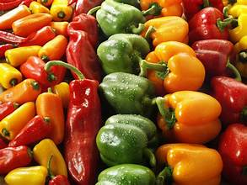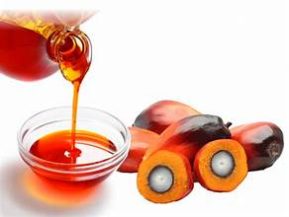
pepper (mkem) oil (mkulem)

mkenan/mkanan (grudgingly), adv: with dislike. M soo ga, kpa m ya sha mkenan. I didn’t like it, but grudgingly ate it.
mkulem (oil), noun: liquid of varying thicknesses. Mkulem ma yôron a min. The oil to cook with (with which to cook).
mkur (end); noun: where something stops. Mkur u kwaghhir. The end of the tale. mkurkwagh (solution, conclusion)
mlu man mgem u tar (climate change): the way temperature and the weather shift over a long time. Ka ior
ve lu nan mlu man mgem u tar ye. People are the cause of climate change. Noun clause.
mnenge (trying), noun: attempt at something. Mnenge hemba u teman aveve. Trying is better than sitting
idle. Idiom: Mnenge hemba mtem (Keep trying).
mngee (amount), noun): a quantity of something that cannot be counted; to show how much. Mngee u asan sha kwavaondo kpiligh se
iyol. We are fascinated by the amount of stars in the sky.
mngerem (water), noun: a liquid that forms rivers and stream. Ma mngerem. Drink (some) water.
mnyam (sleep), noun: the state of the body when one is not awake. Ngu a mnyam ashe. He/she has sleep in his/her
eyes (is sleepy). Mnyam kôr (is sleepy) un.
mnyam cier (dream), verb: to experience images and thoughts one has during sleep. Mnyam cier mo er m
ngu purugh nahan. I dreamed that I was flying. Mnyam ma cien (dream), noun. U lamen mnya (nightmare), noun.
mnyim (smoke), noun: collection of particles of carbon and water in air. Mnyim nyôrom ken ashe. Smoke entered my eyes.
mnyionom (pain, ache), noun: when you experience pain in a part of the body. M zua a mnyionom sha wegh.
I have hand ache/pain. (I have ache/pain in my hand).
mo (me), pronoun: the person being addressed. Ngu lamen a mo. He/she is talking to me.
môm (one), noun: the first counting number. Kon môm. One tree.
mon (neck), noun: joins the head and shoulders. Mon wase itiough gema. The neck helped the head to turn. imon (necks), plural noun:

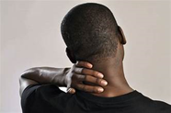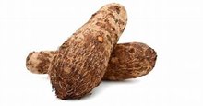
neck (mon) cocoyam (mondo)

mondo (cocoyam), noun: sweet-smelling yam. Jiir mondo ya. Boil the cocoyam to eat.
mor (soak; soaked), verb: to take in water after being left in it for a while. Mor alev man u posu a ye. Soak the
beans before removing the seed coat.
mough (stand), verb: to stay in an upright position on one’s feet. Mough sha. Stand up. See Haa ikav mbi u
tiav inya (Stand down).
mpase (revelation), noun. Something that has not been previously known, now revealed. Mpase ka takeda u
maseityô ken Bibilo. Revelation is the last book in the Bible.
mrumun (agreement, a wish), noun: what has been agreed upon. Mrumun u Ter. The Lord’s wish. M rumun (I agreed), verb.
mtem¹ (settling; rest), noun: state of rest or settlement. Mtem u aningbianev. The settling of families.
mtem² (idleness), noun: state of settling too comfortably. Mnenge hemba mtem. Trying is better than being idle.
mtim (search), noun: exploring or studying. Mtim sha kwagh u angev mbu COVID-19. The search about COVID-19 disease.
mtsee (heat), noun: what comes from a hot source, like the Sun. Mtsee u iyange kehe. The Sun has much
heat. (The heat of the Sun is huge).
mtsem (potash), noun: ash from burnt plants. Kunde atuur wa mtsem. Add potash to okra soup.
mtsera (profit), noun: what one gains from sale of something. M tee takeda m zua a mtsera. I sold the book
for a profit. (… I got a profit).
mtu (calves), noun: back part of leg. M tondo ivav ken mtu (wam). I have a cut in my calf. Mtum (calves), plural noun.
muemue (firefly), noun: a flying beetle that brings out a soft glowing at night. Muemue ngu tan iwanger. The
firefly is giving off light.

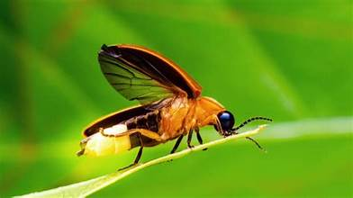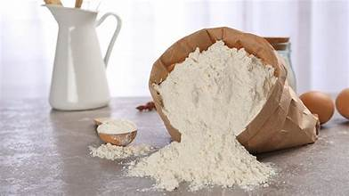
firefly (muemue) flour (mwem)

mule (shade), noun: the dim area resulting by something blocking direct sunlight. Kon gba mule. The tree
cast a shade.
mumu (millet flour), noun: roasted fine-ground millet. Mor mumu ma. Soak (add water to) the roasted millet flour to drink.
mura (swollen), verb: to become enlarged from swelling. Ihowe wam mura. I have a swollen finger. Imor (a swelling), noun.
musan (exchange; change), verb: to give one thing for another. M musan idyer m zua a akôv. I exchanged a
hat for shoes. Imusan (change), noun.
mwem (flour), noun: fine powder made by grinding grains and nuts. Mwem ma amine doo ma kunden iber a
min. Millet flour is good for making porridge. See tukwa (flour). Noun.
myom (blessing), noun: anything that brings one happiness or fortune such as being saved. Vedan zua a myom
hen Aôndo. Vedan got blessing from God. See Oryiman (Saviour).

N
na (give), verb: to provide something to another. Na un kwaghyan (give him/her food). Na m (give me). Na ikaan
(Give an answer). Na ibo (blame, fault). Na jime (turn your back)—disregard someone. Na m (give me), ; nam mngerem (give me (some) water); Na se (give us), nav ve (give them).
naha¹ (row a boat), verb: to make a boat move. Naha tso wou fere fe fere. Row your boat fast.
naha² (knead), verb: stir into a thick paste with spoon. Naha ruam. Kneed fufu. Ruam nahan (kneeded fufu), noun clause.
naha³ (oar, wooden spoon), noun: tool or implement used for steering a boat or for stirring food. 1. Wa naha
shin ityo tso ture mngerem tso a yem. Place the oar under the boat and push the water to move the boat. 2. Tôô naha za naha ruam. Take the wooden spoon to kneed the fufu.

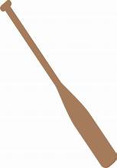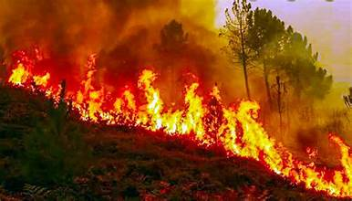
oar (naha³) burn (nande)

nahan (so, so that), conjunction: therefore; for this reason. M vôr her; nahan, m yem m za yav. I was still tired; so, I went and slept.
naira (Nigeria currency), noun: currency used in Nigeria for trading. Naira mom ka kobo deri. One naira equals one hundred kobo.
nam injô (forgive me; I’m sorry), verb: to express a fault or wrongdoing. Nam injô sha ieren i bo yam. Forgive
me for the wrong I have done.
nambe (offer a gift), verb: offer money to appreciate a good act or deed. Nambe un amar. Offer a gift of money for a good dance.
namegh (thigh), noun: part of body between the knee and waist. Chicken thigh. Namegh ku ikegh. Anamaikegh (thighs), plural noun.
nande¹ (burn), verb: to set fire to something. Nande toho. Burn the bush (grass).
nande² (yell), verb: shout at someone or something. M nande a wanye. I yelled at the child.
naregh (stretch), verb: to make something longer. Naregh roba. Stretch the rubber band. Compare, kôôm (to straighten), verb.
ndahar (small), adjective: not big. Nortar ndahar ga; a kehe. An elephant is not small; it’s big.
nder (wake up), verb: to stop sleeping. M nder wanikundan. I woke up the baby.
ndoor (shed), verb: to drop from a tree as in leaves. Ika ndoor. The leaves dropped.
ndor (wet), adj.: not dry; has some water inside. Ikondo ngi ndor. The cloth is wet.
nduur (shake off), verb: to fling something or body (in dogs) to get off unwanted particles or water. Nduur ikondo i
sha gambe ihundu i due sha. Shake off the dust from the bed sheet.
ne (you, plural): the pronoun you. Ne mba nena? How are you (pl)?
neer (excess), adj: a greater amount than needed. Kwaghyan neer. Here is excess food.
nemba (number), noun: a specific quantity or point on the number line. M tôô nemba utar ken atô u mbayev pue. I
took number three out of ten children.
nena (how), adv: in what way. U ngu nena? How are you (sing.)?
nenge (see), verb: to watch with your eyes. M nenge a we ga. I didn’t see you. Nenge avegher cii (examine); nenge shami (observe).
nes (nurse), noun: a person trained to look after patients. Ngumimi ka nes. Ngumimi is a nurse.
ngise (previously), adv: what happened in the past. Peturu ngise i doo ishe. Petrol was previously inexpensive.
ngô (mother, female-type), noun: female-ype that has (expected to have) brought forth new life. Amina ka ngô u Shehu. Amina is the mother
of Shehu. Also, ngô kwase (old woman—impolite); rather: kwase vesen or tamen kwase (elderly woman). ngôbua (cow);
ngôijôv (a wicked witch); (c.f., angôijôv); ngôikegh (hen); ngôiyôngu (ewe); ngôivo (nany or doe). Ngô, noun.
ngohol (get/take), verb: to be given something. Ngohol agogo ne. Get this watch/clock.
- ngohol ase (here it is); ngohol mngerem (take/have/get some water).
ngu (have), verb: to possess or own something. M ngu a naira pue. I have ten naira.
ngu la (that), pron: being particular person, place, or thing mentioned. Ka ngu la ga; ka ngun. It is not that one; it is this (one).
ngun (this), pron: the thing just mentioned that is nearby. Ka ngun; ka ngu la ga. It’s this; not that (one).
ngura (scratch, scrape), verb: to make marks on a surface with nail(s) or sharp object. Kpatema nguram akughur. The cat scratched me.
nom¹ (husband), noun: the male partner in a marriage involving a male. David ka nom u Jane. David is Jane’s husband.
nom² (male-type, spectacular object), noun: something that stands out from a group of things. Nom bua (Bull).
Nom ishan (Brightest star in the sky/male star). Anom (male-types), plural noun.
nombol (tongue), noun: part of the mouth that helps in speech and swallowing. Nombol ka u wase u tesen mnyoho u kwagh. The
tongue helps to identify the taste of something. iniombor (tongues), plural noun: iniombor usu (tongues of fire or flames).
nombua (bull), noun: See nom (male-type); anomaibua (bulls), plural noun.
nomikegh (cock, rooster), noun: See anomaikegh (cocks), plural noun.
nomivo; kpev (buck or billy), noun: male goat. Nomivo ngu nôngon num. The buck is fighting. Wannomivo (buckling or baby male
goat), noun.
nomiyange (noon), adv: the middle of the day; about 12 o’clock before pm. Ma cigh sha nomiyange. Take medicine at noon.
nomiyar (buck), noun: male antelope. See “deer” and “goat.”
nomor (war hero), noun: brave person who fought in war. Iorchôr yan lu nomor u lu nôngu itiav mbi tar cii mbi sha uhar.
Iorchôr was a war hero who fought in the Second World War.
nomso or (man/male), noun: an adult male human being. M ngu nomso or. I am a man/male.
nongo/nongu (line), noun: a group of points or things placed in a path, one after another. Wa nongo za haa
ishangen. Get in the line to go (and) vote.
nôngu/nôngo¹ (try), verb: to attempt to do something. Nôngo u bughum pampam. Try to open the can.
nôngu/nongo² (fight), verb: a physical battle to win something. Nôngu itiav. Fight the war.
normnger (hippopotamus), noun: an animal that looks like an elephant but has no tasks. Normnger tse shin
mngerem ma ma ze ga yô. Hippopotamus lives in shallow waters.

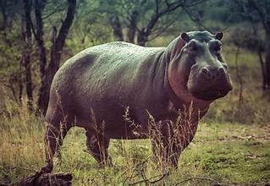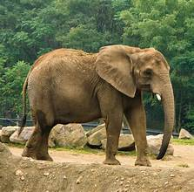
hippopotamus (normnger) elephant (nortar)

nortar (elephant), noun: a large animal that lives on land with ivory tasks, a short tail, trunk and huge feet. Nortar
ye toho. The elephant eats grass.
num¹ (fight/fighting), noun: engaging in a fight. M nôngu num vea Andyar. I fought with Andyar.
num² (scatter, destroy), verb: to destroy or cause to scatter. Uliangi num kasua. Uliangi caused the people at the
market to scatter.
numbe (play), verb: to engage in playing. Yem za numbe. Go and play. Numbu (plays); (ve/ne/se) mba numbu: (they/you, pl/we)
play.
nune (Tiv condiment), noun: fermented seeds of soybeans. Nune huma. The fermented soybeans smell.
nungwa (mix), verb: to blend or put together. Nungwa mwem ma amine man mngerem kunde iber. Mix millet flour
and water to make porridge.
nur (bulge), verb: to curve outward as in a swelling or abnormal extension. Kwaviyologh na nur shie u usu hia un yô.
His skin bulged when he had a burn. Nur igundu (show pomposity by holding shoulders high), idiomatic.
nura¹ (needle), noun: used with a thread to sew. Tumba mough sha nura kor wondo. Thread the needle to sew pants.
nura² (injection), noun: the act of putting liquid medicine into the body. Nyen m kuma anura. I had an injection.
nyadeawambe (hematuria), noun: the disease where one has blood in the urine. M zua a nyandeawambe. I got hematuria.
nyen (yesterday), adv: the day before today. Nyian ka Sati; nyen i lu tom ataan. Today is Saturday; yesterday was Friday.
nyiaawambe (bilharzia), noun: disease where one has blood in one’s stool. Putina ngu a nyiaawambe. Putina has bilharzia.
nyian¹ (ripe), adj: ready to be eaten or harvested; ready for something. Mongol nyian, man nyoho kpaa. The
mango is ripe and is also sweet.
nyian² (today), adv: the current day that we are in. Nyian ka hiitom. Today is Monday.
nyian³ (red), adj: the color after orange in the rainbow. Awambe nga nyian. Blood is red.
nyinya (horse), noun: an animal with four legs, a mane, and a long tail. Rekiya henda nyinya. Rekiya rode a horse.

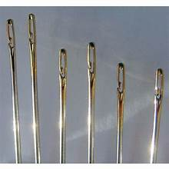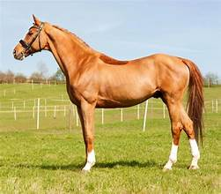
needle (nura) horse (nyinya)

nyion (aching, hurting), verb: to be in pain. Mon ngu nyion mo. My neck is aching. See mnyionom (ache/pain), noun.
nyôr (enter, fit, penetrate, arrive), verb: to come/go into. 1. A nyôr. He/she has entered/arrived. 2. Isheti ne
nyôrom ga. This shirt does not fit me.
nyuma (bite), verb: cut through something with teeth. Nyuma ciinyam ma u tam ye. Bite the piece of meat
before you chew it.
nzughul (confuse; mistreat), verb: to make unclear or be mixed up. 1. Kwagh ne nzughul mo. I am confused about
this thing. 2. Ior mban nzughul a mo. These people mistreated me.

O
oda¹ (order), verb: to give instructions or command. Kyaftin na oda er ve mough (sha). The captain ordered them to stand (up).
oda² (order), verb: to request that goods be sent based on a purchase. M oda akov ken Amerika. I ordered shoes from America.
oda³ (order), noun: a command or request made to act. 1. Poloshi var sha kpande oda u ior ve kar a kar yô. The
police pasted on the board the order for people to keep moving. 2. U faityô u va tôôn oda wou. You can pick up your order.
ombor (dry form), adj: without water; not damp or moist. Koso alev ou ombor. Preserve your beans in dry form.
Also, alev a ombor (dry beans).

omon (dissolve in mouth), verb: help something like a candy to dissolve in the mouth. Omon ishange i
vitamin. Allow the vitamin tablet to dissolve.
ongo (scoop), verb: to lift or pick up grains/seeds with hands or a scooper. Ongo sam abun. Scoop ground nut seeds.
ongol (excavate; drill), verb: remove material from a mass to make a hole or cavity. Ongol kon er imar.
Remove material from a stick to make a flute.
onough (remove), verb: to take material from hole or cavity). Onough tough sha mough. Clear the ear wih cotton.
ônough ônough (callisces), noun: you get them at the base of nails of your hands. U huran kwagh gbing ka a
va a ônough ônough. A lot of weeding brings calluses.
ônov (ofspring), noun: children, babies, young ones; plural for wan. See wan (child). Ônov Tiv. Children of Tiv. (Tiv people).

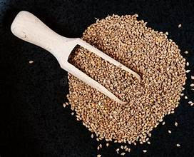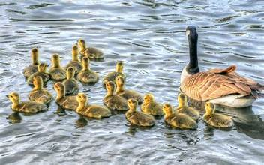
scoop (kese/ongo) offspring (onov)

oo (yes), exclamation: answer with a positive response from afar): A rumun er, oo. He answered with an oo.
ôô (bathe), verb: to wash or clean in water. Ôô iyol. Take a bath or bathe.
or (person): male or female human being. Wanye kpa ka or. A child is a person, too. ior (people); nomso or (man). Also, the following:
- Or Amerika (An American)
- or eren angereke (a gossiper)
- Or Tiv (A Tiv man)
- orangereke (gossiper)
- orfanatindi, loya (lawyer)
ôr¹ (read), verb: to silently or loudly say what is written. Ôr kwagh u mhii u tar sha won. Read about creation of the earth.
ôr² (speak; tell), verb: to say something or narrate a story. Fada ôr kwagh u i doo u wasen mbaastanev yô. The
Rev. Father spoke about why it is good to help the poor. Ôr (tell). Also,
- ôrkuma (convincing);
- ôr i kuma (convince), verb
orkwav (contemporary), adj: persons of the same age. Bako ka orkwav u Bajimba. Bako is the contemporary of Bajimba.
orôronijir, joji (judge), noun: a person assigned to render penalty for violation of laws. Jooji wa un purusu
anyom ahar. The judge gave him a prison term of two years.
orpurusu (prisoner), noun: the person imprisoned. Wasa mba nengen sha orpurusu, the guards are looking after the prisoner.

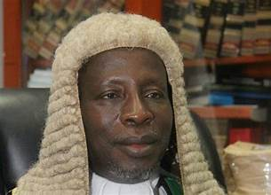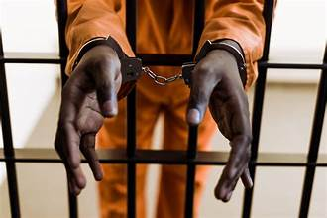
judge (joji) prisoner (orpurusu) worker (ortom)

ortamen (elder), noun: a leader in the church. Saba ka ortamen u ken iyough adua. Baba is a church elder.
ortese (male preacher, Bible teacher), noun. See Atese (female Bible teacher)
ortesen; tica (teacher), noun: one who teaches. Ortesen ayenge. Math teacher.
ortiom (messenger), noun: See mbaitiomov (angels or God’s messengers).
ortiom u Aôndo (angel), noun: spiritual messenger of God. Aôndo tindi ortiom er a va or Elisa kwagh. God sent His angel to come to
tell spmething to Elisa.
ortom (worker), noun; mbatomov (workers, labor force), plural noun. Ortom ngu a ishôm. The worker has a matchet.
ortwer (doctor), noun: someone who keeps people well or treats sick people). See twer (treatment of
the sick). Kwase za u za nengen a ortwer. The woman has gone to see the doctor.
orvesen (elder), noun: a person advanced in age and considered respectable. Akume ka orvesen u Pila. Akume is Pila’s elder.
orwam (my friend), noun phrase: a close friend. Uwua iyange lu orwam. Uwua was my friend.
Orya (head of home), noun: traditional head of the Tiv home. Orya maa iyough. The head of home built a house.
osough¹ (loose hold), verb: to get free from a hanging position. Or unden wo osough gba. The mountain climber lost hold and fell.

osough² (get free), verb: to free from bondage or imprisonment. Dwem osough yevese yem ken ikô. The
hyena got free and run into the forest.
osu (crispy), adj: thin, hard but easily broken. Iyough ki kaan ki osu. Yam chips are crispy.

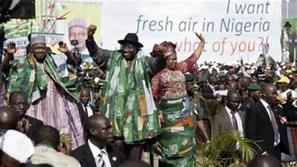
doctor (ortwer) politics (pati)

P
pa (path), noun: narrow road. Yem sha pa u ibua. Go along the cattle path.
paa (cut), verb : to cut grass with a matchet. Paa pa u zan shin ijande. Cut the grass along the path to the pond.
pam (pound sterling), noun: British money. Pam mom ka naira dubu uhar. One pound is two thousand naira.
pampam (can), noun: a metal storage container. Bugh pampam u tematu. Open a (the) can of tomato.
pande (subtract, reduce), verb: to make less. Pande mngerem. Reduce the amount of water. Also, Pande;
mpande (subtraction)
paregh (step aside), verb: to avoid something/danger, verb. Paregh mato a de te sha we ga. Step aside to
avoid being hit by the car.
pase¹ (explain), verb: to make something clear. Tica pase se u eren ayenge a kwaghkwa. The teacher
explained to us how to solve multiplication problems.
pase² (acquit, release) , verb: to let go or set free. Dugel pase un. He/she was freed by the police.
Paselami (psalm), noun: Bible poetry by unknown author. Ôr Paselami 23. Read Psalm 23.
pati (politics), noun: the way governments are run. U ngu ken pati u PDP shin ka pati u APC? Are you in the
PDP party or the APC party?
pav (divide; slice), verb: to split or cut open. Pav mbuer avegher ahar. Slice the pawpaw into two halves.
pel (plate, armor), noun: a protective shield. Orshoja wa pel yen itiav. The soldier put on armor to war.
pelasetiki (plastic), noun: material that can be formed into different shapes to make bottles, cup, buckets,
and so forth. Ikpe i pelasetiki. A plastic bottle.

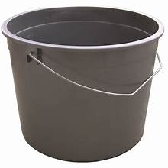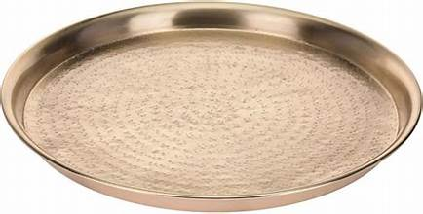
plastic (pelasetiki) tray (pelengi)

pelengi (tray), noun: a large metal plate. Haa atuur sha pelengi a uma. Dry the okra on a tray.
penda (put, place), (v): to set down something. penda sha tebul. Place it on the table.
pepa; pipa (paper), noun: thin sheet on which something can be written or drawn. Kpera kwagh sha pepa.
Draw on the paper.
pepe (morning), noun: the beginning part of the day. Iyange due pepe. The sun rose in the morning.
pepepepe (dawn), noun: very early in the morning. M nder pepepepe u wan ago a yaren tom. I woke up at
dawn to get ready for work.
per (cross), verb: to go from one side to the other. M per wagh sha tso. I crossed the stream by boat.
peturu (petrol), noun: the gas you put in your car. Peturu taver ishe. The petrol is expensive.
pev¹ (valley), noun: an area of low land between hills or mountains. Pev u Seragi. The Seragi valley.
pev² (puncture), verb: to have a hole in something. Balun pev. The balloon punctured.
pev³ (test), verb: feel to see if soft or cooked (of roasted/boiled food). Kuma nurô u nengen iyough kia via yô. Push a pricker to
to find out if the yam is cooked.
pikcha, foto (picture; photograph), noun: an image of something. Tôô foto u wanye. Take a picture of the child.
pine (ask), verb: to put a question to someone. M pine shaciu m soo u fan. I asked because I want to know.
pir (quench, extinguish), verb: to put out a fire or flame or light. Pir usu. Extinguish the fire. Also, Pir usu
(put out the electric light).
pira (boast), verb: to speak too much about oneself. Kaan pira. He/she boasts. Piraor (one who boasts about
his/her strength. Piraikyaa (boastful statement).
pitapita (soggy), adj: full of water. M wa ruam mngerem ngee, a hingir pitapita. I put too much water on
fufu, and it has become soggy.
place (ijiir), noun: a certain space. Ijiir i teman. A place to sit.
pom (pump), noun: a device to push (draw) air or liquid into (out of) a space or container. Suwe bol sha pom.
Use the pump to inflate the ball.
pon (reveal, expose): to leave out in the open. M pon ve mbamyer. I exposed their secrets. apon
(revelations), plural noun
poo (full), adj: filled up till no space is left. Bokoti iv a mngeem poo. The bucket is filled to the brim
with water. Archaic.
porotin (protein), noun: material that helps living things grow. Alev nga a porotin gbing. Bean have plenty of protein.
posu (remove seed coat), verb: posu alev man u wua u kaan akuese ye. Remove the bean seed coat before
grinding to make bean cakes.
pughul (boil), verb: to heat water to the point when steam begins to come off. Pughul mngerem kunde iber.
Boil water to make porridge.
pupur (white), adj: light colour. Awambe nga nyian; ake a mough nga pupur. Blood is red; cotton balls are white.
purugh (fly), verb: move in the air with wings or engine. Inyon purugh yem. The bird flew away.
puse (wrap), verb: tie loosely around waist. Puse ikondo uya vaa ku. Wrap the cloth around the waist to mourn the death.
purusu (prison; jail), noun: a place where prisoners are housed. Ijir kôr Bali, nahan i wuhe un ken purusu.
Bali was found guilty, so he is sent to (locked up in) prison.
purututu (all), pron: the whole of something. Igo ya ahi purututu. The pig ate all the nuts. See cica (all).
putôputô (muddy puddle), noun: shallow pool of water with mud in it. Mbayev hungwa shin putôputô. The
children entered the muddy puddle.
puu (despise, criticize, disparage), verb: to find fault. A puu mhen wam. He/she criticized my idea/opinion.

R
raka (worthless), adj: Hebrew term meaning something has no value. De yilan or we raka ga. Do not to call a person, raka.
redio (radio), noun: a device used for receiving sounds electronically through the air. M ungwa abaver sha
redio. I heard the news on the radio.
reiki (rake), noun: a tool with a long hand attached to a metal bar with teeth or prongs used for spreading
dirt or collecting leaves. Kohol ika sha reiki. Gather the leavers with a rake.
riga (shirt, gown), noun: a dress or garment worn by women and men. Hua riga. Put on a gown.
roboti (robot), noun: a machine that does things almost like a human being. Wegh ku roboti. A robot hand.
ruam (fufu), noun: mashed/pounded yam, thick pottage. Gema er ruam bee. Gema has finished making
fufu. Ruam kumen (pounded yam fufu); ruam nahan (stirred millet/oat fufu).
rule (ruler), noun: a measurement tool. Rule ka kwagh u kperen hwange a min. The ruler is a tool for drawing a line.
rumun (agree; agreed), verb: to have the same idea or opinion about something as others.M rumun. I agreed; se rumun (we
agreed); ior mba rumun (people are accepting or agreeing; ior rumun (people have agreed).

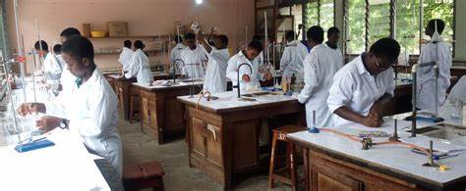
robot (roboti) science (sainz)

S
saa¹ (die), verb: a person losing their life. Tor u Japan saa (ku). The king of Japan is dead.
saa² (lose; lost), verb: something cannot be found or is misplaced. 1. Ka m saa akaa fere fere. I always lose
things. 2. Agogo am saa. I lost my watch.
saa ishe (spoil, useless), verb: to decay or rot; to act without proper thinking. I zôr temato fefa ga, nahan a
saa ishe. The tomatoes were not picked in time, so they spoiled.
saghela (suddenly), adv: quickly and without expectation. Kpatema nule saghela due. The cat suddenly moves away.
sagher (thorny green), noun: small shrub with prickly thorns used for its ash (potash). Nande sagher kura mtsem. Burn the thorny
green to get the ash.
sainz (science), noun: the study of things by obtaining facts through experiments and investigations. Sainz ka
a wase se u zuan a mcimbim ma been iangev. Science helps us find medicines to cure illnesses.
sam (seeds), plural noun: part of a plant that can be sown to produce new plants like the first. See ishange
(seed), singular noun.
sambe¹ (slap), noun: the act of smacking a person. Sambe u a tem la ngu nyion mo heregh. I am still hurting
from the slap he gave me.
sambe² (slap), verb: to hit someone with the palm of the hand. A ta or sambe sha uwasegh. He/she slapped
the man on the cheek. [ta sambe (to slap)].
sambe³ (clear), verb: no longer cloudy or crowded. Abeen sambe. The clouds cleared.
samber (unroll, spread out), verb. Samber ikondo haa sha tebul. Spread the cloth on the table.
sange (remove), verb: pick up grains from a spot or a mixture. Sange inya sha aluer gbande u alev ngu a inya
shimin yô. Remove sand if the bowl of beans has sand in it.
sanger (gourd), noun: a large gourd for storage. Mba kera eren sanger ainge ga. They currently do not make a
gourd for storage. Archaic.
sar¹ (unpeap, dismantle, spread), verb: to flatten a heap of things. Sar tihi inya. Unheap the mound of earth.
sar² (wish, desire, crave), verb: feel a need for something. Sar em u tamen cungam. I crave chewing gum.
Isharen kwagh (a wish), noun. sar u suan (nauseous): feel like vomiting.
sase (gluttonous grabbing), verb: acquiring things more than is necessary. U sase kwaghyan mbagen ve a zua a min ga. Gluttonous
grabbing food will leave others without. See huwa (gluttony), noun.
sati (Saturday), noun: sixth day of work. Sati ka a va man i lu Lahadi ye. Saturday comes just before Sunday.
se¹ (laugh), verb: to make sound to show one is amused or happy. Ve se shaciu kwaghhir hôm. They laughed
because the tale was funny.
se² (we, us): plural pronoun. Se sugh (we thank); na se (give us); se mba (we are)
seer (add, extend), verb: to increase the amount of something. Seer bar. Add salt. Seer (addition, in
mathematics), noun. Also, isheer (additional), adjective; as in isheer ruam (additional fufu).
sekendi (second), noun: one of sixty parts that make one minute. Me hide ken sekendi pue. I’ll be back in ten seconds.
sekul derava (screwdriver), noun: a tool that can turn a screw. Sekul derava u itiough ki ishan. A star-head screwdriver.
sema (kernel), noun: the hard center core of some fruits such as pear and peach. Mzembe ngu a sema. The
African pear has a kernel.
sementu (cement), noun: material made from clay and limestone and mixed with sand and water to make
blocks; pave walkways. Ta akam a sementu maa iyough. Produce cement blocks to build a house.
sen (flow), verb: to move along a path or an area in descent. Haa mngerem sha itiough ki wough ma sen shin
inya. Pour water on top of the mountain to flow down.
senda (lock), verb: to secure so it can be opened only with a key. Senda hunda. Lock the door.
sende (hang), verb: to kill a person by hanging. Aluer u wua or yô, New Hampshire ken 2024 una sende u. If
you kill a person, New Hampshire in 2024 will execute you by hanging.
senge (pretend), verb: A senge er un yav kpa ngu aver. He/she pretended that he/she slept, but is still yawning.
sentimita (centimetre), noun: one part of the 100 parts in one meter. Mita mom ngu a sentimita ker deri
mom. There are one hundred centimeters in one meter.
sesenge (hiccup), noun: uncontrolled breathing movement where muscles abruptly pull in air; a sound is
made. Sesenge wou ngu zan mo iyol. I am bothered by your hiccup.
seta (ginger), noun: plant whose roots are used as spice. Ka m wa seta shin iber. I put ginger in my porridge.

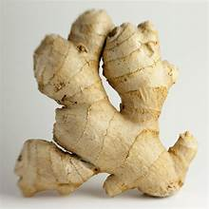
ginger (seta) prominent scientist
(shagba or u sainz)
seturoku (stroke), noun: a disease caused by part of the brain not working well. Nôngu u yangen seturoku.
Try to prevent stroke.
sev (day), noun: the time between sunrise and unset; from dawn to dusk. (See iyange). Sev av. Day has
broken. Also, Sev av! (Goodday!), not common.
sha (up, away, at, by), adv: from a lower to a higher point or position. Mough sha. Stand up. Note: This is not
redundancy, since “stand down” is an acceptable idiomatic expression. See Yem sha (Go away). Also,
sha use (at dawn); sha agee (by force)
shaciu (because), conjunction: the result of something happening. M se shaciu hôm. I laughed because it is funny.
shaciu nahan yo …(therefore), adv: it is required; therefore, I must buy it. Ka keng; shaciu nahan yô, me yam un.
shagba¹ (distinguished; prominent), adj: well-known and highly placed. Shagba or. Prominent/distinguished person.
Shagba kwase (prominent/distinguished woman)
shagba² (claim of authority), noun: claiming to have power to make and enforce decisions. De u eren shagba
sha a vese. Stop claiming to have authority over us.
shase (cashew), noun. See ishase (cashew). Asase (cashew trees), plural noun.
shuga, soga (sugar), noun: a sweet substance that comes from sugar cane or beet. Wa shoga shin tii. Put sugar in the tea.
shi (left), verb (past tense): remaining—of a quantity of something. Se henda ikeke miel uhar; shi miel mom u
nyôron. We rode the bike two miles; with one mile left to get there.
shie (time), noun: a period when something happens. Shie kuma u yemen. It is time to go.
shiga, shigari (cigarette), noun: chopped tobacco leave wrapped in paper for smoking. M soo shigari i man ga.
I don’t like to smoke cigarette.
shilishôn (solution), noun: liquid rubber used for sealing holes or punctures in a tube. Shie shilishon sha tiubu
cir ihula. Rub the solution on the tube to seal a hole.
shin (down, in), prep: at a lower level; not outside of something. Hungwa shin ijôr. Go down the well. Hungwa
shin inya: Come down to the ground.
shingir (sweater), noun: a knitted material worn in cool weather, usually over a shirt. Wuhe kôr; huwa shingir.
It is cold; wear a sweater.

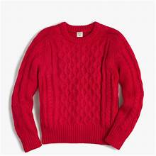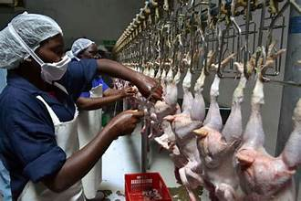
sweater (shingir) slaughter (sôngo)

shiôr (person in courtship), noun: one of the two people seeking to be married. Ashi ka ishior i Ortiv. Ashi is in
courtship with Ortiv.
sôngu (slay, slaughter), verb: to kill an animal for meat. Sôngu ngôbua u eren inongu. Slay the cow for the feast.
songol (lessen), verb: to reduce weight. Apeze songol indi. Apeze has reduced weight.
soo (like), verb: to desire or want something. m soo mbuel u yan. I like to eat pawpaw (papaya). Ishoon: a
liking, attraction (noun). Pila ngu a ishoon hen Tabi. Pila has a liking for Tabi.
sôô (sting), verb: to pierce the skin with a stinger or sharp pint. Ishondoike sôô m. The ant stung me.
sôôr (woo, court), verb: to try to win someone’s love or enter marriage. Atim ngu sôôr wan u Butu. Atim is
courting Butu’s daughter.
soso (sponge), noun: used for scrubbing things to clean them. Ka m kile iyol sha soso. I scrub myself with a sponge.
sua (vomit, puke, throw up), verb: to throw up food or drink taken. M sua. I vomited. Ishuan (vomit), noun.
suga, shuga (sugar), noun: a sweetener from sugar cane or sugar beet. Wa shuga shin tii. Put some sugar in the tea.
sugh (thank), verb: to show gratitude for a good deed. M sugh u er u ve nahan. (I) thank you for coming.
sule¹ (cool), verb: a state of not much heat. Kofi sule; u faityo u man (un). The coffee is cool; you can drink (it).
sule² (shilling), noun: old British coin; one British pound was twenty shillings. Sule kera ngu ga. There’s no
more shilling coin.
sule³ (farm), noun: where crops and animals are grown. Orya ngu a zege sule u ibua. Orya has a large cattle farm.

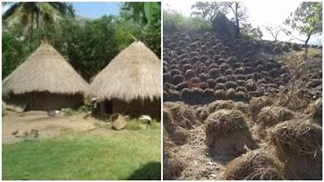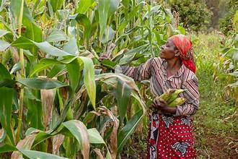
farm (sule) harvest (sunda)

sunda (harvest), verb: to gather crops. Sunda wua. Harvest Guinea corn. sunda—harvest (n): what is harvested.
sur (calm, comfort; cool), verb: to become less excited; to make less hot. 1. Sur un ishima. Comfort him. 2.
Sur tii sha mngerem ma ndôohol. Cool the tea with cold water.
suruwa (cautious), adj: to be aware of how to behave. Ngô na kaa er a er suruwa sha liam na. His mother said
he should be cautious in his speaking.
suse (suck), verb: to lick with the tongue. Suse ahôm sha ihôwe. Suck the fat off the finger.
suse zwa (kiss), verb: display love by sucking air from one’s mouth or cheek. Or suse kwase na zwa. The man
kissed his wife.
suur (lean), verb: to rest on or place against something. Suur ken kpekpe. Lean against the wall.
suwe¹ (pump), verb: to inflate with a pump. Suwe taya u mato. Inflate the car tire.
suwe² (support), verb: to help make a structure firm. Suwe tor sha mtôm ma taver. Support the roof with
strong pillars.
swange (a dance), noun: dance performed by women and men. M fa swange u vinen dedoo. I can do the
swange dance very well.
swase (variety of meats), noun: different kinds of meats such as beef, lamb, and goat. M er inongo; swase
ngee (de ishar). I made a feast; there was a variety of meats.
swem (Tiv traditional god), noun: the god worshiped by Tiv traditionalist. A bum sha Swem. He/she swore by Swem.

Tiv-English Word List from T-Z

T
ta¹ (shoot; hit), verb: to throw something at; to let a bullet or arrow hit something. Ta ivaan. Shoot an arrow. ta sambe (to slap).
Conmpae, ker ivaan (shoot an arrow). Ker iwen (throw a stone).
ta² iwanger (explain), verb: to literally “throw light on” an issue. Ta iwanger sha kwagh u kwase eren u Tiv.
Explain about Tiv marriage. Idiomatic.
taa (aid to walk), verb: to guide a child while learning to walk. Taa wan a zende fere. Aid the child to walk soon.
tahav¹ (freedom), noun: The power to do something (speak, choose, or act); the power to get out of
something. 1. M ngu a tahav mbu lamen er m soo yô. I have the freedom to speak as I want. 2. M ngu a tahav mbu duen
ken mkange. I have freedom to get out of bondage.
tahav² (energy), noun: the ability to do something. M ngu a tahav mbu tôôn kilo utaan. I have the energy to carry 5 kilos.
takeda; takerada (book), noun: bound pieces of paper with writing and pictures on them. Ôr takeda. Read the book.
takema (harness), noun: device attached to a horse to control it. Wa nyinya takema. Put a harness on a horse.

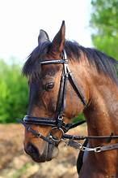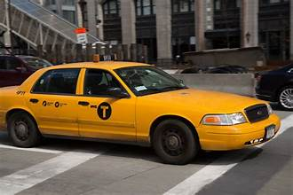
harness (takema) taxi (takezi)

takezi (taxi), noun: a vehicle for hire that carries passengers to places. Nyôr takezi yem Makurdi. Enter a taxi to go to Makurdi.
tam (chew), verb: to grind food with teeth. Tam kwaghyan wou man u mena ye. Chew your food before swallowing.
tambe (gag), verb: to prohibit. I tambe un sha u a de bughun zwa ga yô. He/she was gagged so they wouldn’t talk.
tamber (wait; linger), verb: wait a while. Tamber kpuaa; Fada una nyôr higen higen (wait a while, the Priest will arrive soon.
tamen (older), adj: when one is born at an earlier date than the other. Ter ngu tamen a Ses. Ter is older than Ses.
- Tamen kwase (elderly woman). Compare, tse/ngô kwase (impolite).
- Tamen or (elderly man). Compare, tse or.
tange (barrier), noun: a boundary to stop trespassers. Wa tange hen sule wou. Place a barrier at your farm.
tar¹ (land, country, earth/world), noun: a large area of ground. Tar u Tiv. Tiv land.
tar² (lay furniture), verb: to set furniture. Tar orvaninya ikagh/gambe a yav. Lay or prepare a bed for the
visitor to sleep (go to bed).
tartor (kingdom; reign), noun: the land or people over which one rules. Tartor wou u va. Your kingdom come.
tav (tall), adj: of a greater height when compared to the norm. Ola ta. Ola is tall. Also, tav kar (taller than).

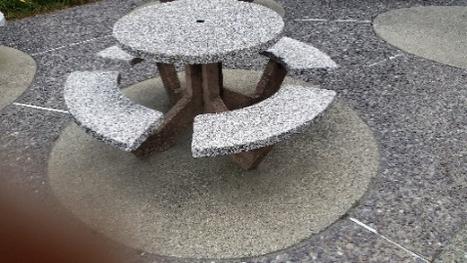
tall (tav) table (tebul)

taver¹ (hard, difficult), adj: not easy to solve. Kwaghkaren taver, kpa seer taver ga. Division is hard/difficult, but
addition is not hard/difficult (is easy).
taver² (strong), adj: not soft. Ikeve i taver; ayaba taver ga. A coconut is hard; a banana is not hard (is soft).
taver ishima (persevere), verb: to be encouraged. Taver ishima yevese mita dubu bee. Persevere to complete
the one-thousand-meter run.
tawel (towel), noun: a piece of cloth or paper that can absorb water used for wiping or drying things. Ngohol tawel uma iyol.
Get the towel to dry yourself.
tebul (table), noun: furniture at which people eat or work. Ver kwaghyan sha tebul. Place the food on the table.
tegh tegh (slowly), adv: hot fast. Baba ngu zan tegh tegh. Grandpa is going slowly.
televishen (television), noun: a device that receives pictures and sound sent electronically from a distance.
Bugh televishen se nenge abaver. Turn on the television for us to watch the news.
tem (crack open), verb: to push out the nut from its shell. Tem abun. Crack open the ground nut (peanut).
tema (sit), verb: to stay rested on some furniture. Tema shin ikôn. Sit in the chair. Also: tema inya (sit down); tema gigh gigh (sit
still); tema tor (ascended to or sat on the throne/kingship)/reigned.
tempecha (temperature), noun: a measure of how hot or cold something is. M hia iyol je tempeca wam nyôr
100ºC. I have a fever so much that my body temperature has reached 100ºC.
tenger (shake), verb: to cause something such as tree branches or rope to move. Tenger gbaa kon. Shake the branch
of the tree.
ter¹ (father), noun: a male parent. Gyado ka ter u Kugba. Gyado is the father of Kugba. Ter em (my father);
ter wen (your father, pl); ter na (his/her father); ter wase (our father); ter ve (their father).
ter² (mention), verb: to speak or tell about something briefly. M ter ve kwagh u mgemishima. I mentioned to
them about repentance.
ter³ (Lord or God), noun: one having great power over others. for example, a king or God. Ter ngu a vese. God
is with us. Ter zungwe (Lord has shown mercy); Ter na se. The Lord or God has given us.
tese (show; teach), verb: to allow something to be seen or understood. 1. M tese ve ape ve tema yô. I showed
them where to sit. 2. Tica tese se ayenge. The teacher taught us mathematics. Tese mhoonom ma zungwen (show compassion/forgiveness/mercy)
tica, ortesn (teacher), noun: a person who teaches. Abur Ger yange lu tica wam. Abur Ger was my teacher.
Atica (teachers), plural noun.
tighir (main, basis, foundation), noun: what something is based/built on. Tighir kwagh i mzough wase ka nyi?
What’s the main idea of our meeting?
tihi (heap), noun: a mound of something. Ta tihi u ikuleke. Make a heap of corn/maize.

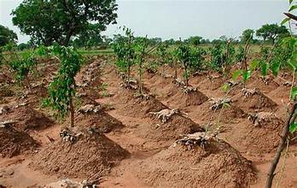
heap (tihi) stand (tile) message (tiligh)
tile¹ (pause; stop), verb: to remain at the same place. Tile a mato Wasem a hungwa. Stop the car for Wasem to exit.
tile² (stand), verb: to stay up on ones feet. Tile sha heregh. Remain standing.
tiligh (massage), verb: to relax the muscle by rubbing. Tiligh mo jime. Massage my back.
tim¹ (destroy), verb: to cause to no longer exist. Mvihi u tar man inyam tim “dodo.” Habitat loss and animals destroyed the “dodo.”
tim² (erect, post), verb: to place a pole or rod in a hole straight up. Tim tôugh ku tuta. Erect a flagpole. timbir (delay; linger), verb: not wanting to leave; doing things to make one late. A kegh kwaghyan timbir un u
zan adua faa. He/she waited for food that made him/her late for church. Ashe a timbir (delaying tactics)
time¹ (dig), verb: to hollow out something like soil to make a hole or pit. Time ihungwa. Dig up soil to make a
pit. The Tiv statements assumes all that is expressed in English. For example, kile zwa (brush your teeth and wash your mouth).
time² (search/research), verb: try to find something by looking carefully and thoroughly. Time sha
msamber u angev mbu Bolabola. Research on the spread of the Ebola disease.
timekumun (burrower-bug), noun: a bug that burrows into soft soil. Mtim u timekumun za ga. The burrow of burrower-bug is shallow.
tingir (tip), verb: to tilt to pour out something. A tingir bokoti er mngerem ma haa cuku. He/she tipped the bucket to pour out a small
amount of water.
toho (grass), noun: a greenish plant that is not a tree; may have grains used for food. Ibua ngi ye toho. Cattle eat (feed on) grass.

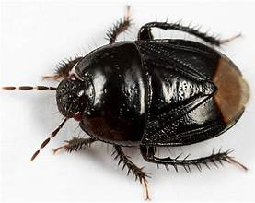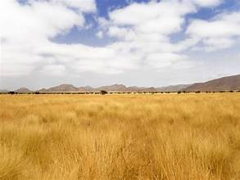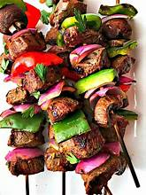
burrower-bug grass (toho) skewer (tombol)
(timekumun)

tôm (covet), verb: jealous desire. De tômon kwagh u or ga. Don’t covet another person’s thing.
tom (work), noun: something that is done when energy or effort is applied. Er tom. Do some work.
tombol (skewer), noun: used for making kabobs. Tumba inyam man tematu sha tombol er suya. Thread the
meat and tomato on the skewer to make kabob.
tôndo (cut), verb: to open or divide something with a knife or sharp object. Tôndo inyam. Cut the meat.
tôndo zwa (promise), verb: to pledge to do or not do something. M tôndo zwa mer me za Abuja. I promised to
go to Abuja. Zwa tomon (promise), noun.
too (pour out), verb: to send a steady stream of liquid flowing out of a container. Too iber ma. Pour porridge
to drink.
tor¹ (king/chief), noun: a ruler of a group of people. Makir ya Tor u Tiv. Makir is crowned the King of Tiv.
tor² (kind of mouse), noun: a mouse that burrows hole deep in the ground for home. Tor ande yem. The mouse burst out.
tor³ (mortar), noun: a short, thick rounded stick for pounding things. Kume ruam sha tor. Pound the fufu with a mortar.
tor⁴ (roof), noun: the top that covers a housing structure. Unde sha tor. Climb the roof.
torough (scald, scrape), verb: to be bruised by hot steam or wounded by scraping. Turugh torough mo wegh.
The hot steam scalded my arm.
tough [ear; ato (pl)], noun: part of the body that helps us hear. Wa abinkuni sha (kughul) tough. Put an earring on the ear (lobe).

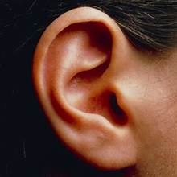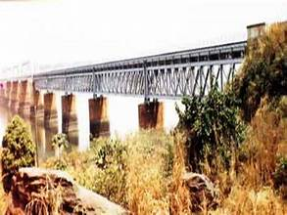
ear (tough) bridge (tsar-Makurdi)

tsa¹ (farrowed land), noun: land left for a year or more before used again for farming. Kaha suyabin hen tsa.
u nan un inya i dedoo. Plant soybeans on the farrowed land to enrich it with nutrients.
tsa² (stay at a place), verb: to stay at a place for a while; to live a long life. 1. Nyen ve tsa heen. They stayed
here yesterday. 2. Anjila tsa sha won je, kuma anyom deri. Anjila lived a long time, up to one hundred years.
tsa³ (tail), noun: the part of an animal such as a dog or horse that is found at the back end of it. Iwa ngi jingir
tsa. The dog is wagging its tail.
tsar¹ (bridge), noun: what is built across the stream or river to allow vehicles and animals to cross. Pe tasr
yem Katsina Ala. Cross the bridge to Katsina Ala.
tsar² (to light), verb: to make light come on by switching on electricity or with a lighter. Tsar imenger. Light a
lantern.

Tsar³ (Mbaduku village), noun: a small village with a large State border market. Nyian ka kasua u Tsar. Today
is Tsar Market day.
tsee (hot), adj: something with a higher temperature than normal. Mngerem man tsee. This water is hot. tseen (heated), adj as in
mkulem ma tseen (heated oil). Also, tsee iyol (it is hot or the body is hot).
tsegh (only, merely), adv: having no one in line or agreement. Ka mo tsegh m ve ye. Only I have come. (I am the only one who has
come).
tsen¹ (expose, of a person), verb: to tell something one has kept secret. Ve tsen iyol ve sha kwagh u iwambe i
gberen. They have exposed themselves about vaccination.
tsen² (leave to sun-dry), verb: to leave something in the sun to dry. Tsen akondo ke won a uma. Leave the
clothes outside (in the sun) to dry.
tsenda (spray), verb: to spread over an area using pressure, hand, or machine. Tsenda ishwa i mende. Spray
the sesame seeds to grow.
tsenger (to be picky), adj: when one desires only the “best.” Ade ngu tsenger u kaan er saa ka namegh ku
ikegh una ya ye. Ade is being picky to only desire to eat chicken thigh.
tser¹ (straw tray), noun: large container woven from straw or other material. Samber sam abun sha tser u uma.
Spread the peanuts on the straw tray to dry.
tser² (shred), verb: cut into small pieces. Tser atuur cii man u kunde a ye. Cut the okra into pieces before
cooking it.
tser³ (trouble), verb: when one is in a situation that is hard to fix or resolve. Kwagh tser se shaciu
mato wase vihi. We are in trouble because our car broke down.
tser⁴ (playing record), noun: a device on which songs are stored to be played. Wa tser u amo a Golozo. Place
(on the record player) the record of Golozo’s songs.
tsev (hatch), verb: when an egg breaks and a chick comes out. Aji tsev. The eggs hatched.

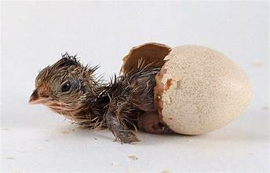
hatch (tsev) boat (tso)
tso (boat), noun: a vehicle engine-powered or rowed that carries people or goods across a stream or river. Nyôr tso
hen Onisha per wagh u Niger un zan Asaba. Enter the boat at Onisha to cross Niger river to go to Asaba.
tsombol (family), noun: father, mother, children and people of the same relationship living together. Terhemba
ka mom ken tsombol u Akpam. Terhamba is a member of Akpam family.
tsombor (hem-end), noun: the corner part of the hem of a piece of cloth. Ulugh zombor ikondo fiil ken
iwenge. Pull the hem-end of the cloth to tuck it in the waist.
tsume (go astray, miss), verb: to go the wrong way or direction. M tsume gbenda. I missed my way.
tsuwa (pick, remove), verb: to take out one thing out of another one. A tsuwa sagh ken ihôwe wam. He/she
removed the pine out of my finger.
tsuwe (hop, jump), verb: to move ver something at a higher level. Jay tsuwe aver gungul kon. Jay
hopped/jumped over the log of wood.
tswen (alone), adj: to be without anyone around. Hanma or yem; m shi tswen hen ya. Everyone has gone; I
am home alone.
tugh (night), noun: time when the sun has set. Tugh ile man ime wa. It is nighttime and it is dark.
tugh tugh (early morning), noun: the beginning of the day. Igirigi purugh mough tugh tugh. The airplane left
in the early morning.
tukwa; mwem (flour), noun: finely ground plant grain. Ngohol tukwa naha ruam. Have some flour to make
pudding (fufu). Idiom: tukwa u purugh hembe u nahan ga (a little loss should not deter you).
tule (sudden pull), verb: to grab and pull, usually shrubs and creeping plants or large sheets. Tule ahu i
wanger u kaha ivom. Pull the creeping plants so it is clear to make a heap.
tumba (to thread), verb: to pass a thread or string through a hole. Tumba mough sha nura. Thread the needle.
turugh (vapor, steam), noun: what water turns into during boiling. Pughur mngerem turugh a due. Boil the
water to produce steam.
tuta (flag), noun: a piece of cloth with symbols that represent a nation or group. Tuta u Nigeria (Nigerian flag).

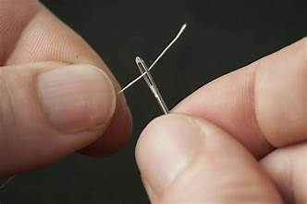
thread (tumba) flag (tuta)

tuur (push), verb: to cause something to move. Tuur hunda u bugh. Push the door to open.
twande (boil), noun: a swelling on body, usually in the armpit. Twande mula wan na. Her son has a boil in his
armpit.
twer (medical treatment), noun: something a doctor or provider does to cure a disease. Ortwer er twer angev
bee. The doctor provided treatment and the illness was cured.
twev (settlement), noun: a group of families that live in a place. Ônov mba Agbur tema twev shin Gwar. Agbur
family established a settlement at Gwar.

U
u hiihii (first), adj: the beginning of something; before everyone. Alu ka or u hiihii u nyôron. Alu is the first
person to arrive. Or u sha uhar (the second person); … utar (third), etc.
U yôr! Great meal! To express appreciation after eating an enjoyable meal. Exclamation, noun.
uka (without soup), adj: describing a lump of fufu not dipped in soup. M ngu a inyam ken zwa; me wa uka ruam.
I am chewing meat; I can swallow fufu without dipping in soup.
Ukan (clan), noun: district in Tiv, Benue, Nigeria. Me za sha Ukan. I shall go to Ukan.
Uke (Hausa), noun: an ethnic group in Nigeria. Mwuese fa u lamen zwa Uke (Hausa). Mwuese (knows how to
speak Hausa language) or can speak Hausa.
ulugh (pull) verb: to use effort to move something towards oneself. Ulugh kor gbaakon a asegh. Pull on the
rope for the branch to snap.
uma¹ (dry), verb; ad: to be without water; not wet. 1. Ijôr uma. The well is dried up. 2. Akondo a uman. Dry clothing.
uma² (life, alive noun: the thing in animals and plants that enable them to grow and reproduce. 1. Inyon i purugh ngi
a uma. A fying bird has life. 2. Inyon i kpen ngi uma ga. A dead bird is not alive.
ume (bear fruits), verb: to produce fruits. Kon ume atam. The tree has borne fruits.
unde (climb), verb: to go up the steps or up a higher level. A unde sha tilela u wan ikav. He climbed the
trailer to load goods.
undu (left behind), verb: not go along with. De undun mo ga. Don’t leave me behind.
ungwa (hear), verb: to obtain sounds through the ear. Ve ungwa kwagh u m er yô. They heard what I said.
ur (spray water), verb: to sprinkle water on something. Ur sam mkee ma mende. Spray water for the pepper
seeds to germinate.

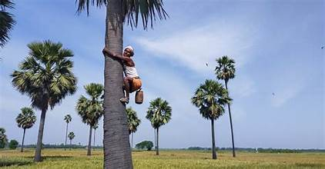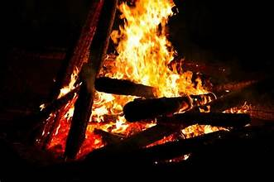
climb (unde) fire (usu)

usu (fire), noun: is produced by something burning. Pir usu; iyough ngi hian. Put out the fire; the house is burning.
uva (rustle), verb: to make soft starchy/cranky sounds) Ihev uva ken silin. The mouse rustles inside the ceilin.
u va (you will), (you will …), verb; as in u va wa atsam: You will sing hymns. U va wase. You will come to help.
uve¹ (sink), verb: to submerge in water. Iwen gba shin wagh maa uve. The rock fell into the stream and sank.
uve² (crouch), verb: to lower the body close to the ground or floor. Kpatema uve shin ityôikôn. The cat
crouched under the chair.
uwagh (stream, noun a body of flowing water that is smaller than a river. Agbur ka uwagh; Niger ka ifi. Agbur
is a stream; Niger is a river.
uzendeinya (animals), plural noun: many animals. Uzendeinya ngee shin ikô. There are a lot of animals in the forest.

V
va (come), verb: to becon to come. Va heen. Come here. va wase m (come help me).
vaa (cry, weep), verb: to weep or cry. Wan vaa sha ciu ijen kôr un. The child cried because she/he was hungry.
vambe (silk cotton tree), noun: very tall cotton-like tree; the silk cotton in the fruit is used for making
pillows. Mba ye ikya i vambe i he. Fresh (new) silk cotton tree leaves are edible.
vande¹ (before, previously), adv: the time preceding a particular event or time. M vande yan kwaghyan. I
previously ate food. (I have already eaten.)
vande² (rock, boulder), noun: a very large piece of rock. Bagu tema sha vande. The monkey sits on the boulder.
vandegh (shoulder), noun: the body part that connects the arm to the rest of the body. Vandegh ku nyion mo.
My shoulder hurts. Avandegh (shoulders), plural noun.
vange (lizard), noun: a small animal with scaly skin an a long tail that lives in the hot tropics. Vange soo
mtsee. The lizard likes heat. avange/uvange, plural noun.

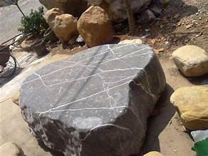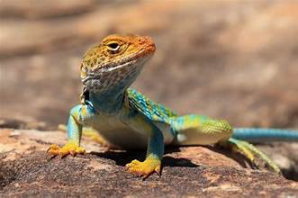
boulder (vande) vange (lizard)

var¹ (familiar), adj: used to; habitual. A ya ikegh i yuwan mkem var un. He/she is used to eating spicy chicken.
var² (adhere), verb: fasten something to a surface with glue. Var tepe sha tiub ahumbe a de u duen. Adhere
tape on the tube to stop it leaking air.
var³ (forge), verb: to heat and beat metal into shape to form a tool or implement. Var ihô. Forge a knife.
ve (them, they), pron: M kaa a ve mer ve hen kwaghkwa. I advised them that they should study multiplication.
vembe (pester), verb: to bother someone to get a wish. M zer vembe hen Adzam mer a za a mo sha Adikpo.
I pestered Adzam to take me to Adikpo.
venda (reject, refuse), verb: unwilling to accept something. Jay venda u yan kwaghyan. Jay refused to eat food.
vendeve (gecko), noun: a soft, smooth-bodied lizard. Vendeve ye iyôn. The gecko eats small ants.
ver (place; direct), verb: to place or put something. Ver gbande sha tebul. Place the dish/plate on the table.
- ver ashe (watch) vera she nenge kwagh u una er yo (Watch/observe to see what would happen)
- ver ishima (be mindful of, concentrate) Ver ishima sha kwaghenen wou dedo (concentrate well on your studies)
- vera ato (listen, pay attention)
vese (grow), verb: increase in size; get bigger (for plants and animals). Kon vese kuma mita utaan. The tree
has grown to five meters. vesen (grown), adjective: wan vesen (older child)
via (cooked), verb: ready to be eaten after thorough cooking. M jiidi iyough; ki via dedoo. I boiled the yam; it is well cooked.
vihi¹ (spoil), verb: no longer good; decay. Inyam vihi. The meat is spoiled.
vihi² (ugly), adj: unpleasant in appearance; not good to look at (in one’s eyes). Tica kaa er ikese i m tum ne vihi. The teacher said the
this basket i wove was ugly.
vihiashe (disgusting), adj: unpleasant to see. Akondo am vihiashe shaciu igo kende a shin anigbiôr. My clothes are disgusting because the pig
threw them into the mud.
vindi vindi (perfectly/cleanly), adv: perfectly done. M ese tembe vindi vindi. I cleaned the yard perfectly.
vine (dance), verb: to move in step with the music. Vine amar a kwaghkuhwan u swange. Dance to swange music.

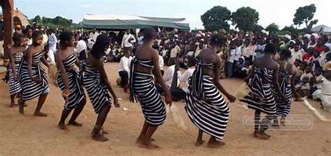
dance (vine) the swange

vingir (whole), adj: an unbroken thing such as an egg or fruit. Iji ngi vingir; i hembe ga. The egg is whole; it is unbroken.
vono (bed), noun: a metal-framed bed. (Note: VONO is a trademark for a spring metal bed common in
Nigeria). Yav sha gambe u vono. Sleep on a metal-framed bed. Compare, gambe-atsor (bed of “atsor” material).
vôr (tired), verb: having little ability to do work. 1. Wea vôr yô, mem kpuaa. If you are tired, rest a while. 2.
M er tom kpishi, nahan m vôr. I have worked a lot, so I am tired.
vule vule (crumbly), adj: can be easily broken into pieces or fragments. Beredi ne ngu vule vule. This bread is crumbly.

W
wa¹ (insert), verb: place in/on something. 1. Wa ajingi sha ashe. Put on eyeglasses. 2. Wa akondo shin
akwati. Place clothes in the suitcase.
wa² (grown), verb: Iyough wa kpishi. The yam has grown a lot. (Note: The yam tubers grow underground.)
- Wa ago iyol (get ready): wa ago iyol u yemen adua. Get ready to go to church.
- wa bo (stingy): or la wa bo gande. That man is too stingy.
- wa aie (to lie): Kunte wa aie kpishi. Kunte lies a lot.
wa kwagh (advise), verb: to suggest a course of action or what direction to take. M wa ve kwagh mer ve de
ayôôso. I advised them to stop talking (to be silent). Kwaghwan (advice), noun.
waarawa (sand), noun: grains of rock often found in beaches and some deserts. Waarawa ngee ken kpe ifi u
Benue. There is a lot of sand at the Benue River beach.
waiko (prepare), verb: think about, consider. A waiko sha u henen kwagh kpishi. She considers studying a lot.
wam (mine/my), pron/determ: belonging to the person speaking. 1. Takeda ne ka u wam. This book is mine.
2. Ka takerada wam. It is my book.
wan¹ (baby, child), noun: male or female child. Kôr wan (hold the baby or child). See ônov (babies or
children). Wankwase (daughter, female child/baby). Wannomso (son).
wan² (son or daughter), noun: a male or female child of a mother and or faher. Wan wam (my child). Terngu ka
wan wam (Terngu is my child). Wanbua (calf). Wanikegh (chick). Wanivo (kid or baby-goat).
wanger (clear, understand), verb: to perceive the meaning of something. Tica pase nahan, wanger mo. The
teacher explained so, I understood.
wanikundan (infant), noun: a very young child at the early stage of life. Wanikundan ngu shin gambe. The infant is in the crib.
wanye (child), verb: male or female child. wanye kwase (girl); wanye nomso (boy)

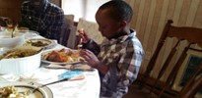
child (wanye) infant (wanikundan)

wantor (queen, chief’s daughter), noun: the female child of a king or chief. Wantor ngu a mbawasen un
kpishi. The queen/chief’s daughter has a lot of helpers.
wankwagh iyol (false accusation), noun phrase: to accuse someone. Jane wa un kwagh iyol er a tôô un takerada. Jane
accused him of taking her book.
wanye kwaor (handsome young man), noun phrase: Ter vese hingir wanye kwaor. Ter has grown into a handsome young
man. See inuunkwase (young girl), noun; anuun a ukase (maidens; young girls), plural noun.

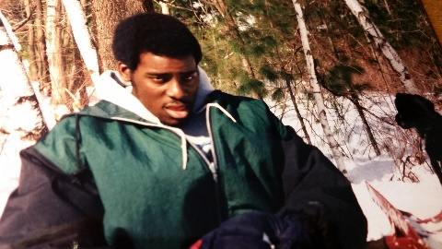
young woman (inuunkwase) young man (wanyekwaor)

wase (help), verb: to provide aid or assistance. Wasem m mough sha. Help me to stand up. Wase se se pir usu.
Help us to put out (quench) the fire.
wegh (hand), noun: part of the body used in holding things. Wegh ku imese. Left hand. Ave (hands), plural noun.
won (brother- or sister-in-law), noun: the brother or sister of either of a married couple. Mngu ka won u
Daniel. Mngu is Daniel’s sister-in-law.
wondo¹ (trousers), noun: a piece of clothing for the lower body that covers both legs. Kasev kpa mba huwan
(hough) wondo. Women wear pants, too.
wondo² (comb), noun: the freshy growth on the top of the head of chickens and some birds. Nomikegh ngu a
womdo. A cock has a comb.

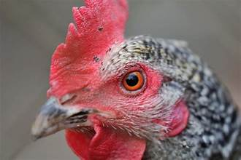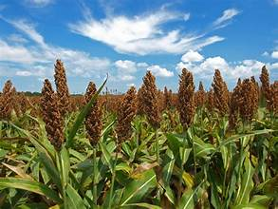
comb (wondo) guinea corn (wua)

wua¹ (grind, sharpen), verb: to grind something on a mortar or using a machine. Wua wua. Grind guinea corn.
wua² (Guinea corn), noun: grass with tall stalk whose seeds are used for food. Wua wua er ruam. Grind the guinea corn to make fufu.
wua³ (kill), verb: to take a life. Mato gba; wua or mom. The car crashed; killed one person.
wuhe¹ (cold, coldness, chill), adj: when it is not hot. Wuhe kôr. It is cold.
wuhe² (concubine), noun: the other wife in a polyandrous marriage. Kwase u Solomon u sha utaan ka wuhe u
kwase na u sha pue. Solomon’s fifth wife is the concubine of the tenth wife.
wuhe³ (shut, close; imprison), verb: to close/shut a door or opening to contain something or a person. Wuhe hunda man senda u.
Shut the door and lock it.
wuhe⁴ (uproot), verb: to uproot a plant or shrub or small tree. Wuhe abun. Uproot a ground nut plant.
wuna (storage place), noun: place to store dry grains and produce. Wa wua sha wuna. Put corn in the storage place.
wura (rain), verb/noun: the falling of drops of water from the clouds in the sky; such drops of water. 1. Wura ngu nôôn. It is raining.
2. Aber a wura tam sha itiough. I had drops of rain on my head.

Y
ya¹ (home), noun: a place where people live. Ya wam ngu sha igungu. (My home is on a hill); Ya doo (Home is
good or the good home)
ya² (eat), verb: to consume food; when things are chewed and swallowed for food. Ya kwaghyan. Eat food.
yam¹ (buy), verb: to purchase something with money. Yam akôv . Buy shoes. Yam anyi (I’m sorry; lit.: eat my
teeth), idiomatic.
yam² (my), determ: belonging to the person speaking. Iti yam er … My name is …
yange (prevent), verb: to keep something from happening or occurring. 1. Iwambe yange agina. Vaccination
prevents smallpox. 2. Yange ior u nyôron. Prevent people from entering.
yar¹ (gone to work), verb: said of someone who has gone to work. Baba yar tom. Grandpa has gone to work.
yar² (full of, infested with), adj: full of something. Kasua yar. The market is full (of people). Iji yar sha inyam
i hôôn. The rotten meat is infested with flies.
yav (sleep), verb: when you close your eyes and go to sleep. Yem za yav shin gambe. Go and sleep in the bed.
yem¹ (go), verb: an order to leave a location or area. Yem sha/kera (go away). Yem vea ve. Go with them.
- a yem a za yav (He/she went and slept)
- yem a na (take him/her with you)
yem² (well), noun: of cleaning or wiping when don perfectly. Ese tebul i yem. Wipe the table perfectly clean.
yer (hide), adv: to keep something so no one can easily see/find it. Yer ihô dedo. Hide the knife well.

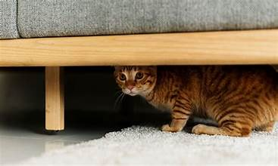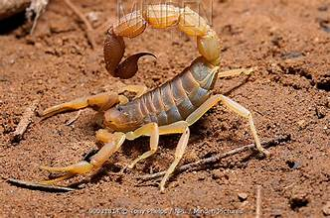
hide (yer) scorpion (yese)

yese¹ (nurse), noun: a person assigned to take care of a young child. Ayar ka yese m. Ayar is my nurse.
yese² (to nurse), verb: to take care of a young child in the home. M yese Mbanan. I nursed Mbanan.
yese³ (scorpion), noun: an animal with eight legs and a poisonous stinger at the end of its long tail. Iyese sôô
wan na. The scorpion stung her son.
yesem (sneeze), verb: to let out air through the nostrils and mouth when one smells fumes. M yesem. I sneezed.
Yesu (Jesus), noun: the name of Christ in the Bible. Yesu ka Oryiman. Jesus is the Saviour.
yevese (run), verb: to run or move from a place. Bagu yevese ior yem ken ikô. The monkey ran away
from people into the forest.
yila (call), verb: to use one’s voice to call a person. Mama yila wan na er a va. Mama called her child to come.
yima (save), verb: to get someone out of trouble or situation. Aondo yima se. God saved us. See oryiman
(saviour), noun; oryimantar (saviour of the world), noun.
yina¹ (less), determ: to indicate a small amount or state. Or yina sha Aôndo. Man is not as great as God.
- M yina sha Aôndo. I am less than (not as great as) God.
yina² (insufficient), adj: when is not enough or inadequate amount of something. Bar yina u wan shin iue. There is
not enough salt to put in the soup.
yôô (announce), verb: issue a statement about an upcoming event or enterprise. Yôô kasua u he u bughun. Announce
the opening of the new store.
you (your), determ: referring to the person one is speaking to (second person singular). Iti you er ana? What is
your name?
yugh yugh (bushy), adjective: like bush but fluffy. Inyamtsar ngi a tsa yugh yugh. The tail of a squirrel is
bushy and fluffy.
yuwa, yua (spicy), adjective: to have a taste like spices. Iue yuwa mkem. The soup is spicy with pepper.

Z
za¹ (go, proceed): the act of going or moving. Za iyougci (Go to the hospital); a za kasua (he/she went to the
market); za za nenge (go and see). Za a mo her (take me there); Za hemen (continue); Za un iyol (bother her), verb; ze iyol (bothers/bother), present tense.
za² (deep), adj: something several meters from the surface. Ihungwa za kums mita utaan. The pit is five meters deep.
zaar¹ (storage place), noun: A storage place over the fireplace. Aya penda ijôndough sha zaar. Aya placed the
calabash on the storage place over the fireplace. Archaic.
zaar² (to seek alms), verb: wanye za zaar u yaren u kwaghyan. The boy has gone to seek alms for food.
zaiyol (bothering), verb, present participle: constant pestering of people. Zaiyol na ngee gande. Her bothering is too much.
Zaiyol wan (bothersome child), adjective.
zaki (chief, elder), noun: the head or leader of a clan or organization. Zaki lôhô ior zua. The chief called people together.

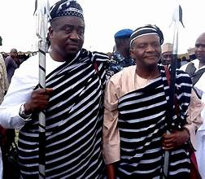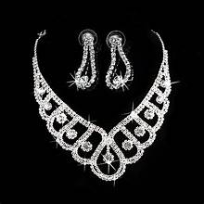
chief (zaki) silver (zanaria)

zamber¹ (beg, verb): to ask for something. Oryaishio zamber er i na un inyaregh. The homeless man begged for money.
zamber² (apologize, verb): to say you are sorry. M zamber we sha er m ngor a we yô. I apologize (am sorry)
for yelling at you. Also: zamber (apology), noun.
zan (going), verb: the act of going. Ngu zan zende. He/she is going on a journey (is travelling).
zan zan (until), conj: in a continuing manner. Haa zan zan bokoti a iv. Pour until the bucket is filled.
zanaria (silver), noun: a shiny metal. Tswekeli u zanaria engem. The silver spoon has a luster.
zar (liquid), noun: a fluid that has no definite shape and can be poured. Mkulem ka zar kwagh. Oil is liquid material.
zar iyough (honey), noun: liquid made from nectar by bees and some other insects. Zar iyough nyoho. Honey is sweet.
zege (big), adj: something that is large. Zege iyough. A large house. zegekwagh (big deal), idiomatic.

zegenan (large, big), adj: something of enormous size. Nombua u zegenan. A large bull.

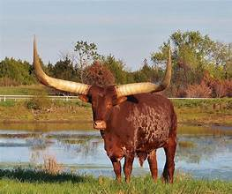
large (zegenan) twist (zômon)

zenda (pursue), verb: to run after something to catch it. Zenda ikegh kôr i. Pursue the chicken to catch it.
zende¹ (journey, trip), noun: To take a trip to a distant place. Baba za zende. Grandpa is on a trip.
zende² (walk), verb: to go from one place to another by walking, not riding or driving. Zanenge ka a zende
sev. Zanenge walks every day. Ngu zenden ( she is walking), present participle.
zer (wrap), verb: to rap clothing or other material around another thing or person. Zer akondo a engem. Wear clean clothes. Zer
ikondo i anger. Wear “anger” clothing.
zber pinen gbem (persistently requesting), verb: to ask for something without ceasing. M zer pinen gbem so m zua a min. I asked
persistently so, got it.
zeze (persistent), adj: to keep doing or saying something without ceasing. A zer ôron zeze, tsô se ungwa. She
was persistent in saying it, so we listened (heard).
zôhô¹ (squabble), verb: to engage in a noisy quarrel about petty or trivial things. M zôhô a wan mer a kile
agbande yem ga. I squabbled with the child about not washing the dishes well.
zôhô² (wrestle down), verb: to throw someone down during wrestling. M wa un agbe; tso, m zôhô un. I hooked my leg against his; so, I wrestled him down.
zômon (twist), verb: to turn a piece of cloth to squeeze out liquid. Zômon ikondo mngerem ma due. Twist the cloth for water to come out.
zongough (rim), noun: the outer or upper edge of a pot or any circular object. A kôr itiegh ki inyaagh sha
zongo tsegh, ki asegh. She held the earthenware pot only by its rim, so it broke.
zua¹ (meet), verb: to come together for a purpose. Ior zua u nan un Tor. The people gathered to make him/her
Chief. Mzough (meeting, conference), noun.
zua² (meet, join), verb: when things come together at a point. Ihange zua hingir gôgônan The lines met to become long.
zua³ (find), verb: to recover something after it was lost. M ker akôv am, tso m zua a min. I looked for and found my shoes.
zua zwa (kiss), verb: to show a close relationship by kissing. Kwase zua zwa vea nom na. The woman kissed her husband. Zwa zuan (a kiss), noun.
zulee (sluggish), adj.: not brisk. U er zulee yô, u gba jime. If you are sluggish, you will fall behind.
zum yô … (would be better if…), phrase: proposing an alternative. Zum yô ma m mough faa. It would be better if I leave early.
zumzum (large piece), adj: a large piece to share. Inyam yam i ken bam ngi zumzum. My share of the bam
was a large piece of meat.
zungwe¹ (show mercy), verb: to show compassion and not punish. Jooji zungwe Semba mhôônom; nahan, wa un purusu ga. The
judge showed mercy; so, did not sentence Semba to prison.
zungwe² (have pity on), verb: to be sad about someone’s condition. Ashi zungwe Ako, nahan, a de un a injô. Ashi
had pity on Ako; so, she cancelled his debt.
zunônunô (hastatingly), adv: acting as one is not sure. Seta ngu eren zunonuno er a soo u nan ngo na iyua ga nahan. Seta is behaving hastatingly about a gift
for his mother.
zurum (nearing), adj: to be approaching a location. Se zurum a geri u Abetse. We are nearing the town of Abetse.
zwa (mouth), noun: a body organ through which animals take in liquid or food. Wa kwaghyan ken zwa wou. Place food in your mouth.
zwar (gigantic pot), noun: a large pot for keeping water cool. Aya haa mngerem shin zwar. Aya poured water
into the gigantic pot.
Zwa Tiv (Tiv language), noun: one of the Tivoid groups of languages spoken in Central and Western Africa. M lamen Zwa Tiv dedoo.
I speak Tiv language well.
zuzu (dizziness), noun: feeling unsteady as if the earth is moving and you are about to fall. COVID-19 ka a
va a zuzu. COVID-19 brings dizziness.
zuzuzu (wobbly), adj: moving from side to side in a shaky manner. Or ngu zenden zuzuzu sha igbudu (godobi). The
man is walking wobbly on the street.

Months of the Year

Januari January; first month of year
Febuari February; second month of year
Marci March; third month of year
Mei May; fifth month of year
Jun June, sixth month of year.
Julai July, seventh month of year
Agusutu August, eighth month of year
Setemba September, ninth month of year
Okutoba October, tenth month of year
Novemba November, eleventh month of year
Disemba December, twelfth month of year

Counting Numbers

môm— one (1)
har—two (2)
tar—three (3)
nyiin—four (4)
taan—five (5)
teratar—six (6)
taan kar uhar—seven (7)
nigheni—eight (8)
taan kar unyiin—nine (9)
pue—ten (10)
pue kar môm—eleven (11)
pue kar u har—twelve (12)
pue kar u tar—thirteen (13)
pue kar u nyiin—fourteen (14)
ikundu—twenty (20)
ikundu kar môm—twenty-one (21)
ikundu gber—thirty (30)
a har akundu —forty (40)
akundu a har gber—fifty (50)
akundu a tar—sixty (60)
akundu a nyiin—eighty (80)
deri (akundu a taan)—one hundred
dubu (akundu ikundu gber)—one thousand
dubu deri—one hundred thousand
dubu dubu—one million
dubu dubu deri—one hundred million

Tiv Idioms and Idiomatic Phrases

- Tegh tegh hemba ayem.
Meaning*: It’s better to take time to do something than to rush.
- Kokombo per sha jime nor.
Meaning: You tag uno someone to get out of trouble or bad situations.
- Mnenge hemba mtem.
Meaning: It’s better to try than to remain idle.
- Tokwa u purugh hembe u nahan ga.
Meaning: You may lose some but gain more.
- Ka wea gba mnger u mor iyav.
Meaning: One is into something and there is no going back—encouraging words.
- Wua u wanye kpa nor ye. Lit.: An elephant even eats a child’s guinea corn.
Meaning: Listening to a child can help adults. Children have useful opinions, too.
- Ahi nga hie orapirashe atsenge ahar ga. Similar: once beaten, twice shy.
Meaning: Don’t make the same mistake twice.
- Yan sha ikughul.
Meaning: Very close relationship.
- Nur akende.
Meaning: Display pride.
- Nur igundu.
Meaning: Act with pride.
- Ta nombol kor. Watch your tongue.
Meaning: Be careful what you say.
- Wa zwa takema.
Meaning: Be careful how you speak or talk.
- Mliam ashe.
Meaning: Show sadness.
- Nduur iyol.
Meaning: Attempt to shake off unwanted acts one is surrounded with.
- Ishange la mwem; ishange la mwem. Lit: flour is made by each grain producing flour.
Meaning: Success comes in bits.
- Orkarenkwar ye ahenge.
Meaning: Avoid taking the best part if you tasked with sharing something.
- Ka u gba sha nam u zua a mtemam ye.
Meaning: You think big even to get a little.
- Haa mngerem sha usu.
Meaning: Quell the flaming issue.
- U dondo orihundu u gba idyeregh.
Meaning: Don’t follow blindly.
- Kôr ave sha kwagh.
Meaning: To unnecessarily cling on something.
- Kema itiough.
Meaning: Putting people log ahead with each other.
- Oruma ngu a memem ga.
Meaning: Life is full of obstacles.
- Kerakekera kuma or ga.
Meaning: Being unsteady is not fitting for a person.
- Yevese mnyim za gba sha usu.
Meaning: You are going from one problem into another.
- Alabar tee gbough ga.
Meaning: News spread unhindered.
- Wegh ku yanegh ka ku kile ku imese; ku imsegh di ku kile ku yan. Lit.: the right hand washes the left; the left washes the right.
Meaning: Show mutual respect or look for and act on common grounds.

- Ka a vaan kpa iyaan.
Meaning: We need not remain unhappy all the time. Show some joy even when you are unhappy.
- Kwambe har mindi ivambe ishe.
Meaning: Don’t make the same mistake twice.
- Mhange hemben itiegh ki ishwagh.
Meaning: You can dip into your savings when it becomes necessary.
- Ormaan ye atsenge.
Meaning: If you have much, you can live humbly.
- Ya anyi.
Meaning: Be patient.
- Ka we a meen inyam u tenge hondo ga.
Meaning: Behave well when seeking something good.
- U kpe kpa u hire a inya ga; u ya ku injô ga.
Meaning: Death is certain.
- Kwa tsa sha saa kpa hemba shin inya.
Meaning: Everything beginning has an ending.
- Ikuleke via or anyishio.
Meaning: Inability to use the good thing that one has.
- Ya gege ya ihi i hôôn.
Meaning: No one is absorbed from having issues or problems.
- Vese ga ye iyol na ga.
Meaning: A little is better than none (or nothing).
- Kukuku kur kwagh ga.
Meaning: Something does not end well with hesitations.
- Ishan kwagh ker inya ga.
Meaning: Expressing good health. M ngu gbang gbang, di er Ishan kwagh i ker inya ga nahan. (I’m fine, just as a grain of something does not get dirty.)
- Ishe sha ishe; inyigh sha inyigh.
Meaning: Paying one in kind.
- Kwagh tsee iyol.
Meaning: The issue has become heated (difficult to resolve).
- U zendan orihundu ideregh. Lit.: running after a mad person without clothes on you.
Meaning: Following another’s bad/improper ways.
- Abanyam kar a kar zende kpa ihuma bee ga.
Meaning: Even small acts of goodness bring rewards.
- Aluer abanyam a kpe yô, or a kera tema hen ya la ga a kuma inyom.
Meaning: The rewards of much goodness are immeasurable.
- Ka naha wen.
Meaning: It’s your turn to act.
- Wanye u tsough tso tsough ye tsa iviha.
Meaning: One is mightily rewarded by acting fast.
- De de ka cigh. Lit.: saying “stop, stop” is medicine.
Meaning: Obeying calls to avoid unwanted behaviour is healthful.
- Kende ave sha.
Meaning: To surrender.
- Tuur or ke(n) ityô.
Meaning: To persuade someone to act where they would otherwise not do.
- Doo iyol ga.
Meaning: Not feeling well.
- Vihi iyol.
Meaning: General state of unwellness or inability to accomplish.
- U za kasua ga tsô u fe we a yara? Lit.: how would you know the open market is full if you didn’t attend it?
Meaning: Equivalent meaning: How would you understand if you have not learned?
- Tume toho a kwagh.
Meaning: To engage in pointless pursuit or reasoning.

- Tôndo itiough na Udam.
Meaning: To rage with anger.
- Zer gbem hemba ikpagher.
Meaning: Persistence pays (i.e., is better than a good luck charm).
- Ican woo or ga. Lit.: Poverty does not kill.
Meaning: You can manage poverty or lack of money or things.
- Kwagh ka a hiin i hiin a min.
Meaning: Tackle issues right at the beginning.
- Bugh ken mtu cir ken igongu.
Meaning: exchange one thing with another.
- Ikyanden bua hemba ivo i kehen.
Meaning: a little is better than nothing. (No gift is too small.)
- Wagh sen tswen hule. Lit.: A river meanders because it flows alone.
Meaning: A better decision is made in consultation with another (others). (Two heads are better than one)
*All interpretations are those of the author. Feel free to offer your take.

Picture and Image Credits

African blue-yellow bird—flickr.com; African necklace—worldofbacara.com; African songbird—africaguide.com; anger—legit.ng; antelope—wallpapersafari.net; arrow—pngimg.com; axe—vecteezy.com; back of leg—danphotos.com; back—barbend.com; banana—commons.wikimedia.org; bedbug—bbq.com;
bed—walmart.com; bee—commons.wikimedia.org; belt—ebay.com; boat—pixelstalk.net; bone—ecokindpettreats.com; boulder—jiameistone.com;
bow—pluspng.com; bridge—guardian.ng; bull—fineartamerica.com; burning bush—science.thewire.in; burrower bug—bugguide.net;
butterfly—commons.wikimedia.org; cassava—premiumtimesng.com; cattle egret—pinterest.com; chemist—sciencephoto.com; chief—jiji-blog.com;
climb—pexels.com; club—freepik.com; cobra—wallpapercave.com; cocoyam—healthyhuenans.com; comb—ecopeanut.com; comb—walmart.com; computer—walmart.com; crocodile—a-zanimals.com; dance—jiji-blog.com; deer—commons.wikimedia.org; doctor—freeimages.com; drum—ajo.danphotos.com;
drum—fortunehistory.blogpost.com; ear—bbc.com; earthworm—tushiewipers.com; eggs—kidseatincolor.com; electric fish—thoughtsco.com;
elephant—commons.wikimedia.org; farm—legit.ng; finger—danphotos.com; firefly—kids.nationalgeographic.com; fire—freepik.com; fish—etna.com.pe;
flag—rawpixel.com; flour—usatoday.com; football—pngimg.com; frog—britannica.com; fruit—healthjade.com; garden snake—photonshouse.com;
ginger—thinkeathealthy.com; goat—wealthresult.com; gong—hamillgallery.com; gorilla—en.wikipedia.org; grass—publicdomainpictures.net;
green squash—greatamericanseedup.org; grey owl—gag.wikipedia.org; ground nuts—narogroundnut.org; guinea corn—jiji-blog.com;
guinea fowl—animalia-life.club; harness—torange.biz; harvest—medium.com; hatch—cs-tf.com; head—turbosquid.com; heap—intechopen.com;
hide—be.chewy.com; hippopotamus—wikipedia.org; horn—pinterest.com; horse—commons.wikimedia.org; house sparrow—pinterest.com; hug—freepik.com; insect leg—pinterest.com; judge—premiumtimesng.com; African trumpet (kakaki)—pinterest.com; kettle—walmart.com; lab—kingswordportal.com;
lamp—walmart.com; leopard—panthers.github.io; lift hands—thegospeltruth.org; lion—worlatlas.com; lizard—publicdomainpictures.net;
massage—chanelbagsukstore.com; millet—simpleayurvedichealthtips.blogspot.com; mirror—danphotos.com; monkey—animalspot.net;
mortar—invaluable.com; mourning dove—flickr.com; narrow road—pxhere.com; neck—health.harvard.edu; needle—quiltsandquilts.com; net—kayakhelp.com; not straight—pinterest.com; oar—clipart-library.com; oboe—pinterest.com; offspring—wallpapermania.eu; oil—shadesofafrica.com; owl—pexels.com; peppers—thespruceeats.com; pigeon—publidomainpictures.net; pig—rurallivingtoday.com; plastic—lowes.com; pointy—vecteezy.com; politics—herald.ng; prisoner—nccred.org; prominent scientist—telegraph.co.uk; pumpkin—publicdomainpictures.net; python—animalspot.com; rail track—pxhere.com;
robot—sloanreview.mit.edu; rope—freepik.com; scabies—theconversation.com; science—stlouisshs.ed.gh; scissors—freeimages.com;
scoop—dreamstime.com; scorpion—mungfali.com; sheep—pinterest.com; silver—aliexpress.com; skewer—agoudalife.com; slaughter—nation.africa; snail—pinterest.com; spear—pngimg.com; spider—mungfali.com; squash—greatamericanseedup.org; squeeze—freepik.com; stand—pinterest.com; stone—en,wikipedia.org; straight—pixels.com; sweater—thefashiontamer.com; table—danphotos.com; tall—newhealthadvisor.org; thread—mmediatraining.com; tie—aliexpress.com; tiger—commons.wikimedia.org; toe—danphotos.com; train—pexels.com; tray—amazon.co,uk; trousers—walmart.com;
taxi—publicdomainpictures.net; Tiv people—youtube.com; viper—britannica.com; vulture—animalia-life.com; wedding—pinterest.com; well—dominicansinteractive.com; wide road—pexels.com; wooden spoon—earlywooddesigns.com; woodpecker—birdguides.com; worker—nccred.org.

