**1**

**Tiv Step-By- Step: Introduction**

People have a desire to speak Tiv for different reasons. Tiv Step-By-Step is written for children born of Tiv speaking parents living outside Tivland whether they reside in Nigeria or elsewhere in the world. The book will also be of use to those non-Tiv spouses and partners of Tiv-speaking individuals.

If you are from other parts of Nigeria or outside Nigeria and are planning to visit or settle in Tivland, this book will walk you through learning Tiv in a short period of time. The vocabulary build-up, practice activities, and glossary of terms are designed to enrich you with the skills to be able to pick up conversation at home, market, restaurant, or the courts. Emphasis is given to language which would aid communication between children and grandparents, including Tiv language use in the digital world.

You are advised to study and practice as often as possible. Write or illustrate with drawings. Tiv Step-by-Step is accompanied by video and audio recording to help you learn Tiv with greater pronunciation ability. Other methods of learning Tiv faster include the following:

1. Practice: Contains questions about each word to use to prepare to test yourself or be quizzed by friends or family members.
2. Vocabulary Practice: Study from the lists of vocabulary provided in each section to prepare for spelling power tests, quizzes, or assignments.
3. Spelling Power: Test your spelling ability. Read the short definition, listen to the word with audio or video method and try spelling it.
4. Learning Activities: These are given throughout for Tiv language learners, to monitor their progress.
5. Quiz: Quizzes are provided to test your vocabulary and sentence construction skills.

This book will probably help fluent Tiv speakers who may be struggling with English as a second language but is required for instruction. The parts involving Tiv grammar and parts of speech would be particularly helpful. Skip these parts if you only desire to understand conversational Tiv.

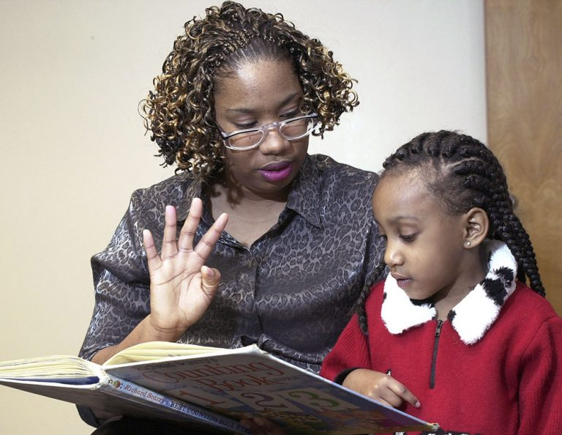

Tese wan wou Zwativ

**Abaacaa (Alphabet)**

Many Tiv letters sound the same as in English, but some Tiv letters are pronounced or written differently.

To learn Tiv sound of these letters or a combination of them, say the word in the example many times and then write it down. In the examples below, the English equivalent is given in parenthesis.

**Tiv Letter English Sound Example Write Word**

a uh bar (salt)

b b bam, banki (bank)

c ch chia (fear)

ch ch chiv (dip)

d d ada (bow)

e e (as in let) se (laugh)

f f fa (know)

g g gar (city)

gh gh sugh (thank)

gb - gba (fall)

h h har (hang)

i ee ime (darkness)

j g (as in gem) ijen (hunger)

k k koti (court)

kp - kper (net)

kpera (draw)

kperegh (wing)

l l lam (speak)

m m ma (drink)

n n na (give)

o oh or (man, person)

oo o too (as in floor), (pour)

ô o môm (one)

p p per (cross)

r ruam (e.g., pounded yam food)

s s sar (spread)

sar (desire)

t t ter (father)

u oo bagu (monkey)

v v ivo (goat)

w w wase (help)

y y ya (eat)

yem (go) – more like ordering

z z za (go) – more like a request

**Sounds, Symbols, and Spellings of Tiv Words**

Tiv sounds in general have nasal sounds. However, there are flat sounds: consonant sounds, vowel sounds, and consonant-vowel sounds.

Vowel sounds are made by allowing the breath to come out freely as the lips are pursed. To make a consonant, the breath stream is partly blocked, and the sound lowered or raised. A word as it is spelled may have different meanings depending on the way it is pronounced.

**Vowel Sounds and Symbols**

Vowel sounds usually are short sounds. A long sound is made by using two vowels together. Use vowel sound in the following manner:

/a/ sound is said as if it were /u/ in sun, not as /a/ in cat or at.

**Short Long**

va (come) vaa = cry, weep

za (go) zaar = storage shelf on posts

ma = drink maa = build

ka = it is kaa = say, said

na = give

man = and

vange = lizard

/o/ as in orbit and story:

**Short Long**

or = person too = measure, pour out

tor = chief, king doo = good

mor = soaked up soo = like

nor = elephant

bol = ball

**Note**: *doo* is the long /o/ sound and not pronounced as /oo/ (as in book, but as in door).

/o/ sound as in pot and dot.

**Short Long**

kor = catch ishoon = a liking, attraction

tom = wish too = pour out a liquid or drink

gom = skin lump in the neck ndoor = shed leaves

bom = bomb poo = to the brim (as *in iv poo*:

won = brother- or sister-in-law filled to the brim)

bom = bomb doo ga = not good

kon = tree doo gande = extraordinarily goo d

nom = male-type doom = I like

pon = reveal, expose dooshima = love

/i/ sound as if it were *ee* in feet, beet, keep, or *ea* in beat, seat, and meat.

**Short Long**

yina = not enough; incomparable atii = sparrow

yima = save ii = bury

tim = destroy, post ii = steal

shi = left fiir = bunch (v)

ifi = large river fiishi = let out stomach gas; fart

time = dig

iti = name

/e/ as in bed and net. For a long sound, use /ee/.

**Short Long**

de = stop bee = finish

ve = them neer = excess

se = we seer = add

sen = flow keer = kindle

ime = darkness mee = entice

we = you (singular)

ne = you (plural)

ve = they

pepe = morning

/u/ as is said as in the English /oo/ in book or look.

**Short Long**

Mu = name of a river tuur = push

kuma = pierce or prick kuma = enough, suit, satisfy

guma = laterite puu = criticize

usu = fire suur = support

kume = to pound uma = life, dry

ku = death

**Exercse1**

These practice exercises show how vowels and vowel sounds are used in phrases for conversation. Use the words in the vocabulary list to construct short sentences in Tiv. You may consult a Tiv language dictionary or other sources to translate the sentences in #2 below into English.

1. Vocabulary: ya (eat), bee (finish(ed)), ya (home), ma, za, ka, nan, vange, vaa, wan, kaa, daa, baba, Adamu, Adagi, Jigawa, Jighjigh, jime, zor, tor (mortar), kuma (enough), kumam (I’m satisfied), guma (laterite), de, yem, makeranta, ga, kwagh, ôr, or, inya, ishange (grain).
2. Sentences:
3. M ya m bee.
4. Aya yem ken ya.
5. Va ma mngerem.
6. Za makeranta.
7. Ortwer na un ichigh.
8. Vange yevese.
9. Wan vaa ga.
10. M kaa kwagh ga.
11. Terngu ôr takeda bee.
12. Baba yem za yav.
13. Na jighjigh hen Aôndo.
14. Adamu yem adua
15. Adingi yan lu orshoja.
16. Wantor tôô tor kume ruam.
17. Tegh tegh hemba ayem.
18. Ishankwagh ker inya ga.

**The Article**

In Tiv language, it is difficult to pinpoint where "*a*" and "the" should be used. One needs to understand how these articles are used. They are mastered through practice and by becoming familiar with the language.

All the words in the following examples have the article "*a*" or "*an*" before them:

alom = a rabbit (as in *alom ngu a zege mba atoov* = a rabbit has long ears)

bua = a cow (as in *bua ye toho* = a cow eats grass)

ijembe = an axe (as in *gber kon sha ijembe* = cut the tree with an axe)

nduhar = a hoe (as in *nduhar ka kwagh u kahan sule a min* = a hoe is for farming)

ihô = a knife (as in *mba tende atuur sha iho* = a knife is for cutting okra)

nor tar = an elephant

To indicate the article "the", the word *ne* or *la* needs to be used. This is usually accompanied by pointing. For example,

Nam ihô *la.* Give me the (that) knife.

Iho *ne* ese. This knife is sharp.

Kwaghyan *ne* tsee. The (this) food is warm (or hot).

Bagu ngu yan ishoho. The monkey is eating tiger nuts.

A tema shin ikon. He/she sat in the chair (seat).

Inyon ngi purugh ken The bird is flying in the air.

ahumbe.

He cuts onions with a knife. Ka a tôndo alabesa sha ihô.

**Consonant Symbols and Spellings 1**

The following thirteen consonants are used with vowels that have different dictions to form Tiv words.

**Consonant Example**

/b/ bem = peace

bam = bank

ber = lake

bar = cave

bua = cattle

butu =mat

/c/ cia = fear

cir or chir = close

/d/ de = stop

dem = leave me

demdem = cooled down

dafa = cooked whole grain

dagi = small spear

dan = counter (v)

damiyo = a kind of yam

dura = make thunder sound

dogo = railroad

deri = hundred

dubu = thousand

dubudubu = million

/f/ fa = know

fam = know me, wet season

fese = quick

fefa = soon

fere = fast, quick

fesefese = quickly

ferefefere = quickly

Fada = Rev. Father

/g/ ga = not

gege = back of leg

gom = cyst

gar = town, city

gema = turn

ger = cheer

gule = kneel

guda = better

gundu = trunk

guma = red soil

/h/ har = hung

haa = pour or spill

hôn = to trap

hondo = whistle (with lips)

hôm = funny

hôm = produce shoots

hôô = rot, decay (v)

hundu = become muddy

hunde = mad

hungwa = descend

hura = make noise

hur = friendship

huror = friend

hunda = door, entrance

hingir = turn during roasting

hide = return, come back

hide jime = to backup

hule = meander, fold

huma = smell

hungur = forget

hange = stuck, hung

hongor = kernel

hoghol = narrow

hogholoo (narrow condition)

/i/ Ijande = swamp or pond

ijem = steep slope

Ijen = hunger

ijor = a well

aji = eggs

iji = egg,

iji = fly

ikange = a partridge

ikon = green algae

ikundu = twenty

ikungugh = dove

ifi =sea

ityeku = ocean

Ifa = Eve (first Bible woman)

Imande = leprosy

Ivungu = owl

Ivurugh = piece, verse

/j/ jime = back

Jighjigh = belief

Jighirii = straight

Jato = Hausa for red

Jaki = donkey

Ajikegh = eggs

Jukum = ethnic group

Jamber = torn piece

Januari = 1st month of year

Jun = sixth month of year

/k/ kam = mould, press

kor = rope, sew

kôr = hold, catch

kua = also, and

kon = tree

kuma = enough, pinch, kuma = pierce or inject

kwaghfan = knowledge

kile – wash

kimbi = pay

/l/ lam = talk, speak (verb)

lanegh = foolishness

lankwagh = is foolish

lu = mortar

liam = speech, talk (noun)

lian = lean, lay

/m/ ma = drink

Mfe = understanding

Mimi = truth, truly

Mindi = burst

mo = me

môm = one (the number)

mon = neck

mem = rest

mena = swallow

mula = swollen

musan = change, exchange

mor = soaked up

mir = soaked in water

mnyam = sleep

mnyam ma cien = dream

mnyim = smoke

/n/ na = give

Ne =you (pl),

nura = needle, injection

nungwa = mix

num = scatter, destroy

num = a fight

/o/

Omon = to suck on dry

matter

Ongol = drill

Or = person

Ortwer = doctor

Orvesen = elder

Osough = get free

Orsar = a man needed

/p/

Pa = path

Pam =pound sterling

Pampam = can

Pande = subtract

Penda = put, pay

pav= divide, cut open

paa = cut (grass), clear

pel = plate, armor

per = cross

pev = valley, has hole in it

pon = expose

pir = quench, put out light

pira = boasting

piraikaa = boastful fact

pepa = paper

pepe = morning

pepepepe = early morning

pitapita = soggy

pupur = white

puu = disparage, criticize

putôputô = puddle

purututu = all, completely

turughtutu = steam

/r/ rumun = agree

ruam = fufu

rule = ruler

roboti = robot

/s/ se = we, us

Seta =ginger

Sende = hung

Senda = harvest

Sha = up

Shin = down

Shin inya = down earth

Shingir = sweater

Shuga = sugar

Shigari = cigarette

soo = like, love

sev = day

suruwa = skeptical

sur = dampen, to cool

/t/ ta = shoot, shot

Takeda (takerada) = book

Tam = chew

Tamen = older (in age)

Tamenor = old man

Tamen kwase = old woman

Tar = land, earth

Tav = tall

Taver = strong

Taverishima = to persevere

Tem = crack open

tom = work

ter = father

tim = destroy, erect, post

tem = crack open

time =dig

tema = sit

tule = pull, snap

tenger = shake

tuta = flag

tumba = to thread

/u/ ungwa = hear

Undu = left behind

Uma = dry

Uma = life

Ume = bear fruits

Ulugh = pull

/v/ va = come

vaa = cry

ve = they, them

vambe = cotton tree

venda = refuse

vendeve = gecko

via = cooked

/w/ wua = kill

wa = pack

wan = son or daughter

waarawa = sand

wuhe = cold, chill

wuhe = concubine

wuhe = to shut or imprison

wuhe = to uproot

/y/ ya = home, eat

yem = go, gone

yuwa = bitter

yam = buy

yevese = run

yese = scorpion

yôô = announce

/z/ za = deep

Za = go, proceed

Zegenan = big

zeze = persistent

zer = wear

zwar = gigantic pot

zu = dizziness

zuzu = dizziness

zungwe = to feel for

zurum = nearing

zanenge = go and see

zanalia = silver

**Consonant-Consonant Symbols and Spellings 2**

Beginners of Tiv language study may find consonant-consonant symbols and blends the most difficult aspects of learning the language. With practice, this problem is easily overcome.

/bw/ bwagi = a pick (for digging)

/gb/ gba = fall

gbaa = branch

gbande = dish

gbande = triangular drum

gbanger = wide

gbem = chin

gbem = large brown ant

gbemgbem =always

gber = cut (a tree), sing

gbide = hit, beat, whip

gbir = lay (as in a crib)

gbor = stomach

/kp/ kpaa = also

akpa = a whip

kpar = partition

kpe = die

kpekpe = wall

kper = tomorrow, net

kpera = draw, drag

/ch/ chia = fear

chicha = all

chii = all

/sh/ sha = up, away

ishe = eye

ishima, shima = heart

shase = cashew

/ny/ nyam = meat

nyen = yesterday

nyian = ripe

nyian = today

nyon = bird

nyuma = bite

/gh/ comes at the end of a word and is pronounced English words like *dough*, *borough*, and *Burrough*.

bugh = open

dugh = take out

kegh = wait

kough = erase

dugh = take out

sugh = thank

tugh = night

tugh tugh = early morning

tegh tegh = slowly

/gw/ gwa = fame

gwar = strand

/kw/ kwase = woman

kwe = a crack

kwende = elbow

/sw/ Swem = Tiv traditional god

Swange = a Tiv dance

Swase = meat

ishwa = beniseed

/tw/ twev = settlement

twer = medical treatment

twar = leftovers of produce

twande = boil on body

the armpit

/ts/ tsar = bridge

tsav = witchcraft

tsa = sleep over

tsa = stayed/lived a while

tser = cut up (into pieces)

tser = to skip the line

tsen = sun dry

tsenda = spray water, spits

tswar = anus

tswen = alone

tswer = abstain

/zw/ zwa = mouth

zwar = large pot

|  |
| --- |
|  |
| Bua  Bua ye toho. Toho doo bua.  Toho   |  |  | | --- | --- | |  |  | |  |  | |  |  | |
| A monkey with a faceDescription automatically generated  Bagu  Bagu ye ahi. Ahi doo bagu.  Ahi |
|  |
|  |

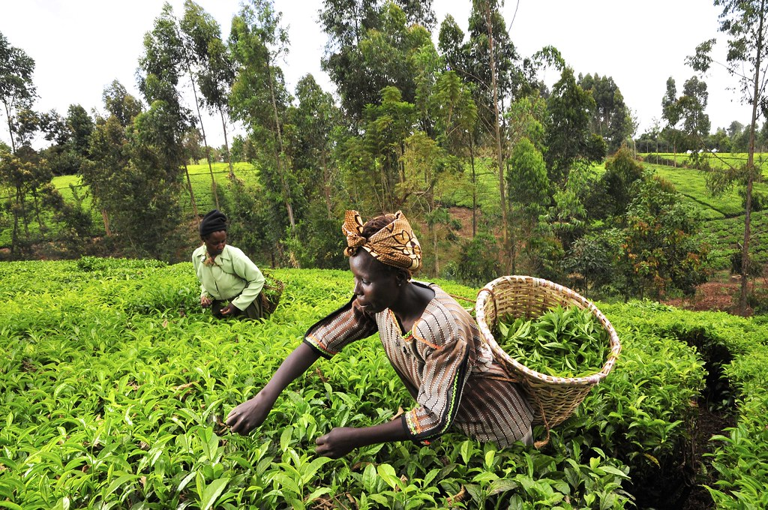

[This Photo](https://www.flickr.com/photos/ciat/5367334314) by Unknown Author is licensed under [CC BY-SA](https://creativecommons.org/licenses/by-sa/3.0/)

Kasev ken sule (Women in the farm)

U henen kwagh u sainz ka mzehemen Mbayev mba agher sha kwagh u sainz

(To learn science is progress) (Children are excited about science)



[This Photo](https://transgriot.blogspot.com/2008/11/waah-nigeria-loses-to-equatorial-guinea.html) by Unknown Author is licensed under [CC BY-NC-ND](https://creativecommons.org/licenses/by-nc-nd/3.0/)

Kasev mba gbiyen futubol (soka) mba Nigeria Mbayev mba nan mhen sha mbampin

Nigeria women football (soccer) team (Children are answering questions)